CAPSID modules executed on measured data

10 · Scope of this supplement
Section 9 reported the behaviour of the five notebooks on synthetic observations drawn through their own forward maps. That exercise tests the samplers and the numerics; it cannot test the model, because the data and the model share a generating mechanism by construction. This supplement reports what happens when three of the modules are driven by numbers that were measured in other laboratories, for other purposes, and published before this framework existed.
Three literature variants were built. Each one is the corresponding production notebook with its synthetic data block replaced at the swap point and nothing else altered upstream of that point, so any difference in output is attributable to the data rather than to the code.
notebook | module | data | source
BruSafe_01L_M1_literature_design.ipynb | M1 | 15-run Box–Behnken design, three recombinant proteins, BL21(DE3) | Gutiérrez-González et al. 2019, Table 2 [1]
BruSafe_03L_M2_literature_arenin.ipynb | M2 | soluble and insoluble target protein at two induction temperatures, with replicate SD | Hidalgo-Vázquez et al. 2025, Table 1 [2]
BruSafe_04L_M3_literature_dG.ipynb | M3 | thermal denaturation midpoints of wild-type MS2 VLPs and engineered variants | Pistono et al. 2024 [3]
Notebooks 02 (lactose arm of M1) and 05 (absolute quantification) were not run. No open-access time course of lactose induction with the states this model resolves was located, and no published VLP preparation reports the three recovery controls of Section 7.4 with uncertainties. Substituting values from unrelated assays would have produced output without evidential content, so nothing was substituted.

11 · M1 · the dose-saturation claim against a factorial design
Section 3.1 argued, from the model alone, that IPTG dose above the Hill midpoint carries almost no information: across a 40-fold range the predicted spread in 24 h protein was 0.0117%, against measurement noise of order 12%. The argument is internal, and a parameterisation can always be made to say that. The test is whether an independent factorial design, run on unrelated proteins, ranks IPTG the same way.
Notebook 01L retains the forward model, the priors, the mass-balance check and both audits, and replaces the inference section with that comparison. For every factor the main effect is the mean response at the high level minus the mean at the low level, divided by the standard deviation of the three centre-point replicates — the design’s own estimate of run-to-run noise. Factor levels differ between the three proteins, so the centre point is located as the replicated factor combination rather than assumed.
protein | temperature | time | IPTG | centre-point SD
IL-23p19 | 11.25× | 7.50× | 0.25× | 0.20 of 2.50 mg mL⁻¹
MICA | 4.64× | 2.77× | 2.18× | 0.06 of 0.29 mg mL⁻¹
anti-MICA scFv | 1.29× | 0.80× | 0.65× | 0.04 of 0.18 mg mL⁻¹
IPTG ranks last for all three proteins, and averaged across them its main effect is 1.03 times the replicate noise — statistically, one condition repeated. Temperature averages 5.73× and induction time 3.69×.
The same design was then put through the model with 400 draws from the prior, all of which integrated successfully. Effects were normalised by the measured relative centre-point noise (0.164) so that model and data are read on the same yardstick. The model predicts 0.67× for time (90% interval 0 to 2.80) and 0.15× for IPTG (0 to 1.46); temperature is identically zero because M1 has no temperature term.
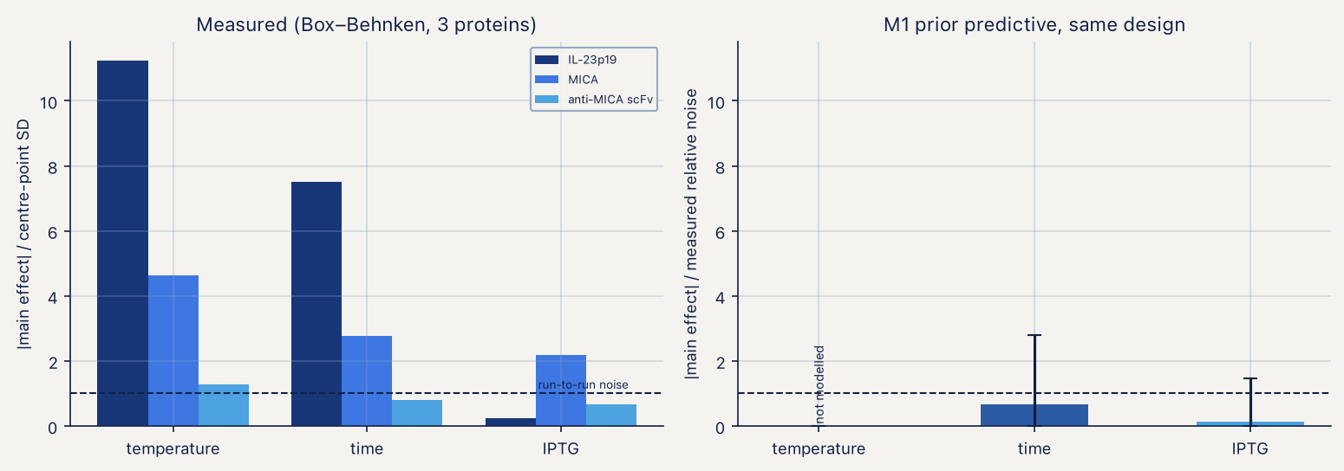
Measured factor effects against the M1 prior predictive
Two things follow. The ordering of the two axes the model does represent is reproduced, which is the strongest statement these data support: the design was not used to build the model and the model was not tuned to the design. The model’s absolute effects are smaller than the measured ones, which is expected and uninformative — the published runs vary temperature within every level set of the other factors, and that variance has nowhere to go in a model without an Arrhenius term. The practical recommendation of Section 3.1 is unchanged: spend replicates on harvest time, not on dose.

12 · M2 · an Arrhenius term that the data require
Notebook 03L reads the measured partition directly. Arenin expressed in BL21(DE3) at 0.5 mM IPTG and harvested 8 h after induction gives a soluble fraction of 0.686 ± 0.039 at 30 °C and 0.341 ± 0.024 at 37 °C. The replicate standard deviations are propagated into beta concentrations (ν = 140 and ν = 382 respectively) and used as fixed observation noise, because two measurements cannot support a fitted noise parameter as well as two structural ones. The aggregation exponent is likewise fixed at n = 2 for the same reason, leaving s₅₀ and ΔE/R free.
The absolute synthesis flux of that experiment is unknown. The M1 trajectory supplies the shape of the flux, and its scale is anchored by the measured ratio of total target protein in the lysate, 126.4 against 85.9 mg L⁻¹, a 1.47-fold increase from 30 °C to 37 °C. This matters for interpretation: s₅₀ is conditional on an assumed absolute scale and is not transferable, while ΔE/R depends only on the ratio of the two fluxes and is.
The first result is a falsification test that the model passes by failing a simpler model. If s₅₀ were temperature-independent, the measured 1.47-fold rise in flux alone would push the soluble fraction from 0.686 down to 0.621. The measurement is 0.341 — 11.6 measurement standard deviations away. The temperature dependence in Equation (3.12) is not a convenience; without it the partition function cannot reach the observed point from the observed flux change.
Sequential Monte Carlo over the two free parameters converged in nine stages and 1.5 s, log Z = 0.13, and returns ΔE/R = 20 000 K with a 94% credible interval of 13 500 to 26 900 K, against the 12 000 K used to generate the synthetic data in Section 9 — outside the interval. The closed-form ratio inversion, which uses the instantaneous partition function rather than the history-weighted observable of Equation (3.18), gives 23 600 K; the difference between the two is the proteolysis weighting plus the pull of a prior still centred at 10 000 K. The posterior is a ridge, as two points and two parameters must be, but a shallow one: the correlation between s₅₀ and ΔE/R is −0.47, not the −0.99 seen between ε and G in the lactose arm.
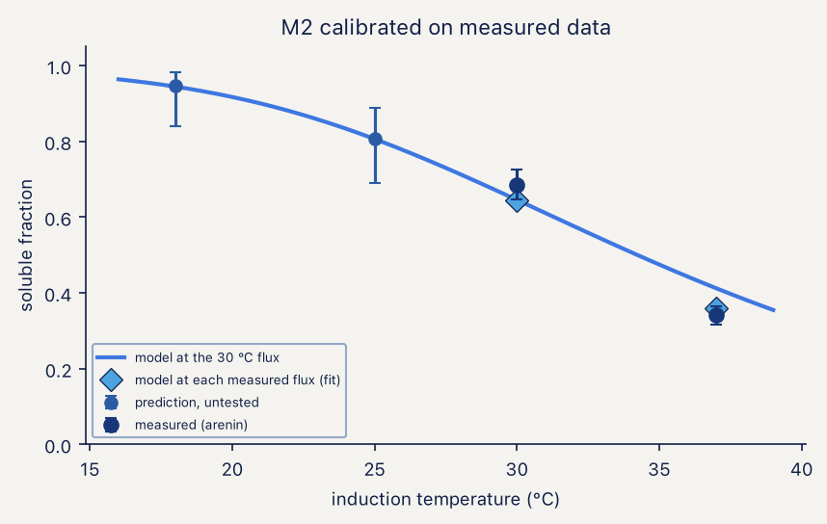
M2 calibrated on measured partition data
Residuals at the two calibration points are +0.018 and −0.041 in soluble fraction, both inside the measurement SD. Holding one temperature out is not possible with two of them, so the calibration is instead spent on a prediction: at the 30 °C synthesis flux the model forecasts a soluble fraction of 0.808 (95% interval 0.691 to 0.889) at 25 °C and 0.946 (0.839 to 0.983) at 18 °C. One gel at either temperature falsifies the Arrhenius closure. That is the cheapest decisive experiment the framework currently proposes.
The export written for M3 carries a dimer pool of 473 µM at 18 h, from 2729 µM total protein partitioned as 947 µM soluble against 1783 µM aggregated.
Consequence for the framework. The ΔE/R prior of notebook 03, N(10 000, 6000) K, puts the measured value 2.3 standard deviations into its upper tail and visibly pulls the posterior. It should be re-centred near 20 000 K before any fit to our own gels, or the first real dataset will be fought by the prior rather than informed by it.

13 · M3 · a contact energy taken from a melting point
The −4.2 kcal mol⁻¹ contact energy used throughout Section 4 was a placeholder. A denaturation midpoint is a disassembly midpoint, so at T_{m} the assay concentration equals c*, and Equation (4.8) inverts for ΔG_{contact} with no free parameters. Wild-type MS2 VLPs melt at approximately 66 °C in a SYPRO orange thermal shift assay run at 5–20 µM coat-protein monomer, which is 2.5–10 µM dimer and therefore −4.05 to −3.59 kcal mol⁻¹ depending on where in the quoted range the assay actually sat. Notebook 04L takes the mid-range value, −3.820 kcal mol⁻¹, and propagates the whole band in its final panel.
At the measured energy the critical concentration rises from the placeholder’s 1.03 µM to 3.84 µM. The M2 dimer pool of 473 µM sits 132-fold above it, so the conclusion that assembly in this system is not concentration-limited survives a 3.7-fold shift in c* — as it should, with two orders of magnitude of margin.
The thermodynamic outputs are likewise robust. Across the full assay band the equilibrium capsid fraction moves from 0.9898 to 0.9970, a span of 0.72 percentage points. The kinetic outputs are not: the capsid fraction reached in 18 h from a 500 µM bolus moves from 0.652 to 0.935 across the same band, a span of 28 percentage points, and the placeholder energy would have reported 0.937 where the measured energy reports 0.760.
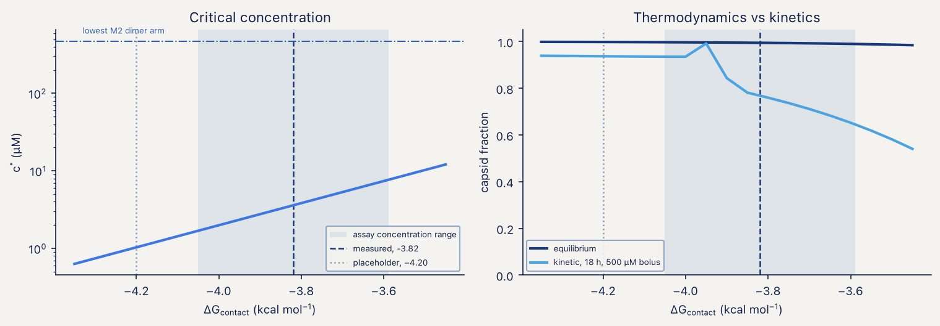
Critical concentration and capsid fraction across the measured contact-energy band
The sweep also exposes a feature the placeholder hid. The 18 h capsid fraction is not monotone in contact energy: it peaks at 0.992 near −3.95 kcal mol⁻¹ and falls to 0.937 at −4.00 and 0.843 at −3.90. The transition is sharp and tolerance-independent — identical to four decimal places at rtol 10⁻¹¹ and atol 10⁻²⁰ — and the free-dimer concentration at harvest moves from 0.03 µM below it to 3.8–18.5 µM above it. Stronger contacts deplete free dimer faster than partial shells can close and strand them; weaker contacts leave the reaction unfinished at harvest. There is an optimum, the measured energy sits on the weak side of it, and the pac-hairpin constructs of Module M4 are designed to move exactly this quantity.
Everything else in the notebook reproduces at the new energy: the contact schedule sums to 180.000000, mass drifts by 3.8 × 10⁻¹⁵ over 18 h, a 20 µM bolus still produces nothing in 18 h despite sitting above c*, and feeding still cuts stalled intermediates roughly three-fold relative to a bolus (0.040 against 0.0084) while leaving tens of µM of dimer unconverted at harvest. The contact-schedule sensitivity scan is unchanged in character: c* is identical across all nine schedules because it depends only on the total contact count, the equilibrium capsid fraction spans 0.978 to 0.998, and the kinetic capsid fraction spans 0.003 to 0.930. The schedule remains the dominant unknown.
What the mutant ladder cannot do. The same publication reports engineered MS2 variants spanning T_{m} from 42 to 61 °C. Converted through Equation (4.8) those span roughly 0.3 kcal mol⁻¹ in contact energy — narrower than the uncertainty on the wild-type value itself, which comes from not knowing where in a 5–20 µM range the assay sat. A ladder built from thermal-shift mutants would therefore calibrate nothing. The pac-hairpin series, which the model expects to move ΔG_{nuc} by 0.8 to 1.8 kcal mol⁻¹, remains the right instrument.

14 · Status
claim | tested on measured data | outcome
IPTG above the Hill midpoint is one condition | yes, 3 proteins, 15-run design | supported, ordinally
soluble partition needs a temperature term | yes, 2 temperatures, 1 protein | required at 11.6 SD
ΔE/R ≈ 12 000 K | yes | rejected; 20 000 K [13 500, 26 900]
assembly is not concentration-limited | yes, via measured T_{m} | survives a 3.7-fold shift in c*
equilibrium capsid fraction > 0.98 | yes | survives the full assay band
kinetic capsid fraction at 18 h | yes | not reportable; 28 pp span
contact schedule dominates predictive variance | not testable without structure | unchanged
recovery-corrected absolute titre | no source found | not tested

References
- Gutiérrez-González M, Farías C, Tello S, et al. Optimization of culture conditions for the expression of three different insoluble proteins in Escherichia coli. Scientific Reports 2019;9(1). doi:10.1038/s41598-019-53200-7
- Hidalgo-Vázquez E, Hernández-Pérez J, Antunes-Ricardo M, et al. Heterologous expression and functional characterization of recombinant arenin to assess its anticancer and wound-healing potential. Bioresources and Bioprocessing 2025;12(1). doi:10.1186/s40643-025-00986-2
- Pistono P, Xu J, Huang P, et al. Exploring the effects of intersubunit interface mutations on virus-like particle structure and stability. Biochemistry 2024;63(15):1913–1924. doi:10.1021/acs.biochem.4c00225

