Topic: Attention Is All You Need

About Me:
I am Alex (Alexander), did M.Sc. (Tech) in Electronics from NIT Warangal (2007)
17+ Years of Industry Experience blending Embedded Systems (12 Yrs) and Artificial Intelligence / Machine Learning (5 Yrs).


The Problem: RNNs & LSTMs forget context
Before transformers (2017), models like RNNs and LSTMs processed words one by one (Sequential).
- They remembered recent words, but forgot older ones (long sentences were hard).
- They had a fixed “memory flow,” so they couldn’t easily look back at all words at once.

Researchers wanted a system that could:
- Look at any word in a sentence, no matter how far apart.
- Weigh how important each other word is — dynamically.

Tokenization — Breaking Text into Pieces
Idea: Splitting text into smaller units called tokens (words)
Purpose: Converts raw text into a structured format that a model can process.
Example:
Text: “AI changes the world.”
Tokens: [“AI”, “changes”, “the”, “world”, “.”]
Types:
Word-level: Each word is a token → simple but large vocabulary.

Vectorization — Assigning Numbers to Tokens
Idea: Machines understand numbers, not words.
Goal: Convert each token into a numerical representation (vector).
Common Techniques:
- One-Hot Encoding: Binary vector → 1 for the token, 0 for others.
- Count/TF-IDF Vectors: Represent word frequency or importance in a document.
Example:
If vocabulary = [AI, changes, world],
“AI world” → [1, 0, 1]
Limitation: No meaning captured — “king” and “queen” are just numbers with no relation.

Embedding — Learning Meaningful Representations
Idea: Represent tokens as dense numeric vectors where similar words are closer in the vector space.
Goal: Capture semantic meaning and context.
Example:
“King – Man + Woman ≈ Queen”
Techniques:
- Word2Vec / GloVe: Pre-trained embeddings capturing word relationships.

The Insight: “Attention” as a lookup system
Asked:
“When humans read, we don’t process words one by one. We look at the whole sentence and focus on the parts that matter.”

So they created Attention — a mechanism to let each word attend to (focus on) all other words.
But they needed a mathematical way to compute how much attention each word should pay to others.

The Inspiration: Information Retrieval (Search Engines)
They borrowed an idea from information retrieval / databases.
When you search for something, you have:
- A Query (what you’re looking for)
- Keys (descriptions of stored items)
- Values (actual stored information)
You compare your query with all keys → find which items are relevant → then retrieve their values.
💡 They thought:
“What if each word could query all other words to find which are most relevant, and then retrieve their meanings accordingly?”

The Implementation: Q, K, and V for words
So for each word/Token:
- It becomes a Query (what I need to know).
- It also has a Key (what information I offer).
- And a Value (the meaning I carry).
They compute attention scores = Q × Kᵀ
Then weight all Values (V) by those scores → that gives a new context-aware representation.

The Breakthrough: “Attention Is All You Need” (2017)
This paper replaced recurrence (RNN) with pure attention using this Q-K-V setup.
It allowed:
- Parallel processing of all words
- Better long-range understanding
- Huge efficiency and accuracy gains

In short
Came up with Q–K–V by combining:
- Human intuition (focus attention like we do)
- Search engine math (query, key, value)
- Neural networks (to learn what to attend to automatically)

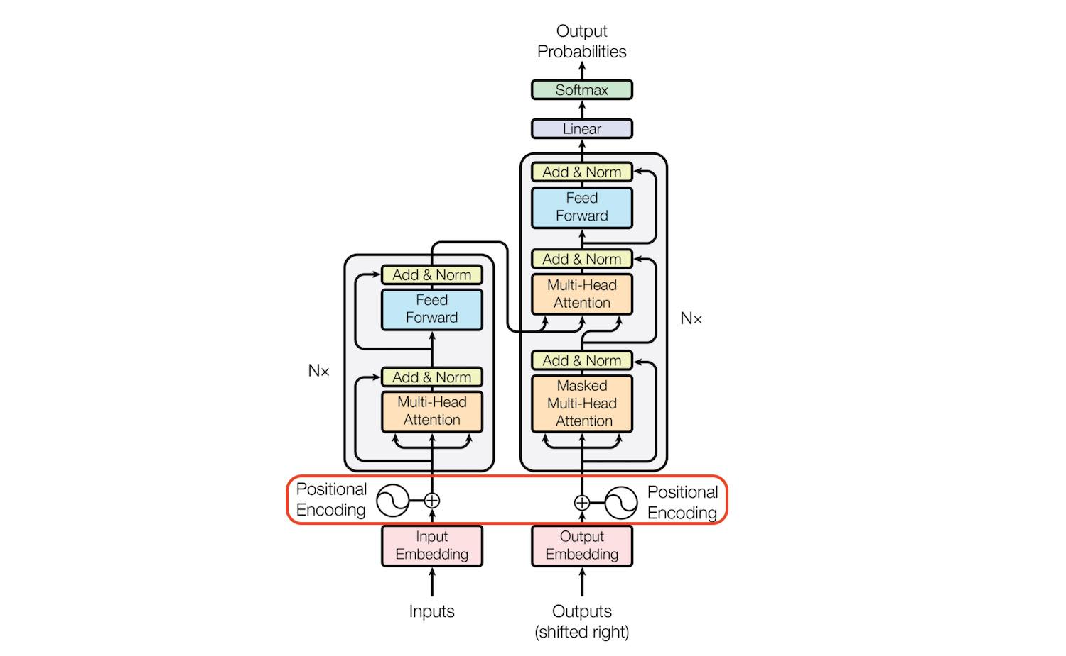

Single-Head Attention
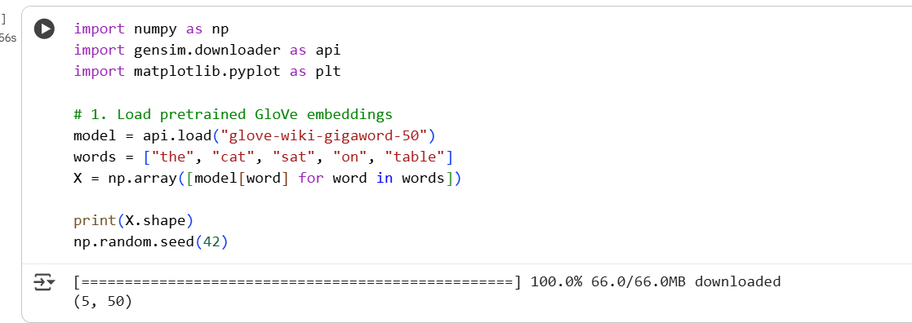

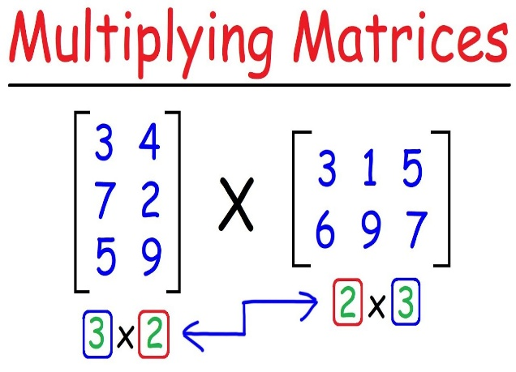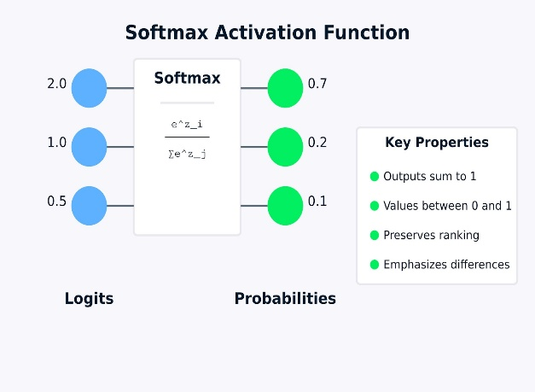

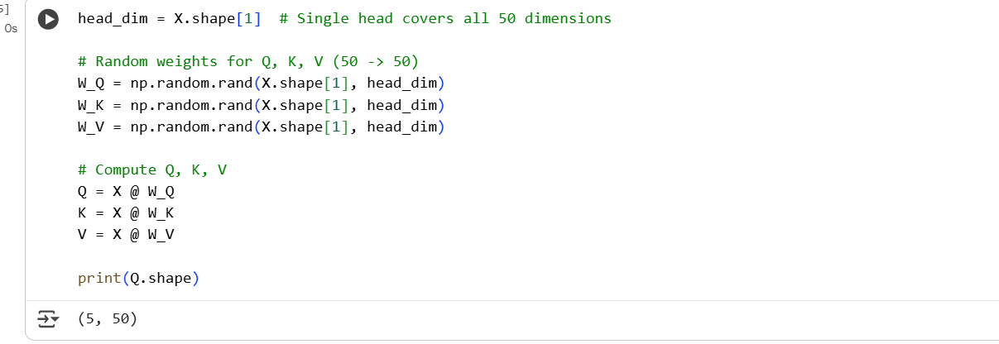
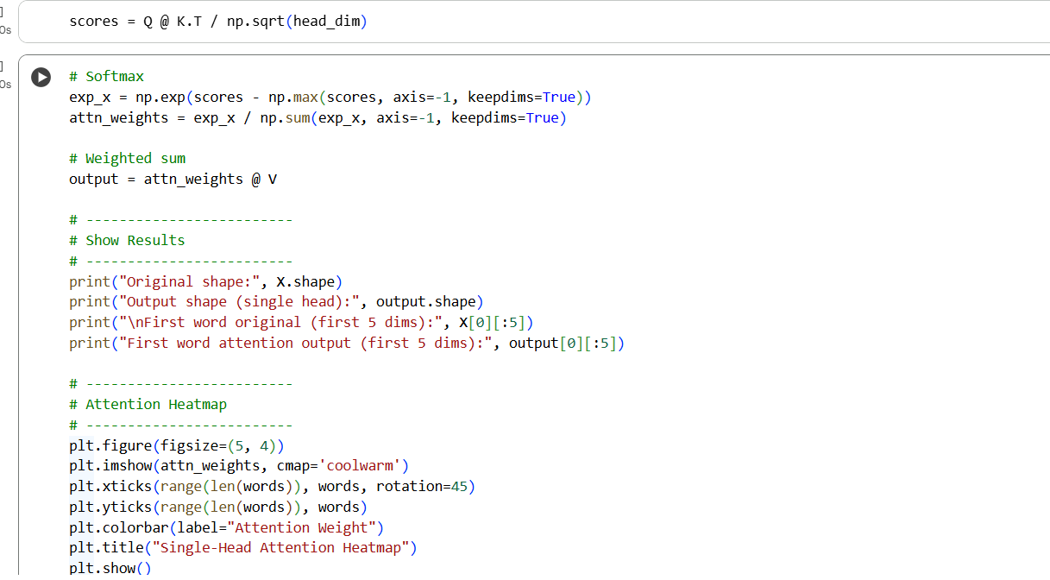
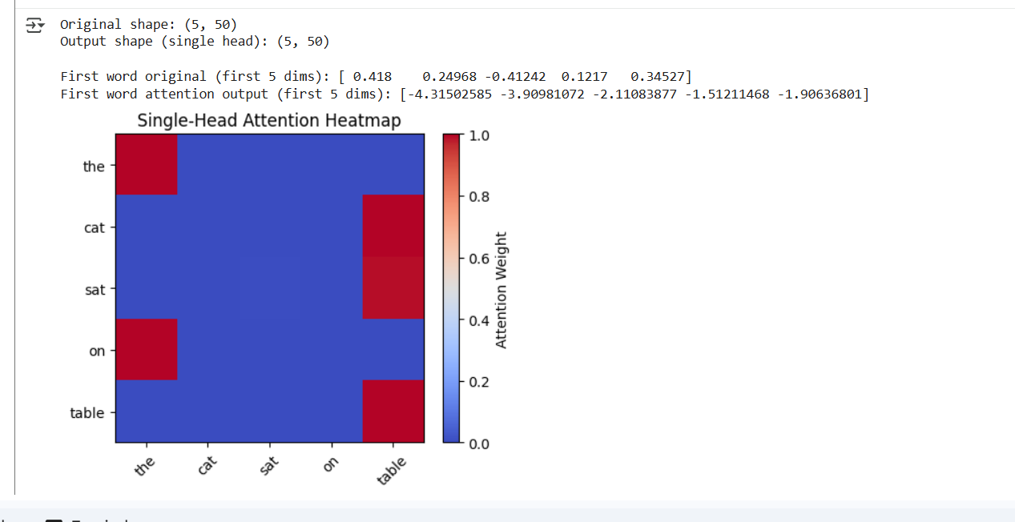

Multi-Head Attention
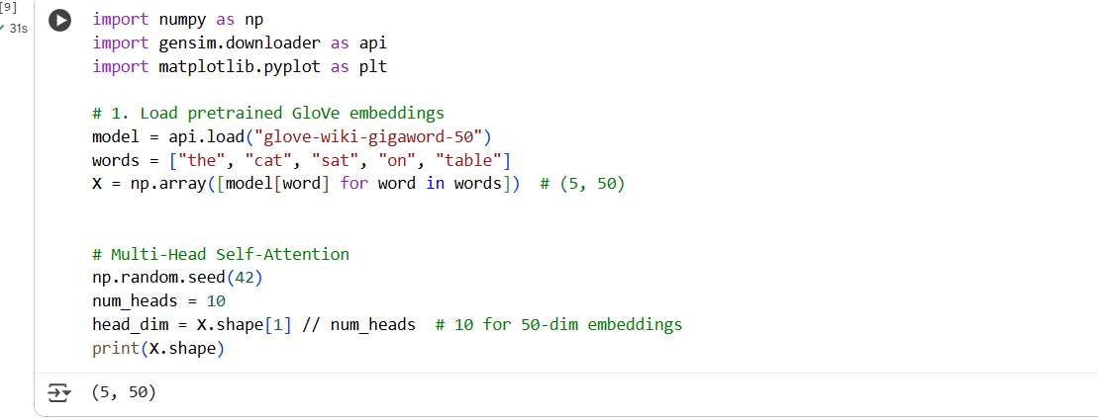
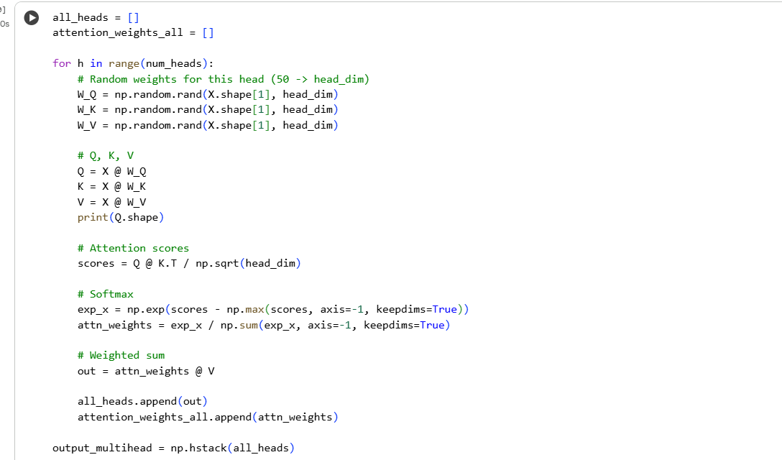
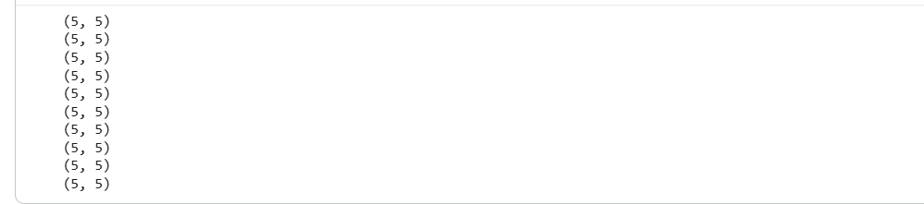
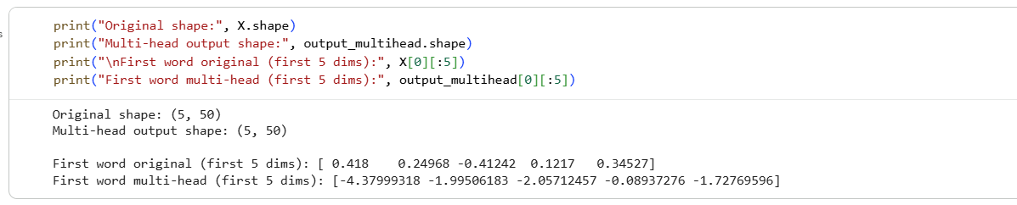
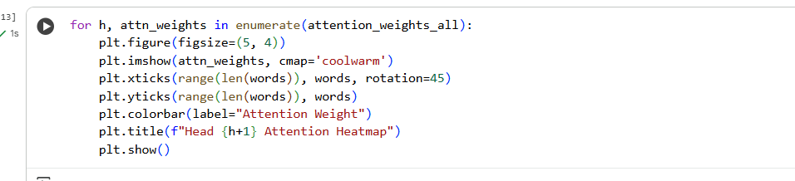
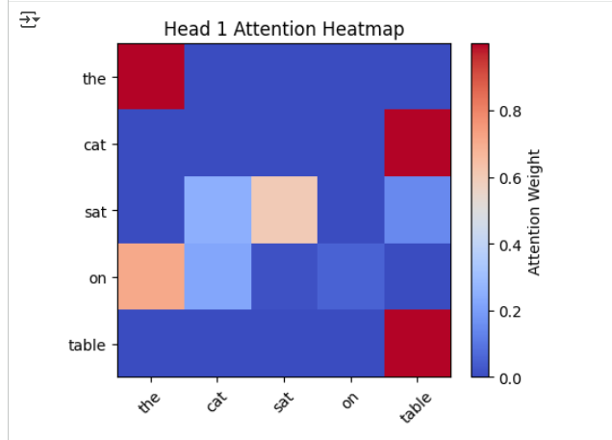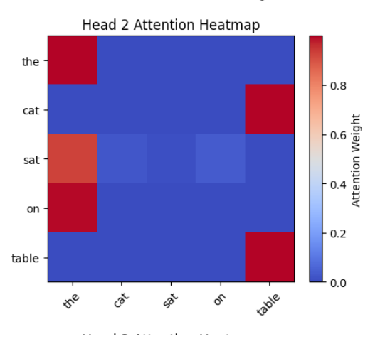
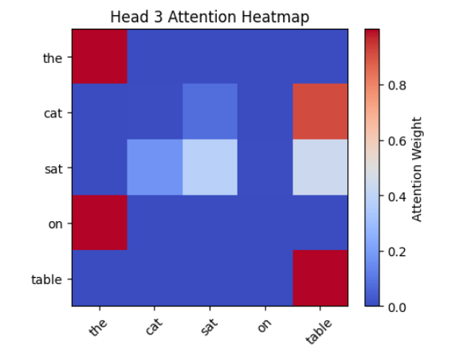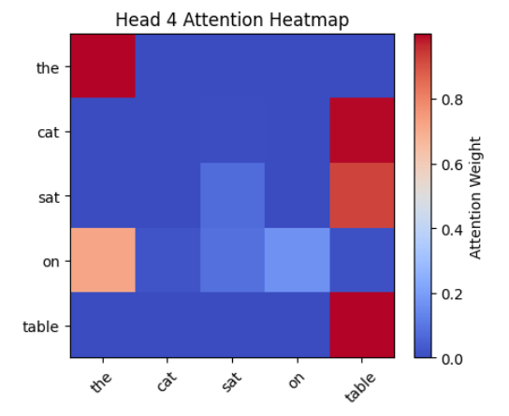

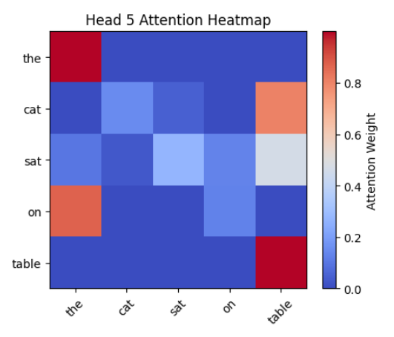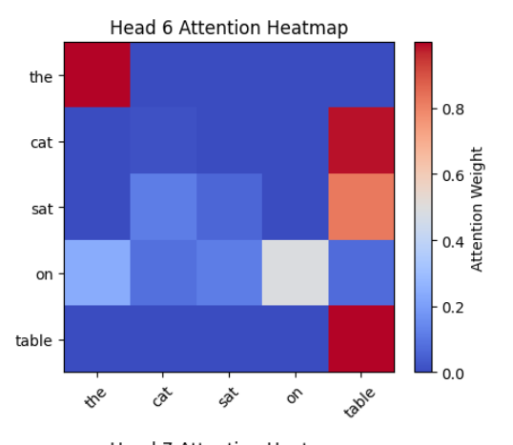
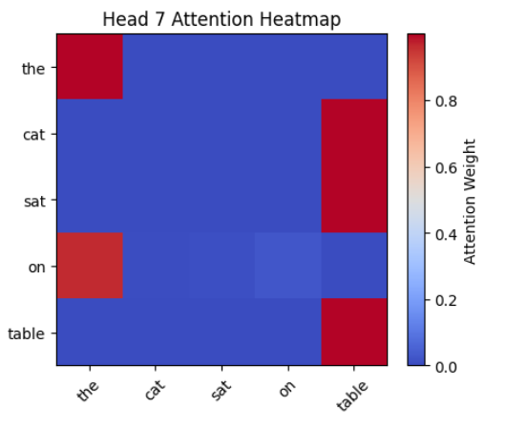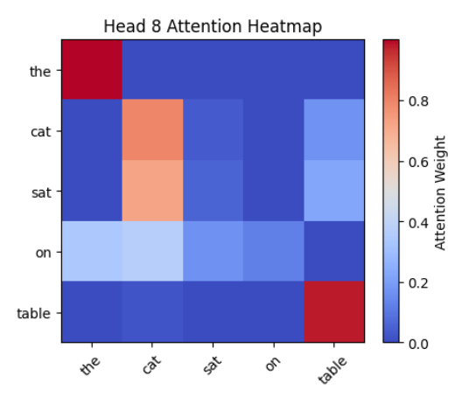
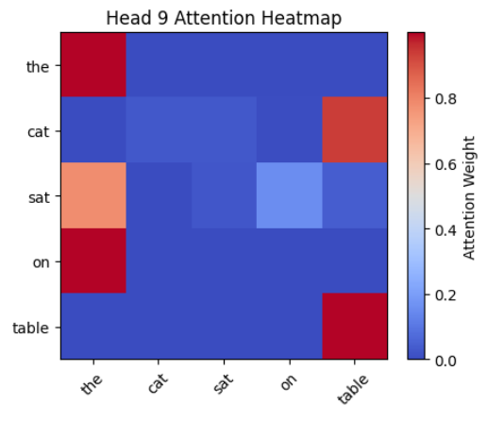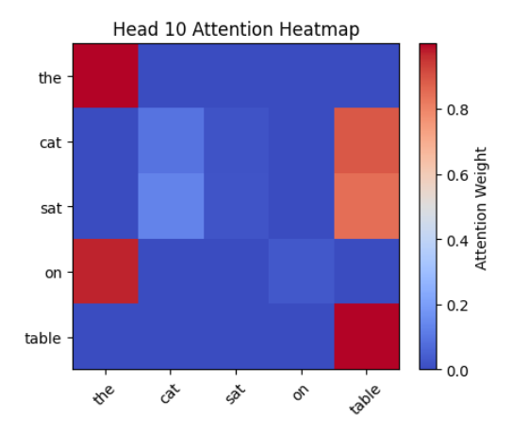

Feature | Single Head | Multi Head
Context capture | One pattern at a time | Many patterns at once
Representation | Shallow | Deep and diverse
Long dependencies | Limited | Strong
Computation | Faster | Slightly heavier but more powerful

Add & Normalization
we apply residual connection + layer normalization:
- Helps retain original information and prevent vanishing gradients.
- Stabilizes training by keeping values in a similar range.
- Ensures smooth learning even in very deep networks.

A Feed-Forward Network (FFN)
A Feed-Forward Network (FFN) in a Transformer is a two-layer fully connected neural network applied separately and identically to each token (position) in the sequence
Purpose: The attention mechanism is mostly linear. FFN introduces non-linear transformations (via ReLU/GELU) to help the model capture complex relationships.

Demo:
https://poloclub.github.io/transformer-explainer/

Thank You All
Any Questions /Query

What “dimension” means
The dimension (size) of a Word2Vec vector is the number of features in which each word is represented — e.g., 50, 100, 300, 768, etc.
It’s not computed from data directly — it’s a hyperparameter chosen before training.

Type | Strategy / Formula | Explanation
Rule of thumb | d ≈ sqrt(V) or d ≈ log2(V) | where V = vocabulary size. This ensures enough capacity to capture variety without overfitting.
Empirical tuning | Try d = [50, 100, 200, 300] | Train & evaluate on your downstream task (e.g., text classification). Pick the dimension that yields the best performance.
Corpus size–based | d ∝ (Total tokens)^0.25 | Larger corpus ⇒ higher dimension can be used. Smaller corpus ⇒ smaller dimension to prevent overfitting.
Semantic complexity–based | If the domain has many subtle distinctions (like legal/medical text) → higher d (e.g. 300–500). Simpler corpora (like tweets/news) → smaller d (50–100).

Corpus Type | Vocabulary Size | Suggested Dim
Small corpus (10k–50k words) | 10k | 50–100
Medium corpus (100k–500k) | 100k | 200–300
Large corpus (1M+) | 1M | 300–600

Intuitive analogy
Think of dimension d like resolution in an image:
- Low d → blurry meaning.
- High d → sharper meaning (but more costly to store/train).

Summary Formula-like Guide
If you want something actionable:
$$\text{Recommended Dim}=k×\sqrt{log⁡(V)}$$
where $k$is between 30–50 depending on corpus complexity.

