# Time Series Components

1. Level: The baseline value or average of the time series data over time.
2. Trend: Long-term movement or direction in the data over time. (up/down)
3. Seasonality: Regular, periodic fluctuations within a specific time period.
4. Cyclical: Fluctuations around the trend over longer periods, typically linked to economic or business cycles.
5. Irregular/Noise: Random, unpredictable variations that are not explained by the other components.

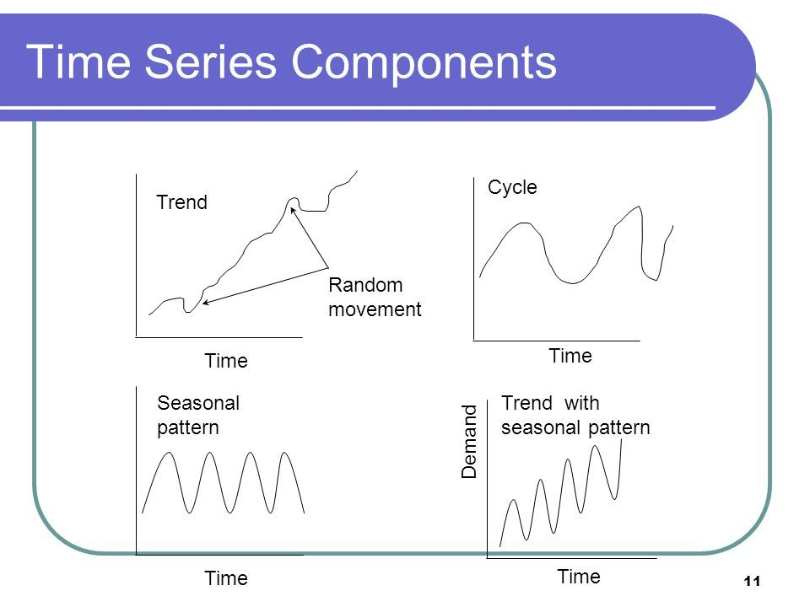

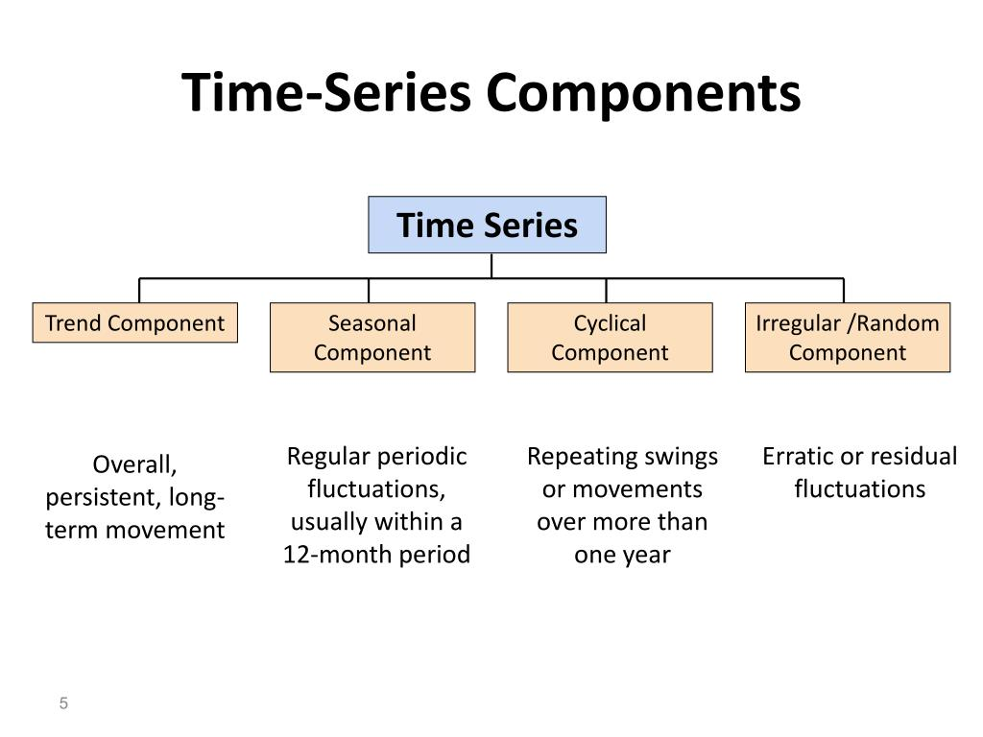

**Stationary Time Series?**

A Stationary series is one whose **statistical properties** such as mean, variance, covariance, and standard deviation do not vary with time, or these stats properties are not a function of time. In other words, stationarity in Time Series also means series without a *Trend* or *Seasonal* components.

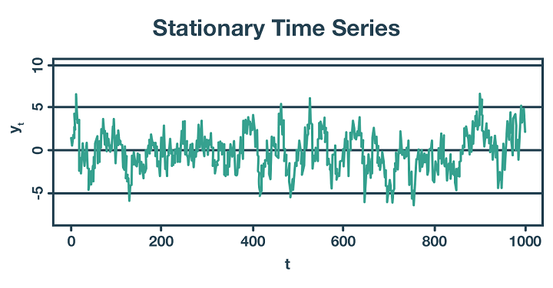

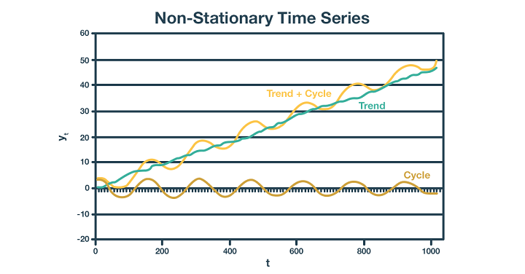

## Check for Stationary:

1. Visual Inspection: Plot the Time Series: Observe if the mean and variance remain constant over time. A non-stationary series will typically show trends, seasonality, or changing variance.
2. Dickey-Fuller Test (ADF Test): Augmented Dickey-Fuller Test: This is a statistical test where the null hypothesis is that the time series has a unit root (i.e., it is non-stationary). A low p-value (typically < 0.05) indicates that you can reject the null hypothesis, suggesting the series is stationary.
3. KPSS Test: Kwiatkowski-Phillips-Schmidt-Shin (KPSS) Test: This test is complementary to the ADF test. Here, the null hypothesis is that the series is stationary. A high p-value suggests that the series is stationary.

**Moving Average (MA) model:**

1. Identify Lag Order: Determine the order 𝑞, q of the MA model, which represents the number of lagged forecast errors to include.
2. Formulate the Model: Express the series as a linear combination of past forecast errors with the chosen lag order.
3. Estimate Parameters: Use methods like Maximum Likelihood Estimation (MLE) to estimate the coefficients of the lagged errors.
4. Fit the Model: Apply the estimated parameters to the historical data to fit the MA model.
5. Make Predictions: Use the fitted model to forecast future values based on past errors.