Shikhara Power Management Unit

Revision History

Rev | Date | Author | Description | Reviewed By
0.1 | 3/12/12 | Team | Initial Release
0.2 | 16/1/13 | Team | Added Implementation details

Table of Contents
Table of Contents 3
1.0 Scope 5
2.0 Power Management Unit 6
2.1 Overview of Power Management Unit (PMU) 6
2.2 Functional Description of PMU 6
2.3 Power Domains of Shikhara 7
2.4 Shikhara Power Domain Regions 9
3.0 Communication between PMU, SCC and SRC 10
3.1 Communication with the System Clock Controller 10
3.2 Communication with the System Reset Controller 11
4.0 Generic Implementation of Power Management Unit 12
4.1 Power Transition Signals 12
4.2 State Machine of Power Management Unit 13
5.0 Register Descriptions 17
5.1 Register Mapping 17
5.2 Register Bit Description 18
5.2.1 CONFIG_PMU Register (0x0033) 18
5.2.2 READY_PMU Register (0x0034) 19
6.0 Power Switching Strategy for the Use Cases 21
7.0 Implementation of Power Management Unit 23
7.1 PMU Implementation for Core CPU Power Domain 23
7.1.1 State Machine of PMU for Core CPU Power Domain 29
7.1.2 Slave State Machine for SCU power domain 42
7.1.3 State Machine for CPU0 and CPU1 power domains 46
7.1.4 State Machine for Debug PTM Power Domain 50
7.1.5 State Machine for Debug VSOC power domain 53
7.1.6 State Machine for Debug MBIST power domain 56
7.1.7 Sources for the eventi signal 58
7.1.8 Sources for the cpu_irqs signal 58
7.2 PMU Implementation for Video power domain 59
7.3 PMU Implementation for GNSS power domain 60
7.4 PMU Implementation for Comms power domain 61
7.5 PMU Implementation for HDMI power domain 62
7.6 PMU Implementation for USB power domain 63
7.6.1 State Machine Implementation for USB power domain 65
7.7 PMU Implementation for Display power domain 70
8.0 UPF Diagram of Shikhara 71

LIST OF FIGURES

Figure 2-1 Shikhara Power Domain block division 9
Figure 3-1 Communication of PMU with the System Clock Controller 10
Figure 3-2 Communication of PMU with the System Reset Controller 11
Figure 4-1 Power Transition signal sequence 12
Figure 4-2 Generic State Machine of the Power Management Unit in Shikhara 13
Figure 7-1 Power Domain Diagram of Cortex-A9 Osprey Macrocell 23
Figure 7-2 Valid Power States of Cortex-A9 Osprey macrocell 24
Figure 7-3 Master state machine for PMU of Core CPU power domain 29
Figure 7-4 State Machine for SCU power domain 42
Figure 7-5 State Machine of the CPU power domain 46
Figure 7-6 State Machine of Debug PTM power domain 50
Figure 7-7 State Machine of Debug VSOC power domain 53
Figure 7-8 State Machine for Debug MBIST power domain 56
Figure 7-9 State Machine for USB Host/DRD power domain 65
Figure 8-1 UPF Diagram of Shikhara 71

LIST OF TABLES

Table 2-1 Power Domains of Shikhara 7
Table 5-1 Register Mapping of Power Management Unit 17
Table 5-2 CONFIG_PMU Register 18
Table 5-3 READY_PMU Register 19
Table 6-1 Power Switching Strategy for use cases of Shikhara 21
Table 7-1 Table depicting the power switching strategy of Cortex-A9 25
Table 7-2 Signal Interfaces of PMU with Cortex-A9 25
Table 7-3 Signal Interfaces of PMU with Video power domain 59
Table 7-4 Signal Interfaces of PMU with GNSS power domain 60
Table 7-5 Signal Interfaces of PMU with Comms power domain 61
Table 7-6 Signal Interfaces of PMU with HDMI power domain 62
Table 7-7 PMU interface for USB power domain 63
Table 7-9 Signal Interfaces of PMU with Display power domain 70

Scope
This is the architectural document to specify the Power Management Unit requirements of Shikhara SoC.

Power Management Unit

Overview of Power Management Unit (PMU)

This chapter describes the Power Management Unit (PMU) in Shikhara. Power management has become one of the most important criteria in the design of mobile application SoCs. Mobile products, especially, have small battery with limited power capacity. The purpose of PMU is to provide various methods in Shikhara to consume less power under specific application scenarios.

The power management schemes in Shikhara provide two system power modes, namely, Active and Sleep modes. The description of each power mode is described as follows:

- Active: In this mode, the power is supplied to the domain and clock is running. In case of processor, the software is running and in case of peripherals, the data transfer is taking place. The active mode can be requested independently to each power domain.
- Sleep: In this mode, the power is internally gated using power switches. During this process, no state is retained and even memories are shut down. The sleep mode can be programmed independently for each power domain.

Note: Shikhara doesn’t support the retention mechanism. But, since L2 Cache is put in the Non power gated block, the dormant mode for L2 Cache is suppported.

Note: During the various internal power gating modes, modules like the system controller, low speed peripherals, LPDDR2, NIC301, IRAM, AXI2MEM, TZASC, TZMA, DMACPU0, DMACPU1, EBI and Real Time Clock (RTC) are non power gated. The RTC block is continued to be powered on even after the external power is switched off.

Two mechanisms are implemented in the System Controller to inform the processor regarding the power sequencing status:

- Polling Mechanism: Where a read-only register is implemented and the power sequencing status of each power domain is reflected here for the processor to read from.
- Interrupt Mechanism: Where an interrupt is used to inform the processor about any power sequencing events i.e. power up sequencing complete or power down sequencing complete. A mask register is also implemented so that the processor can mask the interrupts whenever necessary.

Functional Description of PMU

The total power consumption consists of static and dynamic power consumption. Static power is consumed when power to a circuit is supplied and there is no active operation in the circuit. On the other hand, dynamic power is consumed when the signal to a circuit is changing and there are some active operations in the circuit. The static power consumption is due to leakage current in the process. The dynamic power consumption depends on the operating voltage, operating frequency, and toggling ratios of the logic gate.

To reduce the static current, Shikhara supports block-based power gating. In specific applications, a certain group of modules are not required to run, and therefore do not need to be powered "ON". For example, Video Subsystem and HDMI Transmitter do not need to operate all the time and hence, can be power-gated for minimum static power consumption

Power Domains of Shikhara

Shikhara internal modules are grouped into eleven power domains based on their functions, as shown in table 2-1:
Table 2-1 Power Domains of Shikhara
Sl No. | Power Domain | Included Modules | Explanation for Power Domain Formation
1 | Core CPU | CPU0, CPU1, PL310, PTM, Debug Vsoc and MBIST. | Cortex-A9, being a hard macro, is put under a different power domain even though it internally contains six power domains.
2 | Video Power Domain | AV417V | The Video Subsystem is placed in a separate power domain.
3 | Comms Power Domain | Bluetooth | The Bluetooth Subsystem is placed in a separate power domain.
4 | USB Power Domain | USB 3.0 Host and DRD Controllers | USB 3.0 Host and DRD support an independent power management interface and hence, is put under a single power domain.
5 | HDMI Power Domain | HDMI Controller, HDMI Bridge | The HDMI is placed under a power domain so that it can be switched on only when necessary.
6 | Non Power Gated Block | SCON, NIC301, LPDDR2, APB peripherals, DMAC, TZASC, IRAM, EBI, AXI2MEM, IPC, LCDC, SMC, Coresight, SDMMC and MALI. | The system controller must always be on whenever the external supply is on. So, it is put under a single power domain along with the peripherals that are very rarely switched off and peripherals that do not provide satisfactory power savings when switched off.  Note: MALI has its own internal PMU and hence is considered as an always ON power domain with respect to the external PMU.
7 | RTC | RTC | The RTC is put under a special power domain because it can never be switched off even if the external supply is switched off.
8 | GNSS Power Domain | GNSS | The GNSS module is put under a separate power domain due to its huge size.
9 | Display Power Domain | CSI Controller, CSI Bridge, DSI Controller and DSI Bridge | The CSI and DSI controllers and bridges are clubbed into a single power domain.
Note: The Coresight component is placed in the always on power domain because of its cell count (50,000). So, implementing it as a separate power region is not advantageous.

Shikhara Power Domain Regions
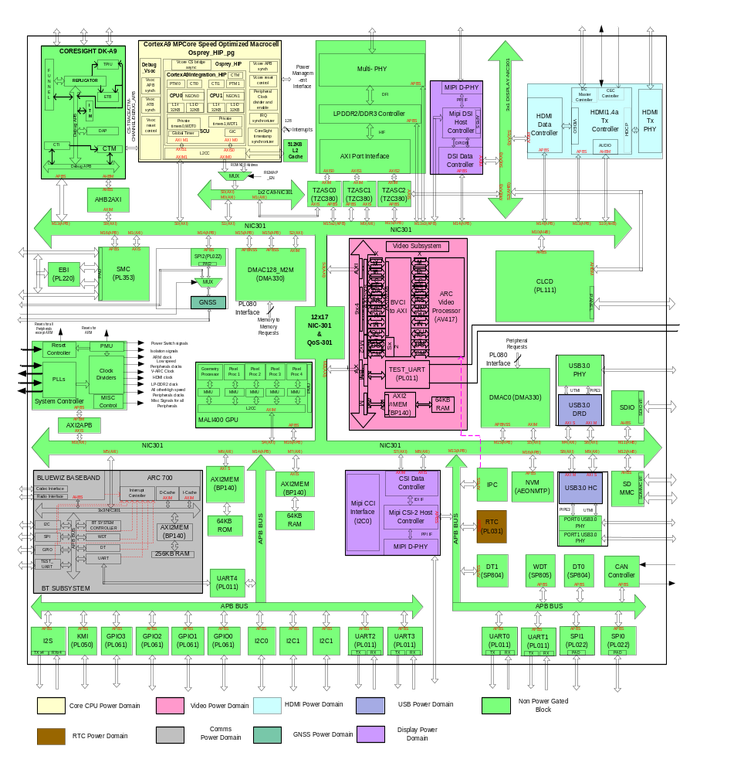
Figure 2-1 Shikhara Power Domain block division

Communication between PMU, SCC and SRC

The power up/down sequences include performing clock gating, asserting/de-asserting resets to the entire power domain. This involves the power management unit communicating to the System Clock Controller (SCC) and the System Reset Controller (SRC). The medium of communication is through the signals enable_clk and enable_reset.

Communication with the System Clock Controller

When the enable_clk signal is de-asserted, the SCC is supposed to gate all the clocks that cover the power domain and when it is asserted, the choice of clock gating is left to the SCC logic. As writing into the SCC registers consumes clock cycles whereby the PMU has no idea when the clock gating was asserted, a much simpler methodology is proposed in this section. The methodology is depicted in figure 3-1.
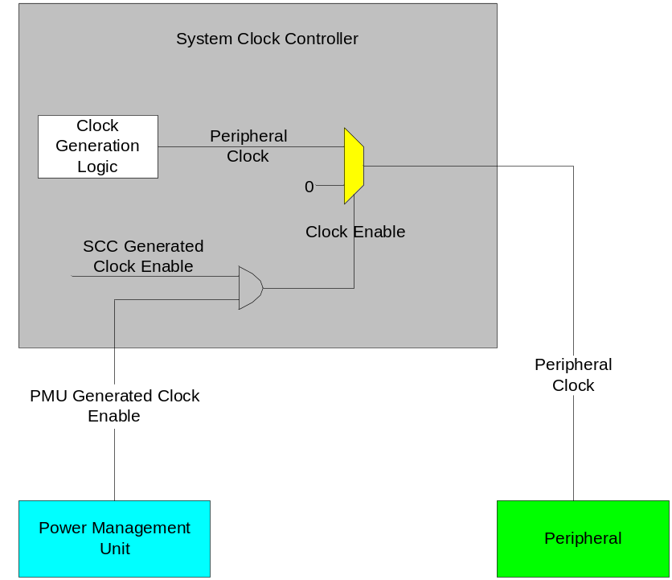
Figure 3-2 Communication of PMU with the System Clock Controller

Communication with the System Reset Controller

When the enable_reset signal is asserted, the SRC is supposed to apply reset to the entire power domain and when it is de-asserted, the choice of reset is left to the SRC logic. As writing into the SRC registers consumes clock cycles whereby the PMU has no idea when the reset was asserted, a much simpler methodology is proposed in this section. The methodology is depicted in figure 3-2.

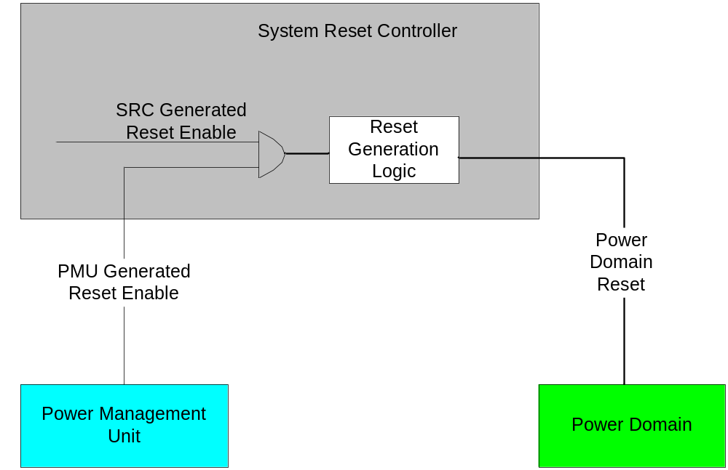
Figure 3-3 Communication of PMU with the System Reset Controller

Generic Implementation of Power Management Unit

Power Transition Signals

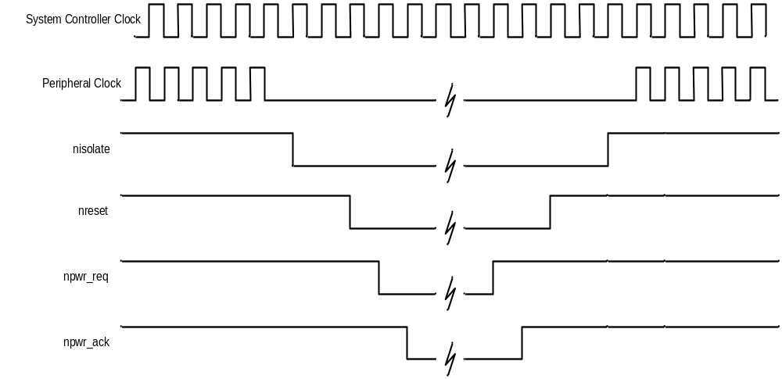
Figure 4-4 Power Transition signal sequence

The power down sequence that has to be strictly followed is listed as follows:
- Stop the clock.
- Isolate all outputs.
- Apply reset.
- Assert a request to the power switching fabric.

The power up sequence that has to be strictly followed is listed as follows:
- Assert a request to the power switching fabric.
- After getting the acknowledgement, de-assert the reset.
- De-isolate the outputs.
- Start the clock

State Machine of Power Management Unit

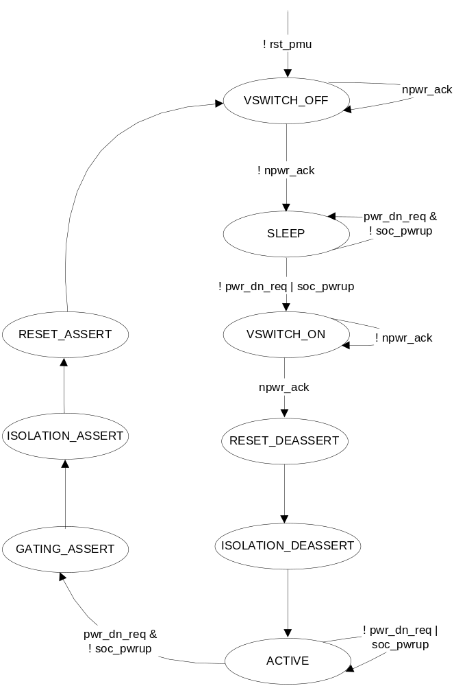
Figure 4-5 Generic State Machine of the Power Management Unit in Shikhara

This state machine is used for Video power domain, Comms power domain, GNSS power domain, Display power domain and HDMI power domain.
VSWITCH_OFF
Operations Performed in this state
This power management unit comes to this state at power-on-reset. In the VSWITCH_OFF state, it de-asserts the npwr_req signal which acts as a request to the power switching fabric to switch off the power to a power domain.
It then, waits for the handshake signal, npwr_ack from the power switching fabric to confirm that the power was successfully switched to that domain.

Exit Conditions in this state
The state doesn’t change until the power management unit gets the npwr_ack signal from the power switching fabric.
When the acknowledgement signal arrives, the state machine moves into the sleep state.

SLEEP
Operations Performed in this state
In the SLEEP state, the power management unit waits for the power up request signal ( pwr_dn_req ) from the APB interface where it is written into the CONFIG_PMU register of the system controller.
When the state machine is in the SLEEP state, it means that the power is switched off to the power domain.

Exit Conditions in this state
In the SLEEP state, the status signal to the Coresight power domain PMU is de-asserted.
The state machine continues in this state until the pwr_dn_req signal is de-asserted or soc_pwrup signal is asserted.
When the CONFIG_PMU register in the APB interface is written into by the processor such that the pwr_dn_req signal is de-asserted or if the SOC_PWRUP signal is asserted by the Coresight component, the state machine moves into the VSWITCH_ON state.

VSWITCH_ON
Operations Performed in this state
In the VSWITCH_ON state, the power management unit asserts the npwr_req signal that is routed to the power switches in the power switching fabric. This signal acts as a request to switch on the target power domain.

Exit Conditions in this state
The state machine stays in this state until it observes that the npwr_ack from the power switching fabric is high.
Once the npwr_ack signal goes high, the power management unit moves into the RESET_DEASSERT state.

RESET_DEASSERT
Operations Performed in this state
In the RESET_DEASSERT state, the reset enable signal ( enable_reset ) to the system reset controller is de-asserted to remove the reset to the target power domain.

Exit Conditions in this state
The state machine moves to the ISOLATION_DEASSERT state in the next clock cycle.

ISOLATION_DEASSERT
Operations Performed in this state
In the ISOLATION_DEASSERT state, the isolation signal ( isolate ) signal to the target power domain is de-asserted to remove the isolation on all the output ports in the power domain.

Exit conditions in this state
The state machine moves to the ACTIVE state in the next clock cycle.

ACTIVE
Operations Performed in this state
In the ACTIVE state, the clock request signal ( enable_clk ) to the system clock controller is asserted to remove the applied clock gating to the target power domain.

Exit Conditions in this state
In the ACTIVE state, the status signal to the Coresight power domain PMU is asserted.
The state machine continues in the same state until the power down request ( pwr_dn_req ) from the APB interface is held high in conjunction with the soc_pwrup signal de-asserted.
Once the CONFIG_PMU register in the APB interface is written in such a way by the processor that the pwr_dn_req signal to the target power domain is asserted, the state machine samples the soc_pwrup signal. If it is de-asserted, the state machine moves into the GATING_ASSERT state.

GATING_ASSERT
Operations Performed in this state
In the GATING_ASSERT state, the clock request signal ( enable_clk ) to the system clock controller is de-asserted to apply clock gating to the target power domain.

Exit Conditions in this state
The state machine moves to the ISOLATION_ASSERT state in the next clock cycle.

ISOLATION_ASSERT
Operations Performed in this state
In the ISOLATION_ASSERT state, the isolation signal ( isolate ) signal is asserted to isolate all the outputs of the target power domain.

Exit Conditions in this state
The state machine moves to the RESET_ASSERT state in the next clock cycle.

RESET_ASSERT
Operations Performed in this state
In the RESET_ASSERT state, the reset request signal ( enable_reset ) to the system reset controller is asserted to apply reset to the target power domain.

Exit Conditions in this state
The state machine moves to the VSWITCH_OFF state in the next clock cycle.

Register Descriptions

Register Mapping

Table 5-2 Register Mapping of Power Management Unit
Address Offset | Register Name | Register Description | Access | Default Value
0x0033 | CONFIG_PMU | Configuration register for the internal power gating in the Power Management Unit. | RW | 0x0000087B
0x0034 | READY_PMU | Power ready register to indicate end of power up or power down sequencing. | RO | 0x00003FCF

Register Bit Description

CONFIG_PMU Register (0x0033)
Table 5-3 CONFIG_PMU Register
Bit | Name | Access | Default | Description
31:12 | Reserved
11 | PWR_DN_DISPLAY | RW | 1 | Power down/up request field for Display power domain.  0 – Power up request  1 – Power down request
10:9 | PWRCTLI0 | RW | 0 | PWRCTLI0 signal control register bits for CPU0.
8:7 | PWRCTLI1 | RW | 0 | PWRCTLI1 signal control register bits for CPU1.
6 | PWR_DN_GNSS | RW | 1 | Power down/up request field for GNSS power domain.  0 – Power up request  1 – Power down request
5 | PWR_DN_COMMS | RW | 1 | Power down/up request field for Comms power domain.  0 – Power up request  1 – Power down request
4 | PWR_DN_DBG | RW | 1 | Alternate Power down/up request field for Debug power domains inside Cortex-A9.  0 – Power up request  1 – Power down request
3 | PWR_DN_VIDEO | RW | 1 | Power down/up request field for Video power domain.  0 – Power up request  1 – Power down request
2 | Reserved
1 | PWR_DN_USB | RW | 1 | Power down/up request field for USB power domain.  0 – Power up request  1 – Power down request
0 | PWR_DN_HDMI | RW | 1 | Power down/up request field for HDMI power domain.  0 – Power up request  1 – Power down request

READY_PMU Register (0x0034)

Table 5-4 READY_PMU Register
Bit | Name | Access | Default | Description
31:14 | Reserved
13:12 | DISPLAY_READY | RO | 0x3 | Power transition complete pointer for Display power domain.  00 – Power up sequencing complete  01 – Power up sequencing in progress  10 – Power down sequencing complete  11 – Power down sequencing in progress
11:10 | GNSS_READY | RO | 0x3 | Power transition complete pointer for GNSS power domain.  00 – Power up sequencing complete  01 – Power up sequencing in progress  10 – Power down sequencing complete  11 – Power down sequencing in progress
9:8 | COMMS_READY | RO | 0x3 | Power transition complete pointer for Comms power domain.  00 – Power up sequencing complete  01 – Power up sequencing in progress  10 – Power down sequencing complete  11 – Power down sequencing in progress
7:6 | VIDEO_READY | RO | 0x3 | Power transition complete pointer for Video power domain.  00 – Power up sequencing complete  01 – Power up sequencing in progress  10 – Power down sequencing complete  11 – Power down sequencing in progress
5:4 | Reserved
3:2 | USB_READY | RO | 0x3 | Power transition complete pointer for USB power domain.  00 – Power up sequencing complete  01 – Power up sequencing in progress  10 – Power down sequencing complete  11 – Power down sequencing in progress
1:0 | HDMI_READY | RO | 0x3 | Power transition complete pointer for HDMI power domain.  00 – Power up sequencing complete  01 – Power up sequencing in progress  10 – Power down sequencing complete  11 – Power down sequencing in progress

Power Switching Strategy for the Use Cases

Table 6-5 Power Switching Strategy for use cases of Shikhara
Use case | Core CPU | Video | USB | HDMI | GNSS | Display | Comms
1 | ON | OFF | OFF | OFF | OFF | OFF | OFF
2 | ON | ON | OFF | OFF | OFF | OFF | OFF
3 | ON | OFF | ON | OFF | OFF | ON | OFF
4 | ON | OFF | OFF | OFF | OFF | ON | OFF
5 | ON | OFF | OFF | OFF | OFF | ON | OFF
6 | ON | ON | OFF | ON | OFF | ON | OFF
7 | ON | OFF | OFF | ON | OFF | OFF | OFF
8 | ON | OFF | OFF | OFF | OFF | OFF | OFF
9 | ON | OFF | OFF | OFF | OFF | OFF | OFF
10 | ON | OFF | OFF | OFF | OFF | OFF | OFF
11 | ON | OFF | OFF | OFF | OFF | OFF | OFF
12 | ON | ON | ON | OFF | OFF | OFF | OFF
13 | ON | ON | ON | OFF | OFF | OFF | OFF
14 | ON | ON | OFF | OFF | OFF | OFF | ON
15 | ON | OFF | OFF | OFF | OFF | OFF | OFF
16 | ON | OFF | OFF | OFF | OFF | OFF | OFF
17 | ON | ON | OFF | OFF | OFF | OFF | OFF
18 | ON | OFF | OFF | OFF | OFF | OFF | OFF
19 | ON | OFF | OFF | OFF | OFF | OFF | OFF
20 | ON | OFF | OFF | OFF | OFF | OFF | OFF
21 | ON | OFF | OFF | OFF | OFF | OFF | OFF
22 | ON | OFF | OFF | OFF | OFF | OFF | OFF
23 | ON | OFF | OFF | OFF | OFF | OFF | OFF
24 | ON | OFF | OFF | OFF | OFF | OFF | OFF
25 | ON | OFF | OFF | OFF | OFF | OFF | OFF

Implementation of Power Management Unit

PMU Implementation for Core CPU Power Domain

The CPU Core power domain consists of the Cortex-A9 macrocell along with the Coresight component. Though the collection is termed as a single power domain, multiple blocks inside it can be switched on/off by the PMU. But, the switching of power between them has to follow a certain set of rules. So, they are brought under a power domain.
The Cortex-A9 osprey macrocell is internally divided into six power domains. They are named below:
- CPU0 domain, consisting of CPU0 and NEON0.
- CPU1 domain, consisting of CPU1 and NEON1.
- SCUPL310 domain, consisting of SCU, L2CC, GIC and other peripherals.
- Debug PTM domain, consisting of PTM0 and PTM1.
- Debug VSOC domain, consisting of Debug blocks.
- Debug MBIST domain, consisting of MBIST controller.

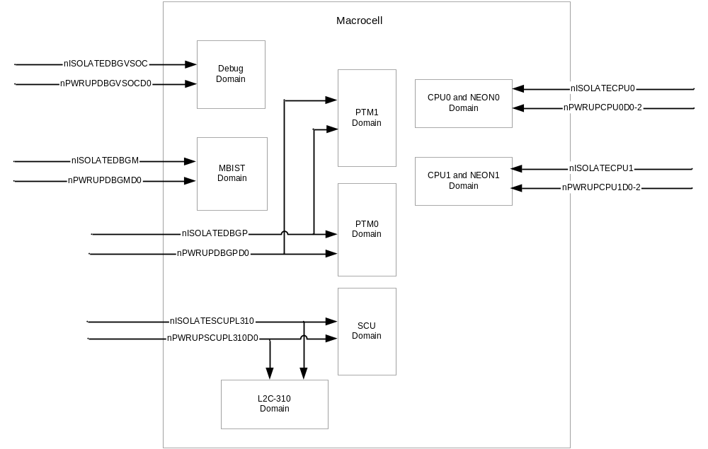
Figure 7-6 Power Domain Diagram of Cortex-A9 Osprey Macrocell

The Cortex-A9 osprey macrocell supports a total of nine power modes valid for safe power up and power down sequencing. They are shown in figure 7-2 along with the recommended passage of power up/down sequencing. The table 7-1 following it describes the power status of the different power domains in these power modes.

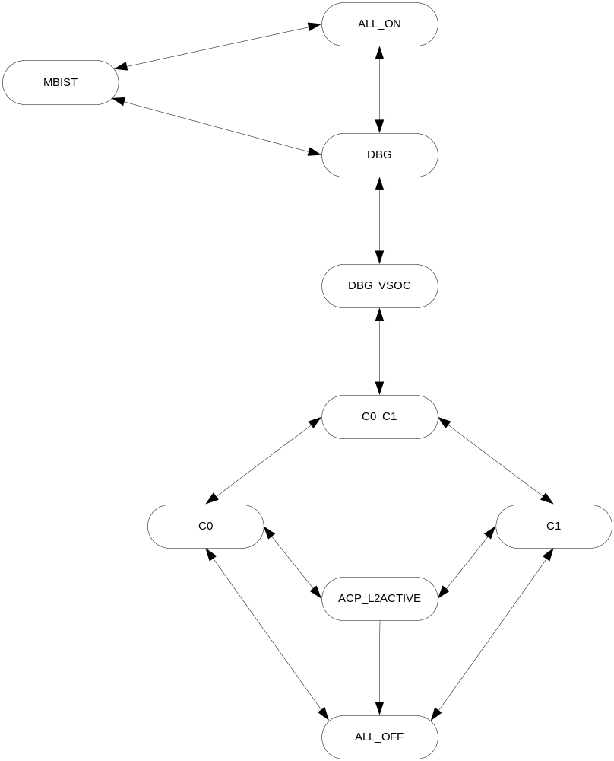
Figure 7-7 Valid Power States of Cortex-A9 Osprey macrocell

Table 7-6 Table depicting the power switching strategy of Cortex-A9
Power Mode | CPU0 | CPU1 | SCU | Debug PTM | Debug_Vsoc | MBIST
ALLON | ON | ON | ON | ON | ON | ON
MBIST | ON | ON | ON | OFF | OFF | ON
DEBUG | ON | ON | ON | ON | ON | OFF
DBGVSOC | ON | ON | ON | OFF | ON | OFF
CPU0CPU1 | ON | ON | ON | OFF | OFF | OFF
CPU0 | On | OFF | ON | OFF | OFF | OFF
CPU1 | OFF | ON | ON | OFF | OFF | OFF
SCU | OFF | OFF | ON | OFF | OFF | OFF
ALLOFF | OFF | OFF | OFF | OFF | OFF | OFF

The SCUPL310 power domain has to be powered up first followed by either of the CPU power domains. In order to power up any of the debug domains, all the CPU domains have to be powered up. The first debug domain that can be powered is the debug Vsoc power domain followed by the debug power domain. Then, the MBIST power domain can be switched on either by leaving the other two debug power domains powered on or as switched off. The power down sequencing has to follow the same order for a safe power down.

The Coresight internally has only one power domain and the power up/down sequencing is done using the signals originating from the Coresight component.

The signal interface of the Cortex-A9 and Coresight with the PMU is described in table 7-2:

Table 7-7 Signal Interfaces of PMU with Cortex-A9
Sl no. | Signal Name | I/O | Description
1 | CLKSTOPPED | I | Indicates Core Link Level 2 Cache Controller clock is stopped. Used by PMU to put L2CC in low power mode.
2 | nIRQOUT [1:0] | I | Active-LOW IRQ output from the internal GIC to CPU0 and CPU1 as appropriate. Used by PMU to wake-up the processors when an interrupt wake occurs.
3 | nFIQOUT [1:0] | I | Active-LOW FIQ output from the internal GIC to CPU0 and CPU1 as appropriate. Used by PMU to wake-up the processors when an interrupt wake occurs.
4 | CSYSACKM0VSOC | I | CPU0 ATB asynchronous bridge acknowledgement.
5 | CSYSREQM0VSOC | O | CPU0 ATB asynchronous bridge request. Should set CSYSREQM0VSOC LOW and wait for CSYSACKM0VSOC to go LOW. This indicates that all of the transactions are flushed out of the bridges and that it is safe to power them down.
6 | CSYSACKM1VSOC | I | CPU1 ATB asynchronous bridge acknowledgement.
7 | CSYSREQM1VSOC | O | CPU1 ATB asynchronous bridge request. Should set CSYSREQM1VSOC LOW and wait for CSYSACKM1VSOC to go LOW. This indicates that all of the transactions are flushed out of the bridges and that it is safe to power them down.
8 | PWRCTLI0 [1:0] | O | Reset value for CPU0 status field, bits [1:0] of SCU CPU Power status register.  2'b00 Default value if processor is present.  2’b01 and 2’b10 - Reserved  2'b11 Otherwise.
9 | PWRCTLO0 [1:0] | I | CPU0 output power control signals  2'b00 Normal Run  2'b01 Reserved  2'b10 CPU can enter dormant mode  2'b11 CPU can enter shutdown.
10 | PWRCTLI1 [1:0] | O | Reset value for CPU1 status field, bits [1:0] of SCU CPU Power status register.  2'b00 Default value if processor is present.  2’b10 and 2’b10 - Reserved  2'b11 Otherwise.
11 | PWRCTLO1 [1:0] | I | CPU1 input power control signals  2'b00 Normal Run  2'b01 Reserved  2'b10 CPU can enter dormant mode  2'b11 CPU can enter shutdown.
12 | nISOLATECPU0 | O | Isolates CPU 0 and data engine 0 inputs and outputs.
13 | nPWRDNCPU0D0 | O | CPU 0 and data engine 0 power up sequencing signal.
14 | nPWRDNCPU0D1 | O | CPU 0 and data engine 0 power up sequencing signal.
15 | nPWRDNCPU0D2 | O | CPU 0 and data engine 0 power up sequencing signal.
16 | nISOLATECPU1 | O | Isolates CPU 1 and data engine 1 inputs and outputs.
17 | nPWRDNCPU1D0 | O | CPU 1 and data engine 1 power up sequencing signal.
18 | nPWRDNCPU1D1 | O | CPU 1 and data engine 1 power up sequencing signal.
19 | nPWRDNCPU1D2 | O | CPU 1 and data engine 1 power up sequencing signal.
20 | nISOLATEDBGVOSC | O | Isolates debug VSOC domain inputs and outputs.
21 | nPWRUPDBGVSOCD0 | O | Debug VSOC domain power up sequencing signal.
22 | nISOLATESCUPL310 | O | Isolates SCU and cache controller inputs and outputs.
23 | nPWRUPSCUPL310D0 | O | SCU and cache controller power up sequencing signal.
24 | nISOLATEDBGP | O | Isolates PTM inputs and outputs.
25 | nPWRUPDBGPD0 | O | Debug power up sequencing signal.
26 | nISOLATEDBGM | O | Isolates MBIST inputs and outputs.
27 | nPWRUPDBGMD0 | O | MBIST Debug power up sequencing signal.
28 | DBGNOPWRDWN | I | Debug request power down from CPU0 and CPU1 debug logic.
29 | PTMPWRUP0 | I | PTM power up request signal.
30 | STANDBYWFI | I | Indicates if CPU0 or CPU1 is in Standby WFI mode.
31 | PL310IDLE | I | Indicates no activity in the cache controller.
32 | PTMIDLEnACK0 | I | When PTMIDLEnACK is driven LOW, the PTM stops generating trace and is in a quiescent state.
33 | PTMPWRUP1 | I | When HIGH, indicates that the PTM is in use.  When LOW, indicates that the PTM is not in use.
34 | PTMIDLEnACK1 | I | When PTMIDLEnACK is driven LOW, the PTM stops generating trace and is in a quiescent state.
35 | nPERIPHCLKGENRST | O | Resets the Macrocell peripheral clock divider
36 | ATRESETn | O | Resets the ATCLK domain logic, the ATB asynchronous bridges and PTM ATCLK domain logic in the ATCLK domain.
37 | nSCUPERIPHRST | O | Resets the SCU and private GIC, timers and watchdog logic on the peripheral clock domain.
38 | nDBGPGRESET | O | Coresight APB debug resetfor power down
39 | nDBGRESET[1:0] | O | Resets CPU0 and CPU1 debug logic and associated Coresight components
40 | nCPURESET[1:0] | O | Resets CPU0 and CPU1
41 | nNEONRESET[1:0] | O | Resets NEON0 and NEON1
42 | nWDRESET[1:0] | O | Resets CPU0 and CPU1 watchdog
43 | WDRESETREQ[1:0] | I | CPU0 and CPU1 watchdog reset requests
44 | SCUREADY | I | Indicates when the SCU is out of reset
45 | CPUREADY[1:0] | I | Indicates when CPU0 and CPU1 are out of reset
46 | NEONREADY[1:0] | I | Indicates when NEON0 and NEON1 are out of reset
47 | nPTMRESET | O | Resets the PTM CLK domain
48 | nPTMPGRESET | O | Resets all PTM logic
49 | nPRESETDBG | O | Debug reset for power down
50 | nBISTRESET | O | Resets the Memory BIST controller
51 | CDBGPWRUP | I | Input from the Coresight component to turn on the debug logic inside Osprey.
52 | CSOCPWRUP | I | Input from the Coresight component to power up the entire Osprey.
53 | osprey_status | O | Output to the Coresight power management state machine delivering the status of Osprey.
54 | soft_debug_req | I | Input from the APB register( CONFIG_PMU ) that is treated as a request to switch on the debug power domains inside Cortex-A9 from other peripherals.
55 | eventi | I | A custom two-bit signal used to power up the Osprey when all the six power domains inside it are powered down. One bit each is used for each processor.
56 | cpu_irqs | I | A custom two-bit signal used as a substitute to the nIRQOUT and nFIQOUT signals if the GIC is not programmed sufficiently due to the loss of data after power-up.

State Machine of PMU for Core CPU Power Domain
The state machine implementation for PMU for Core CPU power domain consists of a master state machine that controls six other slave state machines. The master state machine takes care of the power up/down sequencing as recommended by ARM. The master state machine is depicted in figure 7-3 :

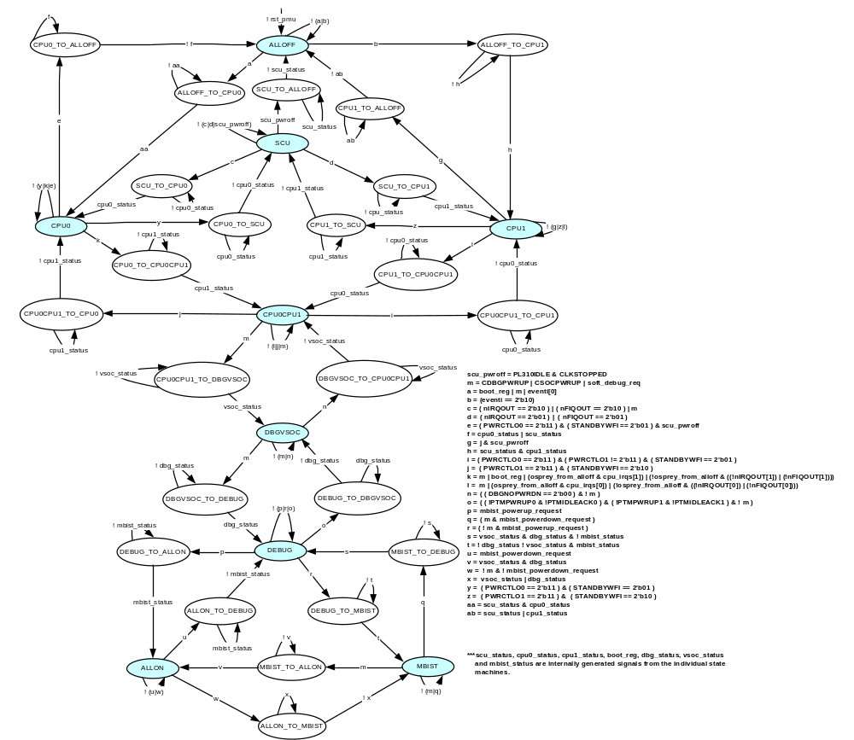
Figure 7-8 Master state machine for PMU of Core CPU power domain

ALLOFF
Operations Performed in this state
The power management unit enters this state at power-on-reset. In the ALLOFF state, all the six power domains inside the Osprey macro-cell are in the power off mode.

Exit Conditions in this state
A register is programmed such that it is asserted during boot and remains asserted until both the CPUs are powered on. If the state machine enters this state at power on reset, this bit is asserted and hence, the state machine moves to the ALLOFF_TO_CP0 state.
When the Coresight component provides a debug power up request through the CDBGPWRUP signal, it is treated as a power up request to the macrocell and it enters the ALLOFF_TO_CPU0 state.
When the coresight component provides an SoC power up request through the CSOCPWRUP signal, it is treated as a power up request to the macrocell and it enters the ALLOFF_TO_CPU0 state.
When the CONFIG_PMU register is written into in such a way that the soft_debug_req signal is set, it is treated as a power-up request to the macrocell and it enters the ALLOFF_TO_CPU0 state.
During an intermediate stage when the entire macrocell is switched off, a two bit event mechanism is used to wake up the macrocell where the events are mapped to RTC, GPIO and KMI.
If none of the above conditions satisfy, the state machine remains in the same state.

ALLOFF_TO_CPU0
Operations Performed in this state
In the ALLOFF_TO_CPU0 state, the cpu0_ctrl and scu_ctrl signals are asserted which are routed to the SCU and CPU0 slave state machines and is taken as a request to power up the SCUPL310 power domain and CPU0 power domain.

Exit Conditions in this state
The state machine stays in this state until the acknowledgement signals from the SCU slave state machine and CPU0 state machines ( scu_status and cpu0_status ) are asserted.
When these signals are asserted, the master state machine moves to the CPU0 state.

ALLOFF_TO_CPU1
Operations Performed in this state
In the ALLOFF_TO_CPU1 state, the cpu1_ctrl and scu_ctrl signals are asserted which are routed to the SCU and CPU1 slave state machines and is taken as a request to power up the SCUPL310 power domain and CPU1 power domain.

Exit Conditions in this state
The state machine stays in this state until the acknowledgement signals from the SCU slave state machine and CPU1 state machines ( scu_status and cpu1_status ) are asserted.
When these signals are asserted, the master state machine moves to the CPU1 state.

SCU
Operations Performed in this state
In the SCU state, the SCUPL310 power domain is powered on whereas the rest of the power domains are continued to be powered off.

Exit Conditions in this state
When the Coresight component provides a debug power up request in the form of CDBGPWRUP signal, it is accepted as a CPU power up request and the state machine moves to the SCU_TO_CPU0 state.
When the Coresight component provides an SoC power up request in the form of CSOCPWRUP signal, it is treated as a CPU power up request and the state machine moves into the SCU_TO_CPU01 state.
When the CONFIG_PMU register is written into in such a way that the soft_debug_req signal is set, it is treated as a power-up request to the CPUs and the state machine enters the SCU_TO_CPU0 state.
When the GIC provides a CPU0 power up request in the form of nIRQOUT[0] signal, the state machine moves to the SCU_TO_CPU0 state.
When the GIC provides a CPU0 power up request in the form of nFIQOUT[0] signal, the state machine moves to the SCU_TO_CPU0 state.
When the GIC provides a CPU1 power up request in the form of nIRQOUT[1] signal, the state machine moves to the SCU_TO_CPU1 state.
When the GIC provides a CPU1 power up request in the form of nFIQOUT[1] signal, the state machine moves to the SCU_TO_CPU1 state.
When the Osprey asserts both PL310IDLE and CLKSTOPPED signals, it is treated as a power down request for SCU power domain and the state machine moves into the SCU_TO_ALLOF state.
If none of the above conditions satisfy, the state machine remains in the same state.

SCU_TO_ALLOFF
Operations Performed in this state
In the SCU_TO_ALLOFF state, the scu_ctrl signal is de-asserted which is routed to the SCU slave state machine and is taken as a request to power down the SCUPL310 power domain.

Exit Conditions in this state
The state machine stays in this state until the acknowledgement signal from the SCU slave state machine ( scu_status ) is de-asserted.
When this signal is de-asserted, the master state machine moves to the ALLOFF state.

CPU0_TO_ALLOFF
Operations Performed in this state
In the CPU0_TO_ALLOFF state, the scu_ctrl and cpu0_ctrl signals are de-asserted which are routed to the SCU slave state machine and CPU0 state machine and is taken as a request to power down the SCUPL310 power domain and CPU0 power domain.

Exit Conditions in this state
The state machine stays in this state until the acknowledgement signal from the SCU and CPU0 slave state machines ( scu_status and cpu0_status ) are de-asserted.
When these signals are de-asserted, the master state machine moves to the ALLOFF state.

CPU1_TO_ALLOFF
Operations Performed in this state
In the CPU1_TO_ALLOFF state, the scu_ctrl and cpu1_ctrl signals are de-asserted which are routed to the SCU slave state machine and CPU1 state machine and is taken as a request to power down the SCUPL310 power domain and CPU1 power domain.

Exit Conditions in this state
The state machine stays in this state until the acknowledgement signal from the SCU and CPU1 slave state machines ( scu_status and cpu1_status ) are de-asserted.
When these signals are de-asserted, the master state machine moves to the ALLOFF state.

SCU_TO_CPU0
Operations Performed in this state
In the SCU_TO_CPU0 state, the cpu0_ctrl signal is asserted which is routed to the CPU0 slave state machine and is taken as a request to power up the CPU0 power domain.

Exit Conditions in this state
The state machine stays in this state until the acknowledgement signal from the CPU0 slave state machine ( cpu0_status ) is asserted.
When the cpu0_status signal is asserted by the CPU0 slave state machine, the master state machine moves to the CPU0 state.

SCU_TO_CPU1
Operations Performed in this state
In the SCU_TO_CPU1 state, the cpu1_ctrl signal is asserted which is routed to the CPU1 slave state machine and is taken as a request to power up the CPU1 power domain.

Exit Conditions in this state
The state machine stays in this state until the acknowledgement signal from the CPU1 slave state machine ( cpu1_status ) is asserted.
When the cpu1_status signal is asserted by the CPU1 slave state machine, the master state machine moves to the CPU1 state.

CPU0
Operations Performed in this state
In the CPU0 state, the CPU0 and SCUPL310 power domains are switched on whereas the other four domains are switched off.

Exit Conditions in this state
When both the bits in the PWRCTLO0 signal are asserted, it is a request to power off the CPU0 power domain. The state machine, in that case, moves into the CPU0_TO_SCU state.
When the above condition occurs along with the SCU power down request in the form of PL310IDLE and CLKSTOPPED, the state machine moves to the CPU0_TO_ALLOFF state.
When the Coresight component provides a debug power up request in the form of CDBGPWRUP signal, it is accepted as a CPU1 power up request and the state machine moves to the CPU0_TO_CPU0CPU1 state.
When the Coresight component provides an SoC power up request in the form of CSOCPWRUP signal, it is treated as a CPU1 power up request and the state machine moves into the CPU0_TO_CPU0CPU1 state.
When the CONFIG_PMU register is written into in such a way that the soft_debug_req signal is set, it is treated as a power-up request to the CPU1 and the state machine enters the CPU0_TO_CPU0CPU1 state.
When the GIC provides a CPU1 power up request in the form of nIRQOUT[1] signal and when the state machine has come from SCU state, the state machine moves to the CPU0_TO_CPU0CPU1 state.
When the GIC provides a CPU1 power up request in the form of nFIQOUT[1] signal and when the state machine has come from SCU state, the state machine moves to the CPU0_TO_CPU0CPU1 state.
When the state machine has come from the ALLOFF state, the cpu_irqs[1] signal is instead taken as the interrupt source and the state machine moves to the CPU0_TO_CPU0CPU1 state.
If none of the above conditions satisfy, the state machine remains in the same state.

CPU1
Operations Performed in this state
In the CPU1 state, the CPU1 and SCUPL310 power domains are switched on whereas the other four domains are switched off.

Exit Conditions in this state
When both the bits in the PWRCTLO1 signal are asserted, it is a request to power off the CPU1 power domain. The state machine, in that case, moves into the CPU1_TO_SCU state.
When the above condition occurs along with the SCU power down request in the form of PL310IDLE and CLKSTOPPED, the state machine moves to the CPU1_TO_ALLOFF state.
When the Coresight component provides a debug power up request in the form of CDBGPWRUP signal, it is accepted as a CPU0 power up request and the state machine moves to the CPU1_TO_CPU0CPU1 state.
When the Coresight component provides an SoC power up request in the form of CSOCPWRUP signal, it is treated as a CPU0 power up request and the state machine moves into the CPU1_TO_CPU0CPU1 state.
When the CONFIG_PMU register is written into in such a way that the soft_debug_req signal is set, it is treated as a power-up request to the CPU0 and the state machine enters the CPU1_TO_CPU0CPU1 state.
When the GIC provides a CPU0 power up request in the form of nIRQOUT[0] signal and when the state machine has come from the SCU state, the state machine moves to the CPU1_TO_CPU0CPU1 state.
When the GIC provides a CPU0 power up request in the form of nFIQOUT[0] signal and when the state machine has come from the SCU state, the state machine moves to the CPU1_TO_CPU0CPU1 state.
When the state machine has come from the ALLOFF state, the cpu_irqs[0] signal is instead taken as the interrupt source and the state machine moves to the CPU1_TO_CPU0CPU1 state.
If none of the above conditions satisfy, the state machine remains in the same state.

CPU0_TO_SCU
Operations Performed in this state
In the CPU0_TO_SCU state, the cpu0_ctrl signal is de-asserted which is routed to the CPU0 slave state machine and is taken as a request to power down the CPU0 power domain.

Exit Conditions in this state
The state machine stays in this state until the acknowledgement signal from the CPU0 slave state machine ( cpu0_status ) is de-asserted.
When the cpu0_status signal is de-asserted by the CPU0 slave state machine, the master state machine moves to the SCU state.

CPU1_TO_SCU
Operations Performed in this state
In the CPU1_TO_SCU state, the cpu1_ctrl signal is de-asserted which is routed to the CPU1 slave state machine and is taken as a request to power down the CPU1 power domain.

Exit Conditions in this state
The state machine stays in this state until the acknowledgement signal from the CPU1 slave state machine ( cpu1_status ) is de-asserted.
When the cpu1_status signal is de-asserted by the CPU0 slave state machine, the master state machine moves to the SCU state.

CPU0_TO_CPU0CPU1
Operations Performed in this state
In the CPU0_TO_CPU0CPU1 state, the cpu1_ctrl signal is asserted which is routed to the CPU1 slave state machine and is taken as a request to power up the CPU1 power domain.

Exit Conditions in this state
The state machine stays in this state until the acknowledgement signal from the CPU1 slave state machine ( cpu1_status ) is asserted.
When the cpu1_status signal is asserted by the CPU1 slave state machine, the master state machine moves to the CPU0CPU1 state.

CPU1_TO_CPU0CPU1
Operations Performed in this state
In the CPU1_TO_CPU0CPU1 state, the cpu0_ctrl signal is asserted which is routed to the CPU0 slave state machine and is taken as a request to power up the CPU0 power domain.

Exit Conditions in this state
The state machine stays in this state until the acknowledgement signal from the CPU0 slave state machine ( cpu0_status ) is asserted.
When the cpu0_status signal is asserted by the CPU0 slave state machine, the master state machine moves to the CPU0CPU1 state.

CPU0CPU1
Operations Performed in this state
In the CPU0CPU1 state, the CPU0, CPU1 and SCU power domains are switched on whereas the other three power domains are switched off.

Exit Conditions in this state
When both the bits in the PWRCTLO1 signal are asserted, it is taken as a request to power off the CPU1 power domain. The state machine, in that case, moves into the CPU0CPU1_TO_CPU0 state.
When both the bits in the PWRCTLO0 signal are asserted and at the same time, the PWRCTLO1 signal bits are not asserted, it is taken as a request to power off the CPU0 power domain. The state machine, in that case, moves into the CPU0CPU1_TO_CPU1 state.
When the Coresight component provides a debug power up request in the form of CDBGPWRUP signal, it is accepted as a Debug VSOC power up request and the state machine moves to the CPU0CPU1_TO_DBGVOSC state.
When the Coresight component provides an SoC power up request in the form of CSOCPWRUP signal, it is treated as a Debug VSOC power up request and the state machine moves into the CPU0CPU1_TO_DBGVSOC state.
When the CONFIG_PMU register is written into in such a way that the soft_debug_req signal is set, it is treated as a power-up request to the Debug VSOC power domain and the state machine enters the CPU0CPU1_TO_DBGVSOC state.
If none of the above conditions satisfy, the state machine remains in the same state.

CPU0CPU1_TO_CPU0
Operations Performed in this state
In the CPU0CPU1_TO_CPU0 state, the cpu1_ctrl signal is de-asserted which is routed to the CPU1 slave state machine and is taken as a request to power down the CPU1 power domain.

Exit Conditions in this state
The state machine stays in this state until the acknowledgement signal from the CPU1 slave state machine ( cpu1_status ) is de-asserted.
When the cpu1_status signal is de-asserted by the CPU0 slave state machine, the master state machine moves to the CPU0 state.

CPU0CPU1_TO_CPU1
Operations Performed in this state
In the CPU0CPU1_TO_CPU1 state, the cpu0_ctrl signal is de-asserted which is routed to the CPU0 slave state machine and is taken as a request to power down the CPU0 power domain.

Exit Conditions in this state
The state machine stays in this state until the acknowledgement signal from the CPU0 slave state machine ( cpu0_status ) is de-asserted.
When the cpu0_status signal is de-asserted by the CPU0 slave state machine, the master state machine moves to the CPU1 state.

CPU0CPU1_TO_SCU
Operations Performed in this state
In the CPU0CPU1_TO_SCU state, both cpu1_ctrl and cpu0_ctrl signals are de-asserted which are routed to the respective slave state machines and is taken as a request to power down both the CPU power domains.

Exit Conditions in this state
The state machine stays in this state until the acknowledgement signal from CPU0 and CPU1 slave state machines ( cpu1_status and cpu0_status ) are de-asserted.
When the cpu0_status and cpu1_status signals are de-asserted by the CPU0 and CPU1 slave state machines, the master state machine moves to the SCU state.

CPU0CPU1_TO_ DBGVSOC
Operations Performed in this state
In the CPU0CPU1_TO_DBGVSOC state, the vsoc_ctrl signal is asserted which is routed to the Debug VSOC power domain slave state machine and is taken as a request to power on the Debug VSOC power domain.

Exit Conditions in this state
The state machine stays in this state until the acknowledgement signal from the Debug VSOC slave state machine ( vsoc_status ) signal is asserted.
When the vsoc_status signal is asserted by the Debug VSOC slave state machine, the master state machine moves to the DBGVSOC state.

DBGVSOC
Operations Performed in this state
In the DBGVSOC state, all power domains except the debug PTM and debug MBIST power domains are switched on.

Exit Conditions in this state
When the Coresight component provides a debug power up request in the form of CDBGPWRUP signal, it is accepted as a Debug PTM power up request and the state machine moves to the DBGVOSC_TO_DEBUG state.
When the Coresight component provides an SoC power up request in the form of CSOCPWRUP signal, it is treated as a Debug PTM power up request and the state machine moves into the DBGVSOC_TO_DEBUG state.
When the CONFIG_PMU register is written into in such a way that the soft_debug_req signal is set, it is treated as a power-up request to the Debug PTM power domain and the state machine enters the DBGVSOC_TO_DEBUG state.
When the two bits of DBGNOPWRDN signal are deasserted, the state machine samples the CDBGPWRUP and CSOCPWRUP. If even they are de-asserted, the state machine moves to the DBGVSOC_TO_CPU0CPU1 state.
If none of the above conditions satisfy, the state machine remains in the same state.

DBGVSOC_TO_CPU0CPU1
Operations Performed in this state
In the DBGVSOC_TO_CPU0CPU1 state, the vsoc_ctrl signal is de-asserted which is routed to the Debug VSOC power domain slave state machine and is taken as a request to power down the Debug VSOC power domain.

Exit Conditions in this state
The state machine stays in this state until the acknowledgement signal from the Debug VSOC slave state machine ( vsoc_status ) is de-asserted.
When the vsoc_status signal is de-asserted by the Debug VSOC slave state machine, the master state machine moves to the CPU0CPU1 state.

DBGVSOC_TO_DEBUG
Operations Performed in this state
In the DBGVSOC_TO_DEBUG state, the dbg_status signal is asserted which is routed to the Debug PTM power domain slave state machine and is taken as a request to power up the Debug PTM power domain.

Exit Conditions in this state
The state machine stays in this state until the acknowledgement signal from the Debug PTM slave state machine ( dbg_status ) is asserted.
When the dbg_status signal is asserted by the Debug PTM slave state machine, the master state machine moves to the DEBUG state.

DEBUG
Operations Performed in this state
In the DEBUG state, all power domains except the debug MBIST power domain are switched on.

Exit Conditions in this state
When an mbist power up request is encountered, the coresight signals are sampled. If they are all de-asserted, the state machine moves to the DEBUG_TO_MBIST state. If even one of them is asserted, the state machine moves to the DEBUG_TO_ALLON state.
When all the four signals, PTMPWRUP0, PTMPWRUP1, PTMIDLEnACK0 and PTMIDLEnACK1 are de-asserted, the power management unit samples the coresight signals. If even they are de-asserted, the state machine moves to the DEBUG_TO_DBGVSOC state.
If none of the above conditions satisfy, the state machine remains in the same state.

DEUG_TO_DBGVSOC
Operations Performed in this state
In the DEBUG_TO_DBGVSOC state, the dbg_ctrl signal is de-asserted which is routed to the Debug PTM power domain and is taken as a request to power down the Debug PTM power domain.

Exit Conditions in this state
The state machine stays in this state until the acknowledgement signal from the Debug PTM slave state machine ( dbg_status ) is de-asserted.
When the dbg_status signal is de-asserted by the Debug PTM slave state machine, the master state machine moves to the DBGVSOC state.

DEBUG_TO_MBIST
Operations Performed in this state
In the DEBUG_TO_MBIST state, the mbist_ctrl signal is asserted which is routed to the Debug MBIST power domain slave state machine and is taken as a request to power up the Debug MBIST power domain. Also, the dbg_ctrl signal is de-asserted to the Debug PTM power domain slave state machine and vsoc_ctrl signal is de-asserted to the Debug VSOC power domain slave state machine to turn off both the debug power domains.

Exit Conditions in this state
The state machine stays in this state until the acknowledgement signals from the Debug PTM slave state machine ( dbg_status ) and Debug VSOC slave state machine ( vsoc_status ) are de-asserted and the acknowledgement signal from Debug MBIST slave state machine ( mbist_status ) is asserted.
If the above condition satisfies, the master state machine moves to the MBIST state.

DEBUG_TO_ALLON
Operations Performed in this state
In the DEBUG_TO_ALLON state, the mbist_ctrl signal is asserted which is routed to the Debug MBIST power domain slave state machine and is taken as a request to power up the Debug MBIST power domain.

Exit Conditions in this state
The state machine stays in this state until the acknowledgement signal from the Debug MBIST slave state machine ( mbist_status ) is asserted.
When the mbist_status signal is asserted, the state machine moves to the ALLON state.

MBIST
Operations Performed in this state
In the MBIST state, the debug and debug VSOC power domains are switched off. The other power domains are switched on.

Exit Conditions in this state
When the Coresight component provides a debug power up request in the form of CDBGPWRUP signal, it is accepted as a debug domains power up request. At the same time, if an mbist power down request is also encountered, the state machine moves to the MBIST_DBG state. Otherwise, the state machine moves to the MBIST_TO_ALLON state.
When the Coresight component provides an SoC power up request in the form of CSOCPWRUP signal, it is treated as a debug domains power up request and the state machine moves into the MBIST_TO_ALLON state.
If none of the above conditions satisfy, the state machine remains in the same state.

MBIST_TO_DEBUG
Operations Performed in this state
In the MBIST_TO_DEBUG state, the mbist_ctrl signal is de-asserted which is routed to the Debug MBIST power domain slave state machine and is taken as a request to power down the Debug MBIST power domain. Also, the dbg_ctrl signal is asserted to the Debug PTM power domain slave state machine and vsoc_ctrl signal is asserted to the Debug VSOC power domain slave state machine to turn on both the debug power domains.

Exit Conditions in this state
The state machine stays in this state until the acknowledgement signals from the Debug PTM slave state machine ( dbg_status ) and Debug VSOC slave state machine ( vsoc_status ) are asserted and the acknowledgement signal from the Debug MBIST slave state machine ( mbist_status ) is de-asserted.
If the above condition satisfies, the master state machine moves to the DEBUG state.

MBIST_TO_ALLON
Operations Performed in this state
In the MBIST_TO_ALLON state, the DBG_CTRL signal is asserted to the Debug PTM power domain slave state machine and vsoc_ctrl signal is asserted to the Debug VSOC power domain slave state machine to turn on both the debug power domains.

Exit Conditions in this state
The state machine stays in this state until the acknowledgement signals from the Debug PTM slave state machine ( dbg_status ) and Debug VSOC slave state machine ( vsoc_status) are asserted.
When the above signals are all asserted by the respective state machines, the master state machine moves to the ALLON state.

ALLON
Operations Performed in this state
In the ALLON state, all the six power domains are powered on.

Exit Conditions in this state
When an mbist power down request is encountered, the state machine moves to the ALLON_TO_DEBUG state.
When both the coresight signals are de-asserted, the power management unit samples the mbist power request. If it is a power up request, it moves to the ALLON_TO_MBIST state and if it is a power down request, it moves to the ALLON_TO_DEBUG state.

ALLON_TO_MBIST
Operations Performed in this state
In the ALLON_TO_MBIST state, the dbg_ctrl signal is de-asserted to the Debug PTM power domain slave state machine and vsoc_ctrl signal is de-asserted to the Debug VSOC power domain slave state machine to turn off both the debug power domains.

Exit Conditions in this state
The state machine stays in this state until the acknowledgement signals from the Debug PTM slave state machine ( dbg_status ) and Debug VSOC slave state machine ( vsoc_status ) are de-asserted.
When the above signals are de-asserted by the respective state machines, the master state machine moves to the MBIST state.

ALLON_TO_DEBUG
Operations Performed in this state
In the ALLON_TO_DEBUG state, the mbist_ctrl signal is de-asserted which is routed to the Debug MBIST power domain slave state machine and is taken as a request to power down the Debug MBIST power domain.

Exit Conditions in this state
The state machine stays in this state until the acknowledgement signal from the Debug MBIST slave state machine ( mbist_status ) is de-asserted.
When the above signal is de-asserted, the master state machine moves to the DEBUG state.

Slave State Machine for SCU power domain

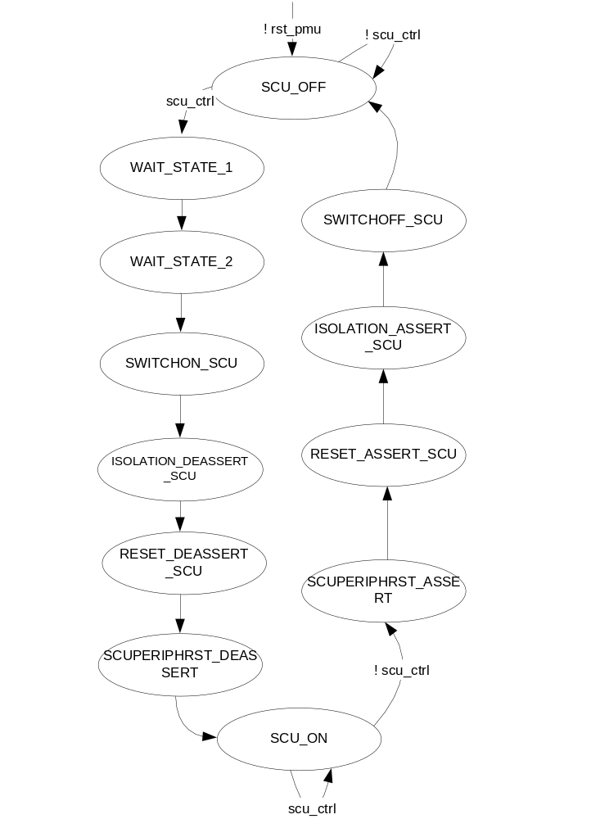
Figure 7-9 State Machine for SCU power domain

SCU_OFF
Operations Performed in this state
The state machine enters this state at power-on-reset.
In the SCU_OFF state, the SCUPL310 power domain is powered off.

Exit Conditions in this state
If the power management unit notices that the scu_ctrl signal from the master state machine is asserted, it moves to the WAIT_STATE_1 state. If it is not asserted, it stays in the SCU_OFF state.

WAIT_STATE_1
Operations Performed in this state
In the WAIT_STATE_1 state, no operation is performed. This state is included to make sure that CPU and SCU are switched ON at the same time. This is because the CPU domains have three switches whereas the SCU power domain has only one switch. So, two clock cycles of delay is required for the SCU state machine.

Exit Conditions in this state
The state machine moves to the WAIT_STATE_2 in the next clock cycle.

WAIT_STATE_2
Operations Performed in this state
In the WAIT_STATE_2 state, no operation is performed. This is the second wait state intended to synchronize the power switching of CPU and SCU power domains.

Exit Conditions in this state
The state machine moves to the SWITCHON_SCU in the next clock cycle.

SWITCHON_SCU
Operations Performed in this state
In the SWITCHON_SCU state, the nPWRUPSCUPL310D0 signal is de-asserted.

Exit Conditions in this state
The state machine moves to the ISOLATION_DEASSERT_SCU state in the next clock cycle.

ISOLATION_DEASSERT_SCU
Operations Performed in this state
In the ISOLATION_DEASSERT_SCU state, the nISOLATESCUPL310 signal is asserted.

Exit Conditions in this state
The state machine moves to the RESET_DEASSERT_SCU state in the next clock cycle.

RESET_DEASSERT_SCU
Operations Performed in this state
In the RESET_DEASSERT_SCU state, the nPERIPHCLKGENRST signal is asserted.

Exit Conditions in this state
The state machine moves to the SCUPERIPHRST_DEASSERT state in the next clock cycle.

SCUPERIPHRST_DEASSERT
Operations Performed in this state
In the SCUPERIPHRST_DEASSERT state, the nSCUPERIPHRST signal is asserted.

Exit Conditions in this state
The state machine moves to the SCU_ON state in the next clock cycle.

SCU_ON
Operations Performed in this state
In the SCU_ON state, the SCUPL310 power domain is powered on.

Exit Conditions in this state
If the power management unit notices that the scu_ctrl signal from the master state machine is de-asserted, it moves to the WF_NSCUREADY state. If it is not de-asserted, it stays in the SCU_ON state.

SCUPERIPHRST_ASSERT
Operations Performed in this state
In the SCUPERIPHRST_ASSERT state, the nSCUPERIPHRST signal is de-asserted.

Exit Conditions in this state
The state machine moves to the RESET_ASSERT_SCU state in the next clock cycle.

RESET_ASSERT_SCU
Operations Performed in this state
In the RESET_ASSERT_SCU state, the nPERIPHCLKGENRST signal is de-asserted.

Exit Conditions in this state
The state machine moves to the ISOLATION_ASSERT_SCU state in the next clock cycle.

ISOLATION_ASSERT_SCU
Operations Performed in this state
In the ISOLATION_ASSERT_SCU state, the nISOLATESCUPL310 signal is de-asserted.

Exit Conditions in this state
The state machine moves to the SWITCHOFF_SCU state in the next clock cycle.

SWITCHOFF_SCU
Operations Performed in this state
In the SWITCHOFF_SCU state, the nPWRUPSCUPL310D0 signal is asserted.

Exit Conditions in this state
The state machine moves to the SCU_OFF state in the next clock cycle.

State Machine for CPU0 and CPU1 power domains

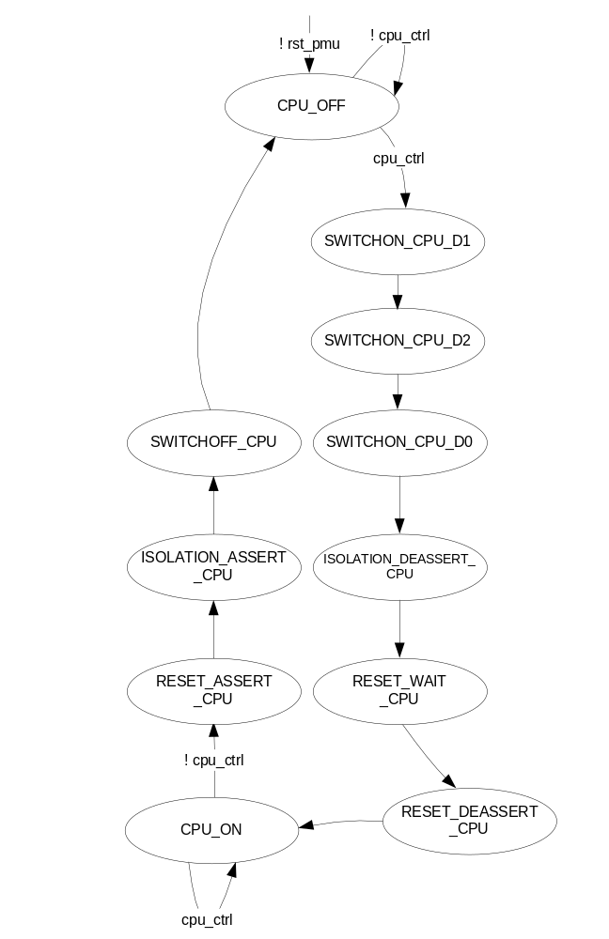
Figure 7-10 State Machine of the CPU power domain

CPU_OFF
Operations Performed in this state
The state machine enters this state at power-on-reset.
In the CPU_OFF state, the CPU 0/1 power domain is powered off.

Exit Conditions in this state
If the power management unit notices that the cpu_ctrl signal from the master state machine is asserted, it moves to the SWITCHON_CPU_D1 state. If it is not asserted, it stays in the CPU_OFF state.

SWITCHON_CPU_D1
Operations Performed in this state
In the SWITCHON_CPU_D1 state, the nPWRUPCPUD1 signal is de-asserted.

Exit Conditions in this state
The state machine moves to the SWITCHON_CPU_D2 state in the next clock cycle.

SWITCHON_CPU_D2
Operations Performed in this state
In the SWITCHON_CPU_D2 state, the nPWRUPCPUD2 signal is de-asserted.

Exit Conditions in this state
The state machine moves to the SWITCHON_CPU_D0 state in the next clock cycle.

SWITCHON_CPU_D0
Operations Performed in this state
In the SWITCHON_CPU_D0 state, the nPWRUPCPUD0 signal is de-asserted.

Exit Conditions in this state
The state machine moves to the ISOLATION_DEASSERT_CPU state in the next clock cycle.

ISOLATION_DEASSERT_CPU
Operations Performed in this state
In the ISOLATION_DEASSERT_CPU state, the nISOLATECPU signal is asserted.

Exit Conditions in this state
The state machine moves to the RESET_WAIT_CPU state in the next clock cycle.

RESET_WAIT_CPU
Operations Performed in this state
In the ISOLATION_WAIT_CPU state, nothing is done. It is used as a wait state so that the resets for SCU and CPU power domains are de-asserted at the same time.

Exit Conditions in this state
The state machine moves to the RESET_DEASSERT_CPU state in the next clock cycle.

RESET_DEASSERT_CPU
Operations Performed in this state
In the RESET_DEASSERT_CPU state, the nCPURESET, nNEONRESET, nDBGRESET, nPTMRESET and nWDRESET signals are asserted.

Exit Conditions in this state
The state machine moves to the CPU_ON state in the next clock cycle.

CPU_ON
Operations Performed in this state
In the CPU_ON state, the CPU 0/1 power domain is powered on.

Exit Conditions in this state
If the power management unit notices that the cpu_ctrl signal from the master state machine is de-asserted, it moves to the RESET_ASSERT_CPU state. If it is not de-asserted, it stays in the CPU_ON state.

RESET_ASSERT_CPU
Operations Performed in this state
In the RESET_ASSERT_CPU state, the nCPURESET, nNEONRESET, nDBGRESET, nPTMRESET and nWDRESET signals are de-asserted.

Exit Conditions in this state
The state machine moves to the ISOLATION_ASSERT_CPU state in the next clock cycle.

ISOLATION_ASSERT_CPU
Operations Performed in this state
In the ISOLATION_ASSERT_CPU state, the nISOLATECPU signal is de-asserted.

Exit Conditions in this state
The state machine moves to the SWITCHOFF_CPU state in the next clock cycle.

SWITCHOFF_CPU
Operations Performed in this state
In the SWITCHOFF_CPU state, the nPWRUPCPUD0, nPWRUPCPUD1 and nPWRUPCPUD2 signals are asserted.

Exit Conditions in this state
The state machine moves to the CPU_OFF state in the next clock cycle.

State Machine for Debug PTM Power Domain

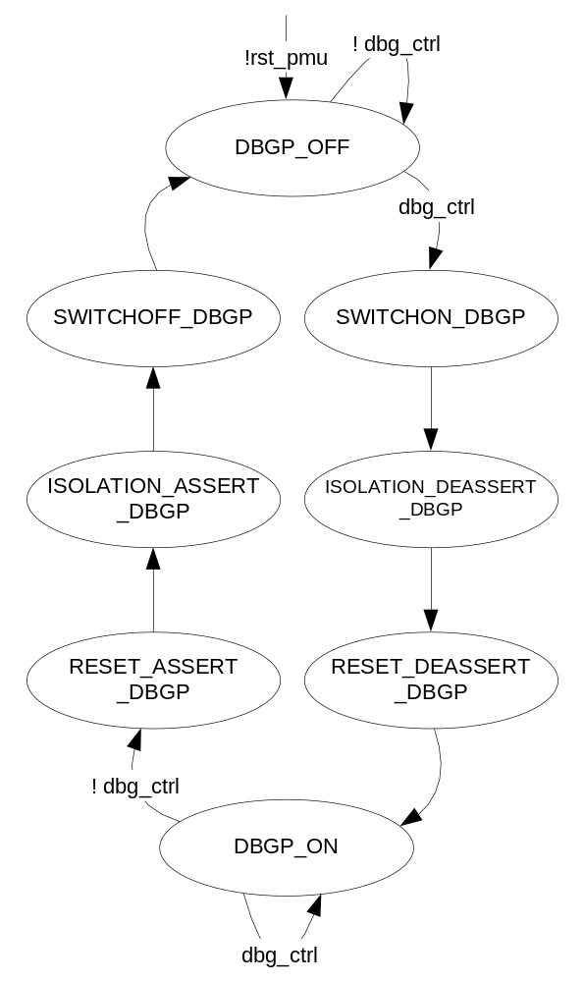
Figure 7-11 State Machine of Debug PTM power domain

DBGP_OFF
Operations Performed in this state
The state machine enters this state at power-on-reset.
In the DBGP_OFF state, the PTM power domain is powered off.

Exit Conditions in this state
If the power management unit notices that the dbg_ctrl signal from the master state machine is asserted, it moves to the SWITCHON_DBGP state. If it is not asserted, it stays in the DBGP_OFF state.

SWITCHON_DBGP
Operations Performed in this state
In the SWITCHON_DBGP state, the nPWRUPDBGPD0 signal is de-asserted.

Exit Conditions in this state
The state machine moves to the ISOLATION_DEASSERT_DBGP state in the next clock cycle.

ISOLATION_DEASSERT_DBGP
Operations Performed in this state
In the ISOLATION_DEASSERT_DBGP state, the nISOLATEDBGP signal is asserted.

Exit Conditions in this state
The state machine moves to the RESET_DEASSERT_DBGP state in the next clock cycle.

RESET_DEASSERT_DBGP
Operations Performed in this state
In the RESET_DEASSERT_DBGP state, the ATRESETn, and nPTMPGRESET signals are asserted.

Exit Conditions in this state
The state machine moves to the DBGP_ON state in the next clock cycle.

DBGP_ON
Operations Performed in this state
In the DBGP_ON state, the Debug PTM power domain is powered on.

Exit Conditions in this state
If the power management unit notices that the dbg_ctrl signal from the master state machine is de-asserted, it moves to the RESET_ASSERT_DBGP state. If it is not de-asserted, it stays in the DBGP_ON state.

RESET_ASSERT_DBGP
Operations Performed in this state
In the RESET_ASSERT_DBGP state, the ATRESETn, and nPTMPGRESET signals are de-asserted.

Exit Conditions in this state
The state machine moves to the ISOLATION_ASSERT_DBGP state in the next clock cycle.

ISOLATION_ASSERT_DBGP
Operations Performed in this state
In the ISOLATION_ASSERT_DBGP state, the nISOLATEDBGP signal is de-asserted.

Exit Conditions in this state
The state machine moves to the SWITCHOFF_DBGP state in the next clock cycle.

SWITCHOFF_DBGP
Operations Performed in this state
In the SWITCHOFF_DBGP state, the nPWRUPDBGPD0 signal is asserted.

Exit Conditions in this state
The state machine moves to the DBGP_OFF state in the next clock cycle.

State Machine for Debug VSOC power domain

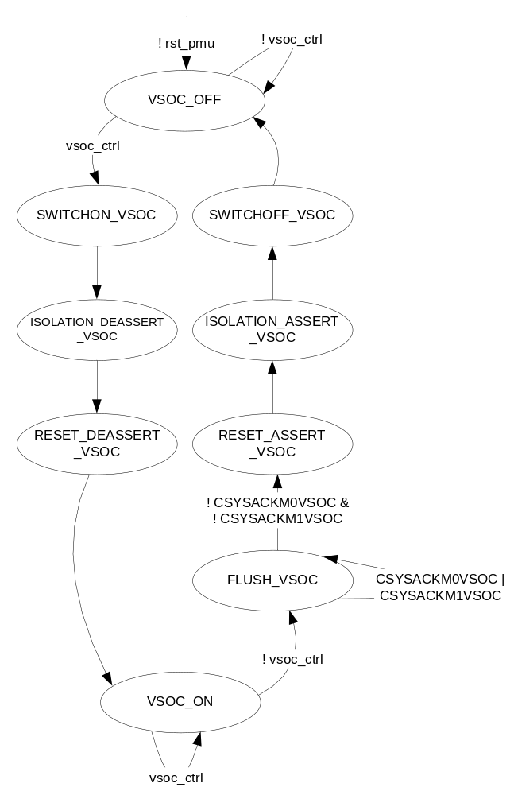
Figure 7-12 State Machine of Debug VSOC power domain

VSOC_OFF
Operations Performed in this state
The state machine enters this state at power-on-reset.
In the VSOC_OFF state, the Debug VSOC power domain is powered off.

Exit Conditions in this state
If the power management unit notices that the vsoc_ctrl signal from the master state machine is asserted, it moves to the SWITCHON_VSOC state. If it is not asserted, it stays in the VSOC_OFF state.

SWITCHON_VSOC
Operations Performed in this state
In the SWITCHON_VSOC state, the nPWRUPDBGVSOCD0 signal is de-asserted.

Exit Conditions in this state
The state machine moves to the ISOLATION_DEASSERT_VSOC state in the next clock cycle.

ISOLATION_DEASSERT_VSOC
Operations Performed in this state
In the ISOLATION_DEASSERT_VSOC state, the nISOLATEDBGVSOC signal is asserted.

Exit Conditions in this state
The state machine moves to the RESET_DEASSERT_VSOC state in the next clock cycle.

RESET_DEASSERT_VSOC
Operations Performed in this state
In the RESET_DEASSERT_SCU state, the nDBGPGRESET and nPRESETDBG signals are asserted.

Exit Conditions in this state
The state machine moves to the VSOC_ON state in the next clock cycle.

VSOC_ON
Operations Performed in this state
In the VSOC_ON state, the CSYSREQM0VSOC and CSYSREQM1VSOC signals are asserted to allow debug operations.
In the VSOC_ON state, the Debug VSOC power domain is powered on.

Exit Conditions in this state
If the power management unit notices that the vsoc_ctrl signal from the master state machine is de-asserted, it moves to the FLUSH_VSOC state. If it is not de-asserted, it stays in the VSOC_ON state.

FLUSH_VSOC
Operations Performed in this state
In the FLUSH_VSOC state, the CSYSREQM0VSOC and CSYSREQM1VSOC signals are de-asserted to make sure that the FIFOs in the ATB bridges are flushed out.

Exit Conditions in this state
If the power management unit notices that both CSYSACKM0VSOC and CSYSACKM1VSOC signals from the ATB asynchronous bridges are de-asserted, it moves to the RESET_ASSERT_VSOC state. If even one of the mis still aserted, it stays in the same state.

RESET_ASSERT_VSOC
Operations Performed in this state
In the RESET_ASSERT_DBGP state, the nDBGPGRESET and nPRESETDBG signals are de-asserted.

Exit Conditions in this state
The state machine moves to the ISOLATION_ASSERT_VSOC state in the next clock cycle.

ISOLATION_ASSERT_VSOC
Operations Performed in this state
In the ISOLATION_ASSERT_VSOC state, the nISOLATEDBGVSOC signal is de-asserted.

Exit Conditions in this state
The state machine moves to the SWITCHOFF_VSOC state in the next clock cycle.

SWITCHOFF_VSOC
Operations Performed in this state
In the SWITCHOFF_VSOC state, the nPWRUPDBGVSOCD0 signal is asserted.

Exit Conditions in this state
The state machine moves to the VSOC_OFF state in the next clock cycle.

State Machine for Debug MBIST power domain

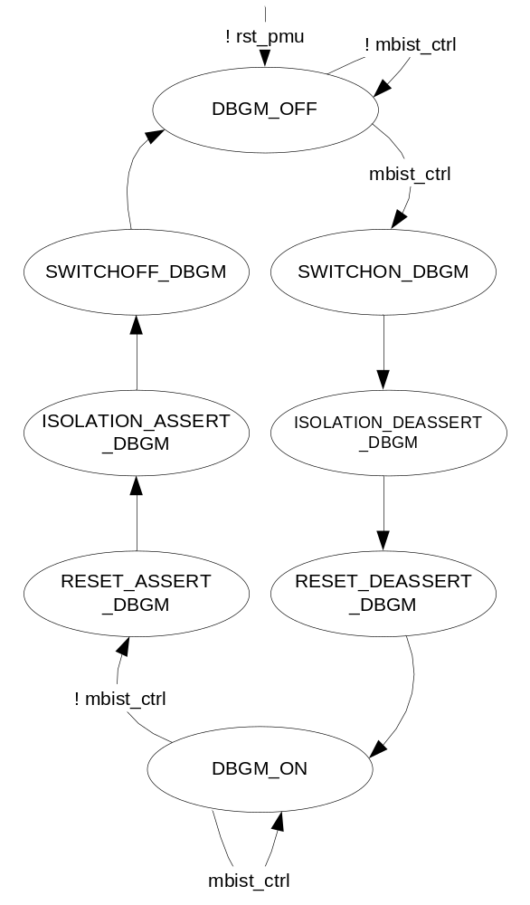
Figure 7-13 State Machine for Debug MBIST power domain

DBGM_OFF
Operations Performed in this state
The state machine enters this state at power-on-reset.
In the DBGM_OFF state, the MBIST power domain is powered off.

Exit Conditions in this state
If the power management unit notices that the mbist_ctrl signal from the master state machine is asserted, it moves to the SWITCHON_DBGP state. If it is not asserted, it stays in the DBGM_OFF state.

SWITCHON_DBGM
Operations Performed in this state
In the SWITCHON_DBGM state, the nPWRUPDBGMD0 signal is de-asserted.

Exit Conditions in this state
The state machine moves to the ISOLATION_DEASSERT_DBGM state in the next clock cycle.

ISOLATION_DEASSERT_DBGM
Operations Performed in this state
In the ISOLATION_DEASSERT_DBGM state, the nISOLATEDBGM signal is asserted.

Exit Conditions in this state
The state machine moves to the RESET_DEASSERT_DBGM state in the next clock cycle.

RESET_DEASSERT_DBGM
Operations Performed in this state
In the RESET_DEASSERT_DBGM state, the nBISTRESET signal is asserted.

Exit Conditions in this state
The state machine moves to the DBGM_ON state in the next clock cycle.

DBGM_ON
Operations Performed in this state
In the DBGM_ON state, the Debug MBIST power domain is powered on.

Exit Conditions in this state
If the power management unit notices that the mbist_ctrl signal from the master state machine is de-asserted, it moves to the RESET_ASSERT_DBGM state. If it is not de-asserted, it stays in the DBGM_ON state.

RESET_ASSERT_DBGM
Operations Performed in this state
In the RESET_ASSERT_DBGM state, the nBISTRESET signal is de-asserted.

Exit Conditions in this state
The state machine moves to the ISOLATION_ASSERT_DBGM state in the next clock cycle.

ISOLATION_ASSERT_DBGM
Operations Performed in this state
In the ISOLATION_ASSERT_DBGM state, the nISOLATEDBGM signal is de-asserted.

Exit Conditions in this state
The state machine moves to the SWITCHOFF_DBGM state in the next clock cycle.

SWITCHOFF_DBGM
Operations Performed in this state
In the SWITCHOFF_DBGM state, the nPWRUPDBGMD0 signal is asserted.

Exit Conditions in this state
The state machine moves to the DBGM_OFF state in the next clock cycle.

Sources for the eventi signal
The two bits of eventi signal are derived from four interrupts – one each from the four following sources :
- KMI
- WDT
- GPIO3
- Timers0
These interrupts are ORed and finally ANDed with a signal each, coming from the event_en_cpu register in the system controller register bank.

Sources for the cpu_irqs signal
The cpu_irqs signal is used as a replacement to the nIRQOUT and nFIQOUT signals when the GIC inside the SCU power domain is not sufficiently programmed by the CPUs to redirect the interrupts to the system controller. This can happen when the CPU0 is powered up from the ALLOFF power state and hence, it programs the CPU0 end of the register bank in the GIC while the CPU1 end remains unprogrammed. This results in the GIC not forwarding the CPU1 interrupts to the PMU. In this case, the PMU is implemented to accept a parallel set of interrupts and AND it with the respective bits of a system controller register and finally ORing them so that they act as an equivalent to the nIRQOUT and nFIQOUT signals. This signal comprises of two bits – one each for the two processors.

PMU Implementation for Video power domain

The Video power domain consists of AV417V. As AV417V does not support any power management interface, a generic model of power management implementation is used for this power domain. The state machine for this power domain can be found in section 4.2. The interface of the PMU for Video Power domain is as in the table 7-3:

Table 7-8 Signal Interfaces of PMU with Video power domain
Sl no. | Signal Name | I/O | Description
1 | pwr_dn_req_video | I | Power Down request originating from the APB interface where it is written into the CONFIG_PMU register by the processor.  0 – Power up request  1 – Power Down request
2 | npwr_ack_video | I | Power down acknowledge from the switching fabric notifying that the power is successfully switched.
3 | npwr_req_video | O | Power down request to the switching fabric.
4 | pwr_ready_video | O | Status signal of the power domain that is transferred to the APB interface so that it can be written to the READY_PMU register.  00 – Power up sequencing in progress  01 – Power up sequencing complete  10 – Power down sequencing complete  11 – Power down sequencing in progress
5 | enable_reset_video | O | Reset enable signal to the System Reset Controller to reset the Video power domain.
6 | isolate_video | O | Isolate signal to the clamp cells to enable/disable isolation to the Video power domain.  1 – Isolation on  0 – Isolation off
7 | enable_clk_video | O | Clock enable signal to the System Clock Controller to gate/un-gate the clocks pertaining to Video Power Domain.  1 – Enable all clocks  0 – Disable all clocks
8 | soc_pwrup | I | Input from the Coresight component to switch on the entire SoC.

PMU Implementation for GNSS power domain

The GNSS Power Domain consists of GNSS. As GNSS does not support any power management interface, a generic model of power management implementation is used for this power domain. The state machine for this power domain can be found in section 4.2. The interface of the PMU for GNSS power domain is as in the table 7-4:

Table 7-9 Signal Interfaces of PMU with GNSS power domain
Sl no. | Signal Name | I/O | Description
1 | pwr_dn_req_gnss | I | Power Down request originating from the APB interface where it is written into the CONFIG_PMU register by the processor.  0 – Power up request  1 – Power Down request
2 | npwr_ack_gnss | I | Power down acknowledge from the switching fabric notifying that the power is successfully switched.
3 | npwr_req_gnss | O | Power down request to the switching fabric.
4 | pwr_ready_gnss | O | Status signal of the power domain that is transferred to the APB interface so that it can be written to the READY_PMU register.  00 – Power up sequencing in progress  01 – Power up sequencing complete  10 – Power down sequencing complete  11 – Power down sequencing in progress
5 | enable_reset_gnss | O | Reset enable signal to the System Reset Controller to reset the GNSS power domain.
6 | isolate_gnss | O | Isolate signal to the clamp cells to enable/disable isolation to the GNSS power domain.  1 – Isolation on  0 – Isolation off
7 | enable_clk_gnss | O | Clock enable signal to the System Clock Controller to gate/un-gate the clocks pertaining to GNSS.  1 – Enable all clocks  0 – Disable all clocks
8 | soc_pwrup | I | Input from the Coresight component to switch on the entire SoC.

PMU Implementation for Comms power domain

The Comms power domain consists of Bluetooth. As Bluetooth does not support any power management interface, a generic model of power management implementation is used for this power domain. The state machine for this power domain can be found in section 4.2. The interface of the PMU for Comms power domain is as in the table 7-5:

Table 7-10 Signal Interfaces of PMU with Comms power domain
Sl no. | Signal Name | I/O | Description
1 | pwr_dn_req_comms | I | Power Down request originating from the APB interface where it is written into the CONFIG_PMU register by the processor.  0 – Power up request  1 – Power Down request
2 | npwr_ack_comms | I | Power down acknowledge from the switching fabric notifying that the power is successfully switched.
3 | npwr_req_comms | O | Power down request to the switching fabric.
4 | pwr_ready_comms | O | Status signal of the power domain that is transferred to the APB interface so that it can be written to the READY_PMU register.  00 – Power up sequencing in progress  01 – Power up sequencing complete  10 – Power down sequencing complete  11 – Power down sequencing in progress
5 | enable_reset_comms | O | Reset enable signal to the System Reset Controller to reset the Comms power domain.
6 | isolate_comms | O | Isolate signal to the clamp cells to enable/disable isolation to the Comms power domain.  1 – Isolation on  0 – Isolation off
7 | enable_clk_comms | O | Clock enable signal to the System Clock Controller to gate/un-gate the clocks pertaining to Comms power domain.  1 – Enable all clocks  0 – Disable all clocks
8 | soc_pwrup | I | Input from the Coresight component to switch on the entire SoC.

PMU Implementation for HDMI power domain

The HDMI power domain consists of HDMI controller and HDMI Bridge. As they do not support any power management interface, a generic model of power management implementation is used for this power domain. The state machine for this power domain can be found in section 4.2. The interface of the PMU for HDMI power domain is as in table 7-6:

Table 7-11 Signal Interfaces of PMU with HDMI power domain
Sl no. | Signal Name | I/O | Description
1 | pwr_dn_req_hdmi | I | Power Down request originating from the APB interface where it is written into the CONFIG_PMU register by the processor.  0 – Power up request  1 – Power Down request
2 | npwr_ack_hdmi | I | Power down acknowledge from the switching fabric notifying that the power is successfully switched.
3 | npwr_req_hdmi | O | Power down request to the switching fabric.
4 | pwr_ready_hdmi | O | Status signal of the power domain that is transferred to the APB interface so that it can be written to the READY_PMU register.  00 – Power up sequencing in progress  01 – Power up sequencing complete  10 – Power down sequencing complete  11 – Power down sequencing in progress
5 | enable_reset_hdmi | O | Reset enable signal to the System Reset Controller to reset the HDMI power domain.
6 | isolate_hdmi | O | Isolate signal to the clamp cells to enable/disable isolation to the HDMI power domain.  1 – Isolation on  0 – Isolation off
7 | enable_clk_hdmi | O | Clock enable signal to the System Clock Controller to gate/un-gate the clocks pertaining to HDMI.  1 – Enable all clocks  0 – Disable all clocks
8 | soc_pwrup | I | Input from the Coresight component to switch on the entire SoC.

PMU Implementation for USB power domain

The USB power domain consists of USB host and DRD controllers. The USB controllers support a specific power management interface as depicted in table 7-7. The state machine implementation is described in figure 7-9.
Table 7-12 PMU interface for USB power domain
Sl no. | Signal Name | I/O | Description
1 | npwr_ack_usb | I | Power down/up acknowledgment from the switching fabric for USB power domain.
2 | pwr_dn_req_usb | I | Power Down request originating from the APB interface where it is written into the PMU_CONFIG register by the processor.  0 – Power up request  1 – Power Down request
3 | current_power_state_u2pmu_host | I | The current power state of the core. When equal to '3', the PMU is controlling the PHY, and when equal to '0', the core is controlling the PHY.  2’b00 – Active State  2’b01 and 2’b10 – Reserved  2’b11 – Hibernate State
4 | current_power_state_u3pmu_host | I | The current power state of the core. When equal to '3', the PMU is controlling the PHY, and when equal to '0', the core is controlling the PHY.  2’b00 – Active State  2’b01 and 2’b10 – Reserved  2’b11 – Hibernate State
5 | pme_generation_u2pmu_host | I | Wakeup request from the 2.0 PMU which is a request to restore Vcc and put the core into the D0 state.
6 | pme_generation_u3pmu_host | I | Wakeup request from the 3.0 PMU which is a request to restore Vcc and put the core into the D0 state.
7 | current_power_state_u2pmu_drd | I | The current power state of the core. When equal to '3', the PMU is controlling the PHY, and when equal to '0', the core is controlling the PHY.  2’b00 – Active State  2’b01 and 2’b10 – Reserved  2’b11 – Hibernate State
8 | current_power_state_u3pmu_drd | I | The current power state of the core. When equal to '3', the PMU is controlling the PHY, and when equal to '0', the core is controlling the PHY.  2’b00 – Active State  2’b01 and 2’b10 – Reserved  2’b11 – Hibernate State
9 | pme_generation_u2pmu_drd | I | Wakeup request from the 2.0 PMU which is a request to restore Vcc and put the core into the D0 state.
10 | pme_generation_u3pmu_drd | I | Wakeup request from the 3.0 PMU which is a request to restore Vcc and put the core into the D0 state.
11 | npwr_req_usb | O | Power down request to the switching fabric for USB host.
12 | pwr_ready_usb | O | Status output of USB host which is written into the PMU_READY register in the APB interface.  00 – Power up sequencing in progress  01 – Power up sequencing complete  10 – Power down sequencing complete  11 – Power down sequencing in progress
13 | isolate_usb | O | Isolate signal to USB host for the clamp cells.  1 – Isolation off  0 – Isolation on
14 | enable_clk_usb | O | Clock enable signal to the System Clock controller to gate/un-gate the clocks pertaining to host controller.  1 – Enable all clocks  0 – Disable all clocks
15 | enable_reset_usb | O | Reset output to the System reset controller to reset the USB host controller Vcc domain.
16 | pm_power_state_request_host | O | Power state request to the core.  2’b00 – Active State  2’b01 and 2’b10 – Reserved  2’b11 – Hibernate State
17 | pm_power_state_request_drd | O | Power state request to the core.  2’b00 – Active State  2’b01 and 2’b10 – Reserved  2’b11 – Hibernate State
18 | soc_pwrup | I | Input from the Coresight component to power up the entire SoC.

State Machine Implementation for USB power domain
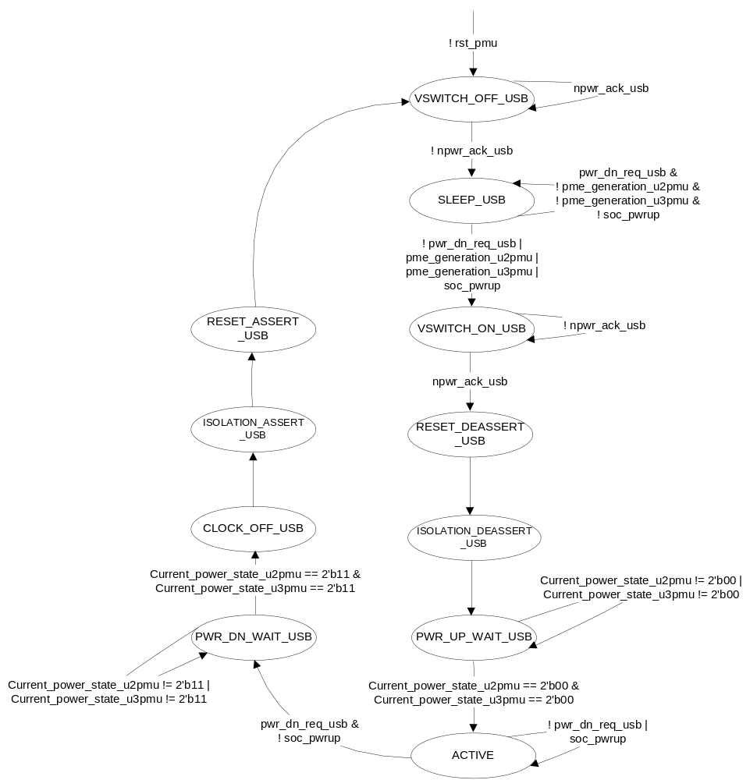
Figure 7-14 State Machine for USB Host/DRD power domain

VSWITCH_OFF_USB
Operations Performed in this state
This power management unit comes to this state at power-on-reset. In the VSWITCH_OFF state, it de-asserts the npwr_req_usb signal which acts as a request to the power switching fabric to switch off the power to a power domain.
It then, waits for the handshake signal, npwr_ack_usb from the power switching fabric to confirm that the power was successfully switched to that domain.

Exit Conditions in this state
The state doesn’t change until the power management unit gets the npwr_ack_usb signal from the power switching fabric.
When the acknowledgement signal arrives, the state machine moves into the sleep state.

SLEEP_USB
Operations Performed in this state
In the SLEEP_USB state, the power management unit waits for the power up request signal ( pwr_dn_req_usb ) from the APB interface where it is written into the CONFIG_PMU register of the system controller or the signals from the PMUs inside USB ( pme_generation_u2pmu and pme_generation_u3pmu) or the wake up signal from the Coresight component ( soc_pwrup ).
When the state machine is in the SLEEP_USB state, it means that the power is switched off to the power domain.
In the SLEEP_USB state, the status signal to the Coresight power domain PMU is de-asserted.

Exit Conditions in this state
The state machine continues in this state until the pwr_dn_req_usb signal is de-asserted or soc_pwrup signal is asserted or if at least one of the pme_generation signals are asserted.
When the CONFIG_PMU register in the APB interface is written into by the processor such that the pwr_dn_req_usb signal is de-asserted or if the soc_pwrup signal is asserted by the Coresight component or if the PMUs inside the USB controller provide the pme_generation signals, the state machine moves into the VSWITCH_ON state.

VSWITCH_ON_USB
Operations Performed in this state
In the VSWITCH_ON_USB state, the power management unit asserts the npwr_req_usb signal that is routed to the power switches in the power switching fabric. This signal acts as a request to switch on the target power domain.

Exit Conditions in this state
The state machine stays in this state until it observes that the npwr_ack_usb from the power switching fabric is high.
Once the npwr_ack_usb signal goes high, the power management unit moves into the RESET_DEASSERT_USB state.

RESET_DEASSERT_USB
Operations Performed in this state
In the RESET_DEASSERT state, the reset request signal ( enable_reset_usb ) to the system reset controller is asserted to remove the reset to the target power domain.

Exit Conditions in this state
The state machine moves to the ISOLATION_DEASSERT_USB state in the next clock cycle.

ISOLATION_DEASSERT_USB
Operations Performed in this state
In the ISOLATION_DEASSERT_USB state, the isolation signal ( isolate_usb ) signal to the target power domain is asserted to remove the isolation on all the output ports in the power domain.

Exit conditions in this state
The state machine moves to the PWR_UP_WAIT_USB state in the next clock cycle.

PWR_UP_WAIT_USB
Operations Performed in this state
In the PWR_UP_WAIT_USB state, the clock request signal ( enable_clk_usb ) to the system clock controller is asserted to remove the applied clock gating to the target power domain.
In the PWR_UP_WAIT_USB state, the pm_power_state_request signal is set to 2’b00 as a request to the PMUs to transfer the control of the PHY to the controller.

Exit conditions in this state
The state machine stays in this state until both current_power_state_u2pmu and current_power_state_u3pmu are equal to pm_power_state_request.
If the above condition is satisfied, the state machine moves to the ACTIVE_USB state.

ACTIVE_USB
Operations Performed in this state
In the ACTIVE_USB state, the data transfer takes place.
In the ACTIVE state, the status signal to the Coresight power domain PMU is asserted.

Exit Conditions in this state
The state machine continues in the same state until the power down request ( pwr_dn_req_usb ) from the APB interface is held high in conjunction with the soc_pwrup signal de-asserted.
Once the CONFIG_PMU register in the APB interface is written in such a way by the processor that the pwr_dn_req_usb signal to the target power domain is asserted, the state machine samples the soc_pwrup signal. If it is de-asserted, the state machine moves into the PWR_DN_WAIT_USB state.

PWR_DN_WAIT_USB
Operations Performed in this state
In the PWR_DN_WAIT_USB state, the pm_power_state_request signal is set to 2’b11 as a request to the controller to transfer the control of the PHY to the PMUs. .

Exit conditions in this state
The state machine stays in this state until both current_power_state_u2pmu and current_power_state_u3pmu are equal to pm_power_state_request.
If the above condition is satisfied, the state machine moves to the CLOCK_OFF_USB state.

CLOCK_OFF_USB
Operations Performed in this state
In the CLOCK_OFF_USB state, the clock request signal ( enable_clk_usb ) to the system clock controller is de-asserted to apply clock gating to the target power domain.

Exit Conditions in this state
The state machine moves to the ISOLATION_ASSERT_USB state in the next clock cycle.

ISOLATION_ASSERT_USB
Operations Performed in this state
In the ISOLATION_ASSERT_USB state, the isolation signal ( isolate_usb ) signal is de-asserted to isolate all the outputs of the target power domain.

Exit Conditions in this state
The state machine moves to the RESET_ASSERT_USB state in the next clock cycle.

RESET_ASSERT_USB
Operations Performed in this state
In the RESET_ASSERT_USB state, the reset request signal ( enable_reset_usb ) to the system reset controller is de-asserted to apply reset to the target power domain.

Exit Conditions in this state
The state machine moves to the VSWITCH_OFF_USB state in the next clock cycle.

PMU Implementation for Display power domain

The Display power domain consists of CSI Controller,CSI Bridge, DSI Controller and DSI Bridge. As they do not support any power management interface, a generic model of power management implementation is used for this power domain. The state machine for this power domain can be found in section 4.2. The interface of the PMU for Display power domain is as in the table 7-9:

Table 7-13 Signal Interfaces of PMU with Display power domain
Sl no. | Signal Name | I/O | Description
1 | pwr_dn_req_display | I | Power Down request originating from the APB interface where it is written into the CONFIG_PMU register by the processor.  0 – Power up request  1 – Power Down request
2 | npwr_ack_display | I | Power down acknowledge from the switching fabric notifying that the power is successfully switched.
3 | npwr_req_display | O | Power down request to the switching fabric.
4 | pwr_ready_display | O | Status signal of the power domain that is transferred to the APB interface so that it can be written to the READY_PMU register.  00 – Power up sequencing in progress  01 – Power up sequencing complete  10 – Power down sequencing complete  11 – Power down sequencing in progress
5 | enable_reset_display | O | Reset enable signal to the System Reset Controller to reset the Display power domain.
6 | isolate_display | O | Isolate signal to the clamp cells to enable/disable isolation to the Display power domain.  1 – Isolation on  0 – Isolation off
7 | enable_clk_display | O | Clock enable signal to the System Clock Controller to gate/un-gate the clocks pertaining to Display power domain.  1 – Enable all clocks  0 – Disable all clocks
8 | soc_pwrup | I | Input from the Coresight component to switch on the entire SoC.

UPF Diagram of Shikhara

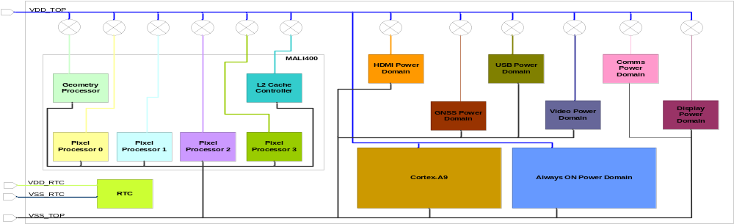
Figure 8-15 UPF Diagram of Shikhara

Figure 8-1 represents the UPF diagram of Shikhara as implemented in the top level UPF file.

