1. DSI Host Configuration

1. Set (Active Low) Display power domain bit in system control register.
2. Configure DSI Pixel PLL as 71.4 MHz (As per ASIC Team) in DSI pixel PLL control register(DSI_PIX_PLL_CTRL0) and wait till PLL is locked. To check the lock need to poll DSI_PIX_PLL_CTRL1 register.
3. Power down/Reset MIPI-DSI Host core

1.1 D-PHY Module Initialization

- Reset D-Phy Module .
- Set lane value and phy stop wait time .
- Configure Number of active lanes in D-PHY .
- Set phy clk division in DSI_CLKMGR_CFG as 0x1070 .
- Set low power and high speed data switching params in PHY_TMR_CFG.
- Set lp and hs clock switching parameters in PHY_TMR_LPCLK_CFG.
- Reset PHY to clean up phy test params.
- Enable HS clock

Note: lp, hs clock and data timing parameters are depends on DSI lane byte clock. We have configured this as 62.5MHZ (speed 500Mbps/lane). These timings we have taken from Synopsys.
Please find the reference sheet below.

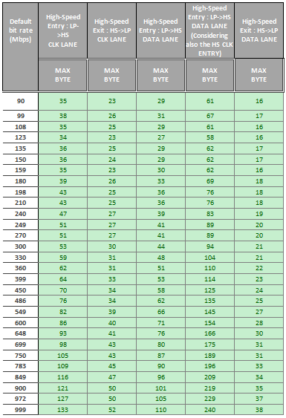

1.2 DPI interface configuration in DSI Host

- Enable the commands transmission only in low-power mode
- Enable the request for an acknowledge response at the end of a frame.
- Configure the DPI virtual channel ID that is indexed to the Video mode packets.
- Configure color coding as 24 Bit.
- Configure polarities of h,v, data_en and Shut Down signals.
- Enable the ECC reception, error correction, and error reporting for transmission and reception .
- Enable the Bus Turn-Around (BTA) request for debugging .
- Enable EOT and EOR.
- Configure the video mode as burst with sync pulses.
- Enables the return to low-power inside the hfp, vactive, vfp, vbp and vsync periods when timing allows.
- Enable Video mode.
- Configure video packet size.
- Configure hline time as 800 (video_params->h_total_pixels * (video_params->byte_clock / video_params->pixel_clock)) ---> (920*(62500000/71980000)
- Configure hbp as 24* (62500000/71980000) .
- Configure hsa as 24* (62500000/71980000) .
- Confgiure Vactive as 1280 in DSI_VID_VACTIVE_LINES register.
- Configure vbp as 10.
- Configure vsync as 2.
- Configure vfp as (video_params->v_total_lines - (video_params->v_back_porch_lines +
video_params->v_sync_lines + video_params->v_active_lines))

4. Masks the interrupt generation, triggered by the INT_ST0 and INT_ST1 register

2. LCD Device initialization:

- To initialize the device, commands should be passed to the display device from the host.
- Commands are passed in the form of Generic short packet (data type:0x23) through generic interface.
- Before sending each command, need to check the full status of the generic command FIFO
by polling the CMD_PKT_STATUS register.

Note: To send the commands to Display device, PHY should be locked and clock lane should be in stop state.

3. Challenges Faced:

- Configuration of DSI Pixel PLL value in DSI pixel PLL control register.
Resolution: Configured as 71980KHz, As per HX8260-A_DS_v01_141127.pdf Page number 77 , Video input timing for 800X1280
- Configure minimum wait period for LP, HS transmission request after a stop state.
- Internal Clock Dividers Configuration in DSI_CLKMGR_CFG.
- lp to hs and hs to lp data and clock lane timings.
Resolution: Configured based on the inputs from synopsys.
- Speed per lane in PHY.
- Timeout errors in TO_CNT_CFG.
- Video polarities and timing parameters.
Resolution: Configured as in TFT Display device to sync with it.
- Multi packet configuration in non burst mode.

