Assessment on working Styles using DISC

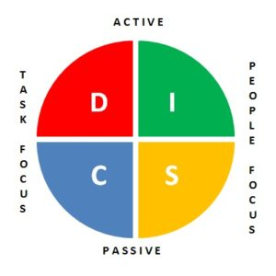

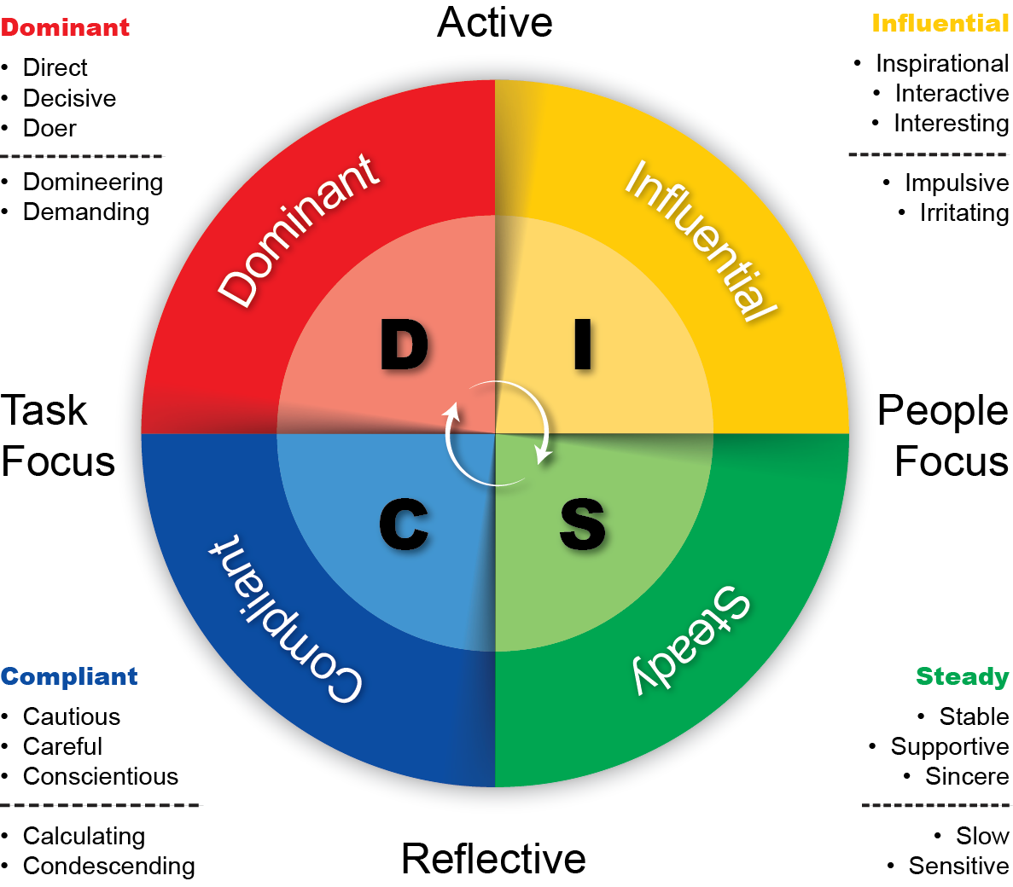

Name of Person : Mr.Vishwanath(VP of Moschip) Mr. Ashok (President of e-con systems) Behavior Style : High Dominance
Profile:  - Places great emphasis on action and results  - Decisive, direct, and pragmatic  - Likes to get things done quickly and hates taking time over things  - Translates ideas into action  - May be accused of looking only at the short term and neglecting long-range  implications  Basic fear: Failure | Management style: Directing  Handling conflict: Will not avoid conflict, may even welcome it  Communication style: Telling  Wants to know: 'What are we going to do?' and 'How soon can we do it?' 'What is the action item'  Motivator/Motivation: Power and authority  Value to the organization: Driving for results
In general, they may  - be direct by nature  - appear to be forceful  - may not give a lot of time  - be running late  - be, or appear to be, rude or blunt  - interrupt, may even take phone calls - appear non-attentive  - override people  - emphasize points through challenging statements  - be critical and fault finding  - appear aggressive and try to dominate  Decisive,independent,practical,determined,efficient,assertive,a risk taker,direct,solves problems | Do Not like:  1. Not using the time efficiently  2. If you are not get down to business  3. If anyone do not come straight to the point  4. if you are disorganized, not skilled  5. if not providing the alternate possible solutions  6. try to control them  7. too much personal  8. stay away from the purpose
Stress-Response: [work under pressure]  1. Impatient, Rude, Direct, Blunt  2. Active – fight – arguments – forceful  3. Not bother about feelings,emotions of others  4. Follow: win-lose game , fault finding ,criticize, Put blame on others  5. Solve the problem with more regard for closure than feelings | Handle These People:  1. Avoid arguments  2. Listen to their complaints and ideas for resolution  3. Ask for the best ways to solve the conflicts  4. Own up quickly to any mistakes made  5. Be ready to put the situation behind you and move forward

Name of Person : Mr. Hanumath, Mr. Nagi Reddy Behavior Style : High Influence
Profile:  1. Interested in taking people with them, enthusing them with optimism and energy  2. Open with people  3. Willing to make personal investment and so they are generally very good with people.  4. Can frighten people by being over-enthusiastic and dominant  5.Can feel personally let down by people and left out  May be viewed as superficial and irresponsible as they can be poor with detail and their hunches can go wrong  Basic fear: Rejection | Management style: Motivating  Handling conflict: Prefers to persuade rather than confront aggressively or demand  Communication style: Talkative  Wants to know: 'What is new, exciting, and innovative?’  Motivator/Motivation: Public praise and recognition  Value to the organization: Working with and through people
In general, they may  - be positive and verbal  - be willing to be friendly and very sociable  - be very communicative  - tell stories and anecdotes  - share personal feelings  - be over-enthusiastic, agreeing to every suggestion  - seem to be very interested and yet may delay on a decision  - act impulsively  - be inattentive to detail  - appear to be superficial  verbal,inspiring,ambitious, enthusiastic, energetic,  - confident,friendly,influential,decisive | Do Not like:  1. Control the call/Situation and keep strictly to a structure  2. Are impatient or controlled  3. Giving/Asking too much details  4. Take away their freedom to choose then close  5. Socialize too much  6. Patronize or remain determined that your way is the only way
Stress-Response: [work under pressure]  1. Attack  2. verbal confrontational  3. Avoid the scene when they sense negativity  4. Try to dismiss or smooth over the situations  5. Become emotional and offensive – take criticism or conflicts personally.  6. Seek control or revenge by persuading others to side with them  7. Openly joke about or trivialize the conflict  8. Overwhelm their opponent with a monologue | Handle These People:  1. Approach them in a friendly and positive fashion  2. Use self-deprecating humor to ease tension  3. Look at a collaborative approach to the conflict instead of taking sides.  4. Ask for their thoughts and ideas for resolution and listen without interruption.
Name of Person : Mr. Amarnath (Lead) , Mr.Subbarao (Lead) , Behavior Style : High Steadiness
Profile:  1. Interested in, and places high value on personal relationships, feelings, human interactions, and affiliation with others  2. Warm and sensitive to the feelings of others  3. Perceptive, able to assess a situation in terms of the human emotions involved  4. May be viewed as emotional, sentimental, and too easily persuaded by others.  Basic fear: Insecurity | Management style: Organizing  Handling conflict: Prefers to smooth over the situation, rather than rush in with an aggressive decision  Communication style: Listening  Wants to know: How others may feel about the matter, who else will be involved in it, past experiences in similar situations, etc  Motivator/Motivation: Security  Value to the organization: Service and support. A specialist.
In general, they may  - listen and may not talk a lot  - be content with things as they are  - question in order to clarify  - strive to maintain status quo  - talk in a slow but firm voice  - not change pace easily or rapidly  - make tentative statements  - be thorough in finishing tasks  - be very security conscious  - seem lacking in imagination  - appear convinced (but don’t assume they are!)  - Allow others to lead  - Act supportively  - Build relationships quickly  Patient,respectful,willing,empathetic,agreeable  dependable, concerned,relaxed | Do Not like:  1. Difficulty identifying priorities  2. Difficulty with deadlines  3. If anyone come to straight to the point  4. Cause them to respond quickly, clearly,accurately  5. Dominate or control the situation / discussion  6. make wild claims  7. if you are extremely factual  8. Keep offering solutions
Stress-Response: [work under pressure]  1. Appear to Give in  2. Passive – flight  3. accept something reluctantly but without protest----acquiesce  4. Become quiet– emotional,sensitive  5. Freeze up and may flush with frustration.  6. Express frustration on others rather than offending party  7. Give in or fake agreement to avoid losing approval | Handle These People:  1. En-quire about their thoughts and feelings regarding the situations  2. Demonstrate concern and respect with good listening skills  3. Outline the necessary steps in resolving the conflict.

Name of Person : Mr. Alex Mr. Srinivas Behavior Style : High Compliance
Profile:  - interested in, and places a high value, on facts, figures, data, and reason  - analytical, systematic, and methodical  - follows an orderly approach in tackling tasks  - well organized and thorough  - May be viewed too cautious, overly structured; someone who does things too much according to the rules  Basic fear: conflict | Management style: Rule enforcement  Handling conflict: Prefers to avoid conflict unless or until they have supporting evidence  Communication style: Writing  Wants to know: Facts, figures, and data presented in an orderly fashion with documentation and the chance to examine carefully what is being  discussed.  Motivator/Motivation:  Standard operating procedures  Value to the organization: Quality and standards.  Technical competence.
In general, they may  - Be very systematic and highly logical  - Be careful and compliant; something of a perfectionist  - Be disciplined with time  - Become too immersed in detail  - Be unwilling to act without precedent and so appear indecisive  - Get defensive when threatened and may yield position to avoid controversy  - Not share personal feelings  - Be very well be prepared for your visit  - Be on time, and will probably have read any material that you have sent beforehand  - Give a nervous laugh or cough to gain thinking time  Accurate,organized,deliberate,cautious,persistent,serious,conscientious | Do Not like:  1. Are disorganized and casual  2. Are late  3. Provide personal incentives  4. Push or gently persuade  5. Use testimonials or opinions  6. Are flippant or use methods that try to increase the appeal
Stress-Response: [work under pressure]  1. Increase resistance and shift inti passive-aggressive behavior  2. Overpower others with facts and logic  3. Become defensive  4. Withhold information  5. Respond with “what if?” questions and “prove it” statements  6. Judge their opponent and situation in distinct factual terms. | Handle These People:  1. Avoid forcing or pushing for a resolution  2. Avoid debate and blaming  3. Ask for their analysis of the situation and for their input to prevent future conflict from occurring  4. Take notes

