Table of Contents
Install Jenkins on Ubuntu 18.04: 2
Install Java. 2
Add the Jenkins Debian repository 2
Install and Configure Jenkins 2
Starting Jenkins 2
Setting Up Jenkins 3
Installing suggested plugins 4
Open the Jenkins: 7
Creating a Freestyle Build Job : Java: 7
Creating a Freestyle Build Job : cpp: 16
Creating a Freestyle Build Job : qt: 16
Configuring the Node in Jenkins 17
Connection the Node in Jenkins: 22
Creating a Freestyle Build Job : libPiccoloCam : Run on Remote 22

Install Jenkins on Ubuntu 18.04:
https://linuxize.com/post/how-to-install-jenkins-on-ubuntu-18-04/
https://www.serverlab.ca/tutorials/linux/administration-linux/how-to-install-jenkins-on-ubuntu-18-04-bionic-beaver/

Install Java.
Since Jenkins is a Java application, the first step is to install Java. Update the package index and install the Java 8 OpenJDK package with the following commands:
sudo apt updatesudo apt install openjdk-8-jdk

Add the Jenkins Debian repository
Import the GPG keys of the Jenkins repository using the following wget command:
wget -q -O - https://pkg.jenkins.io/debian/jenkins.io.key | sudo apt-key add -
sudo apt-add-repository "deb https://pkg.jenkins.io/debian-stable binary/"
sudo apt-add-repository "deb http://pkg.jenkins-ci.org/debian binary/"

Install and Configure Jenkins
With Java 8 installed and the Jenkins repository added, we can now install and configure Jenkins on our Ubuntu server.
Install Jenkins.

sudo apt install jenkins

Starting Jenkins
Let’s start Jenkins using systemctl:
sudo systemctl start jenkins
avatti@office.zone@qindl124:~/projects/jadak/Piccolo$ systemctl status jenkins
● jenkins.service - LSB: Start Jenkins at boot time
Loaded: loaded (/etc/init.d/jenkins; generated)
Active: active (exited) since Mon 2020-04-27 10:06:03 IST; 2min 45s ago
Docs: man:systemd-sysv-generator(8)
Tasks: 0 (limit: 4915)
CGroup: /system.slice/jenkins.service

avatti@office.zone@qindl124:~/projects/jadak/Piccolo$ sudo cat /var/lib/jenkins/secrets/initialAdminPassword
481c0e3fde3d48af85748c2c44f5a334

Setting Up Jenkins
To set up your installation, visit Jenkins on its default port, 8080, using your server domain name or IP address: http://:8080

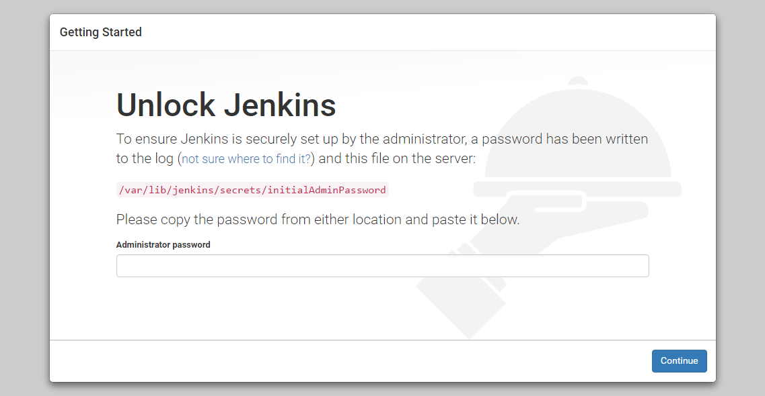

In the terminal window, use the cat command to display the password:
sudo cat /var/lib/jenkins/secrets/initialAdminPassword
Copy the 32-character alphanumeric password from the terminal and paste it into the Administrator password field, then click Continue.

Installing suggested plugins
The next screen presents the option of installing suggested plugins or selecting specific plugins:
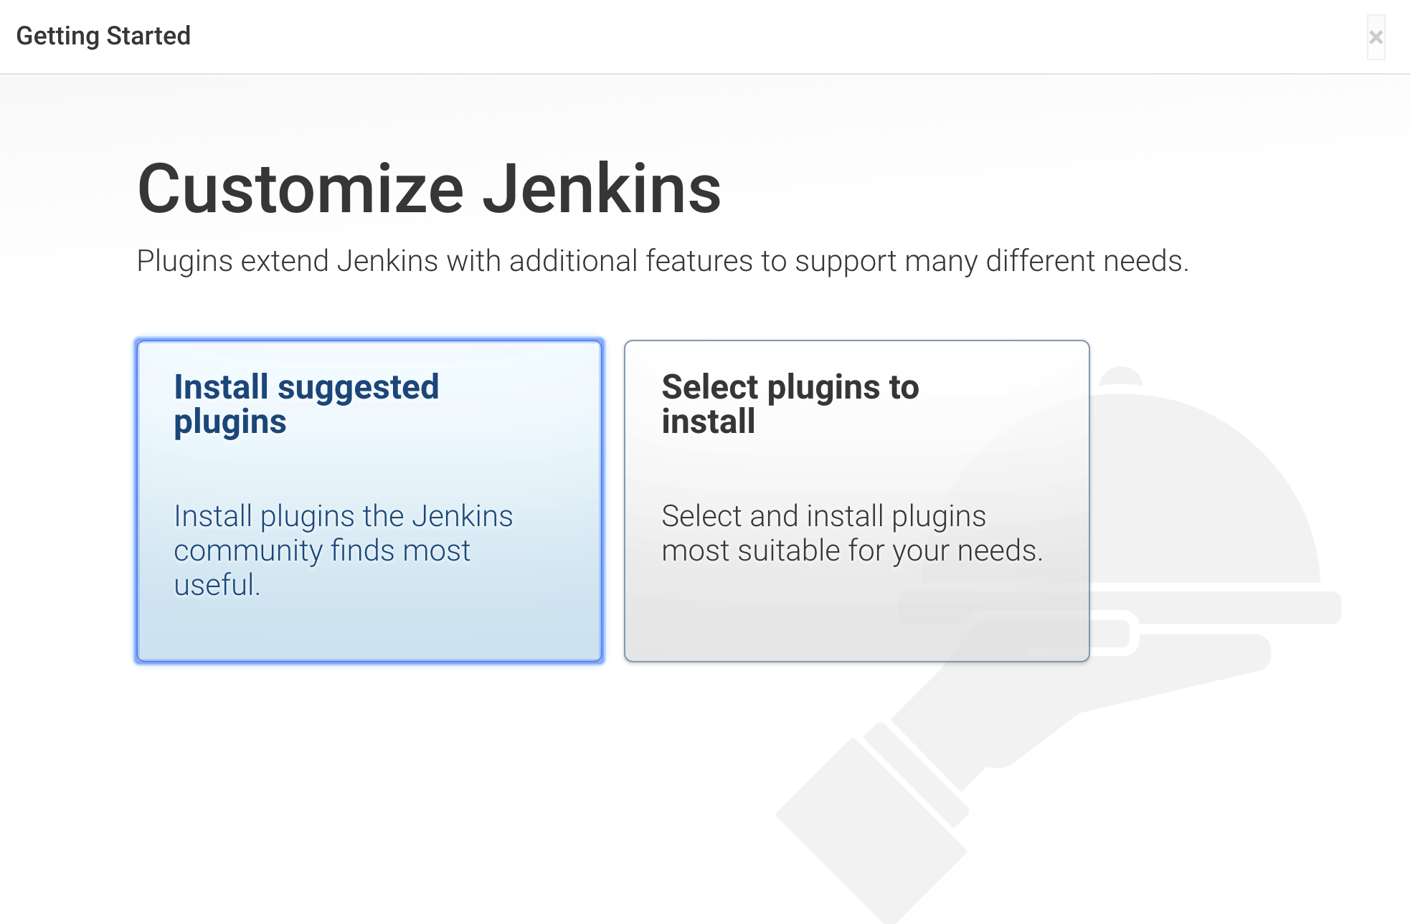
We’ll click the Install suggested plugins option, which will immediately begin the installation process:

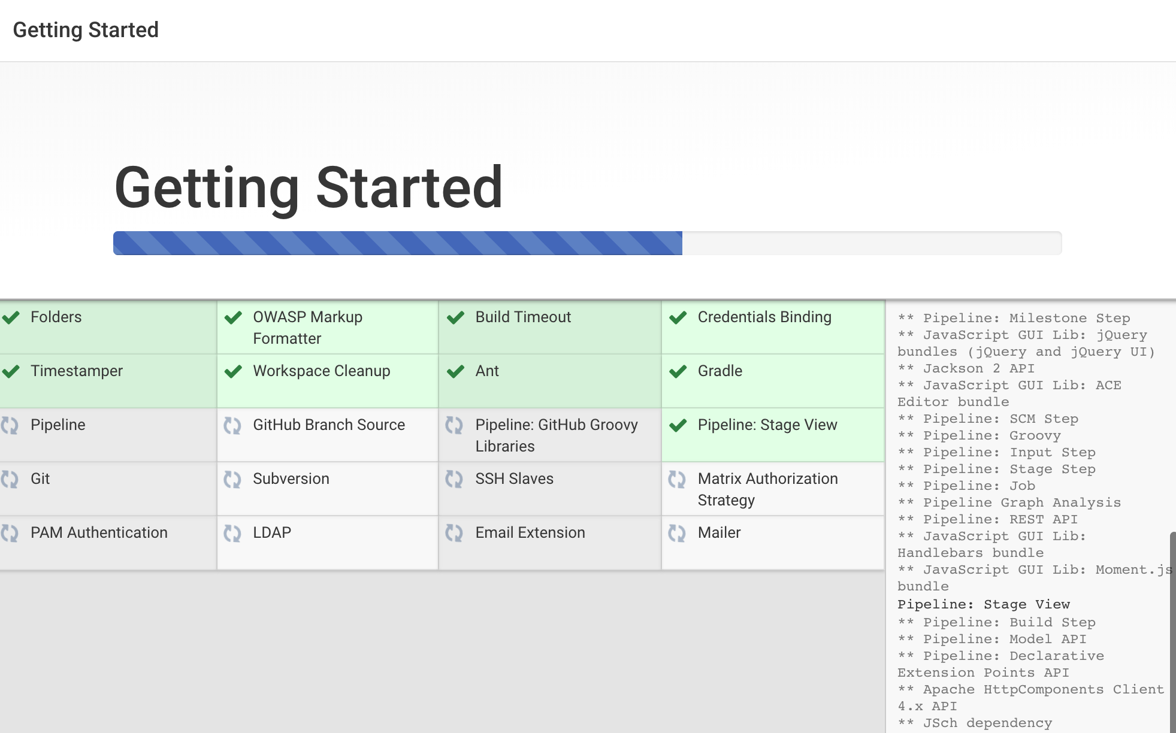
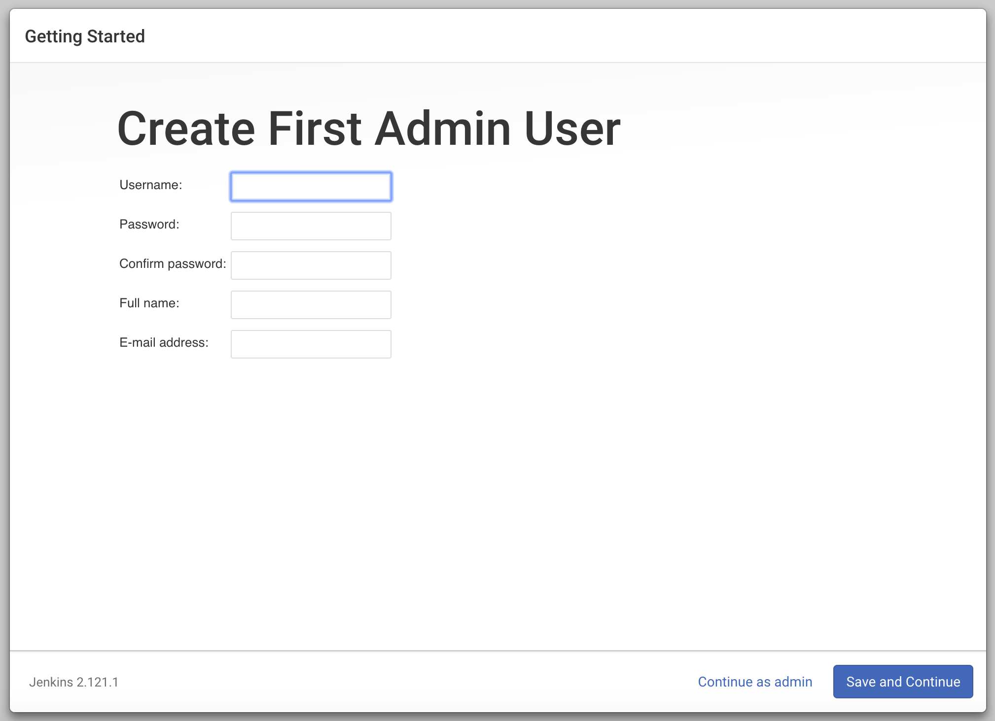
Enter the name and password for your user:

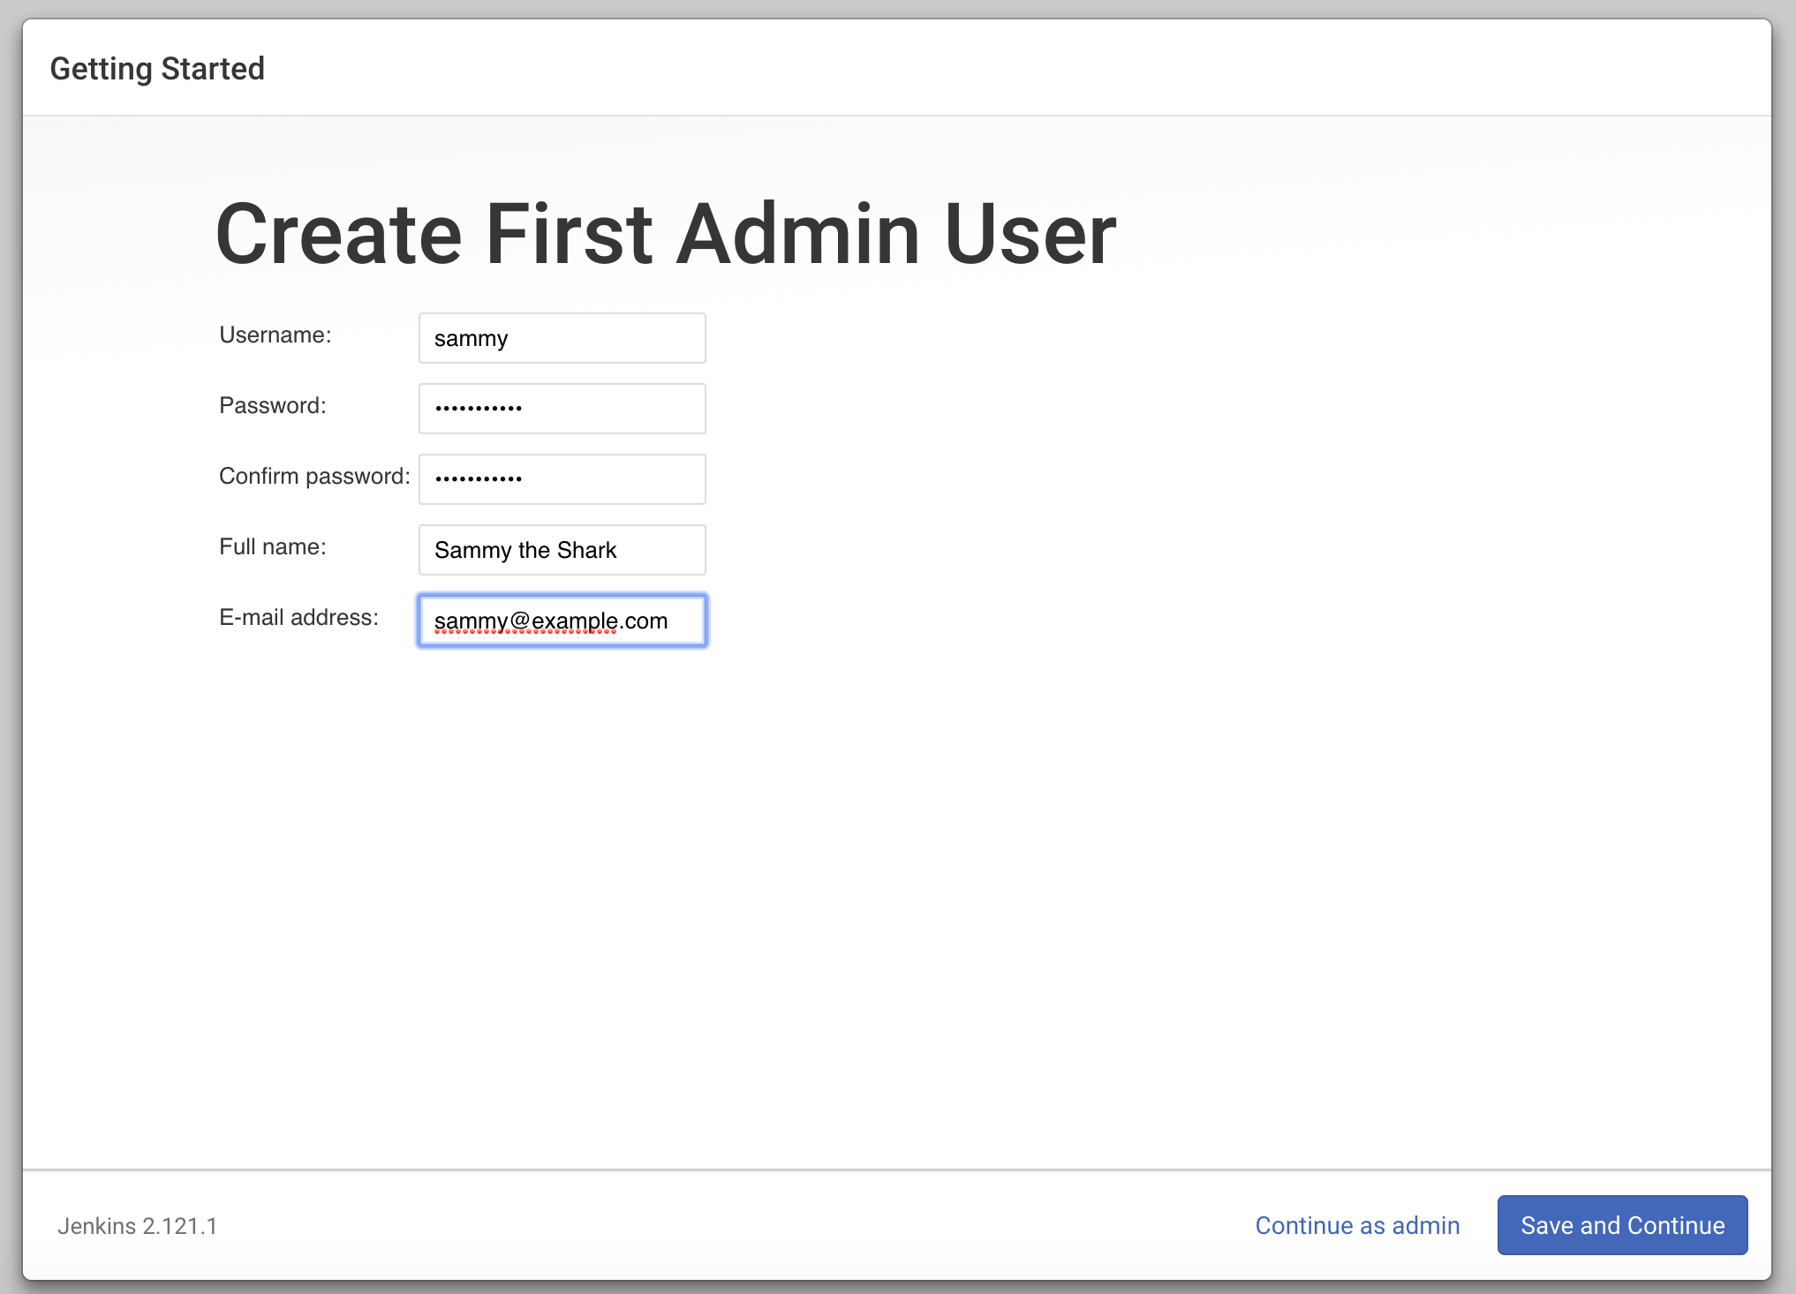

You will see an Instance Configuration page that will ask you to confirm the preferred URL for your Jenkins instance. Confirm either the domain name for your server or your server’s IP address:
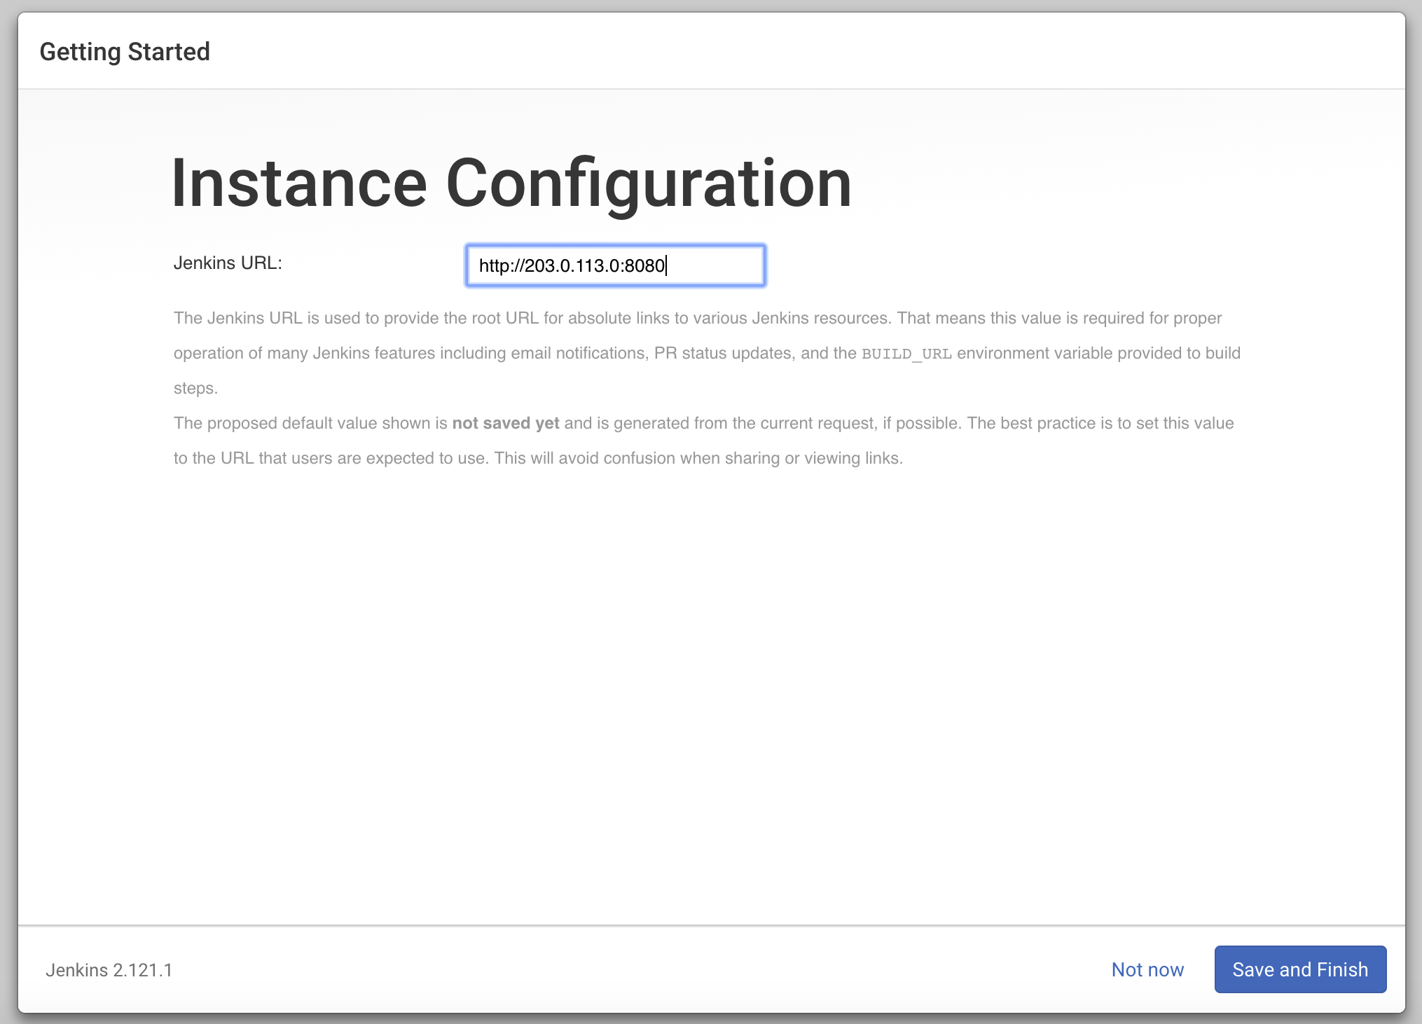

Open the Jenkins:
If you are connected to the vpn can you access this site?
http://192.168.0.53:8080

Creating a Freestyle Build Job : Java:

Step 1) Enter the User credentials

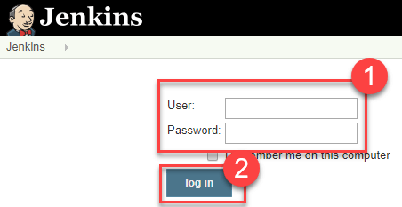

Step 2) Click on "New Item" at the top left-hand side of your dashboard.

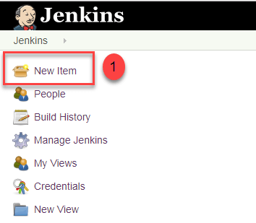

Step 3) In the next screen,
- Enter the name of the item you want to create. We shall use the "Hello world" for this demo.
- Select Freestyle project
- Click Okay
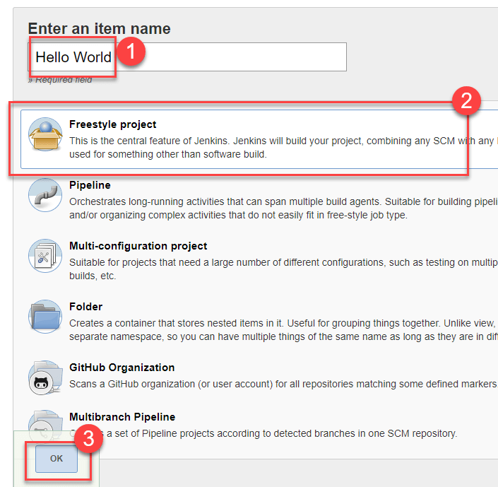

Step 4) Enter the details of the project you want to test.
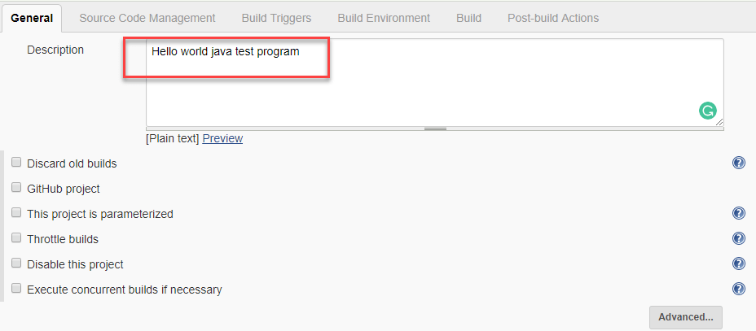

Step 5) Under Source Code Management, Enter your repository URL. We have a test repository located at https://github.com/kriru/firstJava.git

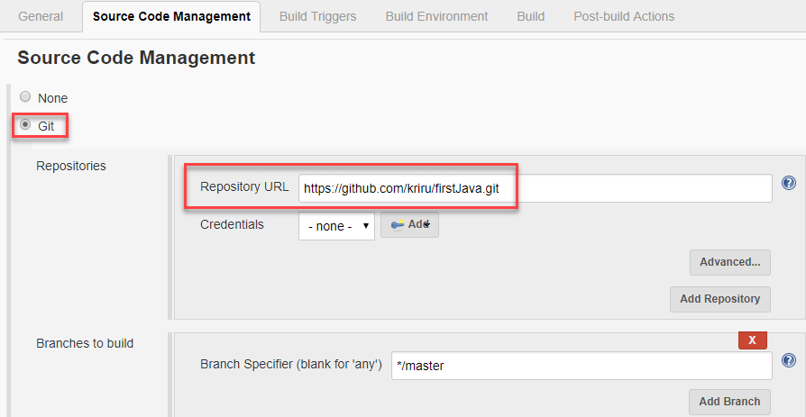
It is also possible for you to use a local repository.
If your GitHub repository is private, Jenkins will first validate your login credentials with GitHub and only then pull the source code from your GitHub repository.

Step 6) Now that you have provided all the details, it's time to build the code. Tweak the settings under the build section to build the code at the time you want. You can even schedule the build to happen periodically, at set times.
Under build,

1. Click on "Add build step"
2. Click on "Execute Windows batch command" and add the commands you want to execute during the build process.
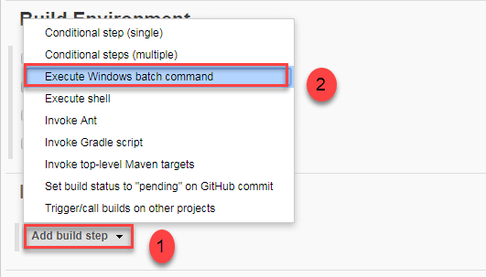

Here, I have added the java commands to compile the java code.
I have added the following windows commands:
javac HelloWorld.java
java HelloWorld
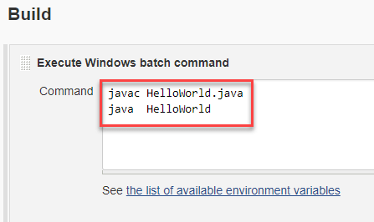

Step 7) When you have entered all the data,
- Click Apply
- Save the project.

Step 8) Now, in the main screen, Click the Build Now button on the left-hand side to build the source code.

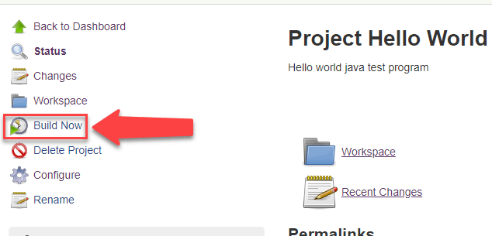

Step 9) After clicking on Build now, you can see the status of the build you run under Build History.

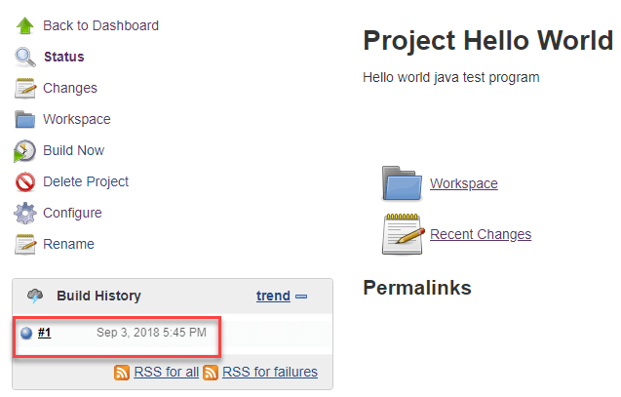

Step 10) Click on the build number and then Click on console output to see the status of the build you run. It should show you a success message, provided you have followed the setup properly.

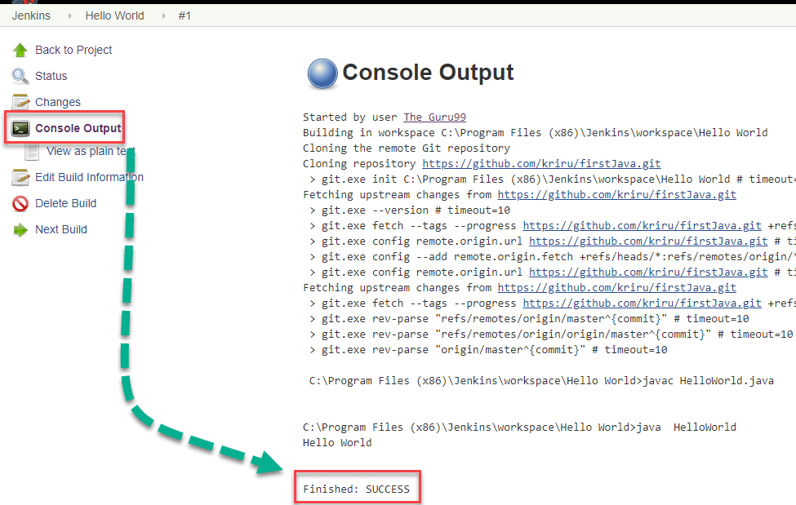

In sum, we have executed a HelloWorld program hosted on GitHub. Jenkin pulls the code from the remote repository and builds continuously at a frequency you define.

Creating a Freestyle Build Job : cpp:

Source Code Management :
https://github.com/jbankes/Hello_Jenkins.git

Execute shell commnad on ubuntu
cd original
make
hello_exec
./hello_exec

Creating a Freestyle Build Job : qt:

Source Code Management :
https://github.com/alexvatti/qt-example.git
Execute shell commnad on ubuntu
qmake hello.pro
make
./hello

Configuring the Node in Jenkins
http://yallalabs.com/devops/how-to-add-linux-slave-node-agent-node-jenkins/
https://linuxacademy.com/blog/linux-academy/adding-a-jenkins-agent-node/
https://embeddedartistry.com/blog/2018/01/11/jenkins-configuring-a-linux-slave-node/

To configure a new node, navigate to “Manage Jenkins” in the classic Jenkins interface or “Administration” in Blue Ocean.

Go to Manage Jenkins -> Manage Nodes
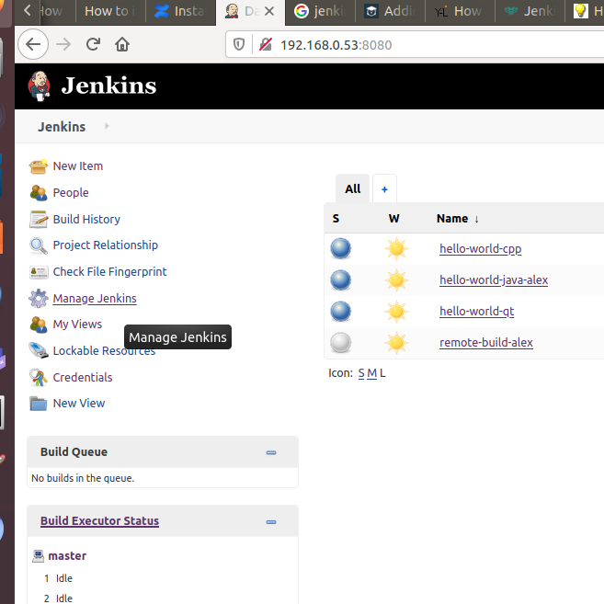
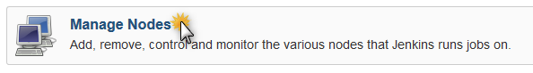
Then click on the New Node button:
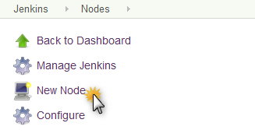

Configure the name of the agent, select Permanent agent and click on the Ok button:

After creating the new node, you have to configure the node settings. Fill in the Remote root directory with a path the user on the agent is allowed to write to, set the Host value with the hostname of the agent, and press the Add button for Credentials :

Choose SSH Username with private key option, fill the Username value with the user account on the agent machine, in our example is jenkins, and choose Private Key -> Enter directly and paste the key from your OS clipboard, and give an ID and a useful Description for this credential. Finally click the add button.

Select the Manually trusted key Verification Strategy value of the Host Key Verification Strategy menu and click save button.

Your new node should now appear in the list of nodes. You may notice a red X on the node’s icon. This indicates that it is not connected yet. Wait a few seconds and refresh the page, and the red X will go away, indicating that the node is successfully connected.

In our case:
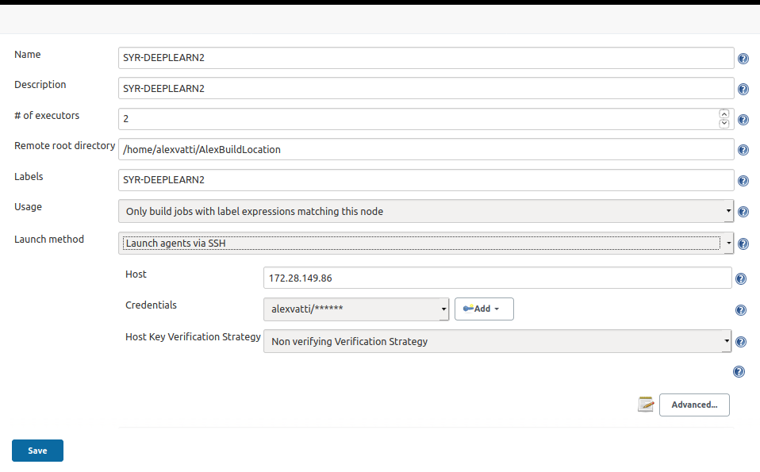

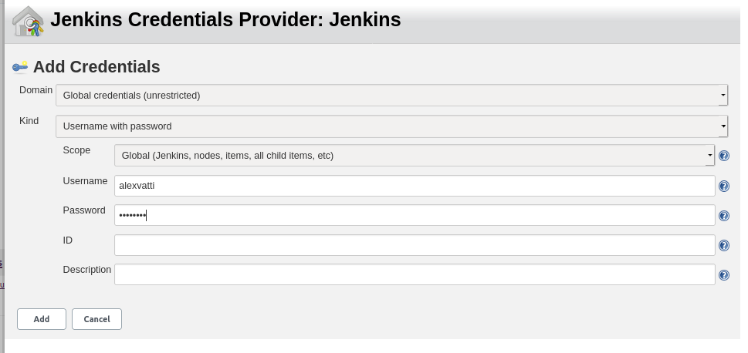
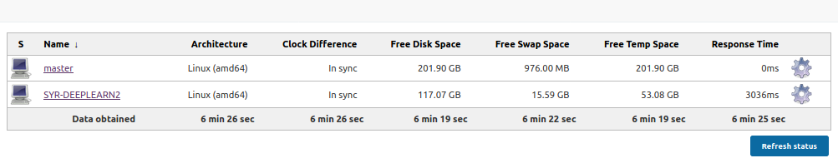

Connection the Node in Jenkins:

Creating a Freestyle Build Job : libPiccoloCam : Run on Remote

Step 1) Click on "New Item" at the top left-hand side of your dashboard.

Step 2) In the next screen,
Enter the name of the item you want to create. We shall use the "remote-build-libpiccolocam" for this demo.
Select Freestyle project

General:
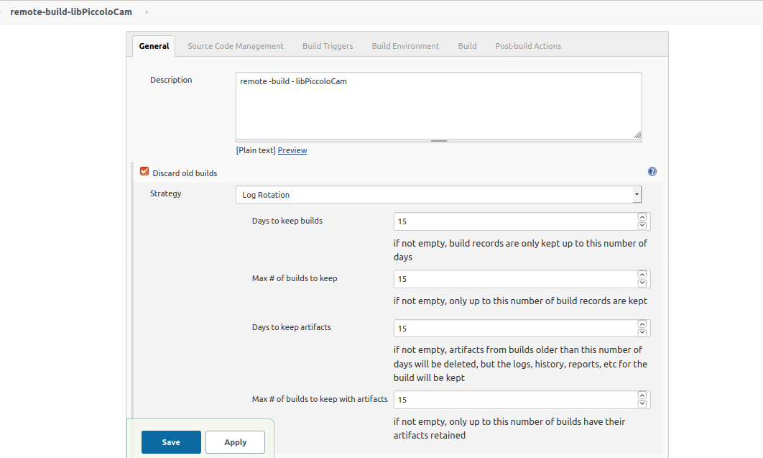
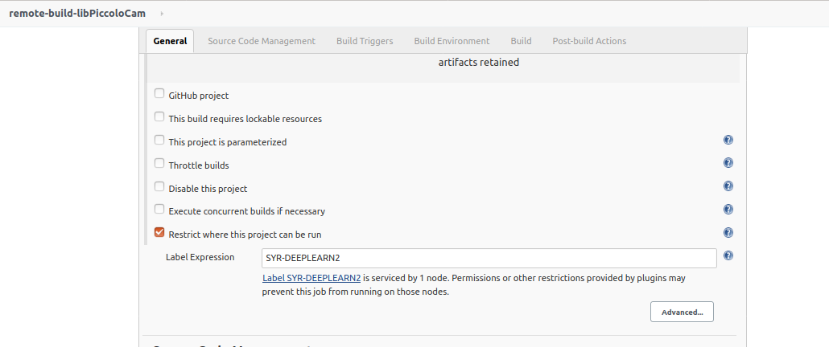

Source code Management
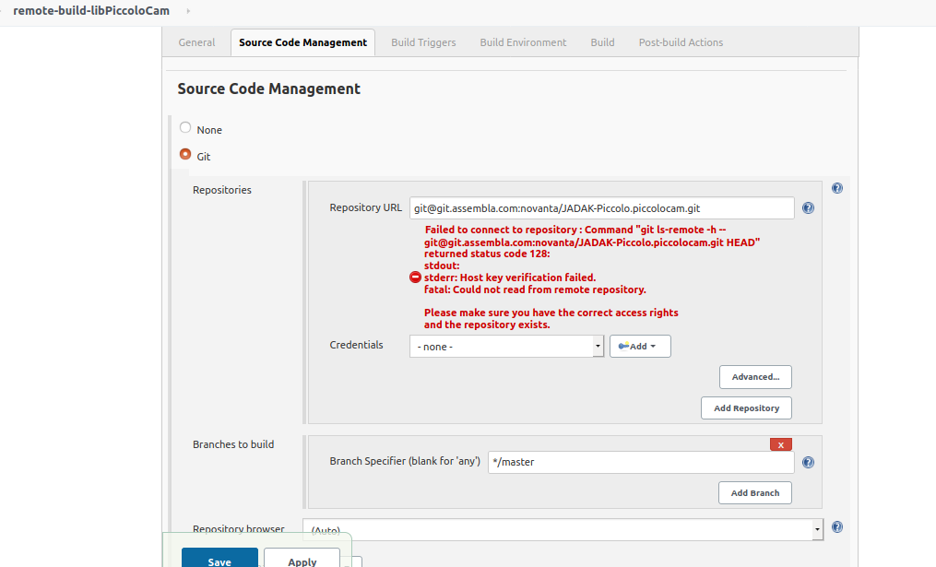
Build Triggers
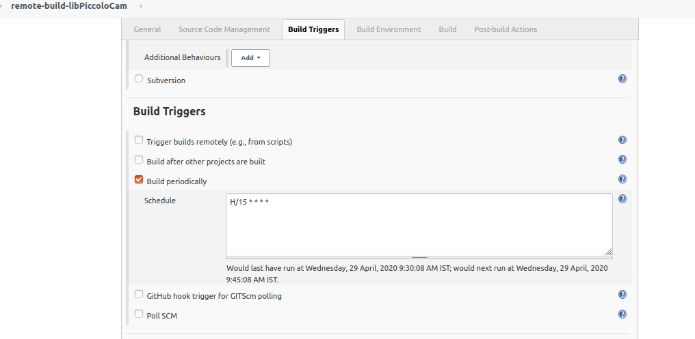

Build Environment
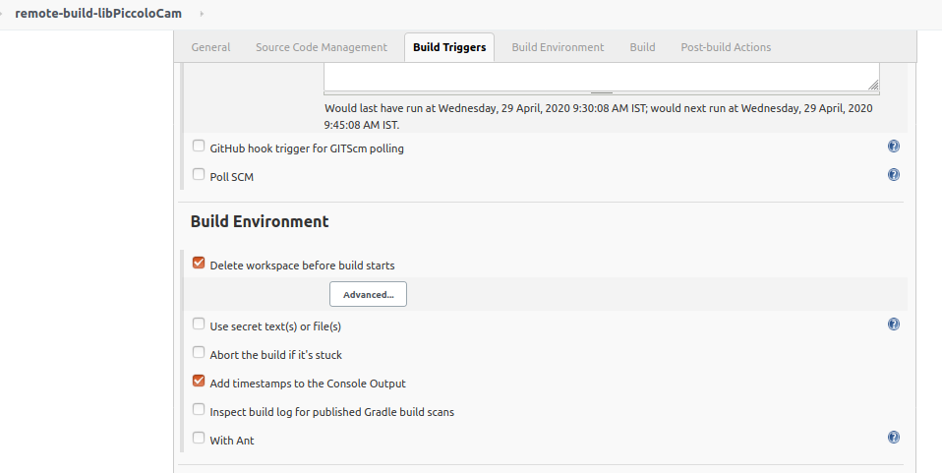
Build
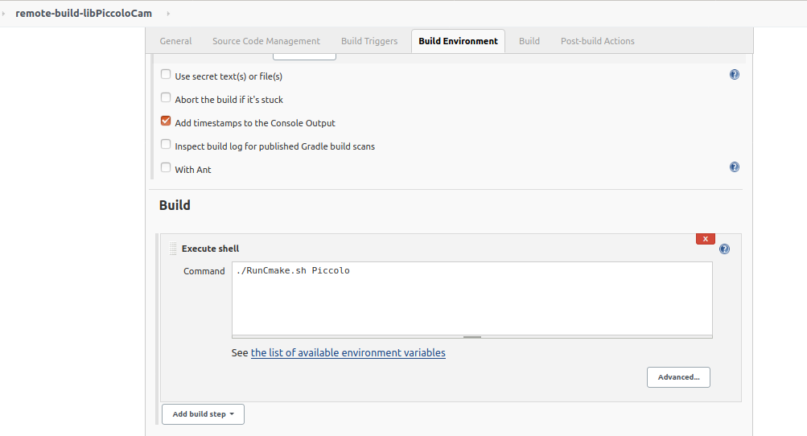

Post-Build Actions
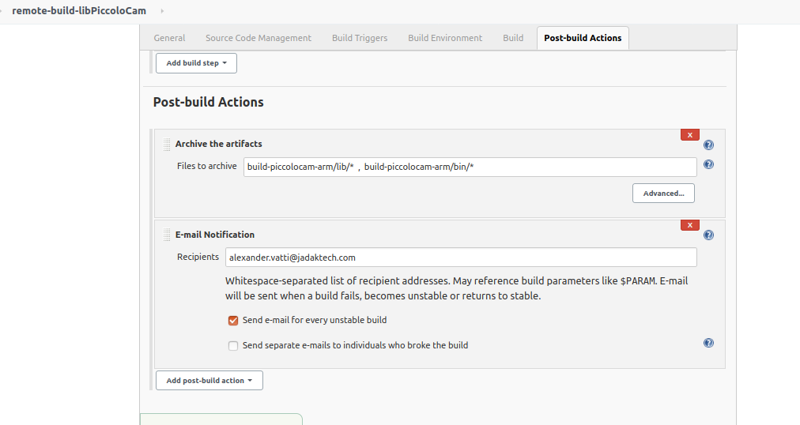
Finally:
