CS3153/5153 - Databases Summer 2010

**Assignment 1: ER Modeling**

1.(20 pts) Create an ER diagram for the following situation:

* We want to model information about books. The only entity type allowed is book, and everything else needs to be modeled as an attribute.
* For each book, we keep their ISBN (Identifier), their title, one or more authors, and a format.
* The book's format is further subdivided into: type of binding, number of pages, dimensions and weight.
* The weight can be calculated from the other attributes of the format.

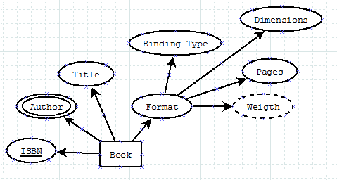

2. (20 pts) Create an ER diagram for the following situation:

* We want to model information about Cars and their Owners (the people who own them).
* For each car we keep their VIN (identifier), make, model and year
* For each person we keep their tax Id (Identifier), name (divided into first, middle, last), and address (divided into street, city, state, zip)

We also need to keep track of which person owns which car. Each person can own zero or more cars, and a car is owned by one or more people. We also want to keep track of the percentage of a car a person owns (different people can own different percentages of a car)

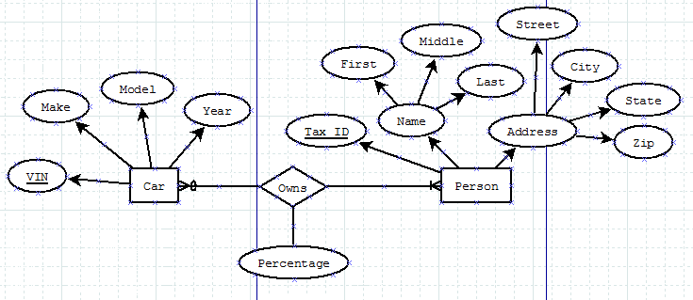

3. (30 pts) Create an ER diagram for the following situation (Hint: At least one weak entity type is involved) – For this exercise we'll model a blog system – like blogger.com – , where there are many users which can have different blogs.:

* We want to model **Users**, their **Blogs**, the **Postings** on each blog, and the **Comments** for each posting.
* For each user, we keep its username (identifier), password and Name, divided into first, middle, last
* For each blog, we keep its id (identifier), title, the date it was created, and the number of posts (which can be calculated); we also keep track of which user created which blog; a blog is created by exactly one user, and a user can create one or more blogs.
* For each Posting, we keep its id (identifier), the blog it belongs to (postings belong to exactly one blog, and blogs may have zero or more postings), its time stamp and its contents.
* For each Comment, we keep its number (which uniquely identifies comments for the same posting, but not all comments in general), time stamp and contents. We also keep track the user who made the comment (comments are made by exactly one user, and a user can make zero or more comments), and the posting the comment refers to (comments refer to exactly one posting, and postings can have zero or more comments).

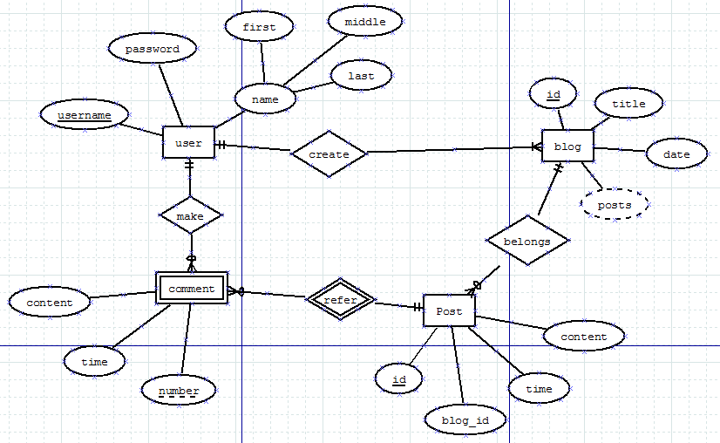

4. (40 pts) Create an ER diagram for the following situation (fields named id are identifiers; HINT: Recursive relationship(s) are involved):

* We want to model curriculum information.
* We want to keep track of **programs**, for which we have its id, and abbreviation, and a title.
* We also keep track of **courses**; for each course we keep its id, a title, the number of credit hours, zero or more course objectives.
* Each course belongs to zero or more programs, and a program will have one or more courses; for each of the programs a course belongs to, we record whether the course is required or elective for the program.
* We keep track of topics; for each topic we keep its id and title.
* We keep track of which course(s) cover which topic(s). Each topic is covered in one or more courses, and each course covers zero or more topics. We also keep track of how many contact hours the course includes for that topic.
* We also keep track of whether a course has other courses as prerequisites. Each course could have zero or more other courses as prerequisites and be a prerequisite for zero or more courses.

