I am an avid coffee drinker and have been a barista for roughly 7 years of my life. This has lead me to have lots of questions about coffee and wanting to brew better and produce different kinds of coffees. The issue with this is that it can be quite hard to find a guide for the specific brew you are after. This is why I am creating my website. I aim for this website to be a one stop shop for any questions one might have on how to brew a coffee, the type of coffee they should use, and where they can get all the tools they might need to brew their perfect cup of coffee. The target audience of this website is both people new to coffee looking to see if it could become a hobby of theirs, or people who are already hobbyists. I am looking to use mostly common language for this website so that anyone can read a guide and get a good understanding of what I am trying to communicate in the steps and instructions. Also offering entry level items as well as much more expensive items that only the customers who are the most into the hobby would ever purchase for their price.

Please find below my planned format for this website as a sitemap, followed by my low fidelity sketches and sitemap, and finally my high fidelity prototype. You can see the other similar pages in the appendix.
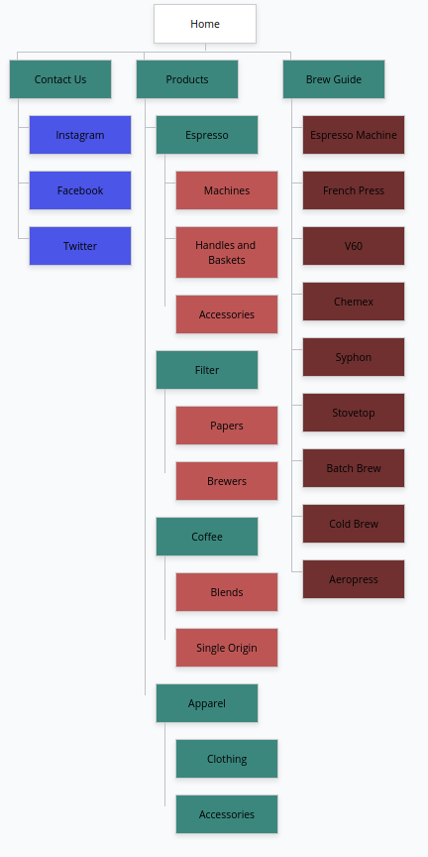Figure 1: https://www.gloomaps.com/xrNNAq6ybp
Sketches
Sitemap
Prototype
I made my design decisions based on Nielsen’s usability heuristics. I will now go over and explain how each of these heuristics impacted my decisions and how I have failed some of them.
In conclusion
Bibliography:

Appendix:

