CalTopo Tools v1 - Help Documentation
  - 2025-12-20 Alex Whitlock

Contents
1 Overview 2
2 System Requirements 2
3 Installing the Application 2
4 Running the Application 2
5 Exiting the Application 3
6 Initializing the Application 3
7 Tool Specific Instructions 3
7.1 Rectangle Tool 3
7.1.1 Set Parameters 4
7.1.2 Create Preview 4
7.1.3 Upload to CalTopo 5
7.1.4 Export to geoJSON 5
7.2 Assignments Tool 5
7.2.1 Manually Reloading Data 5
7.2.2 Sorting and Filtering 5

Overview
CalTopo Tools v1 is a browser-based application that provides tools that augment the capabilities of CalTopo. This application interfaces with CalTopo using the Application Programming Interface (API) documented on the CalTopo support website (link).
The following tools are included in Version 1:
- Rectangle Tool – There is no practical way to create accurate rectangle shapes within the CalTopo user interface (UI). The Rectangle Tool fills this gap by allowing the user to define one rectangle or multiple rectangles in a grid arraignment and either directly upload the shapes to CalTopo via the API or export them as a geoJSON file and manually import them into CalTopo.
- Assignments Tool – The CalTopo UI does not have a good way to see any overview of assignment data. The Assignments Tool reads assignment data via the CalTopo API and displays the data in a table view that can be sorted and filtered.

System Requirements
- Windows 10/11
- Chrome Web Browser

Installing the Application
Download and run CalTopo_tools_installer.exe. Follow the installer prompts.

Running the Application
When the user starts the CalTopo Tools application, two things happen:
- A terminal window opens. This is the backend server. The user should minimize the terminal window but must leave it running. Closing this terminal window closes the application. There is no user interaction with this terminal window.
- A browser tab will open. This is the frontend user interface for the tool. The rest of the instructions below relate to the browser tab user interface.
If the terminal window is closed, the application need to be restarted from the beginning. The browser tab will not automatically close. The user should close this manually before restarting the application.
If the browser table is close, the application is still running in the terminal window. To reopen the application in the browser, navigate to http://127.0.0.1:5000/.

Exiting the Application
To exit the application, close both the browser tab and the terminal window. This can be done in any order.

Initializing the Application
The first thing to do once the application is running is to enter the CalTopo Map ID.
This application can only interact with maps saved to the team SBO-OVSAR folder within CalTopo. It cannot interact with maps saved to ‘Your Data’.
Ensure the map has been saved. This will not work with a map that has not yet been saved.
To find the CalTopo Map ID, click Details/Sharing  on the left side of the map window.
Copy the seven-digit Map ID from the sharing section.
Alternatively, the seven-digit Map ID can also be copied from the URL in the address bar.
Past the Map ID into the CalTopo Map ID field in the top right corner of the CalTopo tools UI. There is no save or confirmation action required.

Tool Specific Instructions

Rectangle Tool
Click the ‘Rectangle Tool’ tab to activate the Rectangle Tool (if not already activated). Ensure the Map ID has been entered per section 6.
The Rectangle Tool is used to create one rectangle shape or multiple rectangle shapes in a grid pattern.
The user sets the parameters and then creates a preview. Once the preview is made, the user can either upload the shapes to the CalTopo map or export the shapes to a geoJSON file and manually import them to the CalTopo map.

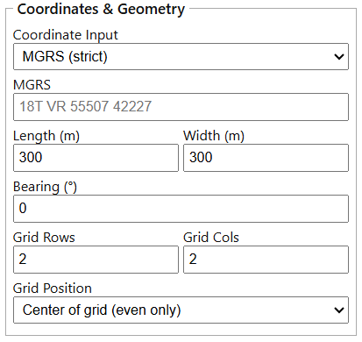
Set Parameters
The user sets the parameters that define the rectangle shape(s).
Coordinate – The rectangles are defined relative to an origin coordinate. This coordinate can be entered in either MGRS or LatLong (decimal degrees, West is negative). Select via the Coordinate Input dropdown.
Dimensions – Sets the length and width of the rectangle(s).
Bearing – Sets the orientation of the rectangle or grid of rectangles about the origin coordinate.
Grid – Set the number of rows and columns for the grid of rectangles. Set to 1x1 for a single rectangle.
Grid Position – There are two options for positioning the grid relative to the origin coordinate. Select the option via the grid Position dropdown.
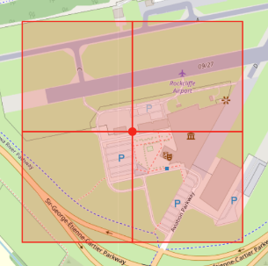
- The origin coordinate is at the center of the grid. In this case, the number of rows and columns must be even.

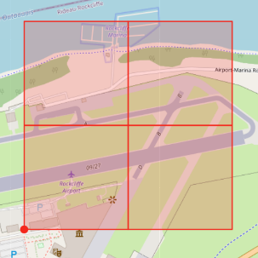
- The origin coordinate is at the corner of the grid.

Create Preview
Once all parameters are set, Click “Preview”. The rectangle shapes will appear on the map view.

Upload to CalTopo
Click “Upload” to upload the shapes shown in the preview to the CalTopo map. The shapes may take some time to appear in the map after the upload is completed.
The shapes in the map will be names with the format API# (# is sequential from 1 to n where n is the number of shapes uploaded).
The upload option is not available without an internet connection.

Export to geoJSON
Click “Export” to export the shapes shown in the preview to a geoJSON file. This file is automatically downloaded to the computer (downloads folder). The file can then be manually imported into CalTopo.
The export option is available without an internet connection.

Assignments Tool
Click the ‘Assignments’ tab to activate the Assignments Tool (if not already activated). Ensure the Map ID has been entered per section 6.
The Assignments Tools is used to view, sort, and filter data about assignments in the CalTopo map.

Manually Reloading Data
The data does not automatically update when changes are made in CalTopo. To reload the data, click the “Reload” button I the top right. The last updated time is shown in the message bar at the top.

Sorting and Filtering
The assignment data columns can be sorted by clicking on the column header. Clicking toggles between ascending and descending sort.
Filter for assignment number or team letter by entering values in the input fields.
Filter for assignment type and status by toggling one or more of the filter option buttons. If no buttons are toggled on then no filter is applied. (Toggle OFF = Grey, Toggle ON = Colour)
For example, the filter options below will show only “Dog” type assignments that have the status “Prepared” or “In Progress”.
