# 1. FIND WHERE JAVA IS INSTALLED

1.1 You will need to get the directory where you have installed Java. To do this, open Terminal in Mac (COMMAND-SPACE to open spotlight, then type 'Terminal').

1.2 Type the following inside the terminal

/usr/libexec/java_home -V

This should list out all Java installations in your system. On my system, I got the following:

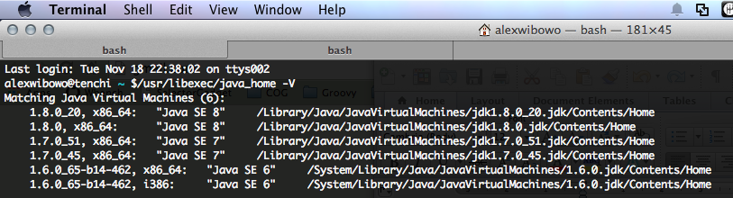

1.3 Hopefully you have installed the latest Java, in which case, the version would be 1.8.<something>. From the output, note down the location of java 1.8. Using my example above, I will use version 1.8.0_20. So the path that I'm going to use is

/Library/Java/JavaVirtualMachines/jdk1.8.0_20.jdk/Contents/Home

# 2. FIND YOUR USER ‘HOME’ DIRECTORY

Inside the terminal, type ‘cd && pwd’. You should get the path to your home directory.



For me, my home directory is at /Users/alexwibowo

# 3. LAUNCH THE INSTALLER

2.1 Double click barcodeSpider-installer-1.0-SNAPSHOT.jar

2.2 Click ‘Next’ button on the welcome screen, readme screen, and license screen (after accepting the license)

2.3 The next screen should ask you about ‘installation path’ (There should be a note about Java version 1.7). This is actually asking where Java is installed (I have misguided you over the phone earlier). So just type the location that you have written down before. For me, it is /Library/Java/JavaVirtualMachines/jdk1.8.0_20.jdk/Contents/Home

Note that you should not get any warning about wrong version of Java. If you get a popup dialog saying ‘The chosen JDK has the wrong version…”, it means that you have used the wrong Java location, or that the installed Java version is less than 1.7.

2.4 The next screen should ask you where you want to install the application. I normally install it under my home directory. E.g.:

/Users/alexwibowo/barcodeSpider

Honestly, I haven’t tried installing the application under /Applications (the default).

2.5 Just click ‘Next’ button on the next screen, where it asked for which component to install

2.6 After the installation has completed, go to the directory where the application is installed. There should be a file called ‘BarcodeSpider.app’. Double click it.

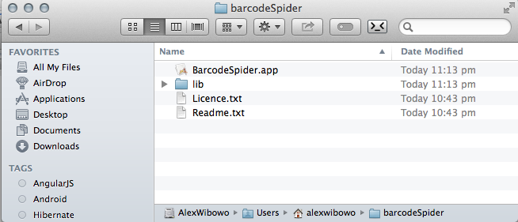

You should see the application.

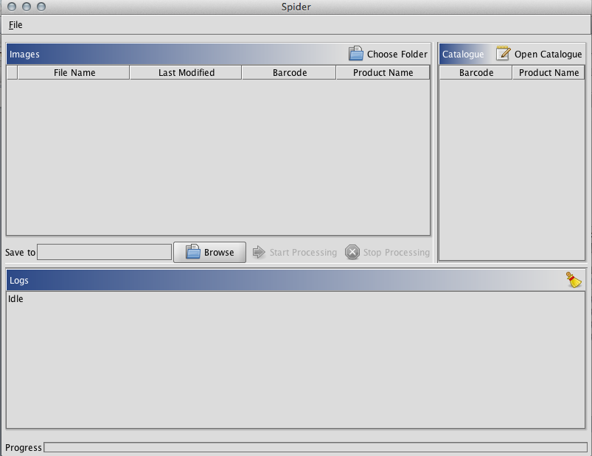

Hopefully the UI is intuitive enough, but on the high level, the workflow is as follow:

1. Choose the directory that contains the images. You can click the ‘Choose Folder’ icon on the top left table (as a shortcut), but you can also access it from the ‘File’ menu.
2. Choose the excel ‘catalogue’ file. I’ve tested the app against Excel 2003 & 2010 files (.xls & .xlsx). You can do this by clicking ‘Open Catalogue’ icon on the top right table, or from the File menu.
3. Choose where you want to store the output images, by clicking ‘Browse’ button next to the ‘Save to’ text field.
4. Click the ‘Start Processing’ button.

Here are a few sample screenshots from my execution:

After choosing a folder that contains images:

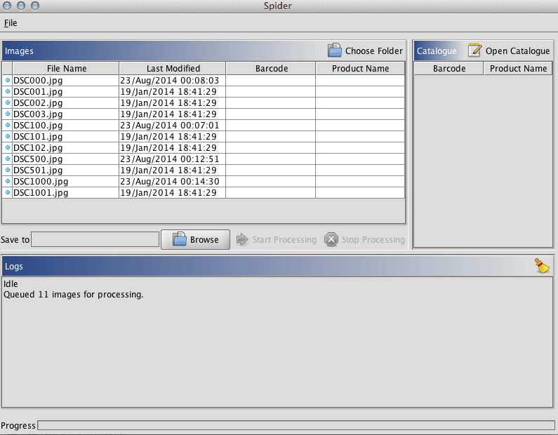

After loading the excel catalogue:

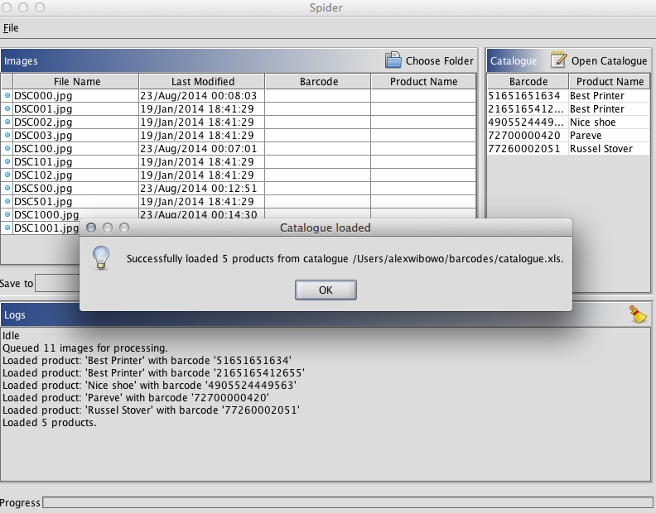

After choosing the output directory (start processing button should be enabled)

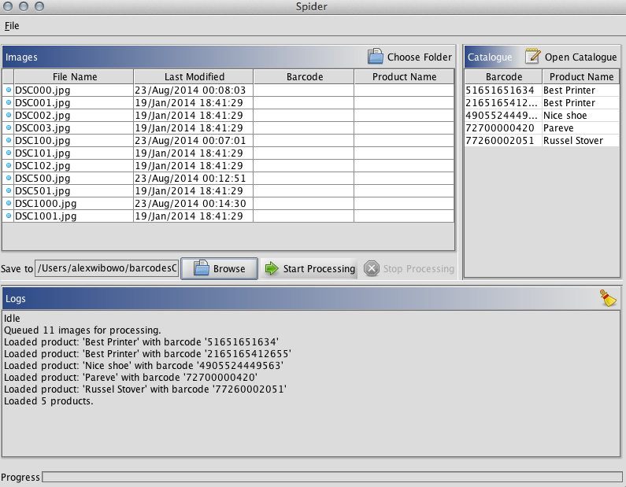

Successful processing:

