Movie Project
Udacity Nanodegree
Alex Wine
7/18/15

Popular Movies App Implementation Guide
Stage 1: Main Discovery Screen, A Details View, and Settings
User Experience
Implementation Guidance - Stage 1
Setup - Library Configuration
A note on resolving poster paths with themoviedb.org API
Stage 1 - API Hints
Stage 1 - Evaluation Rubric
Project Submission (Popular Movies App, Stage 1)
Stage 2: Trailers, Reviews, and Favorites
User Experience
Implementation Guidance - Stage 2
Stage 2 - API Hints
Stage 2 - Evaluation Rubric
Project Submission (Popular Movies App, Stage 2)
UX Mockups (Complete App)
Phone UX:
Tablet UX:

Popular Movies, Stage 1 Implementation Guide
Most of us can relate to kicking back on the couch and enjoying a movie with friends and family. In this project, you’ll build an app to allow users to discover the most popular movies playing.
You’ll build the complete functionality of this app in two stages which you will submit separately.

Stage 1: Main Discovery Screen, A Details View, and Settings

User Experience
In this stage you’ll build the core experience of your movies app.
You app will:
- Upon launch, present the user with an grid arrangement of movie posters.
- Allow your user to change sort order via a setting:
- The sort order can be by most popular, or by highest-rated
- Allow the user to tap on a movie poster and transition to a details screen with additional information such as:
- original title
- movie poster image thumbnail
- A plot synopsis (called overview in the api)
- user rating (called vote_average in the api)
- release date

Implementation Guidance - Stage 1

Setup - Library Configuration
We recommend that this project use:
- Picasso* - A powerful library that will handle image loading and caching on your behalf.
*if you prefer, you’re welcome to use an alternate library such as Glide.
We’ve included this to reduce unnecessary extra work and help you focus on applying your app development skills.
How to Setup Picasso
You’ll need to modify the build.gradle file for your app. These modifications will happen in the build.gradle file for your module’s directory, not the project root directory (it is the file highlighted in blue in the screenshot below).
In your app/build.gradle file, add:

repositories {
mavenCentral()
}
Next, add compile 'com.squareup.picasso:picasso:2.5.2' to your dependencies block.
Using Picasso To Fetch Images and Load Them Into Views
You can use Picasso to easily load album art thumbnails into your views using:
Picasso.with(context).load("http://i.imgur.com/DvpvklR.png").into(imageView);
Picasso will handle loading the images on a background thread, image decompression and caching the images.

A note on resolving poster paths with themoviedb.org API
You will notice that the API response provides a relative path to a movie poster image when you request the metadata for a specific movie.
For example, the poster path return for Interstellar is “/nBNZadXqJSdt05SHLqgT0HuC5Gm.jpg”
You will need to append a base path ahead of this relative path to build the complete url you will need to fetch the image using Picasso.
It’s constructed using 3 parts:
- The base URL will look like: http://image.tmdb.org/t/p/.
- Then you will need a ‘size’, which will be one of the following: "w92", "w154", "w185", "w342", "w500", "w780", or "original". For most phones we recommend using “w185”.
- And finally the poster path returned by the query, in this case “/nBNZadXqJSdt05SHLqgT0HuC5Gm.jpg”
Combining these three parts gives us a final url of http://image.tmdb.org/t/p/w185//nBNZadXqJSdt05SHLqgT0HuC5Gm.jpg

This is also explained explicitly in the API documentation for /configuration.

Stage 1 - API Hints
- To fetch popular movies, you will use the API from themoviedb.org.
- If you don’t already have an account, you will need to create one in order to request an API Key.
- In your request for a key, state that your usage will be for educational/non-commercial use. You will also need to provide some personal information to complete the request. Once you submit your request, you should receive your key via email shortly after.
- In order to request popular movies you will want to request data from the /discover/movie endpoint. An API Key is required.
- Once you obtain your key, you append it to your HTTP request as a URL parameter like so:
- http://api.themoviedb.org/3/discover/movie?sort_by=popularity.desc&api_key=[YOUR API KEY]
- You will extract the movie id from this request. You will need this in subsequent reved from url=(0097)https://docs.google.com/document/d/1ZlN1fUsCSKuInLECcJkslIqvpKlP7jWL2TP9m6UiA6I/pub?embedded=true -->
Table of Contents
Stage 1: Main Discovery Screen, A Details View, and Settings 2
User Experience 2
Implementation Guidance - Stage 1 3
Setup - Library Configuration 3
A note on resolving poster paths with themoviedb.org API 3
Stage 1 - API Hints 3
Popular Movies 6
1.1.1. User Interface 7
1.1.2. Widget Table 8
1.2. Movie Details 9
1.2.1. User Interface 9
1.2.2. Widget Table 10
1.3. Favorites 11
1.3.1. User Interface 11
1.3.2. Widget Table 11
1.4. Settings 12
1.4.1. User Interface 12
1.4.2. Widget Table 12
1.4.3. SortBy 13
1.4.3.1. State1 13
1.4.3.2. User Interface 13
1.4.3.3. Widget Table 13
2. Masters 14
2.1. Master List 14
2.2. AndroidHeader 15
2.2.1. User Interface 15
2.2.2. Widget Table 15
2.3. SettingButton 16
2.3.1. User Interface 16
2.3.2. Widget Table 16
2.3.3. Unnamed 17
2.3.3.1. State1 17
2.3.3.2. User Interface 17
2.3.3.3. Widget Table 17

Popular Movies

This page will need to be passed a settings variable to vary the display order
-May also be required for the Favorites setting
-Pull in database information instead of URI information
    - User Interface
Portrait Phone
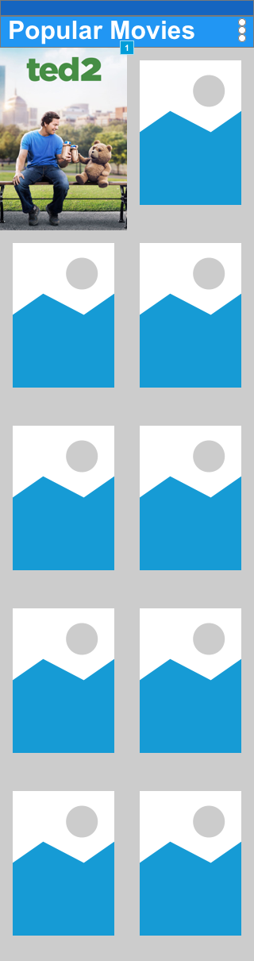
Landscape Tablet
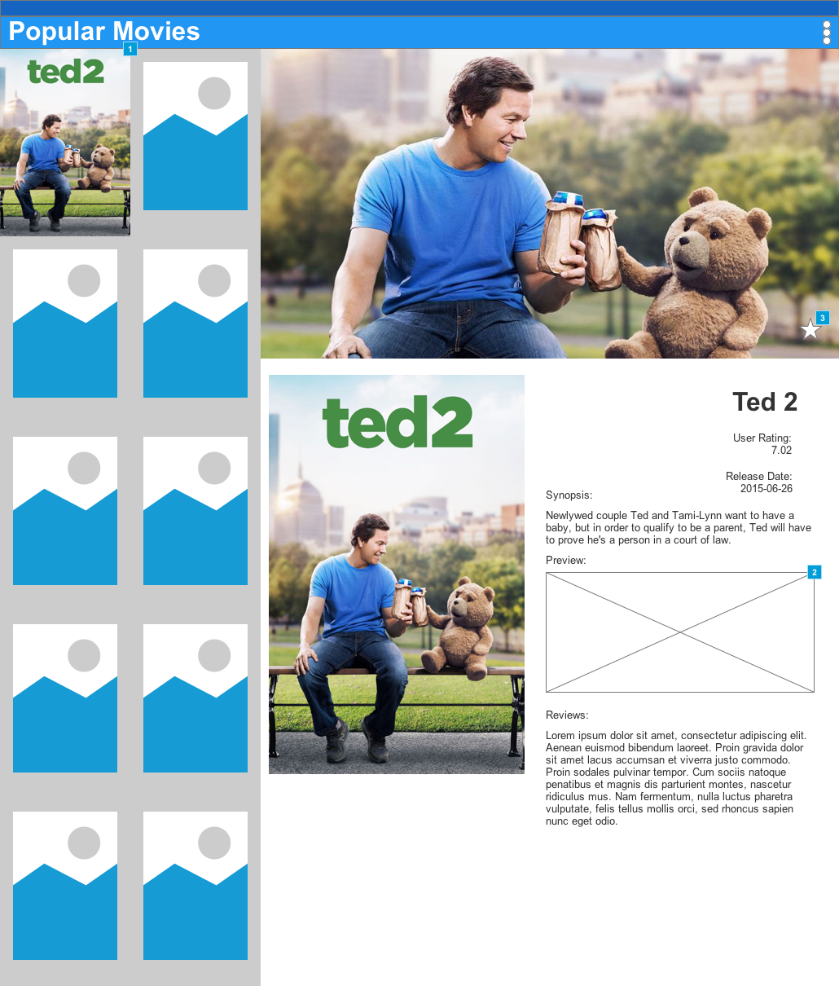
    - Widget Table
Footnote | Name | Interactions | Note
1 |  | OnClick:  imageClick:  Open Movie Details in Current Window
2 |  |  | Most likely will just launch an implicit intent
3 |  | OnClick:  Case 1:  Open Toast in Popup Window

  - Movie Details

OnPageLoad:
Case 1
(If current adaptive view equals Landscape Tablet):
Open Popular Movies in Current Window
    - User Interface
Portrait Phone
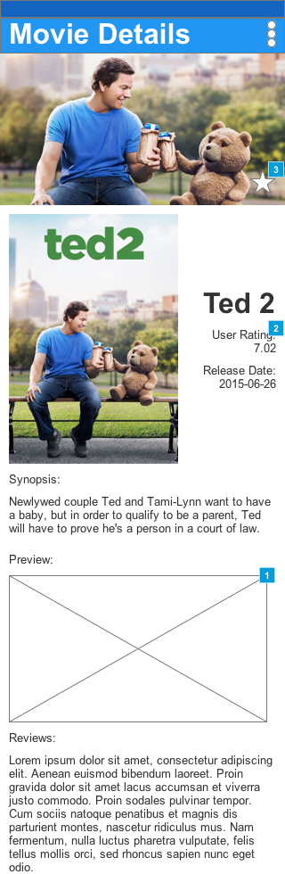
Landscape Tablet
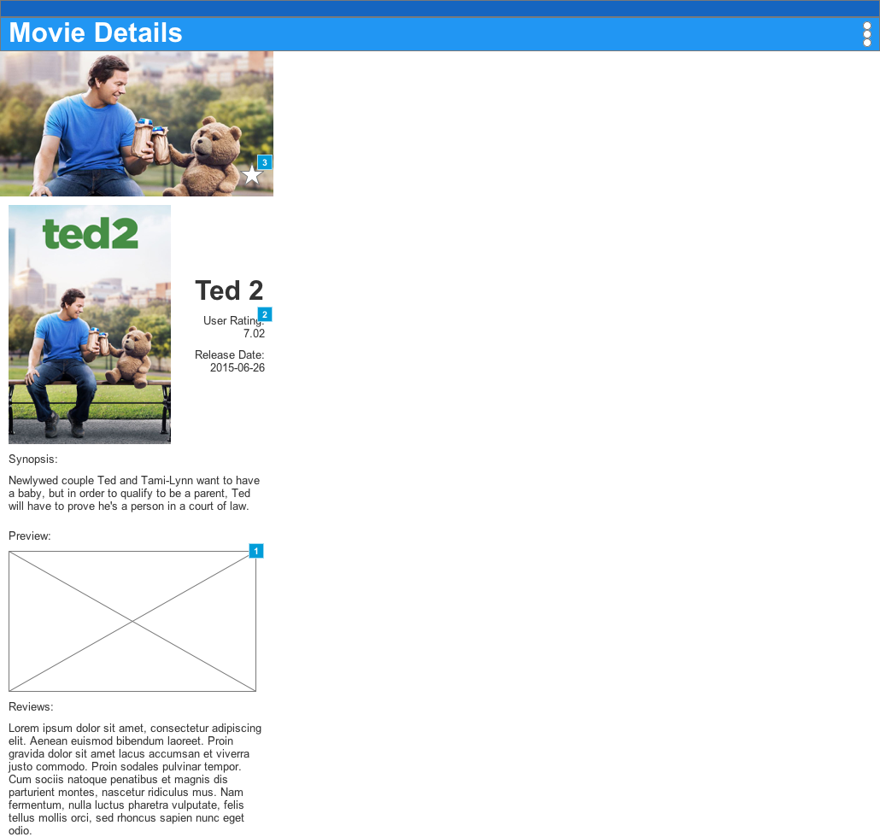
    - Widget Table
Footnote | Name | Interactions | Note
1 |  |  | Most likely will just launch an implicit intent
2 |  | OnClick:  Case 1:  Scroll to ReviewsHeader (y only) swing 500ms  Toggle ReviewsHighlight fade 1000 ms  Wait 1000 ms  Toggle ReviewsHighlight fade 1000 ms
3 |  | OnClick:  Case 1:  Open Toast in Popup Window

  - Favorites

    - User Interface
Portrait Phone
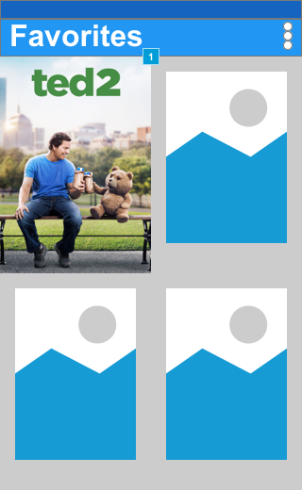
Landscape Tablet
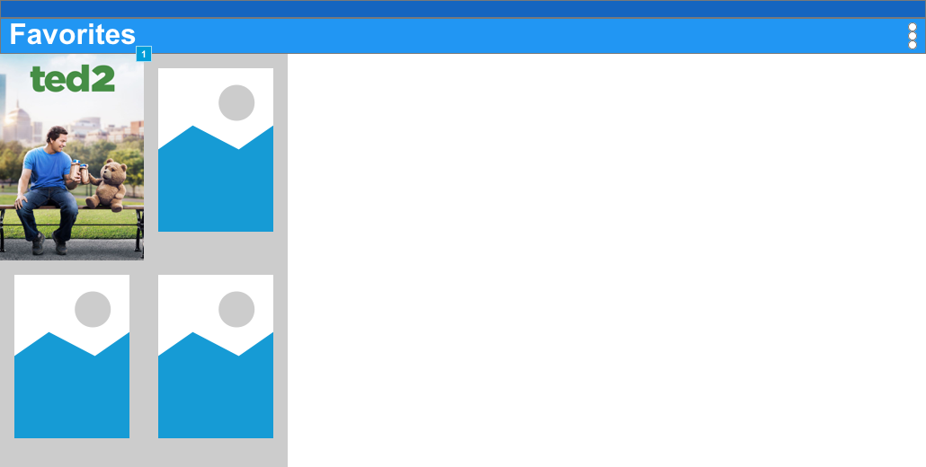
    - Widget Table
Footnote | Interactions
1 | OnClick:  imageClick:  Open Movie Details in Current Window

  - Settings

OnPageLoad:
Case 1:
Set text on SortVar equal to "[[SortSetting]]"
    - User Interface
Portrait Phone
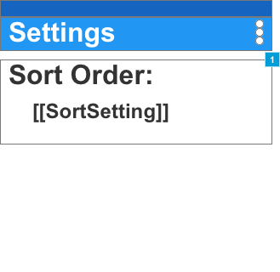
Landscape Tablet
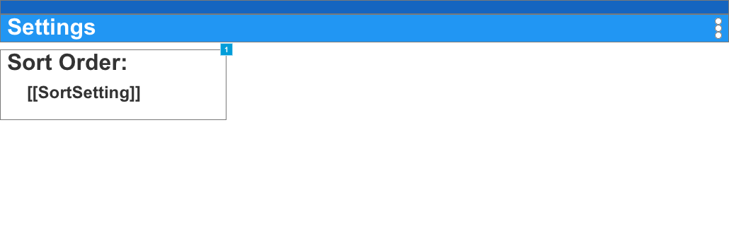
    - Widget Table
Footnote | Name | Interactions
1 |  | OnClick:  Case 1:  Toggle SortBy

    - SortBy
      - State1

      - User Interface
Portrait Phone, Landscape Tablet
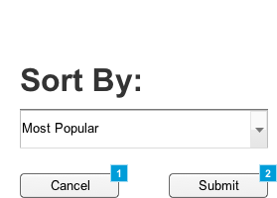
      - Widget Table
Footnote | Name | Interactions
1 |  | OnClick:  Case 1:  Toggle SortBy
2 | Submit | OnClick:  Case 1:  Set value of SortSetting equal to selected option of SortDrop  Toggle SortBy  Set text on SortVar equal to "[[SortSetting]]"

- Masters
  - Master List
AndroidHeader
SettingButton
  - AndroidHeader

OnPageLoad:
Case 1:
Set text on PageTitle equal to "[[PageName]]"
    - User Interface
Portrait Phone
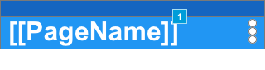
Landscape Tablet
    - Widget Table
Footnote | Name | Interactions
1 | PageTitle | OnClick:  Case 1:  Open Popular Movies in Current Window

  - SettingButton

    - User Interface
Portrait Phone

Landscape Tablet
    - Widget Table
Footnote | Interactions
1 | OnClick:  Case 1:  Set (Dynamic Panel) to State1 show if hidden

    - Unnamed
      - State1

      - User Interface
Portrait Phone, Landscape Tablet
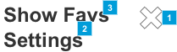
      - Widget Table
Footnote | Interactions
1 | OnClick:  Case 1:  Hide (Dynamic Panel)
2 | OnClick:  Case 1:  Open Settings in Current Window
3 | OnClick:  Case 1:  Open Favorites in Current Window

