Axiom System
Temporary Documentation
Formal documentation to follow
General Information
Framework: .NET 4.0 Windows Communication Foundation
Binding(s): basic http binding with enforced SSL security
SOAP Standard/Schema(s): SOAP/1.2 envelope
http://www.w3.org/2003/05/soap-envelope
Service Location: https://coreapi.iprint.visionps.com/AxiomService.svc
WSDL Location: https://coreapi.iprint.visionps.com/AxiomService.svc?wsdl
Namespace: https://coreapi.iprint.visionps.com
Service Methods:
PlaceAxiomOrder

A service method is an operation that can be called and passed in data through an HTTP POST. A response may or may not occur based on the service’s description.
Authentication
CoreAPI’s authentication will be handled by an application passing in an application ID and its respective key into the SOAP Message header section. An example header section is:
<soapenv:Header> <ApplicationId>00000000-0000-0000-0000-000000000000</ApplicationId> <ApplicationKey>XXXXXXXXXXXXXXXXXXXXX</ApplicationKey> </soapenv:Header>
This section is now required for all soap requests.
Service: PlaceAxiomOrder
Description:
This Service will allow you to place an axiom order given a count id and a Boolean is multiple.
SOAP Action:
https://coreapi.iprint.visionps.com/IAxiomService/PlaceAxiomOrder
POST:
https://coreapi.iprint.visionps.com/AxiomService.svc
Method Signature:
AxiomOrderGetModel PlaceAxiomOrder(bool isMultiple, int countId)
Parameters: isMultiple, countId
On Success Return: AxiomOrderGetModel
Non-successful Return: AxiomOrderGetModel
Throws: InvalidCountIdFault if CountId <= 0

Service: Compose (continued)
Detailed Parameters: Parameter Name | Type | Required | Notes
isMultiple | boolean | Yes | Necessary to determine the list type of Multiple Or Single.
countId | Integer | Yes | Represents the count id for the order must be a positive whole number.

System Overview:
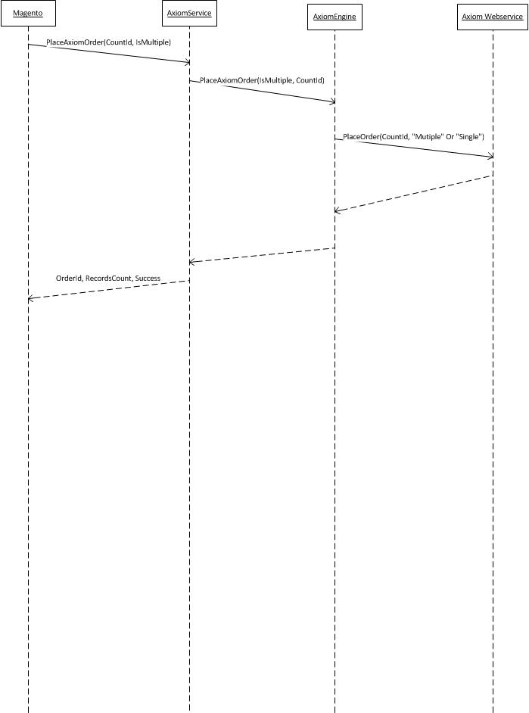
Example Soap Calls:

Key things for Magento:
The soap service is exposed at: https://coreapi.iprint.visionps.com/AxiomService.svc
Given a Boolean named IsMultiple indicating “Multiple” or “Single” where true is “Multiple” and an integer named CountId which is the CountId of the order, you may place an order.
You will get an object back with the following properties:
For .NET:
public class AxiomOrder
{
public bool Success { get; set; } //True If Successful

public string AxiomErrorMessage { get; set; } //Set if an Acxiom Error Occurred

public int OrderReturnCode { get; set; }//-1 if failure some positive number if //suceess

public int RecordCount { get; set; } //number of records excepted from the order

public string AxiomOrderId { get; set; } //The order id from the acxiom system’s Place //Order method returned.
}
Usage For Php:
$myRetObj = $myClientProxy->PlaceOrder(30, false) // note Soap reverses the variables being passed in
if($myRetObj->Success){
//Do something with the variables.
}

