Fluddle Shorebird Surveys
Detailed Protocol for Point Count Surveys
The goal of the ephemeral wetland – or “fluddle” – project in Illinois is to collect data on how migratory shorebirds, especially members of the genera Calidris (sandpipers), Tringa (yellowlegs), and Limnodromus (dowitchers), utilize flooded agricultural fields. To accomplish this, we are looking for volunteers to conduct point count surveys at fluddles across Illinois. If you want to know more about the science behind this project, see Background Information.
Participation involves visiting select fluddle locations during spring (April-May) and fall (July-November) migrations and conducting a point count survey of all shorebirds at the fluddle. Data will be collected through the eBird platform. We ask that volunteers have a basic understanding of how eBird works and experience identifying shorebirds.
If you have any questions or concerns, please contact Alex Smilor via email (awsmilor@illinois.edu).
Table of Contents
- Point Count Survey Instructions
  - Step 1: Selecting Sites
  - Step 2: Visiting Sites
  - Step 3: Submitting Checklists
- Background Information

Definitions
Fluddle. Also known as puddles, ephemeral wetlands, or mudflats. A shallow wetland with minimal vegetation and mudflats, often found in depressions in agricultural fields.
Shorebird. Birds in the order Charadriiformes commonly found in wading along shorelines and mudflats. Members of this group include sandpipers, plovers, stilts, phalaropes, yellowlegs and dowitchers.

Point Count Survey Instructions

Step 1: Selecting Sites
- For this project, we have two different sites, with have been classified by their level of priority. Each are described below.
  - High Priority. High priority sites are selected locations on public and private lands that we will be monitoring intensively throughout the season. These sites have specified survey points and hotspots. These are the sites where we want to focus volunteer efforts.
  - Low Priority. Low priority sites are any other fluddles you want to visit and conduct a point count at using this protocol. This will help us broaden the scope of our analysis and potentially help us identify future fluddles to study.
- The location of each high priority site can be found on this online ArcGIS map.
- If you are interested in volunteering, we strongly encourage you to start by surveying High Priority sites. These are sites we have explicit permission to monitor and are where your data will have the largest impact.

Step 2: Visiting Sites
- Please conduct all your surveys between April 01 and May 31 and between July 01 and November 30. Many sites may not have water or be easily visible past May or June, but you are welcome to visit sites at any time during this period.
- Conduct all surveys between sunrise and sunset.
- You may visit sites as frequently as desired, so you could visit the same site two days in a row or two weeks apart.
Step 2a: Navigating to the Sites
  - If you are visiting a High Priority site, navigate to the selected point count location for the site. In general, these points have been selected to be easily accessible and far enough from the fluddles to prevent birds from flushing.
  - If you are visiting a Low Priority site, find a safe location to survey from that is far enough from the fluddle to avoid stressing the birds.
Step 2b: Conduct a point count at the site
  - Record all birds seen or heard during a 5- to 60-minute period on an eBird checklist. Remain at the point for at least 10 minutes and no more than 60 minutes. Using binoculars or a scope, identify and count all species and individuals at and around the fluddle, including non-shorebird species. This is a stationary checklist, meaning you should not be moving more than a few steps away from the point.
  - When conducting the point count, please refrain from using Merlin Sound ID. While Merlin Sound ID can be a great learning tool, we ask that you not use it during the point count.
  - When possible, obtain exact counts of shorebirds observed, though estimates are acceptable when observing larger flocks. Estimates of non-shorebird species are fine. If you are uncertain if a bird is a new individual, we ask that you remain conservative with your counts. When in doubt regarding a count, submit the highest number of individuals counted at one moment in time. For more information on how to count, see https://ebird.org/news/counting-101/.
  - During the point count, please take a photo of the fluddle with a camera or smartphone. After you submit the checklist, upload this photo as a habitat photo as part of your checklist media. These images will help us track when fluddles dry at both high and low priority sites. For more information on checklist media, see https://support.ebird.org/en/support/solutions/articles/48001269559#Checklist-media-categories

Step 3: Submitting Checklists
After completing the point count, review and submit your checklist following the guidelines below.
eBird Checklist Submission Guidelines:
- Submit a new stationary list for each point count.
  - For high priority sites, select the appropriate hotspot. For low priority sites, create an auto-generated geo location if the fluddle you are visiting doesn’t have a pre-existing hotspot.
  - See the images below for a visual outline of this process.
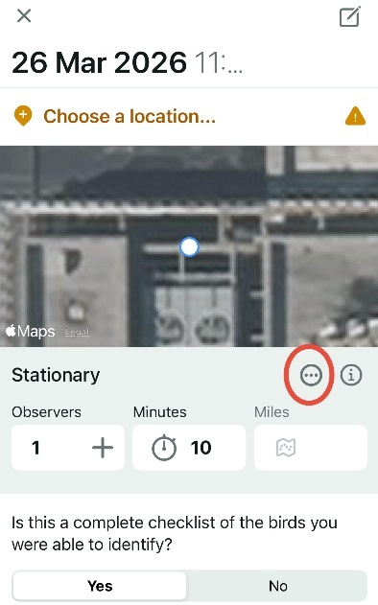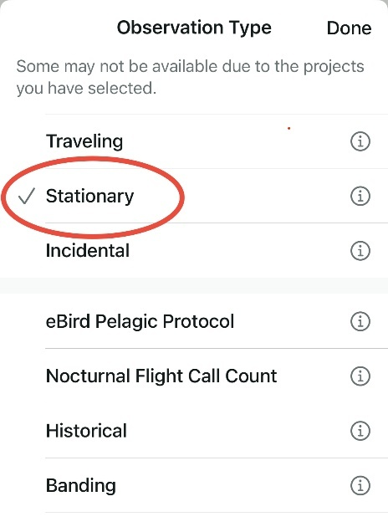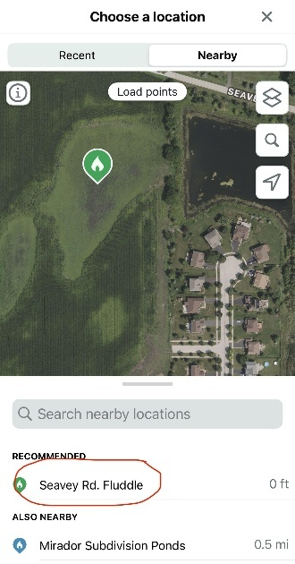
Select the nearby “Illinois Shorebird Survey” hotspot (green) or an auto-generated location (orange)
Then, select stationary under observation type
To select a stationary location, click the circled button (three dots)

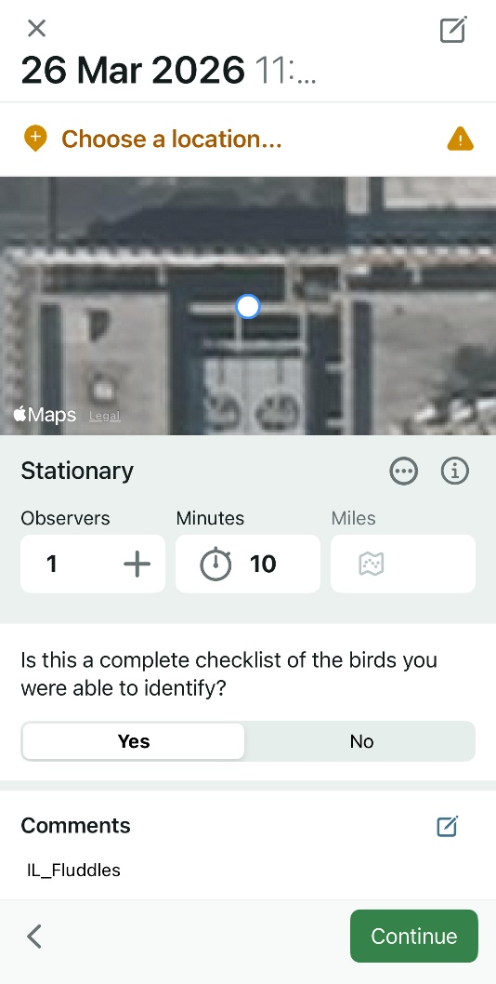
- In the checklist comments, type FluddlesIL. This is important as it is the identifying phrase we will use to filter these survey checklists during data analysis. See image to right for example.
- You can also share the checklist with the project’s eBird account! The username is FluddlesIL. Make sure the number of observers accurately reflects the number of people when sharing.

Thank you for participating in the Fluddle Shorebird Surveys. Your efforts will help advance science and further conservation.

Background Information
Since the early 1800s, Illinois has lost approximately 85% of its wetlands, part of a broader trend of wetland loss both across the US and globally. In addition to habitat loss, remaining wetland habitat is often degraded through agricultural drainage, providing poorer foraging opportunities for migratory waterbirds. For shorebirds, these problems are amplified by the relative rarity of their preferred wetland type in the state: mudflats and shallow wetlands. Only 4 to 6% of all wetland areas in Illinois are estimated to be mudflats.
Given rarity of shorebird habitat in Illinois, our project proposes to investigate a new method of shorebird habitat management – creating shallow seasonal wetlands for migratory shorebirds by partially flooding agricultural fields. Specifically, we aim to create wetlands to provide habitat for small shorebirds, with a focus on the genera Calidris (sandpipers), Tringa (yellowlegs), and Limnodromus (dowitchers). We plan to install water control structures to restrict water drainage and allow portions of agricultural fields to flood. Water levels at each site will be managed to maintain shallow water levels ideal for migratory shorebirds. Sites will be monitored to evaluate shorebird use during migration. We will also assess soil invertebrate biomass, vegetation characteristics, pesticide concentrations, and the landscape surrounding each site to quantify food availability and site suitability. This data will be used to develop best practices for creating stopover habitat for migratory shorebirds in the Midwest and study the efficacy of these flooded agricultural fields as stopover habitat. Results of this work can be used by landowners to manage their properties for stopover habitat throughout the heavily modified ecosystems of the Midwest, helping support the conservation of migratory shorebirds.

If you are interested in learning more about the project, feel free to contact Alex Smilor via email (awsmilor@illinois.edu).

