3. Tossing 10 coins

1. Assumed prior distribution

**Program Flow**

1. define variables

* e.g. coin toss outcome = [1,1,0,0,0,0,0,0,0,0,0,0] where 1=head, 0=tail
* assume distribution of prior is [1/11, 1/11, 1/11, 1/11, 1/11, 1/11, 1/11, 1/11, 1/11, 1/11]

1. calculate likelihood according to coin toss outcome
2. calculate marginal probability p(x) according to prior and likelihood
3. calculate posterior by using Bayes Theorem
4. Estimate p using mle & map
5. repeat from (1) but assume distribution of prior is [0.01, 0.01, 0.05, 0.08, 0.15, 0.4, 0.15, 0.08, 0.05, 0.01, 0.01]

**Theory**

$$\frac{p\left(θ\right)p\left(x | θ\right)}{p\left(x\right)}=p\left(θ | x\right) , where p\left(x\right)=\sum_{θ}{p\left(x,θ\right)}=\sum_{θ}{p(θ)p\left(x|θ\right)}$$

$p\left(θ\right): \text{prio}\text{r}$, $p\left(x | θ\right):likelihood , p\left(θ | x\right)\text{: posterio}\text{r}$

**Maximum Likelihood Estimation:** p with the highest likelihood

**Maximum a Posteriori Estimation:** p with the highest posterior

**Outcome**

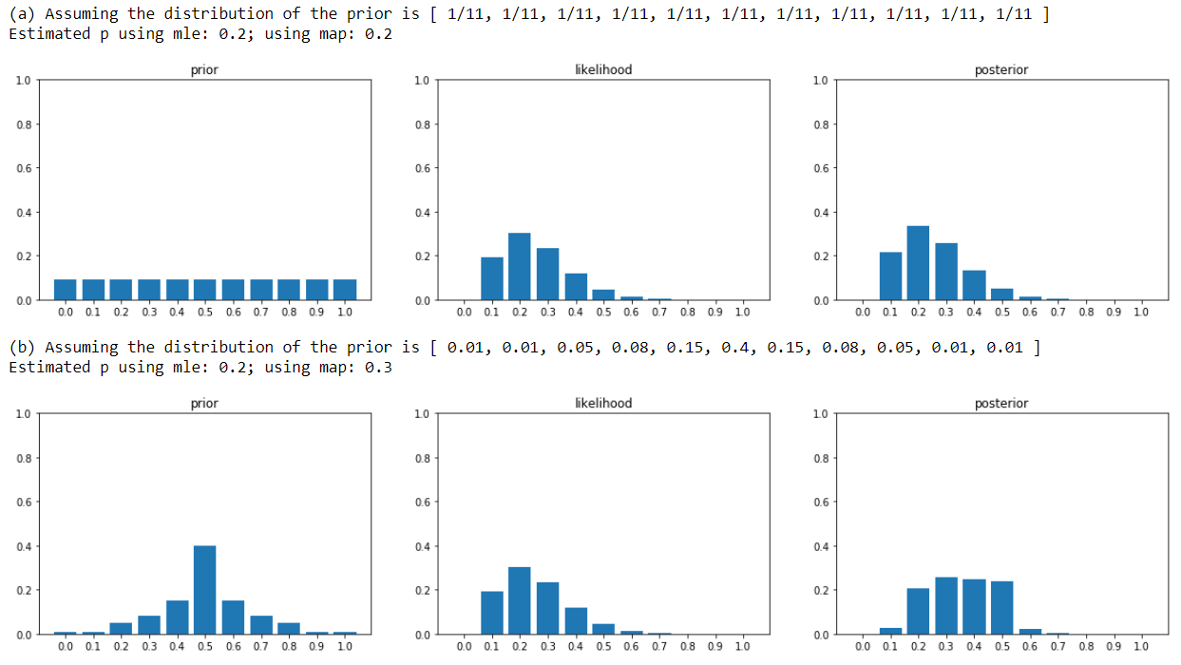

1. Toss 10 coins 50 times

**Program Flow**

1. define variables

* assume distribution of prior is [1/11, 1/11, 1/11, 1/11, 1/11, 1/11, 1/11, 1/11, 1/11, 1/11]

1. toss 10 coins using coin_sim()
2. pick p (assume distribution of p is equally 1/11, not affected by prior)
3. toss coins using p as probability of tossing a head
4. calculate posterior using Bayes Theorem as mentioned above
5. draw graph if iteration is 10 times

* graph is saved to local in png format

1. repeat from (2) using current posterior as new prior for 50 times

**Theory**

Observation $x$

Likelihood

Prior

Posterior $p\left(θ | x\right)$

For every iteration (coin toss), the posterior will become the prior for the next iteration.

**Outcome**

