“Image Mapping” editor for Common - Freestyle HTML Text pagelet

Editor’s requirements:
All browsers, which support “SVG” elements. They are:
- Internet Explorer 9+;
- Firefox;
- Opera;
- Chrome;
- Safari.
If your browser doesn’t support “SVG” elements, you’ll get notification window.
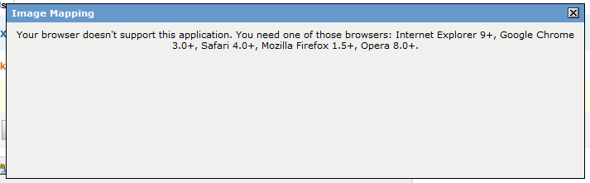

How to use:
- You can run “image mapping” editor, using the button on the TinyMCE toolbar:
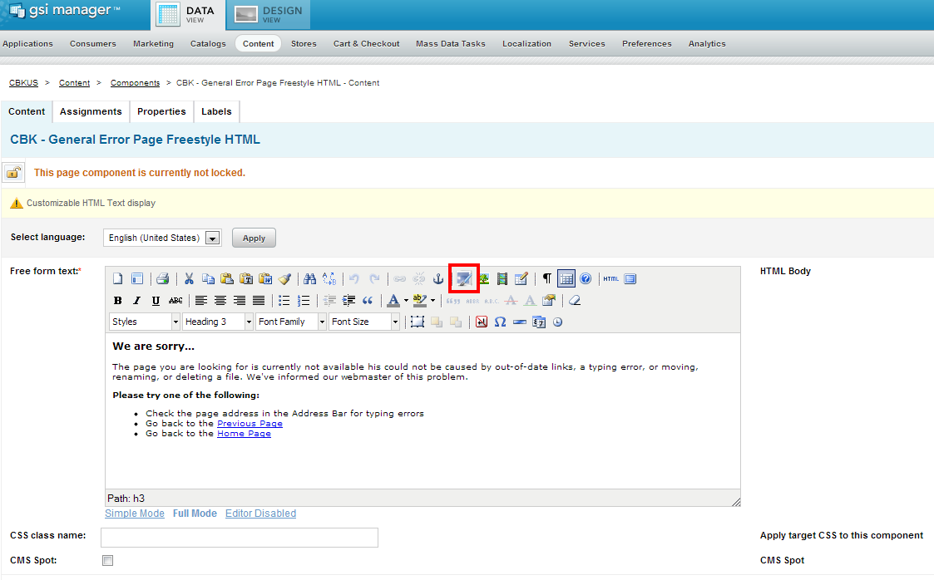
- After that you’ll get the dialog window, where you can type URL from keyboard, or chose your image from BO.
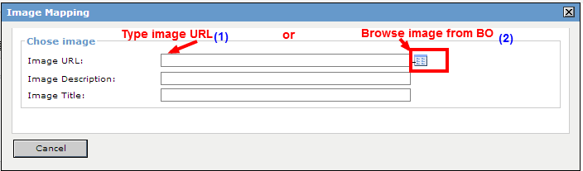

  - If you choose first method, you just need to type image URL and click on blank area. If URL address typed correctly, image will loaded, otherwise you’ll get red border around the URL input.

  - If you choose second method, you’ll get a “Insert Image” dialog, where you can choose your image from catalog.
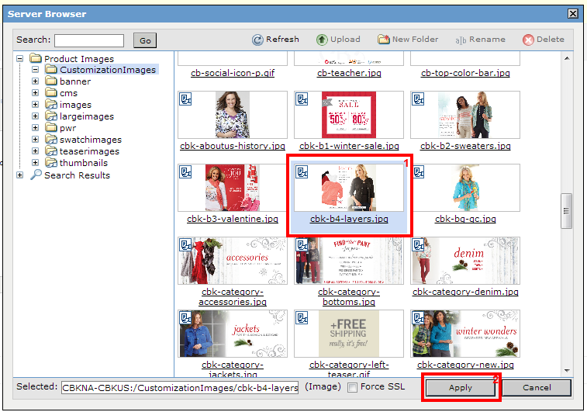

- After that, you’ll get your selected image with instruments for mapping image.

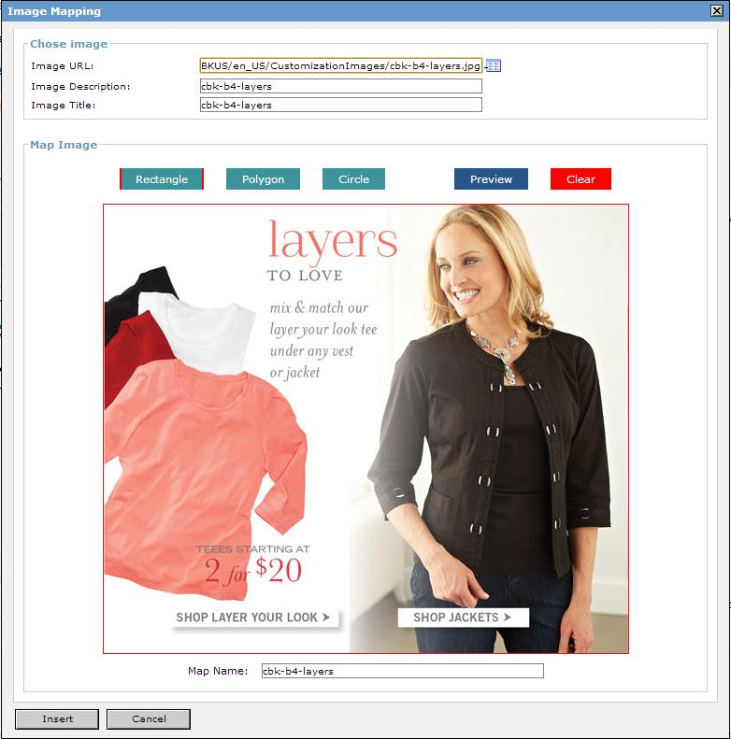

- You can mapping image via Rectangle, Circle and Polygon. Also you can drag marked areas.

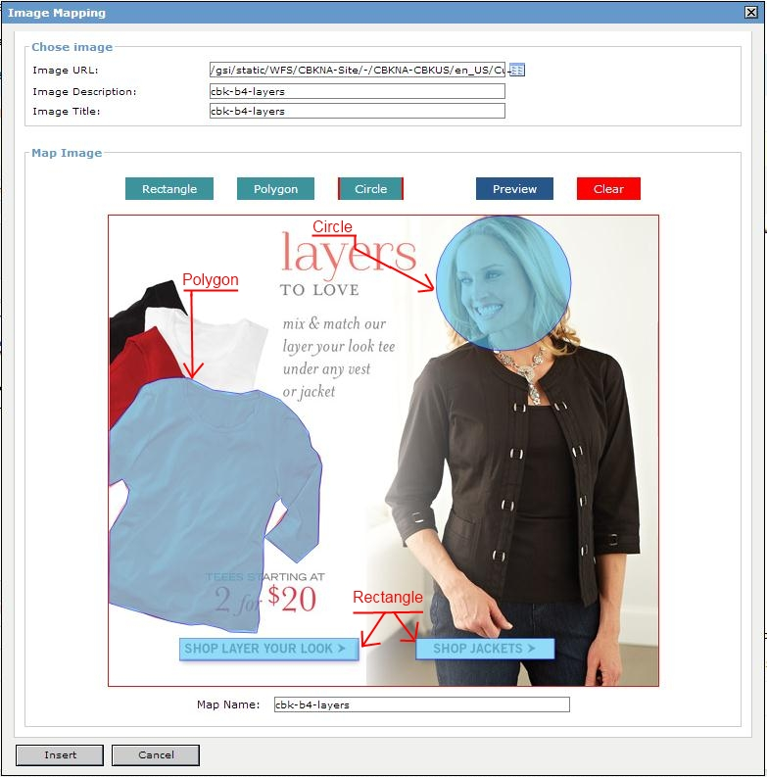

- For set up attributes for marked area, just click twice on element, and you’ll get popup, where you can setup attributes or remove element.
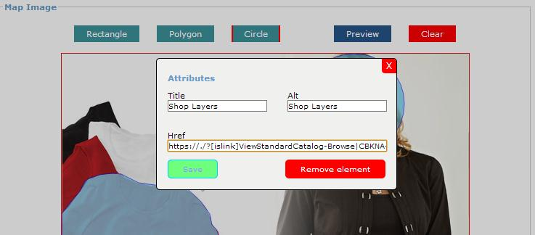
- Also you can preview your marked image using button, and remove all marked areas from this image, using button.
- After you already marked up your image, you can insert it to the document, using “Insert” button. Finished result on the image below:
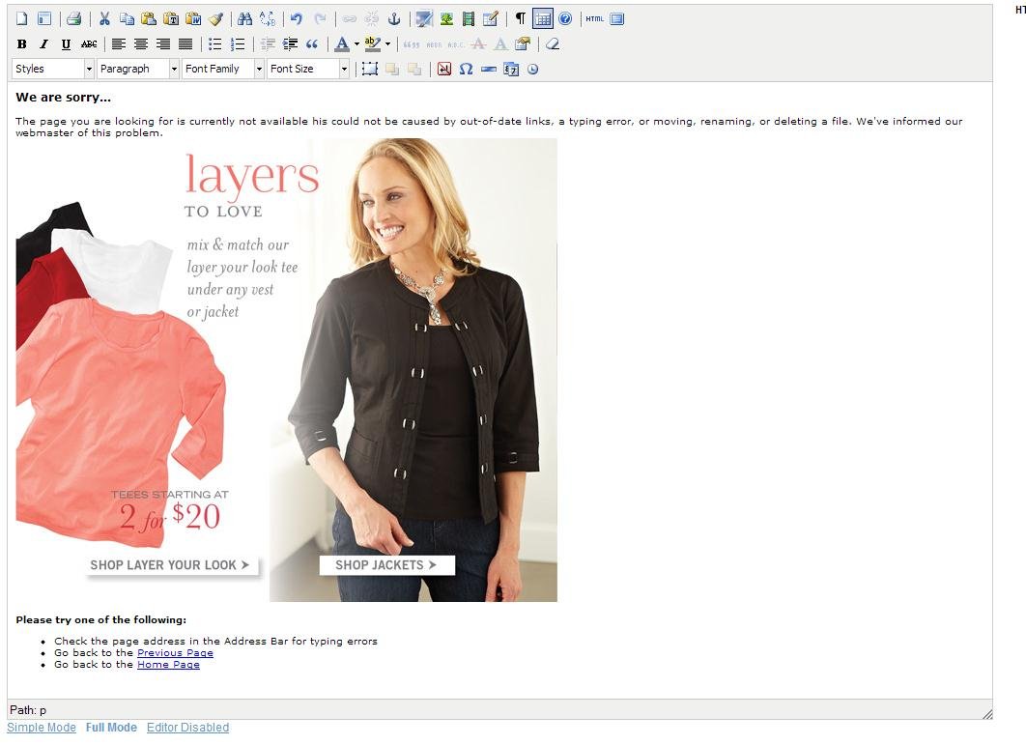

- Also can edit your already marked image by right click on mouse, and choose option "Edit Image mapping".
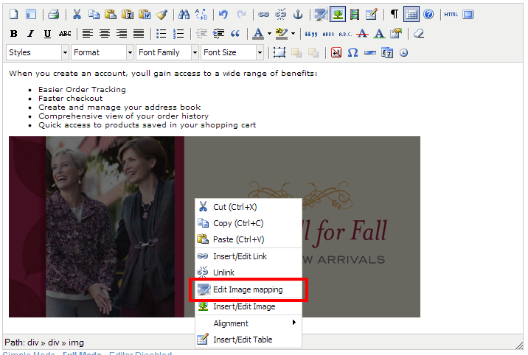

  - After that, you’ll get load selected image with all attributes and marked areas for this image, and you can work with that marked areas(move, remove, change), or add new.
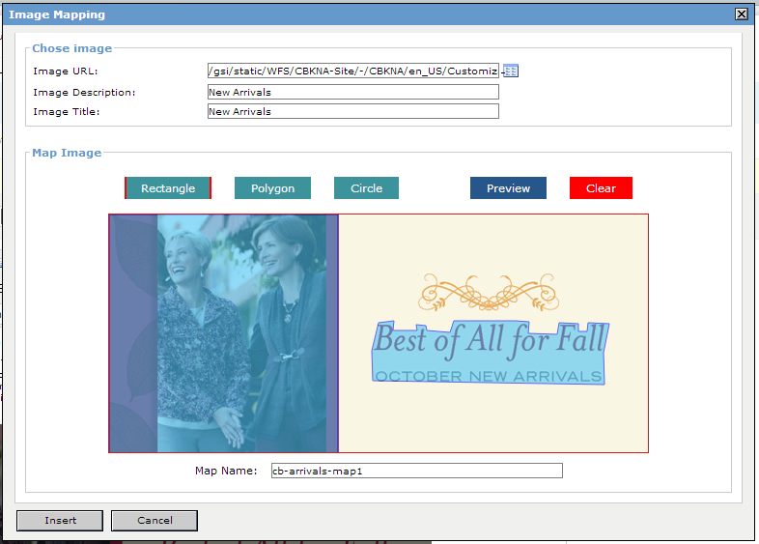
  - To save, click “Insert” button, or cancel changes, by pressing “Cancel” button.

