Ogloblina Alena Dmitrievna 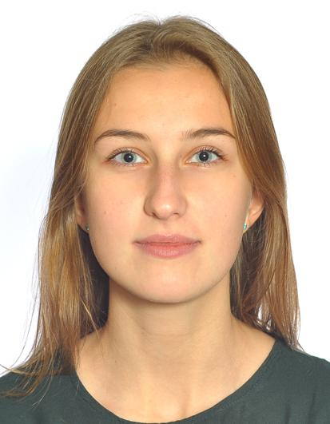

**Junior front-end developer**

St.Petersburg

**Phone, email**

+79605002873, alyona.ogloblina@mail.ru

**Education**

2016 – present time: student of SPbU, faculty of applied mathematics and control processes

**Additional education**

Interface Development: JavaScript (Coursera.org)

**Professional skills**

* JavaScript/HTML/CSS, Java
* jQuery, Express, React
* node.js, ngrok, Microsoft Azure
* Mocha, CHAI
* GIT
* SQL, JDBC, MongoDB, MySQL, PostgreSql
* IDE: Visual Studio Code, WebStorm, IDEA

**Languages**

English – Upper-Intermediate

**Experience**

I have experience in website development, working with DB, testing. Also, I have teamwork skills.

**Personal qualities**

* Always push the matter through
* Self-Starter
* Thorough
* Industrious
* Creative

**Goal**

I would like to apply for an internship in your company to develop global projects.