 TEAM MERCURY

Vocational school of computer programming and innovations

Contents

1. Members 2

2. Purpose of the project 3

3. Diagram 3

4. Most Important Functions 3

5. Realization 4

6. Conclusion 4

# Members

1. **Scrum master:** Alexander Yanev / [AZYanev18@codingburgas.bg](mailto:AZYanev18@codingburgas.bg)
2. **Frontend developer:** Stefan Stratev / [sdstratev18@codingburgas.bg](mailto:sdstratev18@codingburgas.bg)
3. **Backend developer:** Teodor Angelov / [ttangelov18@codingburgas.bg](mailto:ttangelov18@codingburgas.bg)
4. **QA Engineer:** Yavor Karakolev / [YAKarakolev18@codingburgas.bg](mailto:YAKarakolev18@codingburgas.bg)
5. **Documentation:** Nevena Pavlova / [NSPavlova18@codingburgas.bg](mailto:NSPavlova18@codingburgas.bg)
6. **Code checker:** Kaloyan Dimov / [KDDimov18@codingburgas.bg](mailto:KDDimov18@codingburgas.bg)

# Purpose of the project

The purpose is to make a software which will help the code breakers to decode the coordinates of the German battleships so that the allies will be able to track them and destroy them. Using the project the user strengthens his logical and strategic thinking.

# Diagram

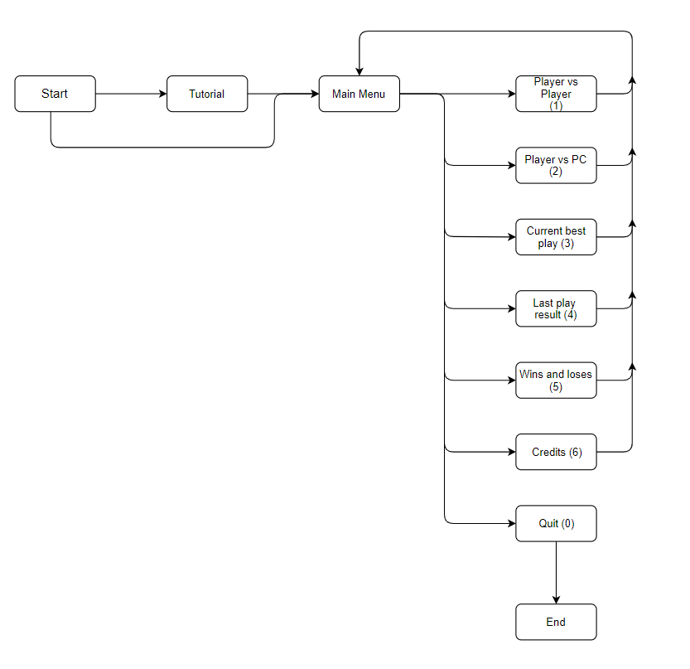

# 

# Most Important Functions

|  |  |  |  |
| --- | --- | --- | --- |
| Function Name | Variables | Returns | Purpose |
| int guess() | Int* battleship | Int tries | The player makes guesses to try and take down the ship |
| void tutorial() | none | nothing | Gives a tutorial on the game |
| void exit() | none | nothing | Desplays message after exiting the game |
| int* bsCoord() | Int* battleship | Int* battleship | User Inputted battleship coordinates |

# Realization

The first part in the realization of this project was a plan for action in which we had a little discussion concerning what to do and then we continued. The second and most important part was executing it so we all separated and started doing different sections of the project. We used various technologies and applications for the implementation of our project. For the hard coding, we used “Visual Studio” and we were writing on C++ as our programing language. For the sharing of our progress we used “GitHub”. We mostly used “Discord", for chatting and doing online meetings in which we discussed our progress and what to do next. For the documentation we used “Word”. And for the presentation we used “PowerPoint”. Using these platforms in-depth really helped us and showed us how many options and valuable things are specifically aimed at getting the job done easier.

# Conclusion

In conclusion, the project really helped us grow. At first it was annoying and pressuring but as time passed, we got used to working on it. We saw how this “project” became something of a daily routine in the past three or four weeks. There is no doubt that this project was completed with a lot of effort, time and organization. This is the second project for this year and as work is considered, the 3 most important things we learned throughout the whole experience were that:

• We got better at collaborating with our teammates.

• We learned how to work with a variety of platforms.

• And we learned how to organize our time (to some extent).