**Exercise 3 Report:** Applying color maps

# Goal

Apply different colormaps for your visualization from Exercise #2. Rectify any color deficiencies encountered by changing colormap.

# Line chart of yearly trending for country comparison

As the line chart tries to illustrate the trending for each country, it’s categorical data and thus qualitative colormap can be used.

Color problems identified:

1. In non-continuous small region, up to 12 bins of color can be distinguished in the human view, so we should limit the country number in this chart to be 12.
2. Hue channel interacts with the size channel which makes it hard to distinguish colors of lines (Figure 1.1), even worse for the case of color blindness (Figure1.2).
3. For red blindness, blue(Norway) and Purple(Germany) are not quite distinguishable, same problem for red(Austria) and brown(Finland), as Figure 1.2

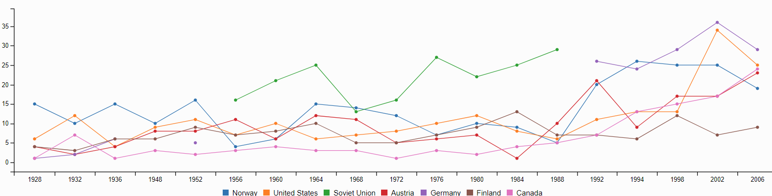

Figure 1.1: Original line chart

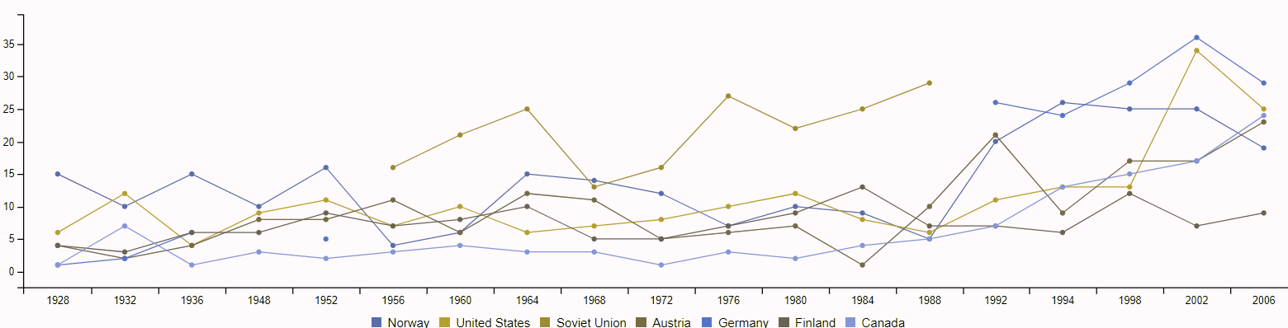

Figure 1.2: Original line chart in red blindness

Fixed color deficiency:

1. Increased line width, and a colormap from colorbrewer2 was selected with some tuning to avoid 3 color blindness, as shown in Figure1.4, Green/blue blindness were also verified.
2. Fully saturated colors are preferred as the lines are non-continuous small regions.
3. Both Hue and Luminance channels are used for this colormap as Hue channel alone won’t be able to distinguish more than 5 classes without deficiency.

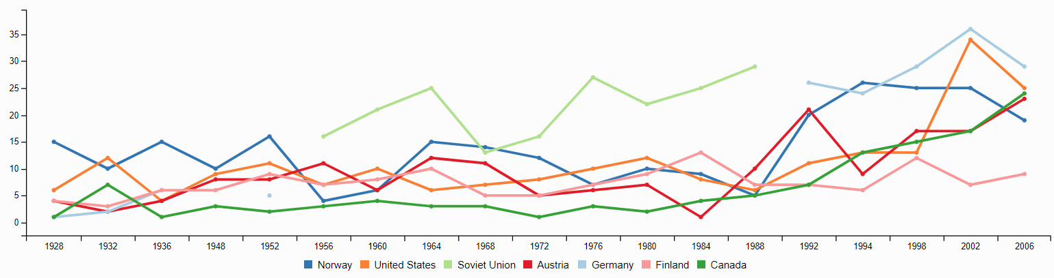

Figure 1.3: Colormap with deficiency fixed

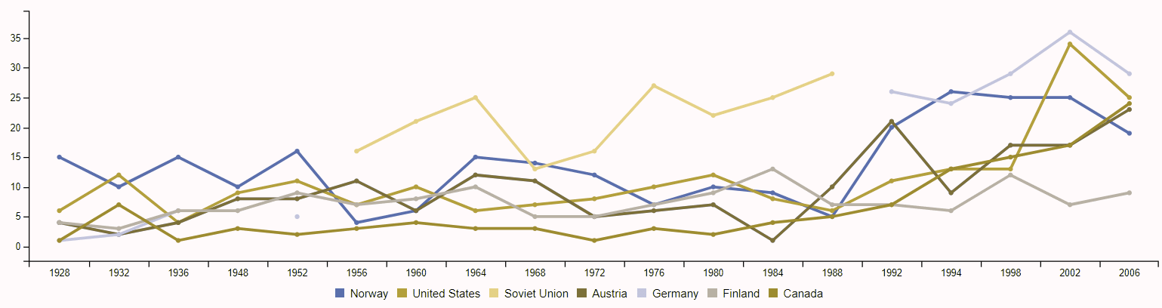

Figure 1.4: red blindness view of Figure 1.3.

# Stacked bar chart for sports per country

This bar chart is also for categorical data which requires qualitative colormap.

Color deficiency identified and fixed.

1. Original colormap has issue in red blindness, as shown in Figure 2.1 right part. It’s fixed in Figure 2.2.
2. Luminance channel was tried for ordering between countries per each sport as Figure 2.3. But it doesn’t receive significant improvement as luminance is weak channel and typically less than 5 steps can be discriminable. And it also interacts with the original colormap which made it even worse.

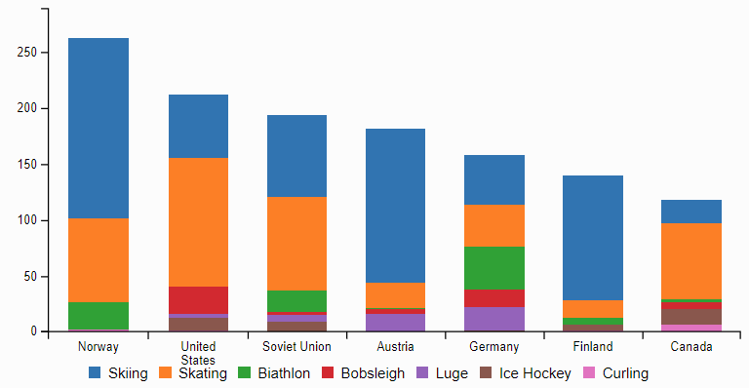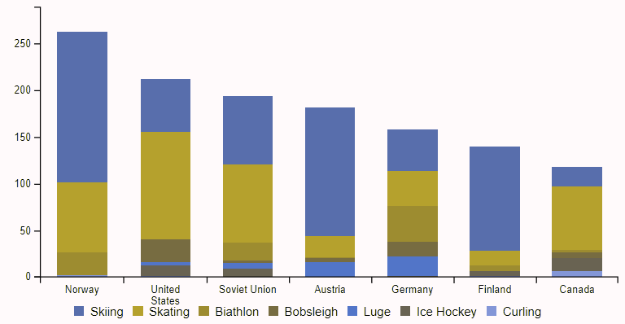

Figure 2.1: original bar chart and red blindness view

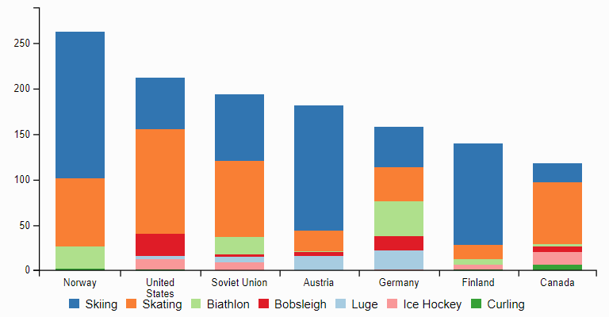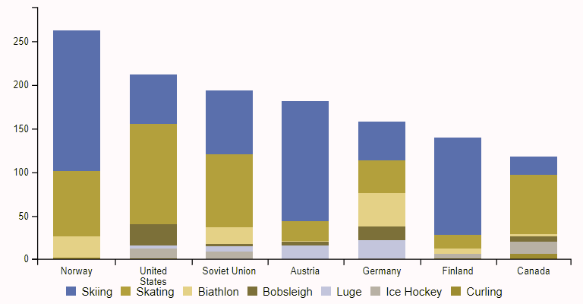

Figure 2.2: Fixed color blindness problem in Figure 2.1

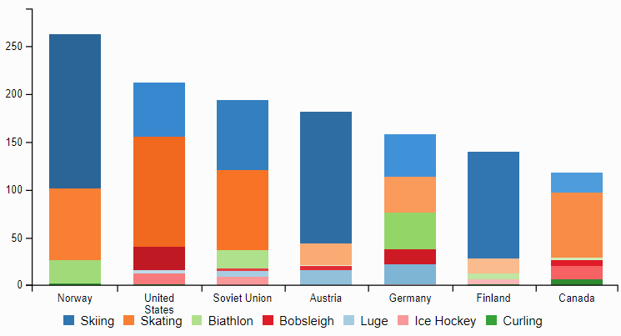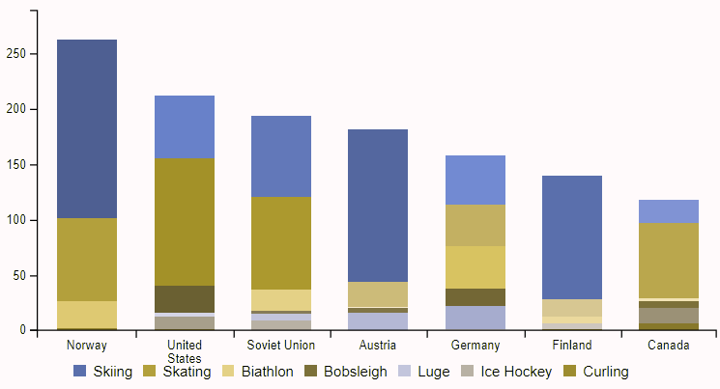

Figure 2.3: Experiment with luminance channel for ordering in each sport

# Stacked bar chart for medals per country

This is still categorical data visualization with qualitative colormap.

1. The colormap of medal’s native color is used for better intuition as comparison in Figure 3.1
2. This colormap works extremely well with color blindness, as they almost still represent gold/silver/bronze.
3. Luminance may be applied since this has only 3 categories, as Figure 3.2. But it doesn’t work for more country number greater than 5.

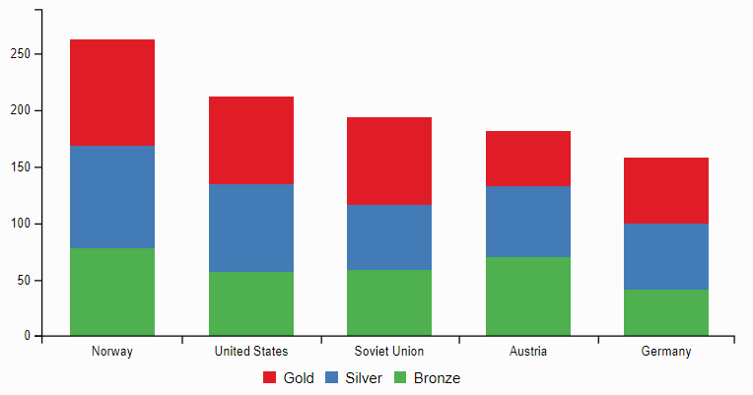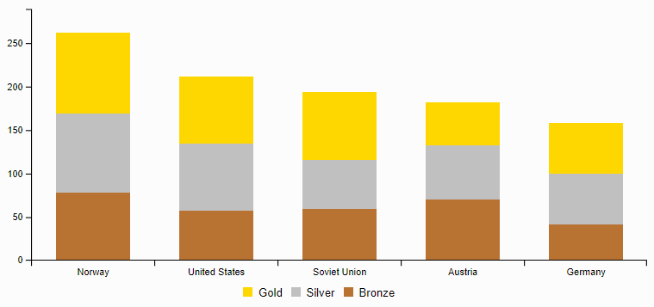

Figure 3.1: Left – Original vs Right – colormap of medal native color

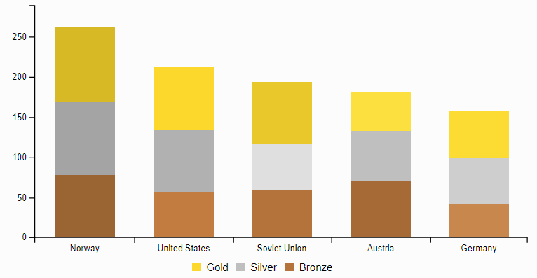

Figure 3.2: Luminance added for ordering per medal type