**Exercise 5 Report:** Visualize a Network

# Motivation

The dataset under study record of wins and losses of 28 female bighorn sheep on the National Bison Range in 1984. A visualization of network is created to discover the relation between fights and age of the sheep. How do these sheep in different ages perform regarding to the total number of fights, wins and the margin(dominance) of the wins or losses?

# Visualization

The circular network is used to layout all the sheep as nodes, and edges represent the dominance of the sheep. Both nodes and edges have various visualization encoding for various information.

**Augmented data**

From the original data, we calculated the total wins, losses, score(wins-losses), and weighted score(total dominance in wins – total dominance in losses) for each sheep.

**Expressiveness & Effectiveness**

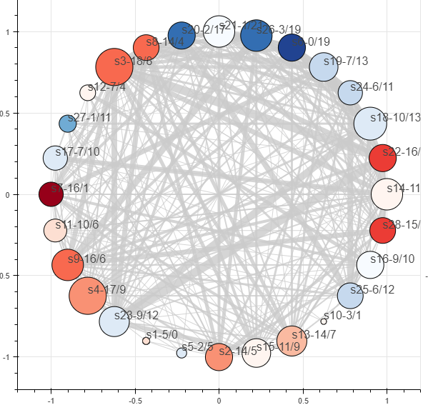

Figure 1: Circular Network – nodes of sheep and edges of dominance

1. The sheep nodes are ordered by age from youngest to oldest and laid out on circular network counter clock wise starting from 3 o’clock. The strongest channel ‘position’ is used for age as the main goal to discover the statistical significance related to age.
2. The node size is used for the total fights the sheep involved. We care more about sheep with more fights which is the basis to draw any significance, as channel ‘size’ is more effective than ‘color’.
3. The node color hue indicates whether the sheep has more wins (in red) or more losses (in blue), which is categorical information.
4. The node color saturation indicates the score of total wins minus total losses.
5. A linked view of 2 graphs shows wins and losses side by side. Selected nodes will have their wins shown on left and losses shown on right, as in figure 2.
6. The edges indicate the fights between linked sheep.
7. The edge width indicates the dominance number in the fight.

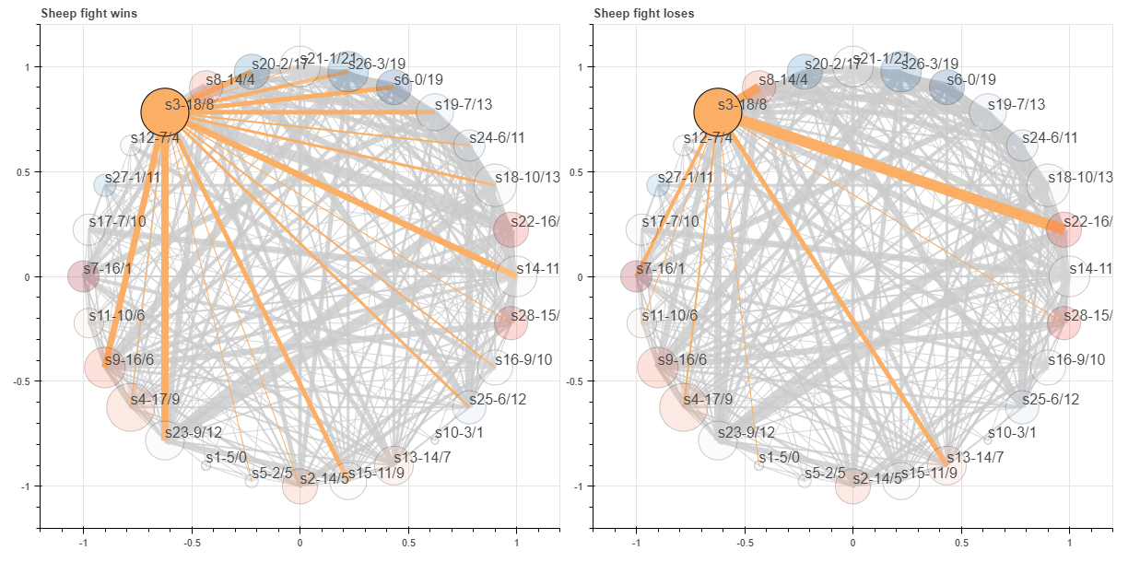

Figure 2: linked view for selected nodes, Left – dominance of wins, Right – dominance of losses

**Interaction**

1. Hover tooltip is added for nodes to show more detailed statistics information.
2. A range slider is added to filter the edges with dominance in certain range, as in figure 3.
3. A tool bar of ‘pan, wheel_zoom, box_select, lasso_select’ is added for user moving, zooming and selection on the graph.
4. Hover tooltip on nodes will show more detailed statistics for each sheep.

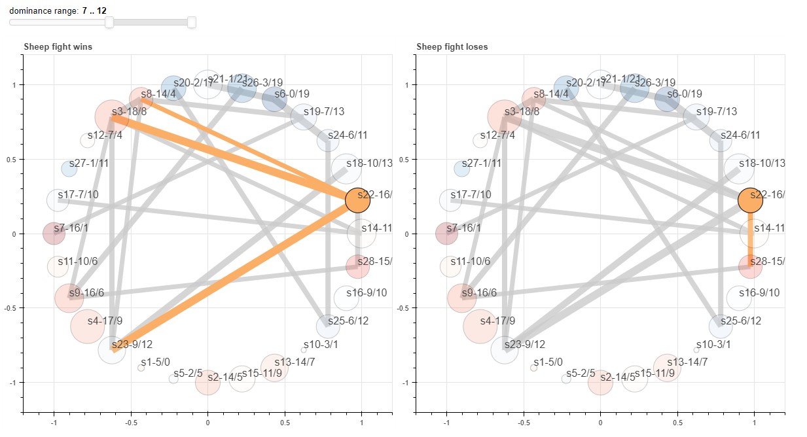

Figure 3: Filtered edges by dominance range.

Highlighted edges are from the selected node, grey edges are from others.

# Findings

1. The fight count doesn’t seem to correlate much to age. There’s no significance that sheep in certain age range like to fight more than others.
2. Sheep from age 1 to 3, especially at age 3 have more losses than wins. Sheep in other ages don’t seem to have strong relation with win-loss ratio.
3. Older sheep with age above 7 have much less dominance count during fight (figure 3). No significance found in other ages regarding to dominance count which is more related to particular sheep.