**Exercise 8 Report:** Geospatial and Temporal Visualization

# Motivation

The visualization explored the incidents of West Nile Virus across geography (California counties) and time (2006-2015) and tried to find clue of how the virus spread over time. Specifically, we tried to identify any origin and hotspot where the virus was spread from consistently.

# Tasks

1. Find potential origin counties that the virus reported in early time.
2. Find the potential hotspot that county had many positive cases and were reported most frequently.
3. Inference the potential county that was not well controlled to spread the virus.

# Visualization

As in figue 1, the geospatial visualization was done through a map on left and linked view of statistics on right. And temporal visualization was done through a play control that allows showing the status at specific time and animation of the time series.

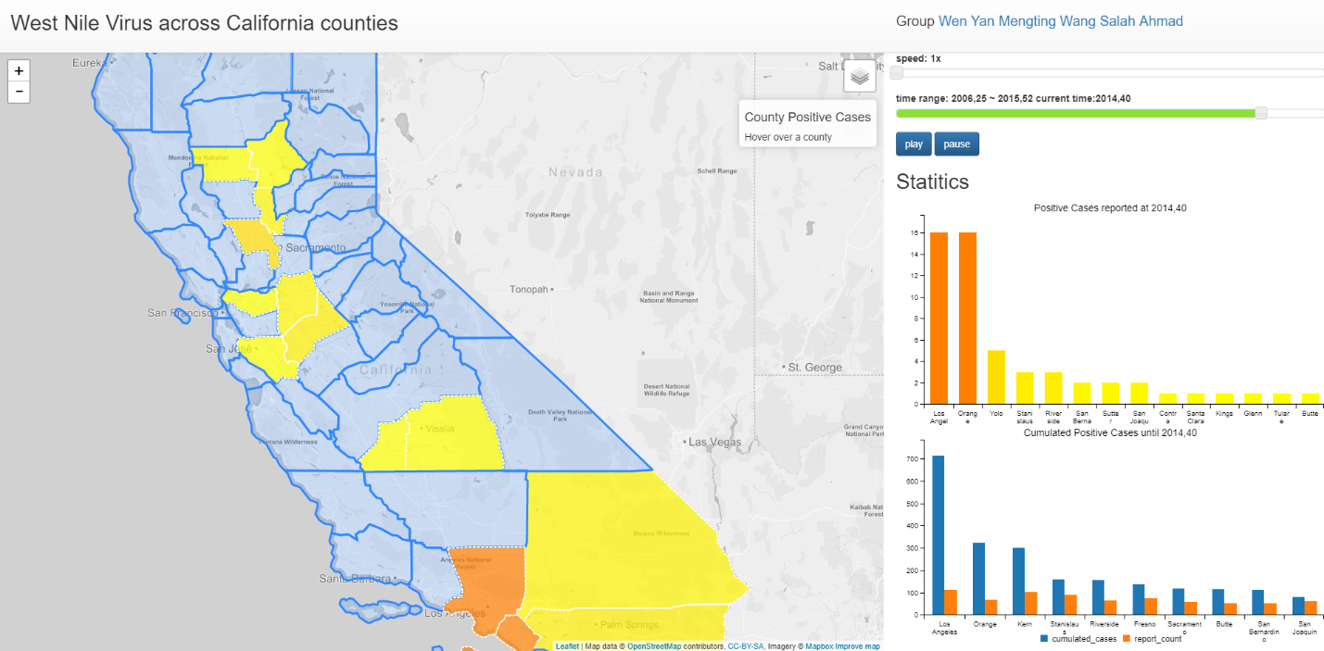

Figure 1: Geospatial visualization layout and temporal play control

**Extra data**

The geojson of boundaries of California counties was downloaded from web. The data uses type ‘FeatureCollection’, but doesn’t follow strictly with GeoJSON format and got fixed in our javascript code.

**Expressiveness & Effectiveness**

1. The map was plotted with focus on California with a bounding box. The map is equipped with base layer control as well as zooming and panning.
2. The county boundary was plotted on the map to show the geospatial information and had linked an information box on top right of the map.
3. The fill color of counties indicates whether they had positive cases with warm color, while non positive counties were shown in light blue. A sequential colormap (from yellow to red) was used to indicate number of positive cases.
4. The barchart on upper right used same colormap to show positive case number of each county at specific time. So both length and color channels are used for visual encoding of the positive case number. And the bars are plotted in descending order of the values.
5. The barchart on lower right showed both cumulated positive number and total report count from time beginning until current specific time on slider.

**Interaction**

1. Hover tooltip is added for the counties on the map.
2. The play controls including speed/time slider, play/pause buttons are used to show the plots at specific time and the animation of the time series.
3. Hover tooltip is also added for the barcharts.
4. Linked view is used when user hover on county to highlight the same county on the barcharts.

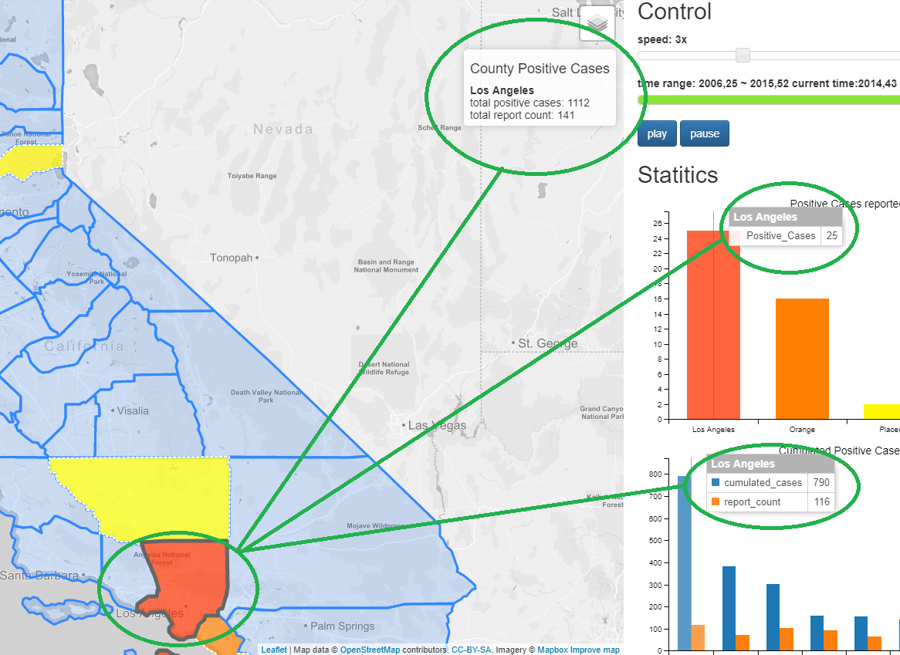

Figure 2: Linked view – hover on map will highlight the according county in barcharts and update info box.

# Findings

1. Butte in the north and Kern in the south were suspected to be the origin counties of this virus breakout, as the two consistently reported positive cases in early time like 2006.
2. Great Los Angels area including counties Los Angels, Orange, Ken, Riverside turned out to be most severe places affected by the virus.
3. It’s hard to inference any spread direction between counties, but generally the north counties had outstanding numbers in early time and south counties caught up in later stage.