### Alexandra Yavnilovitch

# Assignments — Week 02 | Design | Think-aloud + Ideation

In this assignment, you will practice the "empathy" method that will give you the most bang for the buck in terms of understanding user needs, preferences, and behavior. The think-aloud protocol involves (1) identifying users who represent your target group of users, (2) identifying/developing tasks that represent the functioning of the target system, (3) observing users as they perform the tasks, (4) analyzing your data to develop design insight, and (5) ideating design solutions that are informed by the insight you developed from your data. Imagine that you are given the task of redesigning UW–Madison's course search and enrollment system and follow the process below to perform a think-aloud and ideate for solutions.

### Think-aloud

**Step 1. Identify users.** Who are the users of the UW–Madison course search and enrollment system? Describe below the characteristics of this user group, identify one person who might be willing to take part in your user research, and ask the person for their interest/availability. (If the person you identified is in this class, it is acceptable to swap roles.)

The users of the UW-Madison course search and enrollment system are current and prospective students at the university. A typical user would need to use the system in order to search for courses of interests, filter courses by specific requirements and/or categories, and plan a potential schedule. I asked a student in the Communication Arts department to help me with this study.

**Step 2. Identify tasks.** Study the course search and enrollment system and make a list of the main tasks that users of the system might be performing using the system. Rank your list in terms of importance (simultaneously considering impact, frequency, prevalence) and identify the top three tasks. Describe each task in 1–2 sentences in a way that your users can understand.

* Search for a specific course by its department and course number (ex. CS 639)
* Find a course to fulfill a specific requirement (Ethnic studies)
* Search for a course by the professor’s name
* Run and prepare a DARs report to print
* Prepare a course plan for the following semester, and run a DARs ‘what if’ report

Top Three Tasks:

1. **Search for a specific course number**

The user is given a specific course abbreviation (CS 639), and is asked to find the course, and identify the following information: course title, professor, days, time, description.

1. **Find a course to fulfill a specific requirement**

The user is asked to filter and search the system for a course that fulfills the UW Madison Ethnic Studies requirement.

1. **Prepare a course plan, and run a DARS ‘what if’ report**

The user is first tasked with planning their Spring 2020 semester, using the ‘Degree Planner’. Then the user must run a ‘what if’ DARS report, which includes the planned semester. Finally, the user will view and assess the resulting report.

**Step 3. Perform think-aloud.** Hold a think-aloud session with your representative user. First describe to your user how the think-aloud will work (refer to the reading and class notes), describe the tasks one at a time (answer any questions you might have), and ask them to perform each task while they say out loud what they are thinking.

**Pro tip:** If you see your user performing the task but not speaking, probe them by asking what they are thinking or reminding them that they should be describing.

As you observe your user performing the tasks, take notes (using the other sheet) of important actions, problems they encounter, confusions they might voice, and so on. For anything that stands out, after each task, ask your user why they did that or said that. Your observations and notes will form your data. Include your data below.

Task 1 Data

* The user noticed that there is a default value for “Term” – the current session. However, that can create problems, if the student wants to do future course planning, and the course is not offered in the current term.
* Once the user found the course information, she said the way to find the professor’s name was not intuitive. The ‘See Sections’ button is not immediately visible. The user said it would be better if the professor information was available on the same page as the course title and description.

Task 2 Data

* When trying to find a subcategory of courses “Ethnic Studies”, the student did not immediately guess the correct dropdown (“General Education”). Since it is a common requirement, it could be more accessible to users.
* When filtering using the “Ethnic Studies” category, there are too many results to scroll through. The user pointed out that it would be helpful if there was a list of subjects to choose from, after the filter is applied. (Example: Filter by “Ethnic Studies” -> Select from English, Philosophy, Sociology, Psychology -> View reduced result list.)
* The user pointed out that even though the “Subject” dropdown allows for an “All” option, it still outputs an error when no value is selected (only after user scrolls through dropdown options). The user suggested that instead of leaving the “Subject” blank (“none”), the dropdown value should default to ‘All’, when no value is selected.

Task 3 Data

* The user noticed that the “Degree Planner” and “Degree Audit (DARS)” tabs are adjacent, and they both begin with “Degree”, which may be confusing to new users.
* When in the “Degree Planner” tab, the user said that the course search functionality does not include the same filter options as the “Search” tab. She had to switch repeatedly between the “Degree Planner” and the “Search” tabs.
* The user thought that there should be a clear indication that a course was added to a certain plan (after pressing “Add to Plan”
* The user encountered a problem when search for courses to add to her plan: The “Term” defaulted to “Fall 2019”, which limited her to course options in the current semester. She was unable to find a specific course, and realized the issue.
* When trying to run a “what-if” DARS report, the user found the “Plan or program” dropdown inconvenient. The user is unable to type in a search window, and is limited to searching by first letter only.
* In the Audit settings, the user thought that instead of 4 radio button options (which have lengthy descriptions), the window could contain checkboxes (current, planned courses).

**Step 4. Create insight.** In your data (e.g., notes), highlight where you saw significant breakdowns in functioning, need for better functioning, or user preferences that would require an alternative design. Make a list of your findings as design recommendations.

I found the following criticisms to be the most significant breakdowns in functioning:

1. **The search functionality is insufficient for “Add Course” in the “Degree Planner” tab**

It would be helpful for the Degree Planner to include the search function, with all the same filtration options as the “Search” tab.

1. **The “Term” dropdown defaults to the current term (Fall 2019)**

This category should instead require the user to manually select an option – contain “Choose Option” as one of the choices.

1. **The “Plan or program” section in the “what-if report” settings does not allow to search words**

This section should allow the user to enter a string of words, and find the matching programs.

1. **The radio buttons in the DARS settings have long descriptions**

The options in the DARS menu (past, current, planned terms) should be listed as checkboxes, instead of radio buttons.

Ideation

**Step 5. Ideate.** In this step, hold a brief ideation session individually. First focus on generating ideas, and then critique these ideas in terms of how well they address the problems you identified in your think-aloud. Include sketches of two of your ideas below. Remember that these should be conceptual designs and not wireframes or illustrations, focusing on the core idea of a design and not on design elements. You can draw on paper, take a photo, and include the photo below; draw on a tablet computer and carry over the image here; or draw using the drawing tools of a word processor. Remember, these should be very simple drawings just to convey the idea.

Sketch for Idea (1)

This idea expands the existing “Degree Planner” search functionality, to include all the same filters and options as the main “Search” tab, to make it easier to plan future courses.

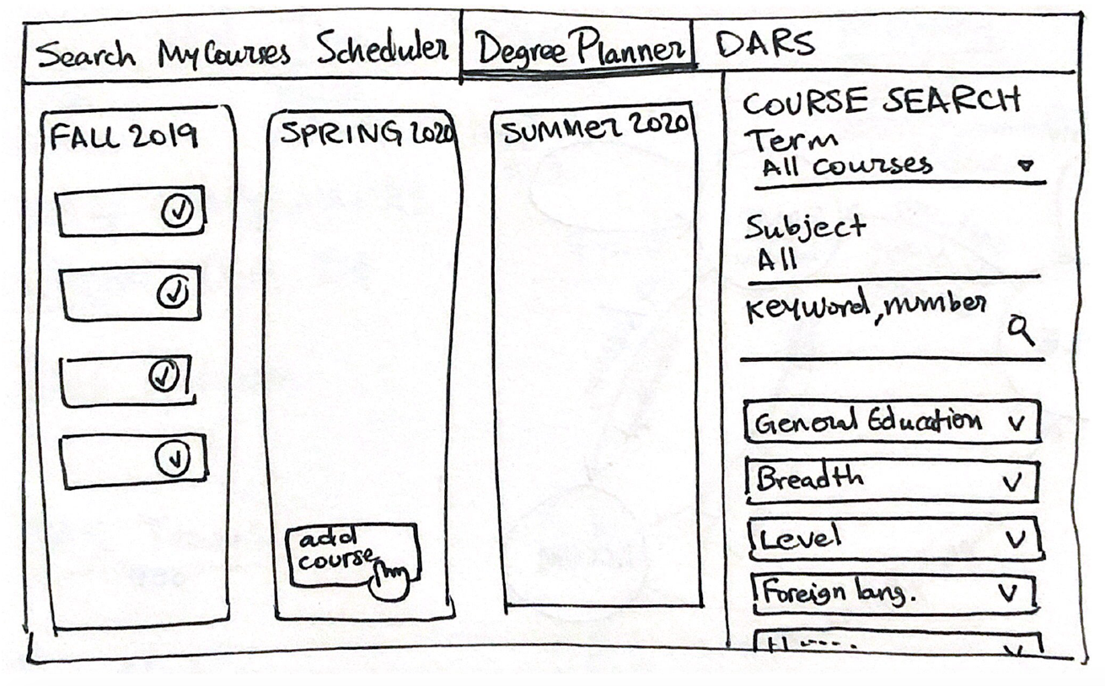

Sketch for Idea (4)

This idea replaces the listed radio buttons in the “What-if” DARS settings, with checkboxes, which are a bit more self-explanatory. I find that this idea is more straightforward, and does not require long descriptions.

