# Alex Yavnilovitch

# Usability Test Plan

*Overview*

The general goal of this usability study is to test the voice shopping assistant for WiscShop. I aimed to design a system that would aid shoppers in navigating, exploring, and shopping on the site. I intend to test the usability of this voice assistant with two friends, and check whether they are able to perform simple tasks on the site.

*Study Design*

1. **Easy to Learn: How intuitive and straightforward is the system for a new site user?**

For the first outcome, I plan to test how a new site user interacts with the voice assistant, and whether it is an ‘easy to learn’ application. In other words, this section would also check whether the voice assistant’s responses are understandable to the user, and are logical in general.

* Scenario:   
  A shopper has discovered the new voice assistant functionality of the site, and wants to user it to browse WiscShop. The user wants to see what kinds of products are available, and how much they cost. This shopper is not looking for any specific product, but wants to get an overview of the website, and find out what it is offering.
* Task:  
  The subject of the study will be asked to explore the WiscShop site, using only the shopping assistant. The subject will be given several general questions about the site, and tasked to answer them using the voice assistant only.

1. **Efficient: Can a user easily accomplish common tasks on the site?**

For the second outcome, the user will be tasked to perform specific tasks using the voice assistant. Unlike the first outcome goal, which tests how the user is able to navigate and learn the site, the second task will require a very specific result. The subject will be given several shopping goals, and will have to accomplish them using the voice assistant.

* Scenario:   
  A shopper is determined to buy a gift for her little brother. She wants to find a toy that is appropriate for his age (4 years old). Furthermore, the shopper knows that her brother loves bucky badger, and would like to narrow down her search. Finally, the user must add the selected gift to cart, and checkout from the site.
* Task:  
  The subject of the study will be given 2 very specific subtasks, (similar to the scenario described above), and asked to perform them as completely as possible. Each subtask will ask the user to locate a specific item, or to inquire about a specific aspect of the site.

Performance Metrics:  
Each of these questions will have a small checklist of “discoveries” attached. The subject of the study will check off items on the checklist as a result of successful interactions with the voice assistant. For example: One item on the checklist could be “Filtered a category by applying 2+ tags”. If the user achieved this item independently, then this goal is checked. The results will then be evaluated based on the number of checked items on the list. In addition to the quantitative measurement, The user will fill out a small survey for each task, evaluating the interaction with the voice assistant.

*Test Procedure*

Overview of the system:

* Provide the subject a brief overview of the study goals, and the general functioning of the voice assistant.
* Study Design: Explain the two sections of the test, their respective outcome goals, and the guidelines of the testing process.

**TASK 1**

Can you navigate through the contents of the site using the voice assistant

* The user was able to login to the site using the voice assistant.
* The user could navigate to different pages (categories) using the voice assistant.
* The user used the “go back” functionality of the voice assistant.
* The user accessed the shopping cart.
* The user was able to enter and view a specific product (without hints).

Can you ask the assistant questions about the site and its contents?

* The user asked the assistant about the types of products that are available of the site.
* The user asked the assistant about his/her cart contents.
* The user asked the assistant about his/her total cart price.
* The user asked the assistant about the tags/filter options.
* The user asked the assistant for information about a specific item.

Can you perform shopping actions on the site?

* The user was able to browse for items of interest.
* The user added at least one item to cart.
* The user navigated between different pages of the site.
* The user accessed the cart.
* The user went through the checkout process.

**TASK 2**

1. You need to buy badger gear for two of your friends, and one of their younger siblings. One of your friends, Patrick, told you he wants a pair of shorts. Your other friend, Jenny, said that she was looking for a red hoodie. Finally, Jenny’s 4 year old brother loves bucky badger. Find the right gifts for them on the site.

* The user navigated to the “pants” category.
* The user applied the “men” tag to the items.
* The user added a pair of male shorts to cart.
* The user navigated to the “sweatshirts” category.
* The user filtered to “women”.
* The user added a women’s sweatshirt to cart.
* The user found a fitting “badger” item for Jenny’s brother.
* The user added the badger item to cart.
* The user reviewed and confirmed the purchase.

1. You need to quickly buy matching T-shirts for your intramural volleyball team. Add enough tees for 10 members. Without navigating to the cart, verify the contents and the price of your purchase. Finally, check out and buy the shirts.

* The user navigated to the Tees page.
* The user viewed the T-shirt that they selected.
* The user added the 10 T-shirts to cart.
* The user asked about the contents of the cart (outside of the cart).
* The user asked about the total cost.
* The user went through the checkout process.

**PARTICIPANT 1: TEST RESULTS**

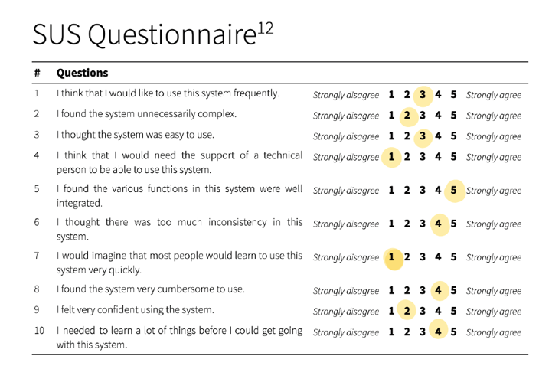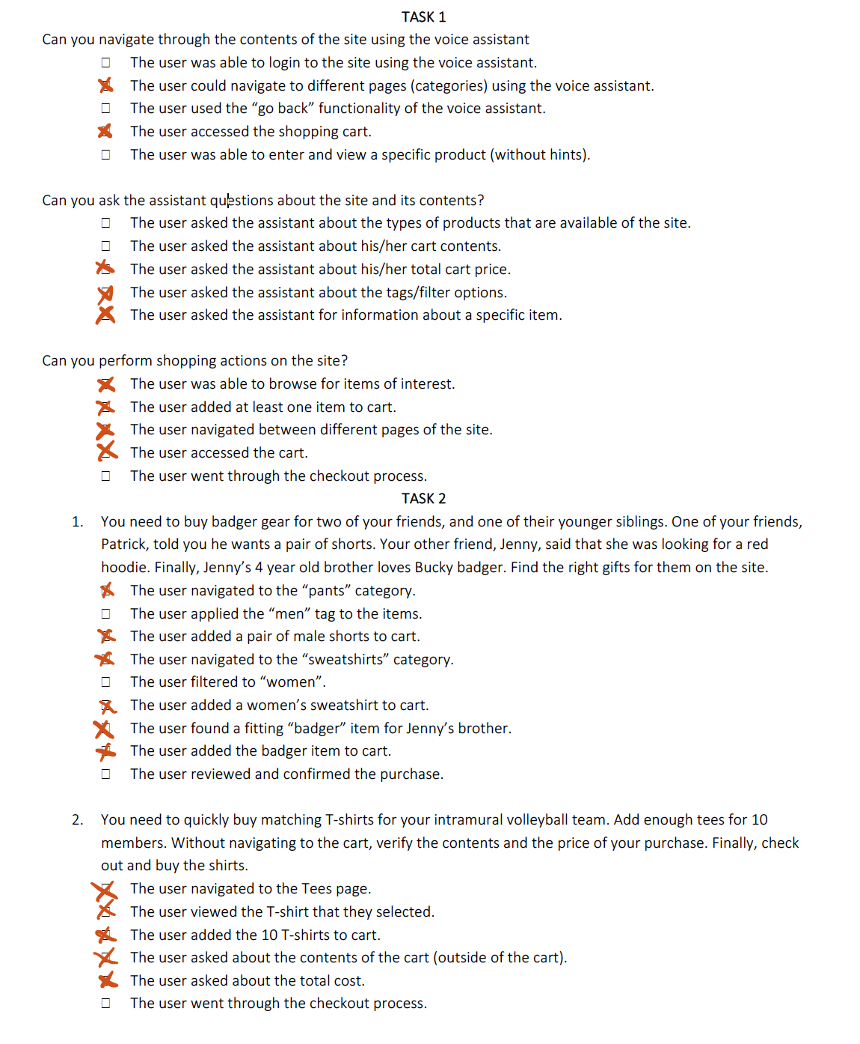

**Observations for Participant 1**

* The way to access a specific item (by index) was not very intuitive – Had to be hinted to use indexing. The first thought was “see details” of an item, or selecting by name.
* The checkout process was confusing – Unclear how to confirm after reviewing the cart.
* At first the user thought she had to go through main menu to navigate. She discovered she can directly go from page to page.
* The user expected to be able to apply several tags at once (not one by one).
* The user asked questions about things that are not integrated in the system at the moment (size, see reviews for an item, color options, etc.)
* Oftentimes, the phrases were confused by the assistant for the wrong function. For example: User – “Can I add this Tshirt?”, Assistant – “Navigating to Tshirt page”.
* Responses not very descriptive. When adding multiple of an item, assistant said “ITEM added” (singular)

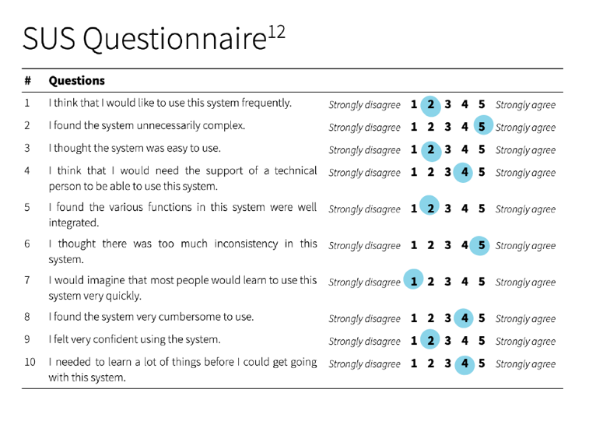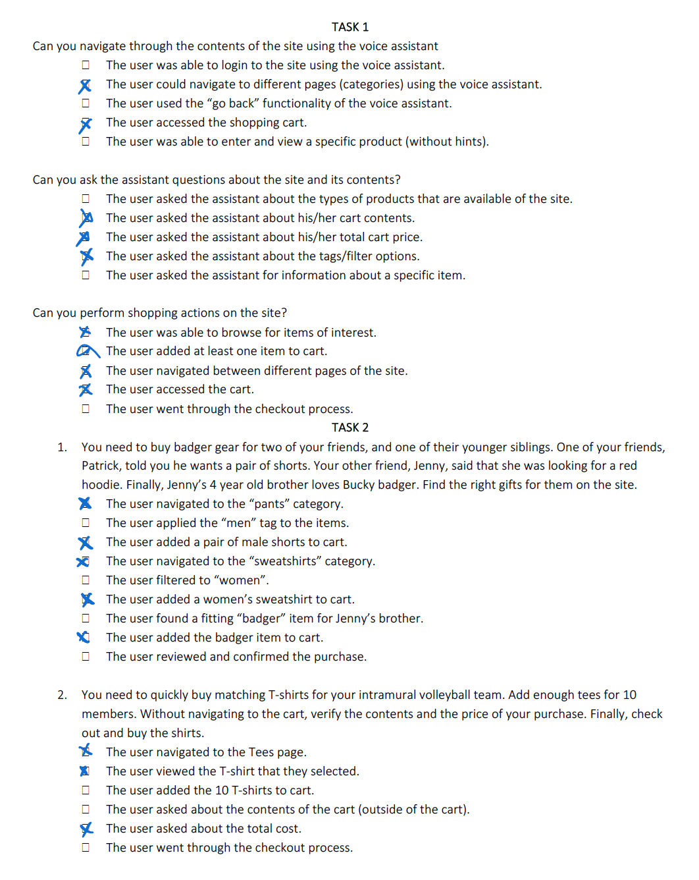**PARTICIPANT 2: TEST RESULTS**

**Observations for participant 2**

* Used phrasing that wasn’t recognized by the assistant.
* Was not aware of the “back” navigation – went to “menu” every time.
* Was unable to access a specific item – had to be told to use indexing
* Tried to ask “Can I view the RED t-shirt”, which did not work for navigation.
* Did not know how to add multiple of an item – thought that had to add them 10 times manually. Had to be told to try and add all at once.
* The user did not immediately know how to apply tags or filter – used phrasing that was not recognized by the agent.

# 

# Usability Findings

*Quantitative Summary*

|  |  |  |  |  |
| --- | --- | --- | --- | --- |
|  | Task 1 | Task 2 | Total Tasks | Total SUS |
| Participant 1 | 60% | 73.3% | 66.6% | 47.5% (F) |
| Participant 2 | 60% | 53.3% | 56.6% | 17.5% (F) |

The quantitative results of the testing range in the 40-60 percentile. During the testing procedure, both participants performed reasonably well on the first task (Ease of use); They were able to act on the primary functionalities of the agent, with several minor exceptions. Both participants were stumbled by the login procedure, as well as the checkout process. The two users tested differently on the second task. However, each of them was able to carry out most of the subtask provided, and got the general flow of the interaction.

According to the SUS evaluation, the current version of the agent deserves an F. It is not very intuitive to new users, and requires the assistance of a “technical” person (the developer). Furthermore, this evaluation answered the outcome questions about ease of use and efficiency. The survey showed that the system is not very easy to use, and in fact, can be quite cumbersome. As for efficiency, the users were able to complete most of task 2, but not entirely smoothly.

*Qualitative Summary*

The two users tested similarly, and even had some of the same concerns regarding the system. It seemed like both participants were able to navigate rather easily around the interface (between pages). However, the users were often unsure of the expected form of request/statement that was expected by the agent. The two primary observations of the study are:

1. The users did not know what phrasing and terminology to use to express a command

Both users often used phrasing that was not recognized or understood by the agent. They had to try various statements before the correct action / response was executed. This points to insufficient training for the agent. I believe that with added training phrases, the agent could more fluently execute requested tasks.

1. The users had difficulty accessing specific products (using indexing)

The participants expected to be able to access specific items by the name or by color. However, the agent is currently designed to access items by index (“Show me the first item on the page”). Thus, the assistant could be improved by recognizing the names of products, or specific tags / descriptions.

*Conclusions*

In conclusion, the agent still requires development in order to be more accessible for new users. The shopping assistant could be improved with additional training phrases for each functionality (navigation, cart actions, checkout process, and viewing products). Furthermore, the agent should be able to access specific products in more intuitive ways than indexing.