# Alexandra Yavnilovitch

# Assignments — Week 04 | Design | Structure, Layout, & Navigation

In this two-part assignment, you will first practice the principles of layout design you learned in class in designing the layout of a product page and then use the principles of effective navigation to determine the appropriate navigation model for an e-commerce site, focusing on the check-out process. Part 1 focuses on visual design, building on the principles we have learned in class on visual design as well as layout design. Part 2 focuses on effective navigation that supports the user’s task and not on visual design. For both parts of the assignment, you will primarily use Adobe XD. If you have not yet explored this tool, the first step in completing this assignment would be to visit the Technology Requirements section of the website and follow the instructions to set up and start using Adobe XD. The first part uses assets that are provided in [this template file](https://drive.google.com/a/wisc.edu/file/d/11Zg9USziob138TDjF32F1DgNSybDKmV7/view?usp=sharing).

### Part 1. **Layout Design**

In this part of the assignment, you will be given a set of essential design elements that must be placed on a product page and will be asked to create an effective layout building on one or more of the principles of layout design (e.g., golden proportion, visual hierarchy, visual scan patterns) using these elements. You are not limited to these elements and can add additional elements that help you achieve your layout design goals. Additionally, you can modify the size, typeface, and color of the provided design elements. To complete the assignment, download the Adobe XD template [linked here](https://drive.google.com/a/wisc.edu/file/d/11Zg9USziob138TDjF32F1DgNSybDKmV7/view?usp=sharing), complete your layout design, capture a screenshot of your design, and include it below. Along with your design, provide a brief justification for your layout design choices, specifically why you chose the principle(s) you followed and how did you use the existing and new design elements in support of the principle(s). In your justification, focus on your layout design choices even if you have made additional design choices, such as changing the color of a button or text element.

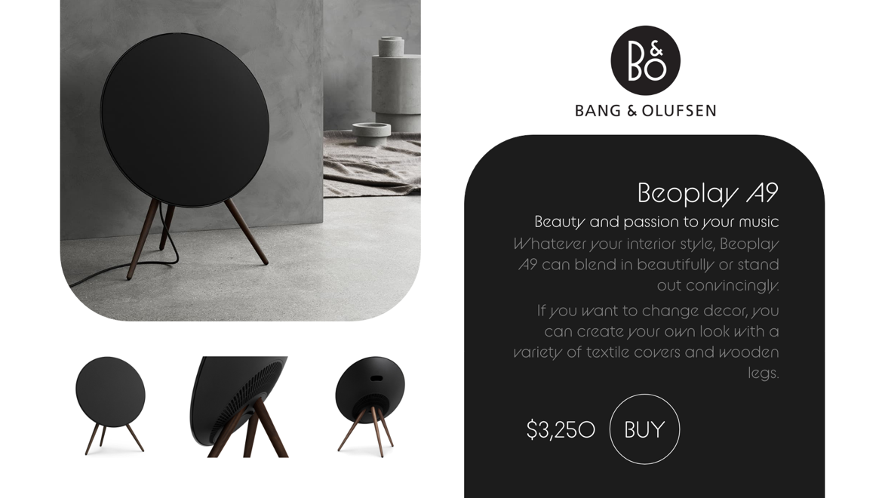

**The border is not part of the design – it is just used to indicate the edges of the artboard

In order to create this layout, I decided to apply several of the design principles discussed in class. I chose to use the Z-pattern to structure the page: the eye is drawn to the company logo, then the large image of the product, then to the description box, and finally to the smaller photographs. This pattern maintains a symmetry and balance on the page.

Additionally, I used color contrast (black and white) to achieve a bold and consistent look. The product resembles a black circle, and the theme is followed throughout the page (the logo, and the ‘BUY’ button).

Finally, I chose a striking white font, on a black background, for the product title, slogan, and price. The description has a muted gray color. This way, the user notices the most important elements of the design first.

### Part 2. **Navigation Design**

In this part of the assignment, you will design the navigation structure of an e-commerce website, specifically a store that sells running supplies (e.g., shoes, apparel, accessories). You will focus on the product checkout process, including the pages listed below and additional pages as necessary for the navigation structure you have devised. In your design, you must use one or more of the navigation models we have discussed in class and create the necessary aids for successful navigation. (A good design would likely require combining multiple models.) You will not be judged on the placement or specific design choices of the elements on each page, as we are only focusing on navigation. Place wireframe elements that sufficiently identify the page (e.g., a shopping cart page can look like in [this example](https://xd.adobe.com/view/0c2a796c-5784-4619-4a8c-d54c2c95ecd0-7a1b/?hints=off)). Your pages must have the custom size of 800 x 600 pixels. Add the navigation aids (e.g., links to the home page) that are necessary for your design. Again, do not focus on the design of these aids; our focus is to get the navigation structure right, and we need the bare minimum aids necessary for it. Create a link to your design using the “Share for review” option, and provide the link below. Capture a screenshot of your navigation structure as it appears in the “Prototype” tab in Adobe XD and annotate it to highlight what transitions make up what navigation structure. You can also hand-draw this structure and include a scan/photo below. Finally, justify your navigation model choices in a brief paragraph.

Pages that must be included:

* **Product page** that shows a running shoe and associated information and task options
* **Shopping cart** that lists products that are currently in the cart and options to remove items
* **Options page** that shows shipping address and payment options
* **Confirmation page** that summarizes the purchase and provides options to finalize

When you are determining what additional pages you might need, what navigation model your design might follow, and what navigation aids you might create, think about the user’s task. What are the possible actions that the user might take on each page?

<https://xd.adobe.com/view/e75fdc0c-065e-4ef8-6a1d-d72fea673c89-916e/>

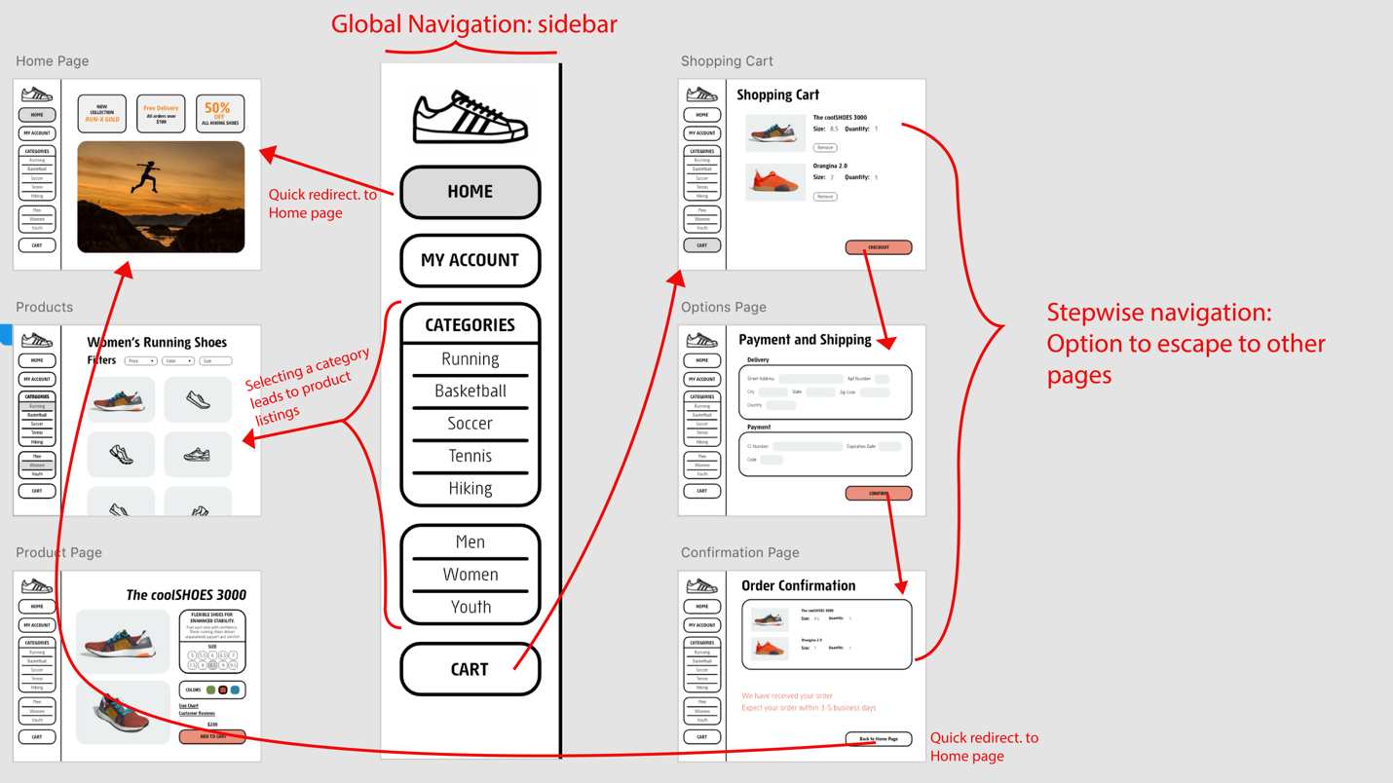

The prototype I created follows two main models: multilevel and stepwise navigation. The **multilevel navigation** model is seen through the accessibility of the Home page, product listings (multiple products), and the shopping cart. In order to create this model, a **global aid** (sidebar) is shown on all pages. The product listings page has a **sub-component** – the product page of a specific item (coolSHOES 3000). The sub-component can only be accessed from the product listings page. Finally, from the shopping cart page, the user has the option to enter a **stepwise navigation** process. Using this process, the user ca pay and confirm the order (Shopping cart -> Payment and Shipping -> Order Confirmation).

The main user task on this site, is to search for and purchase footwear. The user should have an option to return to the Home page, and the product listings page, at any given point. For this reason, the product categories are listed on the global navigation aid. This way, no page appears as a dead-end. Additionally, the checkout process can only be accessed from the cart – because the user must verify his/her delivery and payment information in a sequential order. Otherwise, the order may have inaccurate information.