### Alexandra Yavnilovitch

# Assignments — Week 05 | Design | Design Paradigms

In this assignment, you will explore the use of two design paradigms—metaphorical and idiomatic design—in the context of redesigning the UW–Madison course search and enrollment system. Consider any aspect of the system, *e.g.*, search, scheduler, and degree planner, and think about how you would redesign these systems using metaphors and idioms following the instructions provided below. The “aspect” of the system can be the high-level organization of the interface, such as the “master/detail” pattern that the panes of the course search function follow, or a smaller component, such as the “drawer” that shows course sections. As in past assignments, you will create annotated, hand-drawn or digitally created sketches/mock-ups/wireframes supported by design justifications.

### Part 1. **Metaphors**

In this part of the assignment, you will borrow a “brick and mortar” metaphor from the real world that might serve as a good way to organize the functions provided by the system. For example, a [rolodex](https://en.wikipedia.org/wiki/Rolodex) can serve as a good metaphor for large lists, such as the list of courses; [baseball cards](https://en.wikipedia.org/wiki/Baseball_card) might serve as a metaphor for information on each course; and a [weekly planner](https://en.wikipedia.org/wiki/Personal_organizer) can be a good metaphor for the scheduler. Follow the steps below to redesign the system function using metaphorical design:

1. **Identify the system element that you will redesign.** The element can be a major system function, such as the “scheduler,” or a minor component that supports such a function, such as the ability to add courses to a cart.
2. **Search for appropriate real-world metaphors.** Think about situations in the real *physical* world where people perform functions that are similar to what the users do with the function/ component you chose.
3. **Apply metaphor to the design element.** This step would involve creating the appropriate visual and behavioral representations for the metaphor. E.g., if you chose to represent courses as baseball cards that students will collect, what should appear on the cards, and how should students collect them? Remember to consider and define both the **appearance** and **behavior** of your metaphorical redesign.

Provide an annotated mock-up/sketch of your redesign below. Your mock-up/sketch can be in any level of fidelity, e.g., a hand-drawn conceptual design sketch or a wireframe created in Adobe XD—whichever you prefer. Take photos of hand-drawn designs and screenshots of digitally created ones. Your annotations should highlight the different components of the metaphor, including its appearance and behavior. In a brief paragraph, justify your choice of the metaphor and describe how the metaphor supports the user’s task in using the system element you chose to redesign.

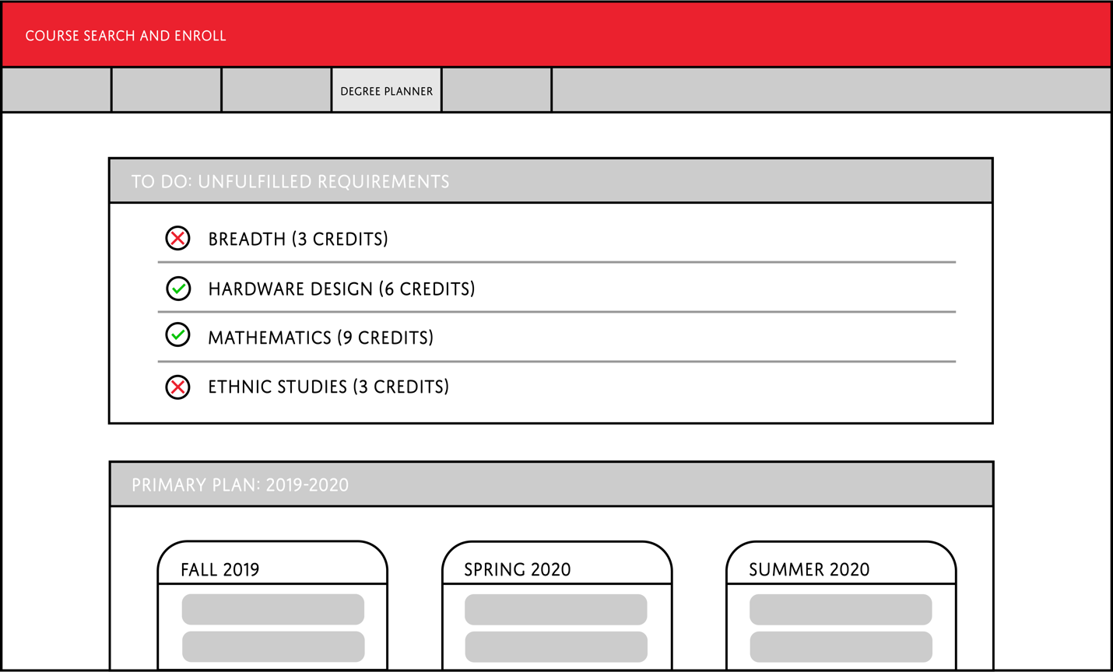

I chose to redesign the content of the degree planner, and combine it with the functionality of the DARS audit report. I thought that it would be useful for students to see which requirements are not yet fulfilled by their past or current courses. This way, users do not have to refer back to their DARS report while planning for future semesters. I selected the ‘to do list’ as my metaphor, because the function of fulfilling graduation requirements is similar to a list of actions. It seemed appropriate to create 2 different symbols for the “checkboxes” (circles in this case). The (✕) symbol represents the requirements that are not fulfilled yet – the red color conveys an error. The (✓) symbol means that the user is planning to fulfill the requirement in a future semester. I believe that the “to do list” is a strong choice for displaying the remaining courses, and for making DARS information more accessible.

### Part 2. **Idioms**

In this part of the assignment, you will practice idiomatic design by redesigning either the same system element you focused on in Part 1 or a different system element. Remember that idioms are highly expressive, dedicated interaction capabilities that users might learn. To practice idiomatic design in this part of the assignment, follow the steps below:

1. **Study the element.** Inspect the element to analyze how it is visually represented and how it behaves, *i.e.*, characterize the current idiom. What is the essential function of the element? For example, if there is a “drawer” that comes out to show more information on a course selection, how does that work, and what are the visual elements that make it up?
2. **Devise an alternative structure.** Now that you understand the essential functionality of the element, can you think of alternative—and potentially more effective—idioms to support its functioning? In the example above, what might be a novel way to present the necessary information?
3. **Define the idiom.** Remember the three levels of the idiom from Cooper et al., *idioms*, *compounds,* and *primitives*. Describe how your idiom will work at each level. What visual elements will cue users into using them, and how will your new design behave?

To describe your idiomatic design, provide an annotated mock-up/sketch below in the same fashion as you did in Part 1. Support your sketch/mock-up with a brief paragraph that justifies your design choices and describes the elements of the idiom.

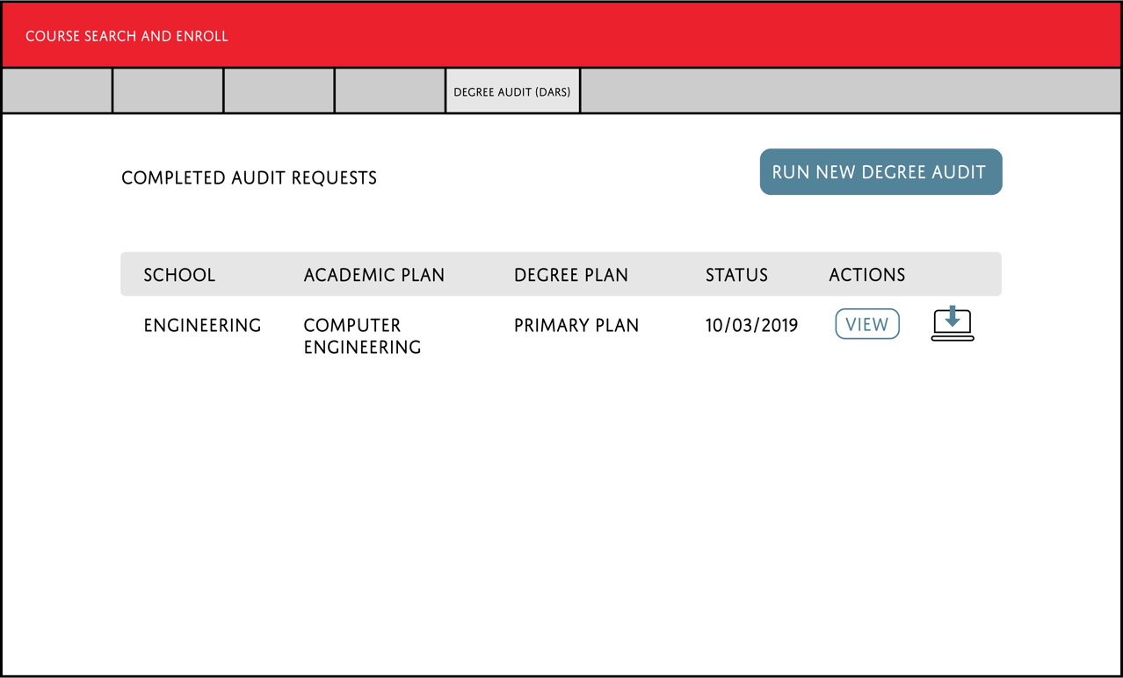

 

I chose to inspect and redesign the ‘download’ icon from the DARS page. The small image on the left is of the current download icon; the design is simple and recognizable. However, I believe that it is not an intuitive design for an inexperienced user. I thought that the addition of a simple laptop shape, would more easily imply the action of downloading content onto one’s personal computer. The small image on the right is my new design of the icon. The action performed would be the same – the user must press on the symbol to open a PDF copy of his/her DARS report.