### Alexandra Yavnilovitch

# Assignments — Week 06 | Design | Designing for the Web

This assignment is designed to help you start making design decisions toward the final product you will build in Module 1. In the *React 3* assignment, you will have the option to build a *course recommender application* or a *course planner application*. The course recommender application will recommend the new courses to take based on user ratings of the courses they have taken in the past and the user’s general areas of interest. The course planner application will construct schedules based on a tentative list of courses, enabling the user to plan a course schedule for a given semester. Review the [React 3 assignment README](https://canvas.wisc.edu/courses/169115/assignments/668903) for the specifications of each application. In this assignment, you will choose one of these options and make design decisions regarding what content you will include in your application, how the content will be organized within the application canvas, what navigation aids you will provide your user with, and what component hierarchy will result from your design.

**Step 1. Conceptual Design.** Choose one of the options for your application: *recommender* or *planner*. After reviewing the design specifications in the React 3 README, ideate on how it will work and sketch a conceptual design of the application. Your conceptual design can be hand-drawn or in the form of a digital wireframe (e.g., created in Adobe XD). Annotate your design to describe how the application will work and its main sections. Provide a photo or screenshot of your annotated design below.

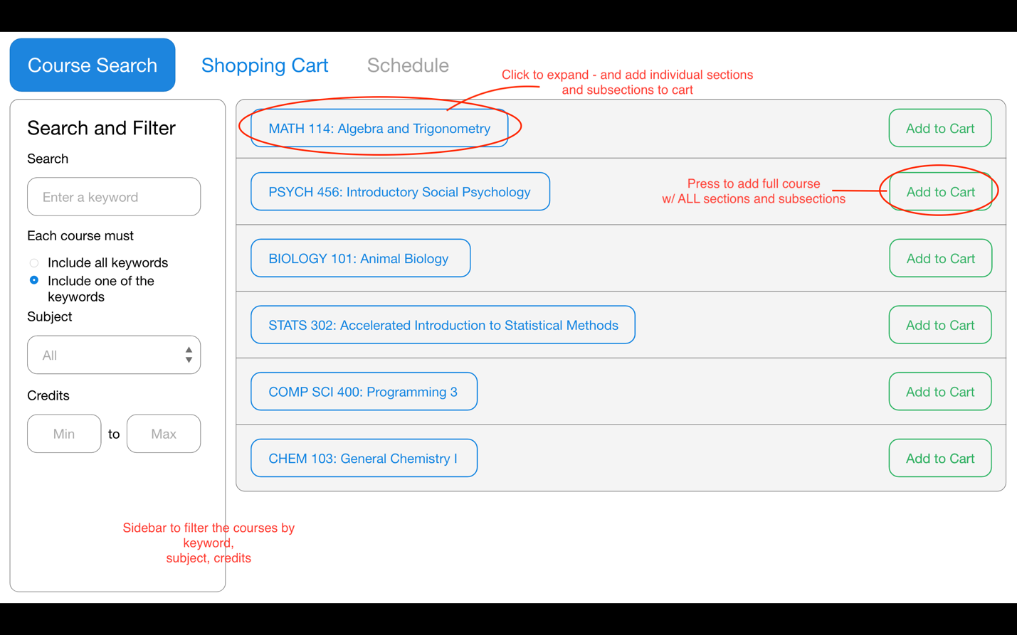

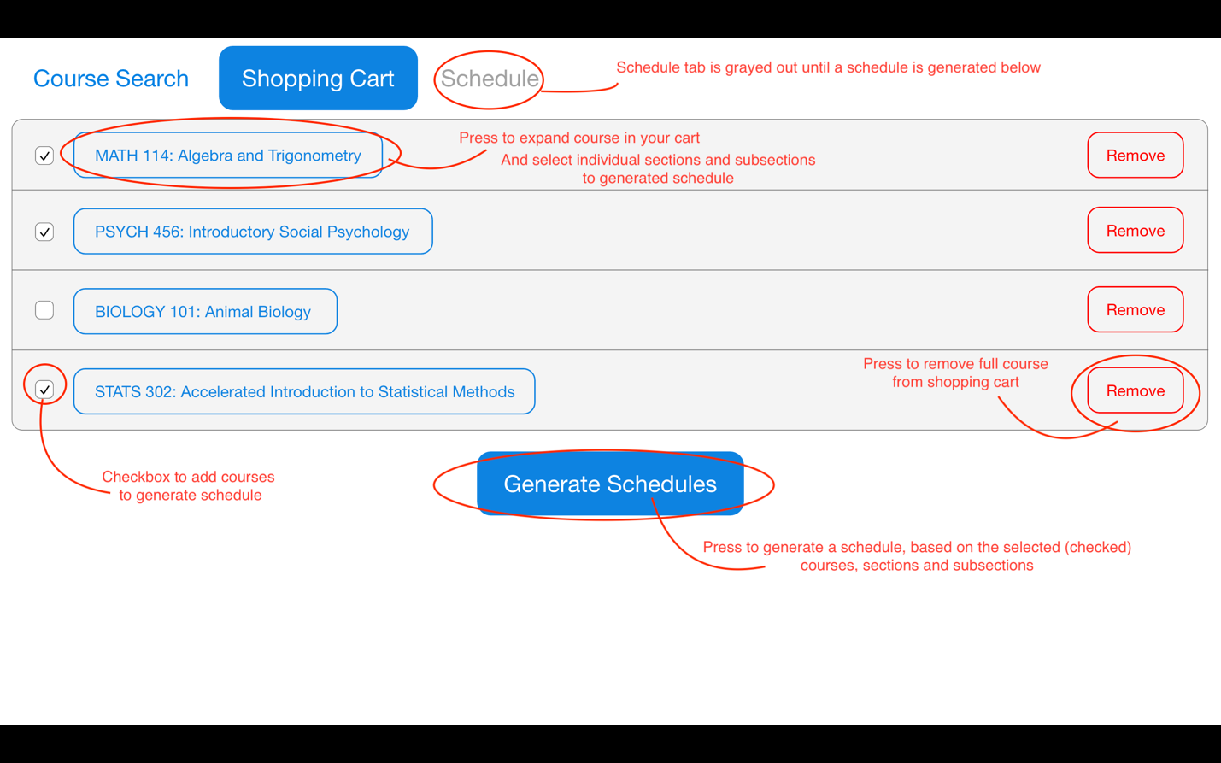

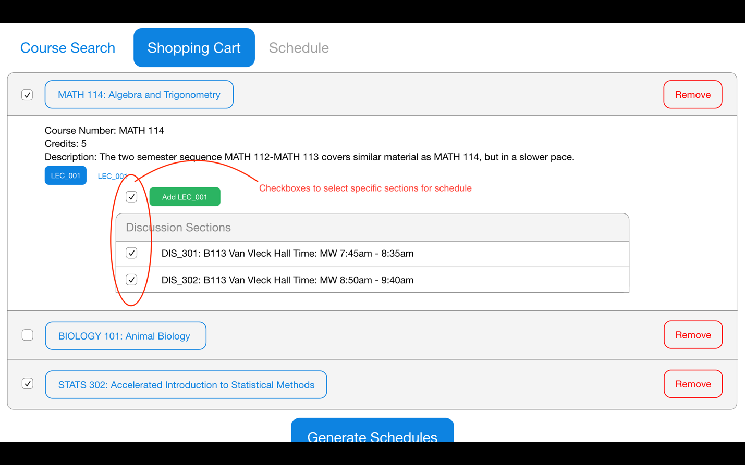

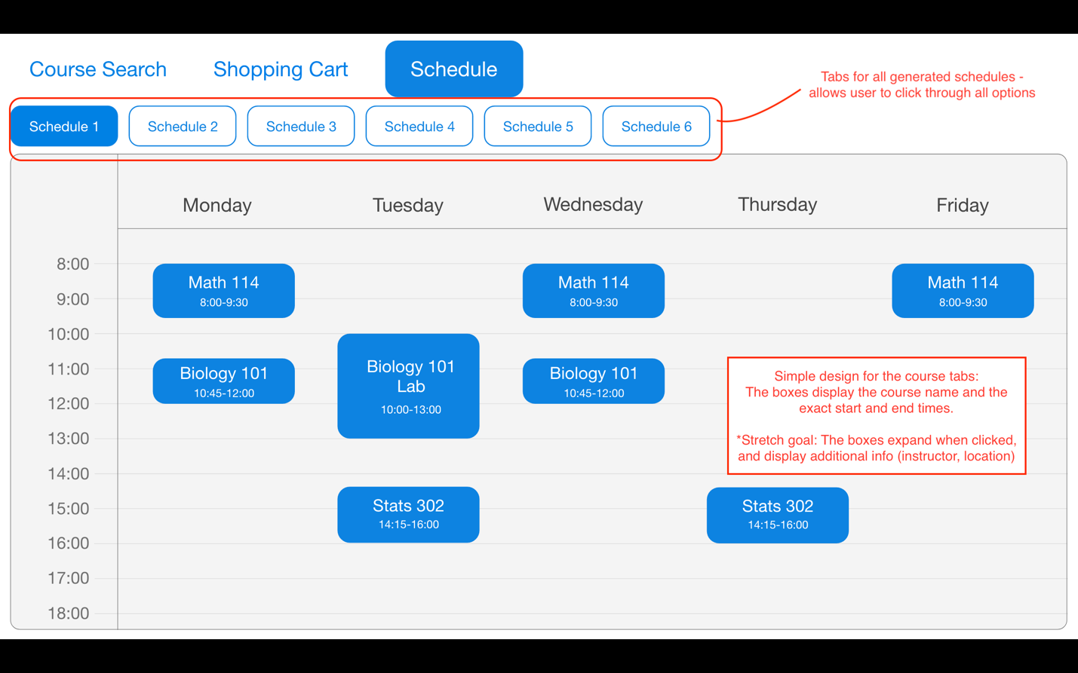

**Step 2. Information Structure.** Make a list of all the *content* that will be included in your design and displayed to the user, including content necessary to obtain user input, the output that your application will provide to your user, and other content that the user will need to effectively use your application. You can refer to previous lectures for discussion on Information Structure and Design Patterns for what kinds of elements/content your application might include. For each item in your list, provide a brief (2-to-3-sentence) description of the content, including the type of information included and its form (e.g., textual course description, shape that represents a class, a card that contains course information).

The following list is referring to the added content (not including the content from build assignments 1 and 2):

* **Checkboxes on the Shopping Cart Page:** I will be adding checkboxes in the shopping cart page, corresponding to each course, section, and subsection. This will allow the user to select the desired courses, and then generate the possible schedules.
* **“Generate Schedules” Button:** When the users have selected the courses, sections, and subsections to add to their schedule, they can press the “Generate Schedules” button, and populate the “Schedule” tab. The button is shown in a bold color (blue), to draw the attention of users.
* **Schedule Field:** A chart representing the schedule generated from the user’s course selection. This field contains information about the titles and times of all courses in the current schedule. The vertical axis represents the time of day, and the course tabs align with the axis based on the course times. The horizontal axis represents the days of the week.
* **Schedule Tabs:** Located above the schedule field. These are tab buttons, corresponding to the different schedule options, based on the user’s selection. The user can select different tabs, which will impact the schedule field content.

**Step 3. Content Organization.** In this step, make decisions about how you will organize the content you described in the previous step on the application canvas. Specifically, make decisions about what will appear above and below the fold, whether there will be any content below the fold, whether the application will include multiple pages or a single page, and whether content that may not fit within a single page will be paginated or loaded using infinite scroll. For example, do you plan to show all recommended courses on a single page or show one on each page. If all courses are shown on a single page, will some of them be below the fold? If you are showing one course at a time, will you paginate the recommended courses or load more on the page as the user requests them? Provide a narrative description of your decisions and their justifications below.

The checkboxes will be organized to align with each item the user can add to a schedule (Directly to the left of every course, section, and subsection). The organization of the shopping cart page requires the user to scroll below the fold (if there are many courses in the cart), in order to see the “Generate Schedules” button. I believe that this should not cause many problems, because a typical user would only add 4-5 courses to a schedule. This amount of courses (not expanded) would remain above the fold.

As for the generated schedules, they would be displayed on one separate tab (The tabs will now include: “Course Search”, “Shopping Cart”, and “Schedule”). The schedule tab will be disabled, until the user presses to generate schedules. Once the “Schedule” page is available, the contents will include a list of tabs, corresponding to all the generated schedules. This page will not go below the fold, because each schedule will take up the entire view, once its tab is pressed.

**Step 4. Navigation Aids.** Determine what navigation aids will be necessary for the user to effectively use and navigate through your application. For example, if the user is reviewing multiple recommended courses or multiple course plans, how you envision the user to navigate through them? Do you need a menu that reflects the main sections of your application or the steps of the process users must follow? Create a hand- or digitally drawn mock-up of your application that illustrates the decisions you made in Steps 3 and 4 and annotate pieces of content and navigation aids.

As previously stated, tabs will be used to organize the generated schedules, as in the following mock-up:

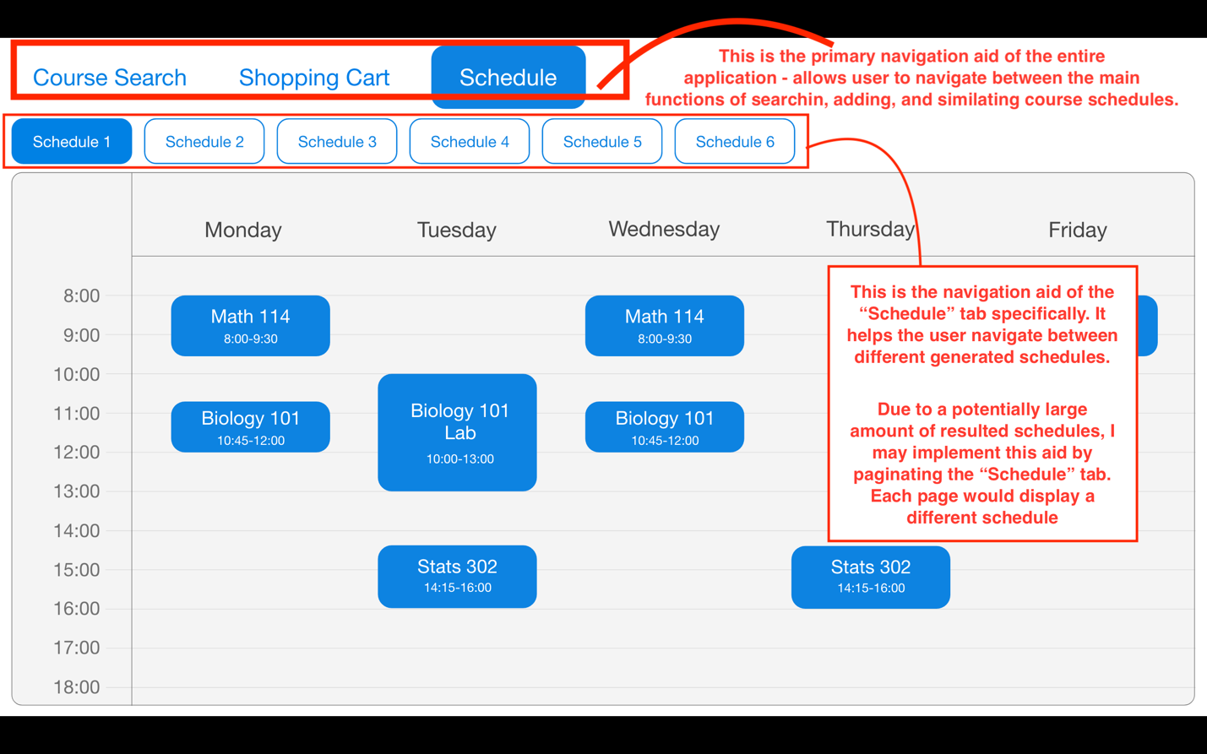

**Step 5. Component Hierarchy.** In this final step, review the mock-up you created in the previous step and describe the component hierarchy that you expect your application will have in its implementation. Review React 2 lecture for example hierarchies. An example/template is also provided below. Include a one-sentence description of each component. The output of this step will be the input into your React 3 assignment and guide the development of your application.

**Application –** The full course search and enroll application

**Course Search –** A page which allows the user to search, filter, and add courses to cart

**Sidebar –** Allows user to filter all courses by different criteria

**Keyword input –** String input for course keywords

**Radio button (or/and) –** Determines if all courses must include all keywords

**Subject dropdown –** User may select a subject from the dropdown menu

**Credit inputs –** User may enter minimum and/or maximum number of credits

**Course Cards –** An entry for each result of filtered courses

**“Add to Cart” button –** Allows user to add full course to cart

**Course Information –** Course number, credits, description

**Section tabs –** A tab to switch between all sections of given course

**Section Information –** Instructor, location, and meeting times

**“Add to Cart” button –** Allows user to add section to cart

**List of discussions –** A list of entries for each subsection in current section

**Subsection Information –** Subsection name, location, times

**“Add to Cart” button –** Allows user to add subsection to cart

**Shopping Cart –** A page to display the courses the user added to cart

**Course Cards –** An entry for each added course

**Checkbox –** Allows user to select desired course for schedule

**“Remove” button –** Allows user to remove full course from cart

**Course Information –** Course number, credits, description

**Section tabs –** A tab to switch between all sections of given course

**Checkbox –** Allows user to select desired section for schedule

**Section Information –** Instructor, location, and meeting times

**“Remove” button –** Allows user to remove section from cart

**List of discussions –** A list of entries for each subsection in current section

**Checkbox –** Allows user to select desired subsection for schedule

**Subsection Information –** Subsection name, location, times

**“Remove” button –** Allows user to remove subsection from cart

**“Generate Schedules” button –** Triggers the generation of different schedule versions

**Schedule –** The tab contains all generated course schedules (divided into tabs/pages)

**Navigation tabs –** When pressed, page displays corresponding schedule

**Schedule field –** A classic schedule with time and days of the week

**Course boxes –** Boxes corresponding to each course in the generated schedule