### Alexandra Yavnilovitch

### CS-639 Building User Interfaces, Fall 2019, Professor Mutlu

# Assignments — Week 07 | Design | Usability Heuristics

In this assignment, you will put the ten usability heuristics we learned in class into practice toward improving the usability of your Module 1 deliverable. Specifically, you will create a hi-fi prototype of your design, identify potential violations of the heuristics, make design recommendations to address these violations, and implement recommendations that are feasible in your prototype. Use this opportunity to make concrete design decisions about your Module 1 project, to improve your design using the heuristics, and to build a keen eye for identifying usability issues as a UX developer.

**Step 1. Prototype your Design.** In this step, you will build on the design decisions you made in the previous Design assignment and your plans for the React 3 assignment to create a hi-fi prototype of your Module 1 deliverable using Adobe XD. The prototype should represent the visual design elements and the navigation behavior of your design, although you can make any necessary simplifications due to the limitations of Adobe XD. (If you need to use a scrollable artboard for your prototype, see [this page](https://helpx.adobe.com/xd/how-to/scrollable-artboards.html) with instructions and sample files.) Provide screenshots of the main 2–3 screens of your prototype.

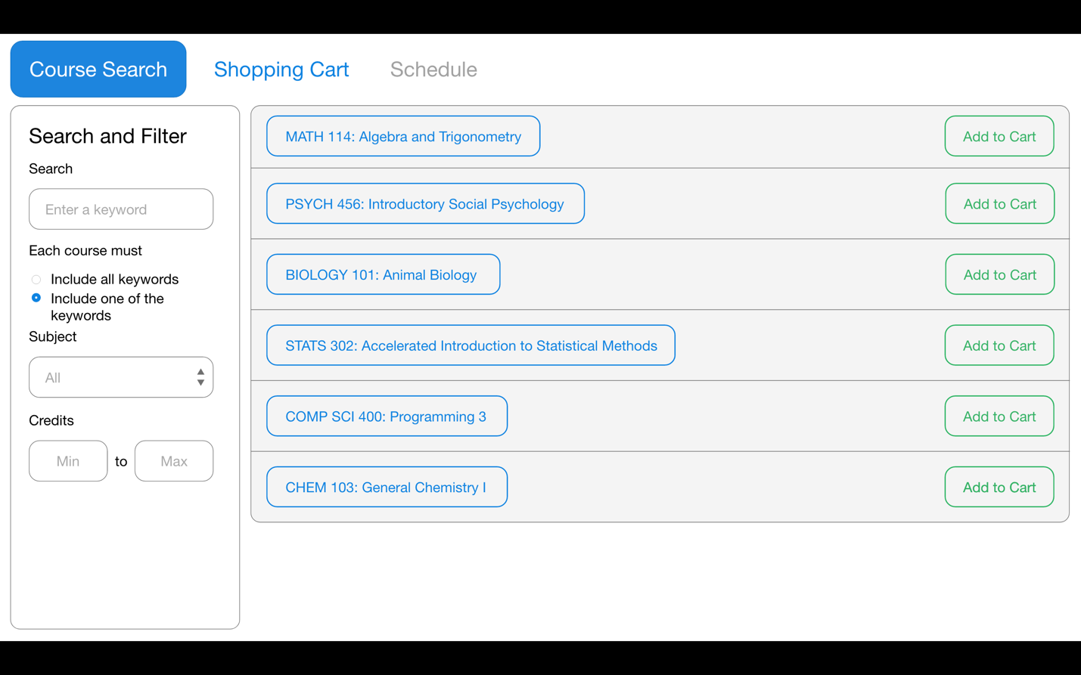

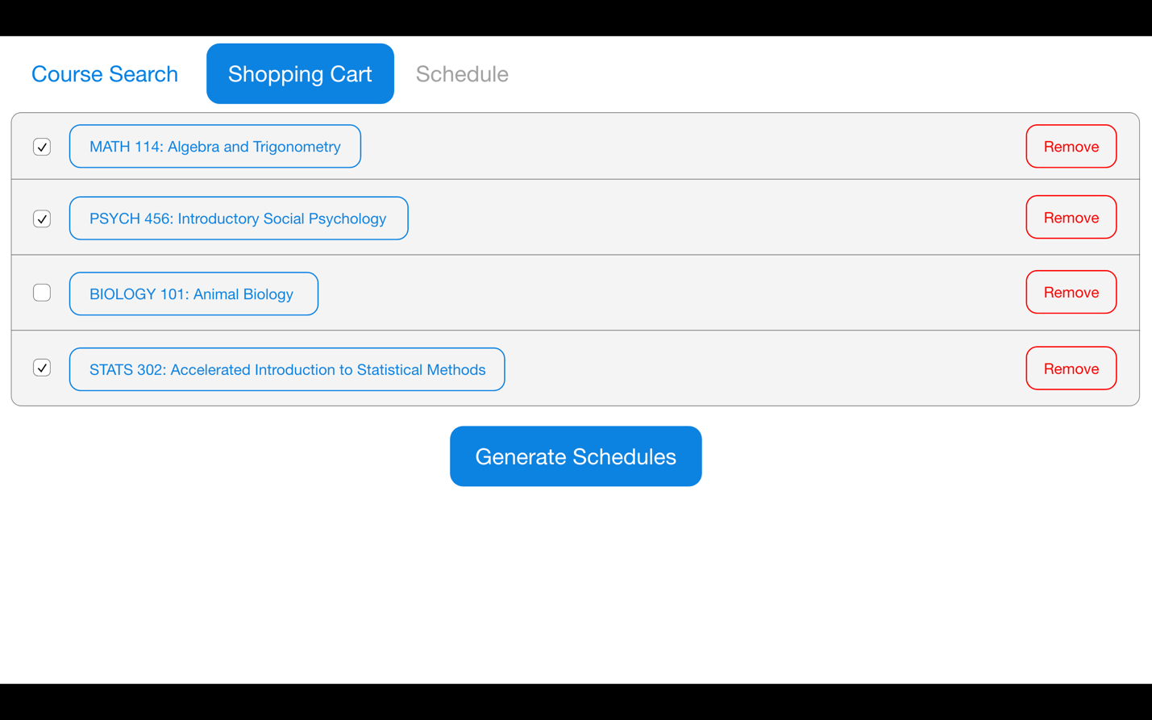

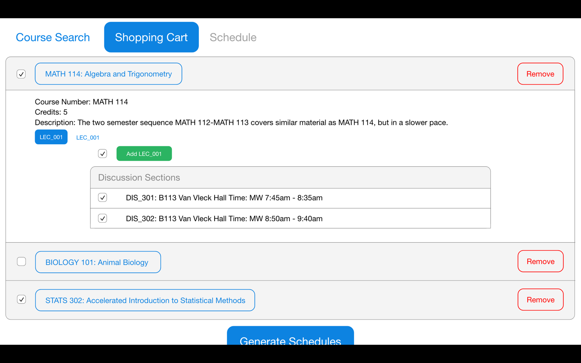

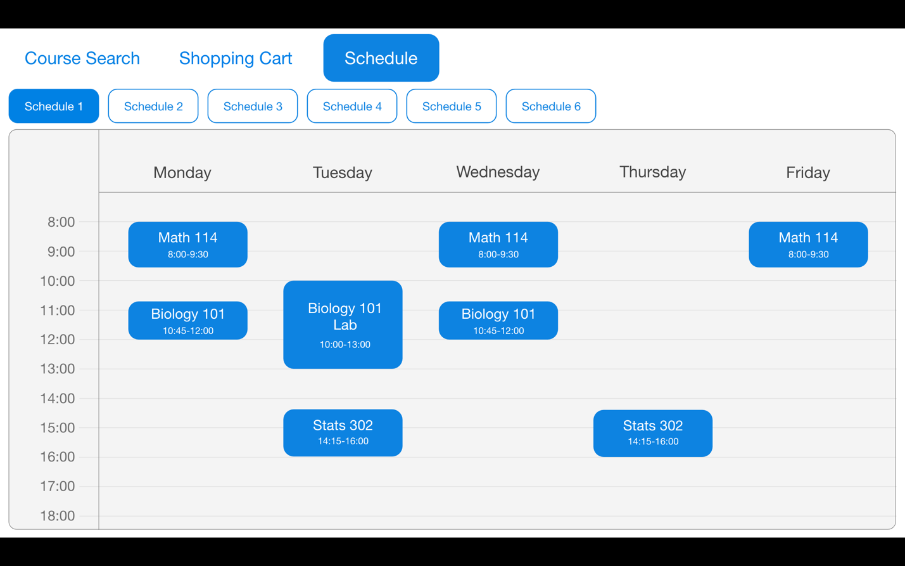

**Step 2. Review the Heuristics.** Review the ten usability heuristics we discussed in class from the slides, what principle each heuristic represents, and examples of the designs that violate and support the heuristics. Below is a cheat sheet for the Nielsen’s ten heuristics that you can use in the next step. (This step does not have any deliverables.)

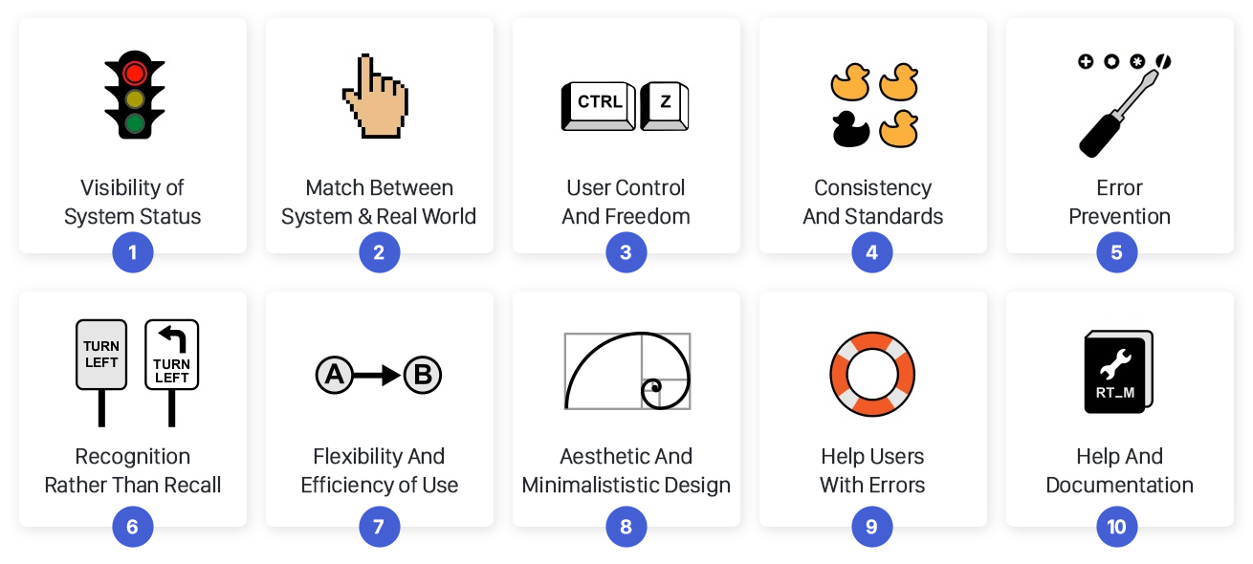

Image source: [UX Collective](https://uxdesign.cc/10-usability-heuristics-every-designer-should-know-129b9779ac53)

**Step 3. Identify Potential Violations.** Focusing on 2–3 key design elements of your prototype, inspect your design, considering each usability heuristic, for any violations of the heuristics. For each violation, use the following table to briefly describe the violation and give it a number. Make copies of your screenshots from Step 1, focusing on the design elements you are considering in this step, and mark them with the numbers so that the reader of your report can find the location of the violation in the screenshots and read your description in the table below. Color-code the violations for severity, using red (4), orange (3), yellow (2), green (1), and gray (1) for the severity-rating scale we covered in class.

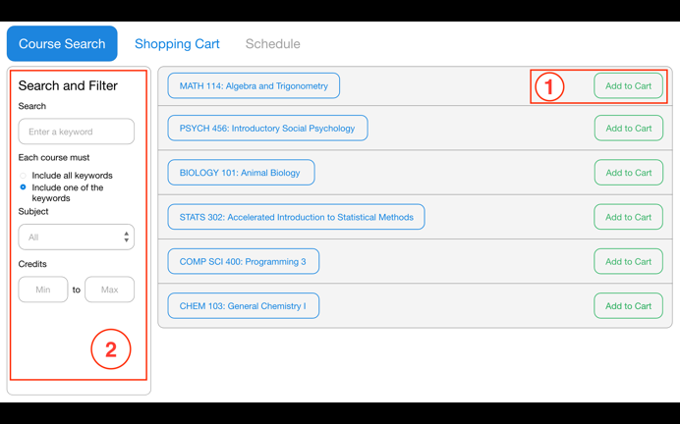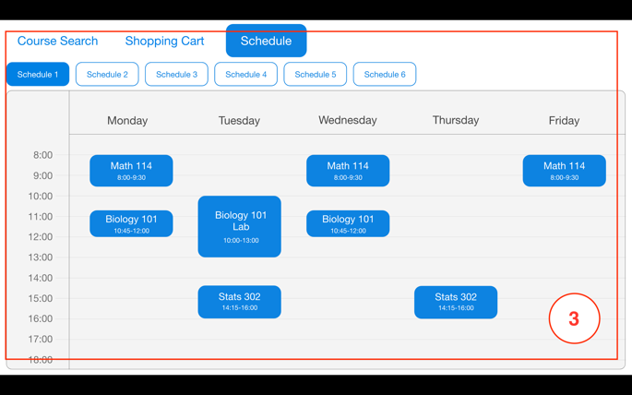

|  |  |  |  |  |  |  |
| --- | --- | --- | --- | --- | --- | --- |
| **Heuristic** | **#** | **Design element 1**  **Add to Cart Button** | **#** | **Design element 2**  **Search and Filter sidebar** | **#** | **Design element 3**  **Schedule tab** |
| *Visibility of system status* |  | Once button is pressed, no indication of whether the item was added to cart. |  |  |  | There is no information about the date or time when the schedules were generated. |
| *Match between real world & system* |  | The button text is descriptive, but not immediately recognizable (no icon). |  | There are no visuals in the sidebar, to indicate which criteria is used for filtering (All text). |  |  |
| *User control & freedom* |  | If item is added to cart (button pressed), there is no shortcut to reverse the action – user must go to cart and press ‘remove’. |  |  |  |  |
| *Consistency & standards* |  |  |  |  |  | The current layout for the schedule tab is not polished, and does not completely follow the theme of the other tabs |
| *Error prevention* |  |  |  | In the search bar – users can enter any string (misspelled), which could result in 0 course results. |  |  |
| *Recognition rather than recall* |  |  |  |  |  |  |
| *Flexibility & efficiency of use* |  |  |  | When the subject dropdown is used, and a subject is selected, the courses are only updated after the user presses the subject dropdown. |  | The schedule tab scheme is not designed to account for a large number of generated schedules. Not the ideal structure. |
| *Aesthetic & minimalist design* |  | “Add to Cart” button may look repetitive when appears for all courses, sections, subsections. |  | The design is minimal – not too busy. However, it could use some negative space in between the filter criteria. |  | The current look of the schedule chart is not as polished and simple as I planned. |
| *Help users with errors* |  |  |  | The selected filters can only be seen in the sidebar – not visible in the course area |  |  |
| *Help & documentation* |  | When users attempt to add an item which has already been added – nothing happens. No warning or error message is displayed. |  |  |  | The main “Schedule” tab is grayed out when a schedule has not been generated – users do not know why it is disabled |

**Step 4. Develop Design Recommendations.** For each violation you identified in the previous step, provide a design recommendation for addressing it along with an indication of whether or not it is feasible to implement the recommendation in your prototype. (Only recommendations that are beyond the capabilities of Adobe XD or beyond the scope of the project should be marked as not being feasible.) Rank the recommendations based on the severity of the usability problem, from most severe to least severe. Use the table below for the recommendations, adding additional rows as needed, and follow the same color-coding from the previous step for severity ratings.

|  |  |  |
| --- | --- | --- |
| **#** | **Recommendation** | **Feasibility (Yes/No)** |
|  | Remove the option to add an item to cart (the button), once it has been added. Re-add the option if the item is removed from cart. | yes |
|  | Resolve the ‘subject’ dropdown issue – update courses when an option is selected | no |
|  | Use a different structure for the different generated schedules – dropdown | yes |
|  | Complete what user is typing in the search bar with possible keywords (taken from the list of keywords in the course hierarchy) | no |
|  | Change the “Add to Cart” button to show a cart icon, rather than just text. This would solve the violations of guidelines 2 and 8. | yes |
|  | Make the schedule color palette and layout more cohesive with the rest of the application. Reduce the view to only 2 colors, and remove the borders. | yes |
|  | Add appropriate spacing in the sidebar, to distinguish the different filter options. Separate into 3 parts: The search bar (including the radio buttons for AND/OR), The subject dropdown, and the credit limits. | yes |
|  | Verify that the size and proportion of the “Schedule” tab matches the other tabs (Search, Cart) | yes |
|  | Add a tooltip for when the schedule tab is disabled – explain to users that they must generate schedule in the “Cart” tab | yes |
|  | Add an “Undo” button after a user adds a course to cart, in order to reverse the action | yes |
|  | Add icons for the different filters in the sidebar | yes |
|  | Create a section in the course area that displays which filters are being applied in the search | yes |
|  | Indicate the date and time when the schedules have been generated in the schedule tab | yes |
|  |  |  |

**Step 5. Update your Design.** In this step, you will implement the design recommendations that you identified as “feasible” in the previous step in your prototype, updating your design. Provide a link to the live Adobe XD prototype below and a paragraph that summarizes the outcome of the heuristic evaluation. Reflect on how your design improved, what you learned about usability in the process of applying the heuristics, and whether you gained any unexpected insights about your design.

<https://xd.adobe.com/view/e96c26bb-0327-4b91-4f28-d9108d7f0766-9f5d/>

The evaluation was helpful in identifying the main violations in my original design (and the implementation). One of the big improvements I made to the mock-up, is the replacement of the “Add to Cart” button with a cart icon. The prototype shows the user a check mark once an item has been added to cart. Furthermore, if the user decides to undo the assign action, he/she can click on the check mark. This improvement made the design more simple and helpful to users, in viewing and adding courses to cart. Another major improvement was to replace the tabs for the generated schedules, which did not account for a large volume of results. Instead of tabs, I decided to use a scrollable dropdown, which allows the user to see all the options, and select which one to view. I made additional cosmetic changes: I verified the design proportions in the tabs at the top of the page, and added negative space in the search sidebar. I would like to note, that certain corrections could not be represented in the Adobe XD mock-up – they would have to be added (or corrected) in the code implementation of the application. Throughout the process, I realized that simple changes, which do not require a lot of effort, may drastically improve the user experience.