### Alex Yavnilovitch

### CS-639 Building User Interfaces, Fall 2019, Professor Mutlu

# Assignments — Week 11 | Design | Designing for Accessibility



In this assignment, we will explore some of the concepts we learned about in class around *accessibility*. Specifically, we will try to better understand how accessible design and assistive technologies are implemented in existing mobile platforms and design accessibility features for our Module 2 deliverable fitness app. You will choose a mobile platform and analyze its accessibility features and build on this understanding to specify similar features for your app. You may have to do some online research map impairments to design requirements, as how the accessibility features on the mobile platform work in different situations may not be clear. The premise of the assignment to think about how accessibility features work at the lower level and how we might implement them in our designs, so your focus should be on the mappings between impairments and accessible design features. You can be creative with your designs, but they should also be feasible (e.g., enlarging buttons is feasible, but predicting calories from a photo is not).

**Part 1. Discovery.** In this part of the assignment, you will discover the accessibility features of mobile platforms. You will choose (1) *a mobile platform*, such as a mobile device or a tablet computer, running running iOS, Android, or an alternative operating system and (2) *an existing app* from any domain (e.g., fitness, weather, social media, news). Analyze the accessibility features in the general settings of the device to choose one from each of (a) *vision*, (b) *physical/motor*, and (c) *hearing* assistive technologies. Define a core task for the app (e.g., entering food into a fitness app, adding a new city into the weather app, posting on social media, or adding a new news feed) and perform the task a total of four times, first with all accessibility features disabled and then by enabling them one by one. Analyze how the app behaves differently with each assistive technology and describe the changes you noticed either in narrative form, dedicating one paragraph for each assistive technology, or using annotated screenshots. Pay particular attention to (1) any changes in how the components appear and behave and (2) the addition of other components, elements, or behaviors.

I chose to test out and interact with the “Seeing AI” application. Specifically, the task I selected is to read handwritten notes out loud, using AI and text analysis. With this feature, the user can take a photo of handwritten notes, and the application will convert them into printed text, and read the result aloud. This is very useful in a learning environment, if someone needs to borrow handwritten notes, or read a handwritten message, but has a visual disability.

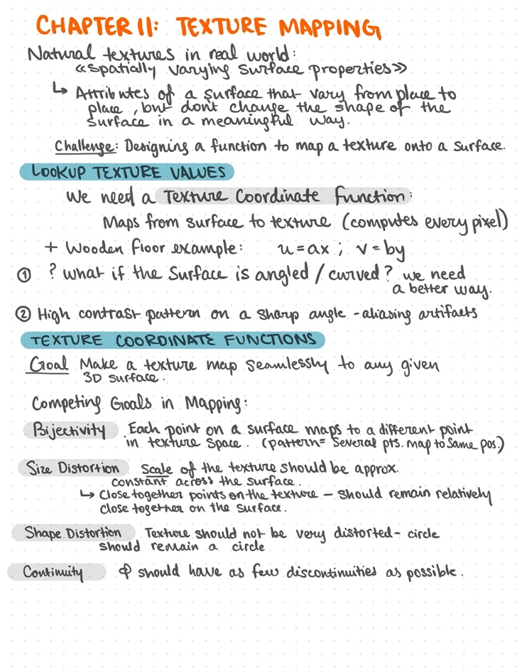 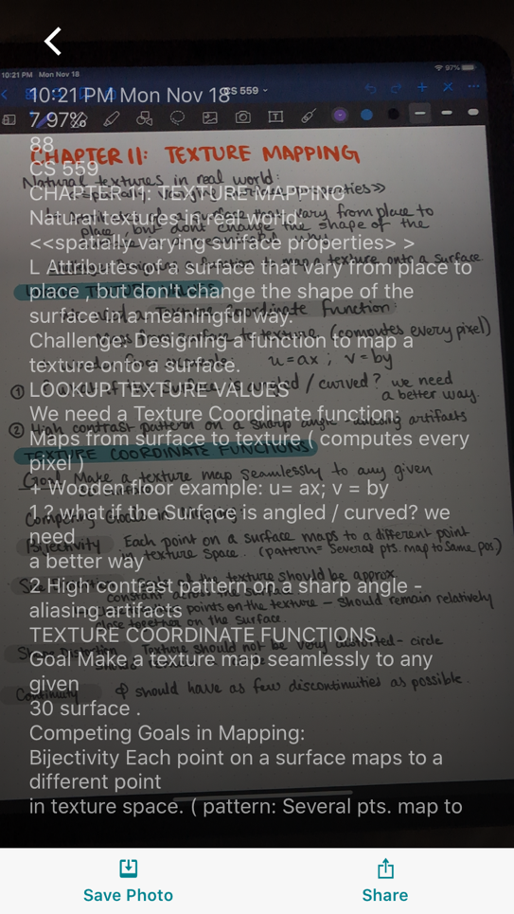

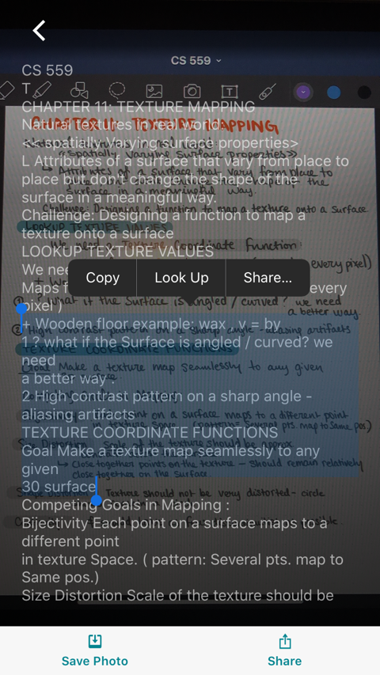

From the given screenshots, it is apparent that the handwritten notes are analyzed and converted to print. Then, the perceived printed text is read aloud. The UI allows the user to select the resulted text, and even output (share, look up) the contents. Some impressive features of this functionality are the speed of the execution, and the ease of use and interaction. A few things that could improve in the functionality are: natural speech when notes are read aloud – recognition of section separation, new heading, etc. Furthermore, I wish the printed text was more interactive and allowed users to make changes within the app. Also, I am unsure why the printed text is overlaying the handwriting – the view is quite cluttered and distracting.

I explored a few of the other functionalities within “Seeing AI”. The application allows for real time “Short Text” analysis (reading headers, titles). This feature could be very useful in daily life for navigation. Furthermore, there is a face detection and analysis feature, which allows the users to evaluate the number of people in the surroundings, and even to analyze one person at a time, and his/her facial features. Finally, I also tried the “Color preview” feature: it allows the user to analyze the colors around him/her in real time. Many of these features would be incredibly useful for an individual with a visual disability.

**Part 2. Design.** In this part of the assignment, you will build on your understanding of how assistive technologies work from Part 1 to practice accessible design for your fitness app. You will choose one *permanent impairment* and one *situational* *impairment* that you would like to target with your app. Determine the design requirements (what should the app do or not do to offer users with these impairments a similar experience) for each impairment using one or a combination of the following: (1) your observations of how assistive technologies worked in Part 1; (2) quick-and-dirty online research you can do about the effects of these impairments on mobile device use; and (3) novel ways in which you can think of addressing the impairments. Choose a task that your app will support and prepare wireframe screenshots (1–3 screens, depending on the task) of your app, demonstrating the task. Create two additional versions of the screenshots that implement accessible design features for the impairments. Annotate these versions to highlight and describe the features.

I chose to target visual impairment for this exercise – users with low vision, blindness, or a temporary circumstance during which he/she cannot see the information on the screen well.

The design requirements for this accessibility feature is to incorporate audio projection within the fitness application. Instead of having to manually review the information on the screen, the application will allow the user to listen to an audio summary. For instance: If visually impaired users want an overview of their daily progress, they can triple tap on the current page (or current section), and have the content read aloud.

