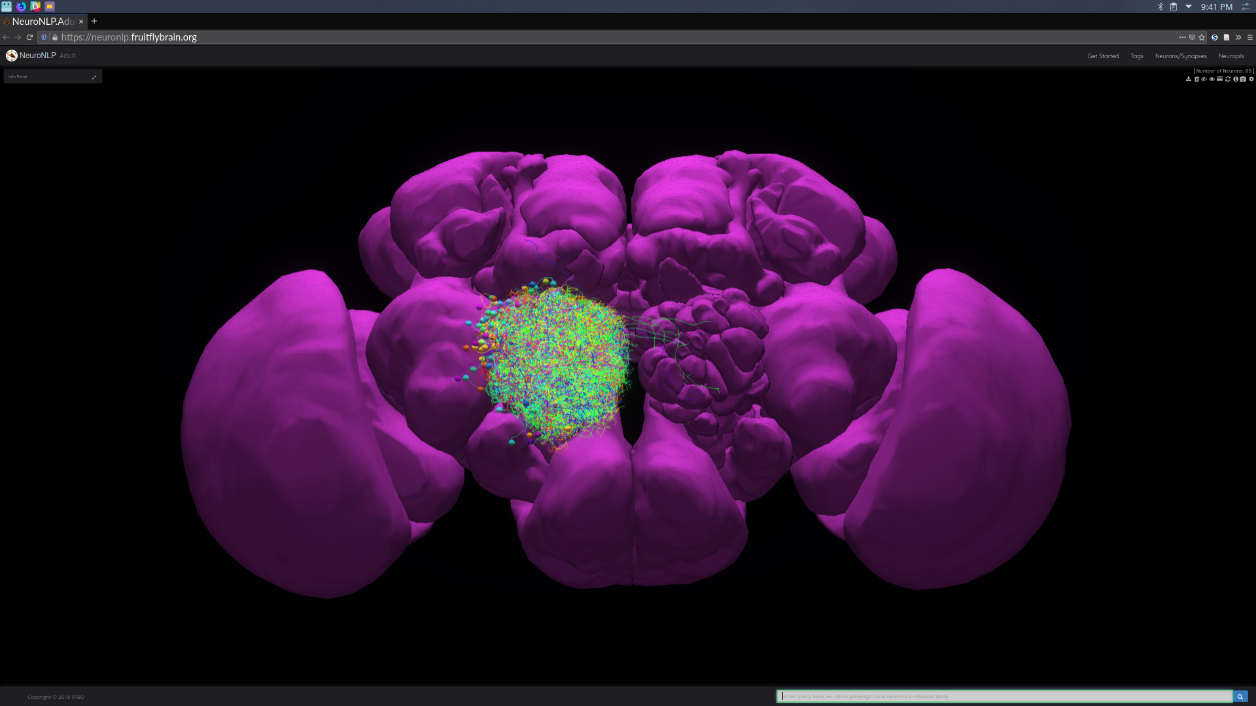
Step 1:

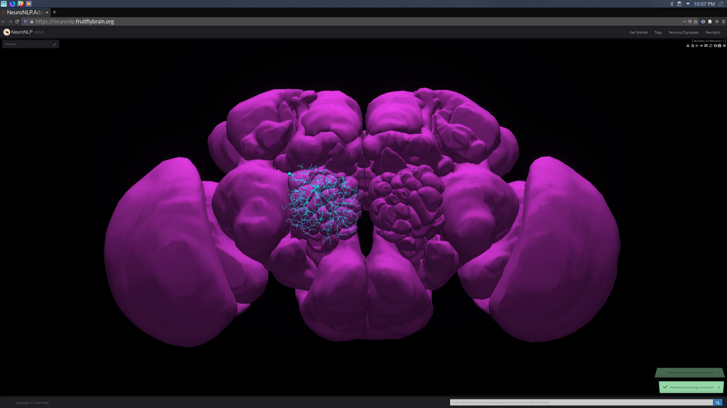

Step 2:

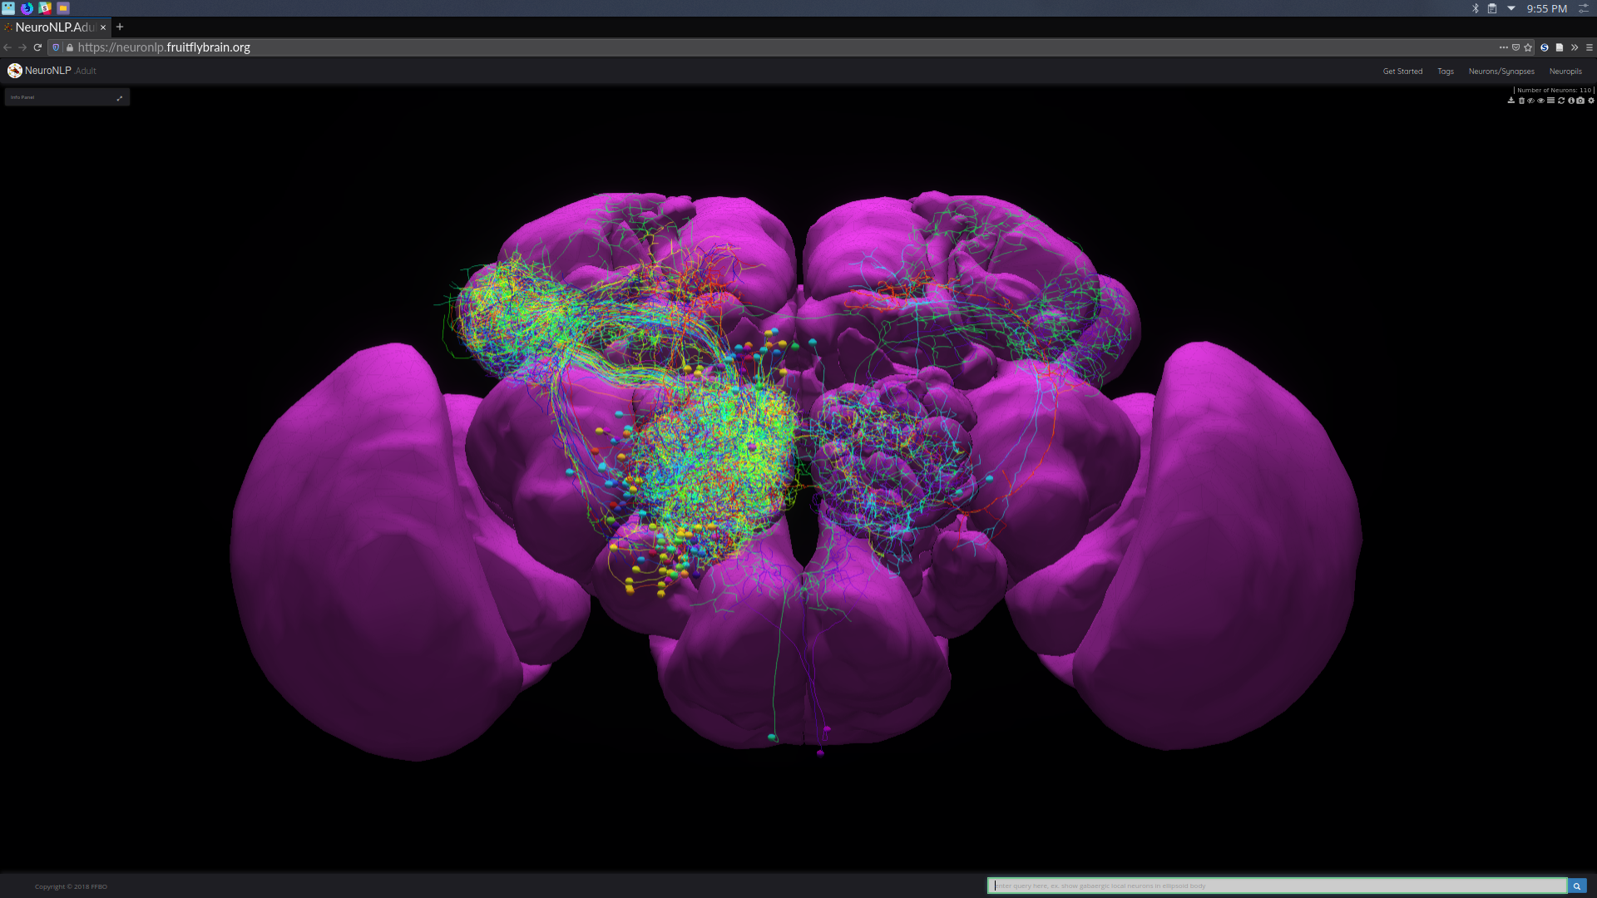

Step 3:

awy2110_assignment_1

Task #4:

1. The neuron types I mostly observe are lamina types (L1-5), lamina wide-field (Lawf1-2), and T1.
2. I observe numerous connections to neurons of type Tm, Mi, C, and Dm, as well as connections to the neuron types found within the lamina. It also appears that neurons within the lamina have more presynaptic partners than postsynaptic partners in general, and the connections with presynaptic partners also have more synapses than with postsynaptic partners.

