Alex Kwon

12-8-14

Github: <https://github.com/alexykwon/hw6>

Time spent: 30 minutes

Challenges: none

Version 1:

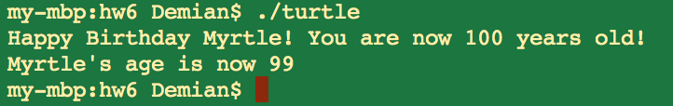

Version 2:

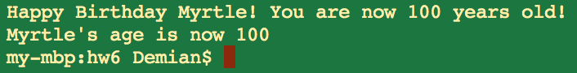

Version 3:

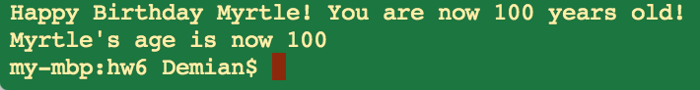

Memory Diagram:

