ETCDCTL

Binary 安装包

<https://github.com/etcd-io/etcd/releases>

环境配置

alias etcl='etcdctl --endpoints=127.0.0.1:2379 --cacert=/etc/kubernetes/pki/etcd/ca.crt --cert=/etc/kubernetes/pki/etcd/healthcheck-client.crt --key=/etc/kubernetes/pki/etcd/healthcheck-client.key'

alias etcl='etcdctl --cacert=/etc/kubernetes/pki/etcd/ca.crt --cert=/etc/kubernetes/pki/etcd/healthcheck-client.crt --key=/etc/kubernetes/pki/etcd/healthcheck-client.key'

ENDPOINTS=192.168.0.216:2379,192.168.0.147:2379,192.168.1.254:2379

指令集：

查看集群状态

etcl endpoint status --write-out=table --endpoints=$ENDPOINTS

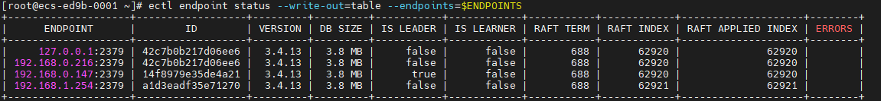

备份脚本

#!/usr/bin/env bash

date;

CACERT=" /etc/kubernetes/pki/etcd/ca.crt"

CERT=" /etc/kubernetes/pki/etcd/healthcheck-client.crt"

EKY=" /etc/kubernetes/pki/etcd/healthcheck-client.key"

ENDPOINTS="127.0.0.1:2379"

ETCDCTL_API=3 etcdctl \

--cacert="${CACERT}" --cert="${CERT}" --key="${EKY}" \

--endpoints=${ENDPOINTS} \

snapshot save /data/etcd_backup_dir/etcd-snapshot-`date +%Y%m%d`.db

# 备份保留30天

find /data/etcd_backup_dir/ -name *.db -mtime +30 -exec rm -f {} \;

<https://zhuanlan.zhihu.com/p/101523337>

停止kube-apiserver --> 停止ETCD --> 恢复数据 --> 启动ETCD --> 启动kube-apiserve

ETCD备份恢复

参考：https://www.voidking.com/dev-k8s-etcd-backup-restore/

ETCDCTL_API=3 etcdctl snapshot restore etcd-snapshot-20210917.db --data-dir /var/lib/etcd-from-backup

