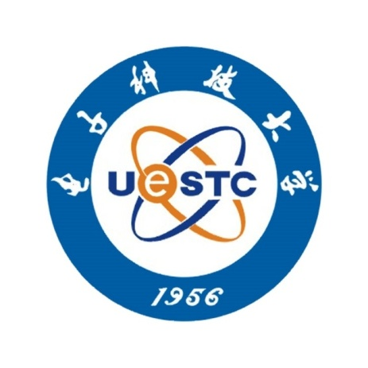

Objective
To obtain an offer of acceptance into the master program
Educational Background
09/2006-Present School of Optoelectronic Information, University of Electronic Science and Technology of China
Major: Information Display and Opto-Electronic Technology
GPA: 3.85/4.0(major) 3.82/4.0(overall)
Academic Experiences
10/2009-Present Algorithm Research on Detection of Human Faces Based on Skin Color Segmentation and Feature Localization
- Proposed a mixed skin model combining the model in YCbCr space and HSV space to obtain the facial region by using the filter
- Validated the region by using method in Mathematical Morphology and located eyes and mouth
09/2009-10/2009 Improvement of Infrared Touch Panel on 8051F020
- Designed the differential circuit of infrared signal to eliminate influence of environmental lighting
- Generated specific infrared signals, wrote the program for data process and the interface program with host computer
06/2009-09/2009 Digital Image Processing System Based on Visual C++6.0
- Enhanced the G component in RGB space of the micro image of blood cells
- Processed the enhanced image with erosion method
- Generated the codes for recognizing and counting the blood cells in the processed image
06/2009 Audio Guidance System on MSP430F5435
- Created the software drivers for processing and collecting aural signals and the software drivers for wireless module and DC motor
- Designed the algorithm for locating the toy car with processed aural signals and the fuzzy motional control algorithm
05/2009 Digital Frequency Meter on Spartan-II (1Hz to 1MHz)
- Wrote the codes for the digital frequency meter in VHDL, conducted simulation with ModelSim
- Downloaded and tested its performance on Spartan-II development board, displayed measuring result with the digital tubes on the board
05/2009 Fast Balance of Firstorder Inverted Pendulum on MC9S12XS128
- Created the mechanical structure of the triangle car, designed the DC motor driving circuit
- Wrote the programs to sample voltages on the rheostat and to drive DC motors
- Created both PID and fuzzy motional control algorithms
11/2008-05/2009 Freescale Intelligent Car on MC9S12XS128
- Generated the codes to drive digital camera, steering motor and DC motor with MCU
- Processed image data with difference method
- Designed the motional strategies of the car (including PID algorithm and fuzzy control algorithm)
Internships
07/2008-08/2008 Panzhihua City ChangNing Industry & Commerce CO., LTD
- Designed the whole video surveillance system based on the specific environment, including selecting positions of cameras and terminal, routes of the signal wire etc
- Installed and debugged the whole system
07/2007-09/2007 Panzhihua City ChangNing Industry & Commerce CO., LTD
- Designed the automatic weighing sack packer based on MSP430F1611 including the motor-drive circuit for the sluice gate, MCU circuit and weighting sensor circuit
- Generated software drivers for the peripheral devices mentioned above and the codes for control algorithm
Activities
09/2009 “NEC Cup” National Electronic Design Contest
08/2009 Southwest Division of “TI Cup” National Electronic Design Contest
06/2009 The 4th National Freescale Intelligent Car Contest
09/2008 Served as a volunteer of the Communist Youth League during the Wenchuan Earthquake
05/2008 Served as a volunteer of Red Cross during the Wenchuan Earthquake
04/2008 Western Open Tournament of Topcoder International Programming Challenge Match
03/2008 The 6th EDA Contest of University of Electronic Science and Technology of China
11/2007 English Translation Contest of School of Optoelectronic Information of UESTC
10/2007 English Free Thinking Contest of School of Communication and Information Engineering of UESTC
05/2007 ACM Programming Contest of University of Electronic Science and Technology of China
Professional Skills
Proficient in C++, MATLAB, C and VHDL Language
Proficient in Freescale MCU, MSP430 MCU, 8051 MCU and driving peripheral equipments
Proficient in programming with FPGA and DSP, and relevant development tools
Familiar with software of Protel (DXP) and ANSYS finite element analysis software
Familiar with application and programming of embedded system
Familiar with JAVA, C# and relevant programming tools
Honors & Awards
2008 Won the third prize of UESTC in the 4th Freescale Intelligent Car Contest of China
2007 Won the third prize in the English Translation Contest of School of Optoelectronic Information of UESTC
2007 Won the award of The Best Defense in the English Free Thinking Contest of School of Communication and Information Engineering of UESTC

