CPE301 – SPRING 2019

Design Assignment 01A

Student Name: Alfonso Contreras

Student #: 1012383150

Student Email: contra2@unlv.nevada.edu

Primary Github address: https://github.com/alf8420/Submit.git

Directory: alf8420/Submit

Submit the following for all Labs:

1. In the document, for each task submit the modified or included code (only) with highlights and justifications of the modifications. Also, include the comments.
2. Use the previously create a Github repository with a random name (no CPE/301, Lastname, Firstname). Place all labs under the root folder ESD301/DA, sub-folder named LABXX, with one document and one video link file for each lab, place modified asm/c files named as LabXX-TYY.asm/c.
3. If multiple asm/c files or other libraries are used, create a folder LabXX-TYY and place these files inside the folder.
4. The folder should have a) Word document (see template), b) source code file(s) and other include files, c) text file with youtube video links (see template).

1. **COMPONENTS LIST AND CONNECTION BLOCK DIAGRAM w/ PINS**

N/A

1. **INITIAL/MODIFIED/DEVELOPED CODE OF TASK 1/A**

; AssemblerApplication1.asm

;

; Created: 2/13/2019 10:57:02 PM

; Author : Alfonso Contreras

; Instructor: Dr. Venki Muthukumar

; This program will perform a multiplication of 16 bit multiplicand with

; a 8 bit multiplier. It uses an iterative addition to perform the multiplication.

;

START:

LDI R25, HIGH($100) ; R25 will hold the high value of hex 150 multiplicand

LDI R24, LOW($100) ; R24 will hold the low value of hex 100 multiplicand

LDI R22, ($50) ; R22 will hold the value of hex 50 multiplier

LDI R21, 0 ; R21 will be used to store a zero for carry

LOOP: CPI R22, 0 ; it will compare R22 with zero

BREQ DONE ; it will stop when branch is equal

ADD R18, R24 ; it will add R24 to R18

ADC R19, R25 ; it will add r25 to r19 if carry is set

ADC R20, R21 ; it will add r21 to r20

DEC R22 ; it will decrease r22

RJMP LOOP ; it will jump to LOOP

DONE: RJMP DONE ;it will relative jump back to DONE

****************************************************************************************

Modified with MUL command

;

; Created: 2/13/2019 10:57:02 PM

; Author : Alfonso Contreras

; Instructor: Dr. Venki Muthukumar

; This program will perform a multiplication of 16 bit multiplicand with

; a 8 bit multiplier. It uses the MUl instruction and is proof of the same result

; using the iterative addition

START:

LDI R25, HIGH($100) ; R25 will hold the high value of hex 100 multiplicand

LDI R24, LOW($100) ; R24 will hold the low value of hex 100 multiplicand

LDI R22, ($50) ; R22 will hold the value of hex 50 multiplier

MUL R22, R25 ; Multiply unsigned R22 and R25

MOVW R20, R0 ; Copy result in R20

MUL R22, R24 ; Multiply unsigned R22 and R24

MOVW R24, R0 ; Copy result in R24

1. **SCREENSHOTS OF EACH TASK OUTPUT (ATMEL STUDIO OUTPUT)**

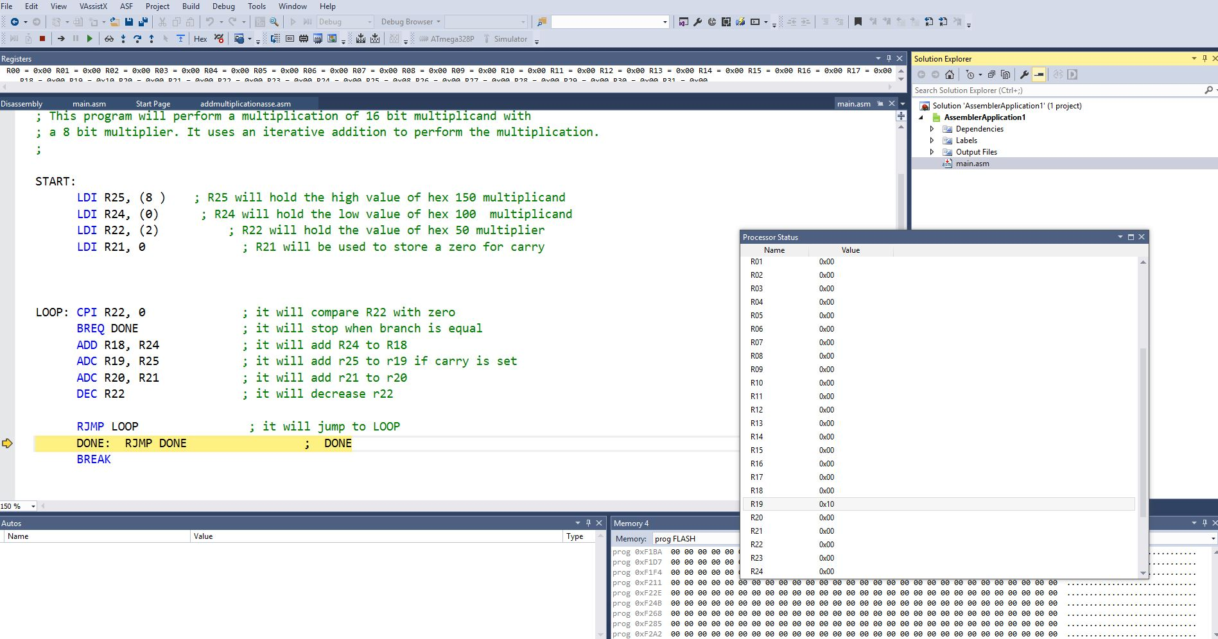

**Screenshot of the mul command: (proving same result)**

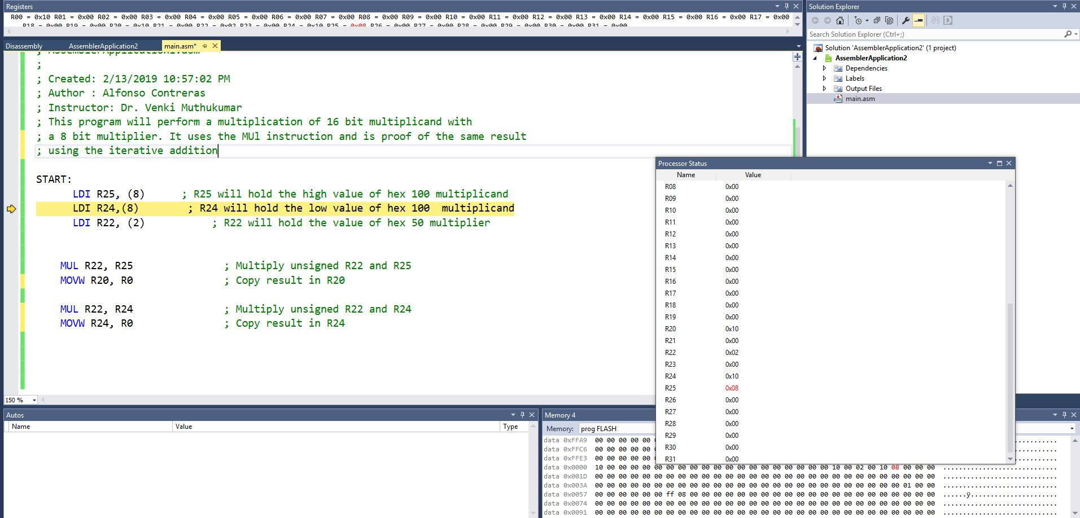

1. **SCREENSHOT OF EACH DEMO (BOARD SETUP)**

N/A

1. **VIDEO LINKS OF EACH DEMO**

<https://youtu.be/IenHjg7oCKk>

1. **GITHUB LINK OF THIS DA**

https://github.com/alf8420/Submit.git

**Student Academic Misconduct Policy**

<http://studentconduct.unlv.edu/misconduct/policy.html>

“This assignment submission is my own, original work”.

NAME OF THE STUDENT