| **SI SESSION PLAN** | | SI Leader: | Audrey Fuller | Session Date: | 4/6/23 | | --- | --- | --- | --- | | Week #: | 11 | Session Letter: | B | | Course & Section: | GCIS-123.4 | Course Instructor: | Toni Audi | | Planning Date: | 2/5/23 | Planning Time: | 9:52 | |
| --- | --- | --- | --- | --- | --- | --- | --- | --- | --- | --- | --- | --- | --- | --- | --- | --- | --- |

**Beginning reminders:**

☑ Is the room set up in a way conducive to collaborative learning?

☑ Is the agenda posted to the board for participants to see?

☑ Do you have your attendance sheet up to record your attendance?

☑ Do you have any other documents/resources up and ready to go for your session?

If you are all set with the reminders, then go have fun and good luck!

**Is there a study strategy you want to focus on? (If so, what is it? Otherwise, leave blank.)**

Collaborative Brain Dump (also plugging the review session on Sunday).

**Main concepts student should feel more comfortable with:**

# Units 7-9 Study Guide I Made

## <https://docs.google.com/document/d/1ebL8biacHQvcsYR_-VacXJt929plIarX0wOGVTSES2c/edit?usp=sharing>

## ASCII

* Encoding characters as integers
* ord(char): translates a character to an integer.
* chr(code): translates an integer to a character.

# Unit 10: Classes & Objects

* Mnemonics: giving a name to something in order to more easily recognize it

## Classes

* Group information together and name components
* Encapsulation: everything associated with an object in one place (default fields)
* like a blueprint, it tells us how to build something
* class Class_Name:

field = value

field2 = value

* Must be instantiated before being used (made into an object)
* Constructor used to create class
* Default constructor has no fields, instance = Class_Name()
  + Allocates memory for all encapsulated entities
  + Copies any values from the class to the new instance
* Can create custom constructors with reserved function __init__(self):
* precede all references to variables with *self*: reference to the object that is being created
* Self can create attributes that are not part of the class, they only exist inside instances

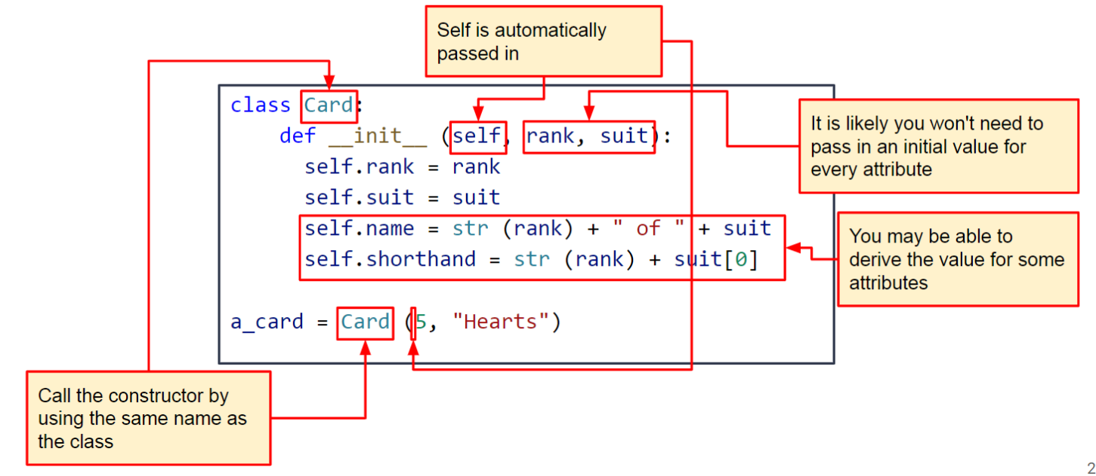

* Fields accessed/added using dot notation, Class_Name.field = new_value
* Classes’ fields are its state
* Static: attributes that are part of the class
  + Can be accessed without creating instance
  + Shallow copy: both the class and the instance reference the same memory address
* __slots__ key field used to specify the name of each state variable
  + List where only the specified attributes are allowed
  + Trying to use a different attribute results in an AttributeError

## Noun-Verb Analysis

* Nouns will be become classes or attributes
  + State is what does my class contain
  + determine what type each of our attributes will be
  + Think about how the attributes will be initialized
* Verbs will become functions
  + Behavior is what does my class do
  + Basis for the functions that need to be written

| **Activity\*** | **Process to use** | **Time** | **After Session Thoughts** |
| --- | --- | --- | --- |
| **Opener:**  **Brain Teasers** | Have the students work together to solve these brain teasers:  What is full of holes but still holds water?   * A sponge   A man who was outside in the rain without an umbrella or hat didn’t get a single hair on his head wet. Why?   * He was bald   What has many teeth, but can’t bite?   * A comb   What is so fragile that saying its name breaks it?   * Silence   What can run but never walks, has a mouth but never talks, has a head but never weeps, has a bed but never sleeps?   * A river | 5 | | ☹ | 2 | 3 | 4 | 5 | 6 | 7 | 8 | 9 | ☺ | | --- | --- | --- | --- | --- | --- | --- | --- | --- | --- | | ☐ | ☐ | ☐ | ☐ | ☐ | ☐ | ☐ | ☐ | ☐ | ☐ | |
| **Vocab Review** | <https://jamboard.google.com/d/1VoUnNQifQaGKte_490yoIFK7mdf71yXFx4kSJqlxWXA/edit?usp=sharing> Have the students work on this jamboard to review vocab |  | | ☹ | 2 | 3 | 4 | 5 | 6 | 7 | 8 | 9 | ☺ | | --- | --- | --- | --- | --- | --- | --- | --- | --- | --- | | ☐ | ☐ | ☐ | ☐ | ☐ | ☐ | ☐ | ☐ | ☐ | ☐ | |
| **Coding Activity** | Have the students work on this coding activity regarding classes: <https://github.com/alf9310/GCIS-123-4-SI-Sessions/blob/main/week11/classes.py> |  | | ☹ | 2 | 3 | 4 | 5 | 6 | 7 | 8 | 9 | ☺ | | --- | --- | --- | --- | --- | --- | --- | --- | --- | --- | | ☐ | ☐ | ☐ | ☐ | ☐ | ☐ | ☐ | ☐ | ☐ | ☐ | |
| **Closer:** | Plug review session on Saturday! Share this study guide if they attend <https://docs.google.com/document/d/1ebL8biacHQvcsYR_-VacXJt929plIarX0wOGVTSES2c/edit?usp=sharing> |  | | ☹ | 2 | 3 | 4 | 5 | 6 | 7 | 8 | 9 | ☺ | | --- | --- | --- | --- | --- | --- | --- | --- | --- | --- | | ☐ | ☐ | ☐ | ☐ | ☐ | ☐ | ☐ | ☐ | ☐ | ☐ | |

*\*See the* [*Activity Database*](https://docs.google.com/spreadsheets/d/1Oc6uAX2Uaq2Ym6M1FQjivRI_ryA_T9k1AcEKi__3Ml4/edit?usp=sharing) *and* [*SI Share*](https://drive.google.com/drive/folders/1WKkkRXpRW6_OVdc4eFVgAkDRt7y8E_VT?usp=sharing) *for ideas.*

**Ending reminders:**

☑ Did you mark down attendance on your attendance sheet?

☑ Did you remind everyone of the next session and any upcoming tests or quizzes or due dates?

☑ Did you fill in the after session thoughts?

**Optional Notes and Comments:**

**Bi-Weekly Question:** What have you done to improve upon feedback you received in your observations? Have you completed your peer observations yet?

During a couple of my observations I’ve received feedback about trying to do lecture-style conversations about topics less. Because of this I’ve been trying to gear more of my session plans towards collaborative activities so students are less likely to ask me for the answer or to explain content, instead they talk to their partner about it. In addition I’ve been trying to redirect more, now that I know the comprehension levels of my regulars I can usually redirect to one of them and boost their confidence in their responses.