Carbon Footprint of Relational and Hybrid Object-Relational Storage for Image-Based Time-Series Workloads

Alfa Yohannis¹, Alexander Waworuntu², Master Edison Siregar¹, Arya Sanjaya¹, Refgiufi Avrianto¹
¹Universitas Pradita, Indonesia
{alfa.ryano, edison.siregar, arya.sanjaya, refgiufi.patria}@pradita.ac.id
²Universitas Multimedia Nusantara, Indonesia
alex.wawo@umn.ac.id

Abstract—This paper compares two architectures for image-based time-series workloads in smart building IoT: PostgreSQL with TimescaleDB storing images inline as BYTEA (PG), and PostgreSQL with TimescaleDB externalising binaries to MinIO object storage (PM). Using isolated Docker deployments and hardware-level energy tracking via CodeCarbon, we benchmark seven quality-90 JPEG resolutions from 360p to 5K. For insertion, PG is faster from 360p through 1440p (up to ~8×); PM becomes faster at 4K–5K. For point reads, PG leads only at 360p–480p; PM is faster from 720p onward (~8× at 5K). At the whole-phase level, PM reduces energy and CO₂eq emissions by ~27%. Profile-level estimates show PM emitting more at small resolutions but less from 1440p upward. These findings suggest that inline BYTEA suits lower-resolution ingest-heavy workloads, whereas externalised object storage becomes more suitable as payload size and carbon efficiency grow in importance.
Keywords—time-series databases, IoT building monitoring, PostgreSQL, MinIO, object storage, carbon footprint, green computing

Introduction
Smart building and facility-monitoring deployments increasingly combine conventional telemetry with image streams from embedded cameras, doorbells, inspection devices, and other edge systems [1,2]. These applications often need to retain binary media together with timestamps, device identifiers, and other metadata so that operators can inspect the latest frame, replay recent events, or query activity over time [3,4]. In such systems, the data tier runs continuously and its energy use contributes directly to the operational carbon footprint of the building or edge infrastructure [5].
Many organisations prefer to build on PostgreSQL [6] and TimescaleDB [7] rather than introduce a specialised storage stack. When binary media is small, inline storage inside relational rows can be operationally convenient. When binary media becomes large, however, a common alternative is to keep only queryable metadata in PostgreSQL and store the bulk payload in an S3-compatible object store such as MinIO [8] or Amazon S3 [9]. These two options imply different write amplification, memory behaviour, and retrieval paths, and therefore potentially different energy profiles.
Existing benchmarks in the time-series literature focus primarily on lightweight numeric events [10,11,12]. They rarely evaluate multi-megabyte image payloads, and even more rarely report energy or CO₂-equivalent emissions. This leaves a practical gap for image-heavy IoT deployments that must decide whether the simplicity of inline database storage outweighs the performance and sustainability benefits of separating metadata from binary objects.
This paper addresses the following research question: What are the performance and carbon-footprint trade-offs of inline PostgreSQL BYTEA storage (PG) versus PostgreSQL+MinIO externalised object storage (PM) for image-based time-series workloads across increasing image resolutions?
To answer this question, we benchmark both architectures across seven JPEG profiles from 360p to 5K in isolated Docker containers, measure whole-phase energy and emissions with CodeCarbon [13], and analyse insertion throughput, latest-payload point-read latency, storage amplification, and per-profile carbon estimates.

Related Work
Time-series databases are designed to sustain append-oriented ingestion by combining time-based partitioning, compression, and storage layouts that reduce the write amplification of traditional B-Tree update paths [4,14]. TimescaleDB [7] extends PostgreSQL [6] with hypertables while preserving SQL semantics and the operational ecosystem many organisations already use.
Most comparative benchmarks in this space target lightweight scalar data rather than binary media. TSBS [10] uses small DevOps and telemetry records, CrateDB's benchmark [11] focuses on numeric IoT metrics, and the evaluation by Mohamud and Broström [12] studies numerical sensor workloads. These benchmarks do not characterise the behaviour of multi-megabyte image payloads, where storage-engine internals become far more consequential.
That gap matters because large binaries stress systems differently. PostgreSQL's TOAST [15] mechanism relocates oversized values out of the main row, but the payload still remains within the database's transactional and retrieval machinery. Object stores such as MinIO [8], by contrast, are designed to stream large immutable objects directly while leaving relational systems responsible only for lightweight metadata and indexing. The architectural trade-off is therefore not simply “one system versus two systems,” but “one transactional path for everything” versus “separating metadata management from binary transport.”
The carbon footprint of software systems has also attracted increasing attention. Lannelongue et al. [16] formalised the Green Algorithms approach, and CodeCarbon [13] provides a practical implementation that estimates energy use and associated emissions from machine-level measurements and regional grid intensity. Within database systems, however, relatively little work applies this style of accounting to binary time-series storage workloads. The present study addresses that gap for relational versus hybrid object-relational image storage.
Building on the preceding analysis, this study offers two principal contributions:
- An empirical assessment of write and read performance for inline PostgreSQL BYTEA storage (PG) versus PostgreSQL paired with externalised MinIO object storage (PM), reporting ingestion throughput and latest-payload point-read latency across a sweep of seven JPEG profiles ranging from 360p up to 5K.
- A side-by-side carbon-footprint assessment of the two architectures executing the same image-based time-series workloads, with CO₂-equivalent emissions derived from CodeCarbon using RAPL-based hardware energy measurements.

Methodology

Hardware and Software Environment
All experiments execute on a single host machine running Ubuntu 24.04.4 LTS with Linux kernel 6.8.0-107-generic. The machine provides an 11th Gen Intel Core i9-11900H processor (8 cores / 16 threads, 2.50 GHz base, 4.90 GHz max), 30.99 GB RAM, and a 1.9 TB Samsung MZVL22T0HBLB-00BH1 NVMe SSD. The machine is located in Indonesia (Banten grid region); CodeCarbon uses the corresponding national carbon intensity factor. CPU and RAM power are measured via Intel RAPL (Running Average Power Limit) hardware counters (tracking_mode=machine). Containers share host CPU and memory with no explicit CPU pinning or memory limits. The software stack consists of Docker 29.4.0 with Docker Compose v5.1.1, PostgreSQL 15 with TimescaleDB (latest-pg15), MinIO (minio/minio:latest), Python 3.14.3, and the benchmark libraries psycopg2 2.9.11, minio 7.2.20, Pillow 12.2.0, and CodeCarbon 3.2.6.

Environment and Workloads
Both architectures are deployed in Docker containers on the same host. PostgreSQL exposes port 55432 and is launched with max_connections=100. MinIO exposes ports 59000 and 59001 and uses the bucket sensor-media. The benchmark harness generates deterministic JPEG payloads from a single source image using a collage transform implemented in Python with Pillow. All profiles use JPEG quality 90.
Seven image profiles are evaluated: 360p (640×360, ~0.09 MB), 480p (854×480, ~0.16 MB), 720p (1280×720, ~0.36 MB), 1080p (1920×1080, ~0.80 MB), 1440p (2560×1440, ~1.40 MB), 4K UHD (3840×2160, ~2.99 MB), and 5K (5120×2880, ~5.09 MB). For each profile, the benchmark performs a 100-row warm-up, followed by 5 measured insertion runs of 2,000 rows each in batches of 50. Latest-payload retrieval is measured as a point-read query with 2 warm-up runs and 5 measured runs. Driver overhead uses 10 warm-up and 10 measured roundtrips. The boxplot figures display the interquartile range and median across all runs; observed variance remained low, supporting the adequacy of 5 runs.
A representative PG row at 1080p contains: sample_id=1, device_id=1, ts=2025-04-20T00:00:00Z, payload_data=~0.80 MB JPEG binary, payload_size_bytes=838860, width=1920, height=1080. For PM, the same row replaces payload_data with minio_object_key=“sensor-media/1080p/frame_0001.jpg”.

Schema and Operations
PG stores each frame as a TimescaleDB hypertable row with a BYTEA payload column, allowing PostgreSQL's TOAST [15] mechanism to manage oversized values transparently. PM stores the metadata in PostgreSQL but replaces the inline payload with a minio_object_key; the binary image itself is uploaded to MinIO. Both tables use a compound index on (device_id, ts DESC) to support latest-payload access. Each measured insert run recreates the target table, and PM also recreates the MinIO bucket. For retrieval, PG returns the inline payload through PostgreSQL, whereas PM first retrieves the latest object key from PostgreSQL and then issues an HTTP GET to MinIO. This design isolates the core storage behaviour of each architecture while preserving realistic end-to-end operations.

Carbon Footprint Measurement
Each architecture phase runs as a single CodeCarbon [13]-tracked process. CodeCarbon reads CPU and RAM power via Intel RAPL hardware counters and converts total energy to CO₂-equivalent using the regional grid intensity for Indonesia (≈0.676 kg CO₂eq/kWh). Each tracked phase therefore includes driver overhead, warm-up work, insert benchmarks, point-read benchmarks, and setup/teardown costs inside one measured duration. CodeCarbon reports total phase duration, energy consumed, CPU energy, RAM energy, and CO₂-equivalent emissions. To obtain per-profile carbon estimates, we apply a constant power-rate model to the measured phase totals. For a phase with total energy E, emissions C, and duration T, we derive average rates E/T and C/T and multiply them by each profile's measured insert and point-read durations. These per-profile values are estimates rather than direct measurements, while the phase-level totals remain directly measured by CodeCarbon.

Result

Supporting Performance Observations
Table I shows a write-side crossover. Insert throughput (Fig. 1) is faster on PG from 360p through 1440p, with especially large margins at 360p (738.32 vs. 104.05 rows/s, 7.10×) and 480p (475.75 vs. 56.88 rows/s, 8.36×). The gap narrows steadily as payload size increases and reverses at 4K, where PM reaches 28.49 vs. 23.04 rows/s (1.24× faster), and remains in PM's favour at 5K (15.59 vs. 13.16 rows/s, 1.18× faster). On this host, inline BYTEA provides higher insert throughput up to 1440p, while PM becomes faster at the two largest profiles.
Latest-payload point-read latency (Fig. 2) follows a different pattern. PG is slightly faster at the two smallest profiles: 0.720 vs. 1.717 ms at 360p and 1.017 vs. 1.163 ms at 480p. From 720p onward, PM becomes faster. At 1080p, PM reduces latency from 3.641 to 2.352 ms (1.55× faster); at 4K, from 14.942 to 2.461 ms (6.07× faster); and at 5K, from 27.322 to 3.360 ms (8.13× faster). The read-side crossover therefore occurs earlier than the write-side crossover, but only after the two smallest profiles.
PM consistently shows lower storage amplification (rightmost columns of Table I). PG remains near 1.04× storage amplification for all profiles, whereas PM stays essentially at raw-payload size, between 1.0029× and 1.0001×. At 5K and 2,000 inserted rows, PG occupies 10555.0 MB versus 10172.9 MB for PM, a 382.1 MB gap despite similar logical content.

- Insert throughput, point-read latency, and storage amplification (2,000 rows). PG = PostgreSQL+TimescaleDB with inline BYTEA. PM = PostgreSQL+TimescaleDB+MinIO.
Res. | Insert (rows/s) |  | Point Read (ms) |  | Storage amp.
 | PG | PM | PG | PM |  | PG | PM
360p | 738.32 | 104.05 | 0.720 | 1.717 |  | 1.0453 | 1.0029
480p | 475.75 | 56.88 | 1.017 | 1.163 |  | 1.0435 | 1.0017
720p | 205.12 | 51.69 | 2.589 | 1.767 |  | 1.0394 | 1.0007
1080p | 91.86 | 39.02 | 3.641 | 2.352 |  | 1.0388 | 1.0003
1440p | 50.51 | 35.47 | 7.909 | 2.280 |  | 1.0390 | 1.0002
4K | 23.04 | 28.49 | 14.942 | 2.461 |  | 1.0378 | 1.0001
5K | 13.16 | 15.59 | 27.322 | 3.360 |  | 1.0376 | 1.0001
- Per-profile carbon footprint estimates from the constant power-rate model.
Res. | Duration (s) |  | Energy (µWh) |  | CPU (µWh) |  | RAM (µWh) |  | Emissions (mg CO₂eq)
 | PG | PM | PG | PM | PG | PM | PG | PM | PG | PM
360p | 17.3 | 103.6 | 218.4 | 979.3 | 122.5 | 403.9 | 96.0 | 575.4 | 147.6 | 662.0
480p | 27.4 | 183.9 | 346.7 | 1738.4 | 194.4 | 716.9 | 152.3 | 1021.5 | 234.3 | 1175.0
720p | 62.3 | 202.3 | 788.3 | 1912.6 | 442.0 | 788.8 | 346.3 | 1123.8 | 532.8 | 1292.8
1080p | 141.6 | 273.8 | 1790.7 | 2588.8 | 1004.1 | 1067.7 | 786.6 | 1521.2 | 1210.4 | 1749.9
1440p | 254.3 | 301.2 | 3216.1 | 2847.6 | 1803.3 | 1174.4 | 1412.7 | 1673.2 | 2173.8 | 1924.8
4K | 564.6 | 371.8 | 7140.1 | 3514.8 | 4003.7 | 1449.6 | 3136.5 | 2065.3 | 4826.2 | 2375.8
5K | 993.0 | 671.1 | 12558.4 | 6344.6 | 7041.8 | 2616.6 | 5516.6 | 3728.0 | 8488.6 | 4288.5
Measured whole-phase totals including driver overhead, warm-up, and setup: PG = 0.029330 kWh / 19824.8 mg CO₂eq; PM = 0.021427 kWh / 14483.0 mg CO₂eq.

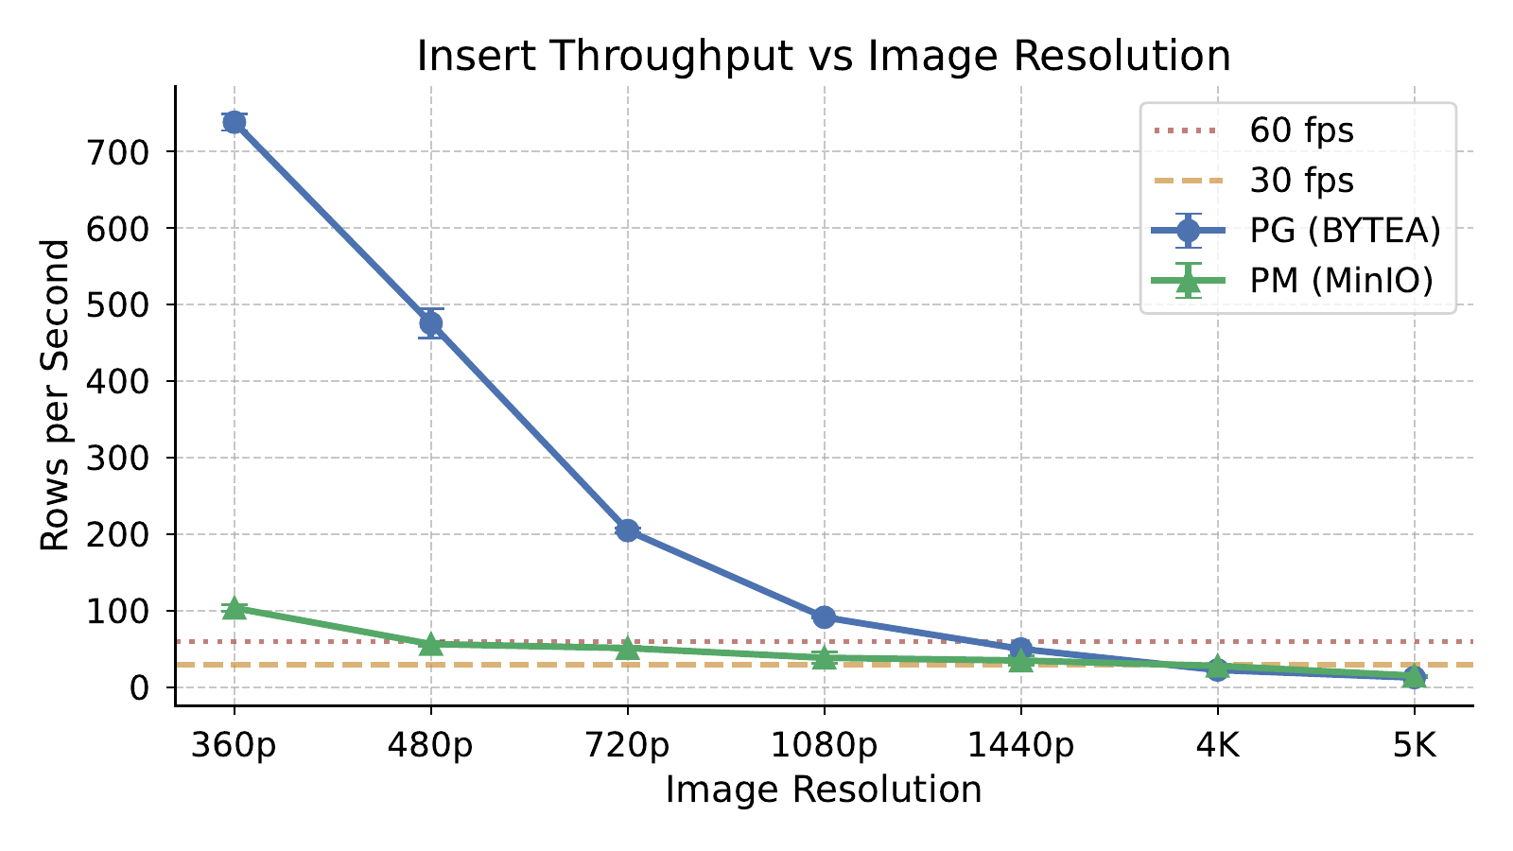
- Insert throughput across 360p–5K. PG leads through 1440p, while PM overtakes at 4K and remains ahead at 5K.
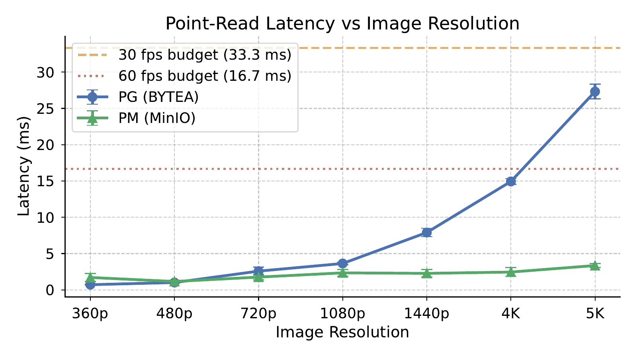
- Latest-payload point-read latency across 360p–5K. PG is slightly faster at 360p and 480p, while PM is faster from 720p onward and the gap widens sharply at 4K and 5K.
Driver overhead provides additional context. Averaged across the seven profiles, PostgreSQL's driver roundtrip measures 0.062 ms, while the MinIO list_buckets roundtrip used here measures 0.606 ms. This auxiliary measurement suggests a higher fixed client-side roundtrip on the MinIO path, although it does not by itself determine the end-to-end insert or point-read results.

Carbon Footprint (RQ)
The whole-phase CodeCarbon measurements show that PM is more carbon-efficient overall on this seven-profile benchmark. The PostgreSQL-only phase ran for 2319.1 s, consumed 0.029330 kWh, and emitted 19824.8 mg CO₂eq. The PostgreSQL+MinIO phase ran for 2266.3 s, consumed 0.021427 kWh, and emitted 14483.0 mg CO₂eq. This corresponds to a 26.9% reduction in both energy and emissions for PM at the phase level.
Table II, together with the per-profile emissions in Fig. 3 and the energy breakdown in Fig. 4, refines that picture by estimating the profile-level contribution of insert and point-read work. These estimates show that PM is not uniformly greener. At 360p, PM emits 662.0 mg CO₂eq versus 147.6 mg for PG (+348.3%). At 480p, the PM penalty is even larger (1175.0 vs. 234.3 mg, +401.4%), reflecting its poor small-payload insert throughput. PM remains worse at 720p and 1080p, though the gap narrows substantially by 1080p (1749.9 vs. 1210.4 mg, +44.6%).
The carbon crossover occurs at 1440p. There, PM emits 1924.8 mg versus 2173.8 mg for PG, an 11.5% advantage. At 4K the PM advantage becomes pronounced, dropping from 4826.2 to 2375.8 mg (-50.8%), and at 5K the reduction remains substantial at 4288.5 versus 8488.6 mg (-49.5%). This pattern is consistent with the throughput crossover observed in the previous subsection: once payload sizes become large enough for PostgreSQL's inline binary handling to dominate execution time, PM's separate object-storage path is associated with both faster completion and lower estimated carbon.
The difference between the measured whole-phase totals and the summed profile estimates is expected. The per-profile table only allocates insert and point-read time, whereas the tracked phases also include warm-up activity, driver-overhead measurements, and setup work. The directly measured phase totals therefore remain the correct basis for the overall RQ answer, while the profile estimates explain where that overall difference originates.

Discussion
Resolution-dependent crossover. The updated benchmark does not support a universal “always use MinIO” or “always use inline BYTEA” conclusion. PG remains faster for writes through 1440p on this machine and also keeps a small point-read advantage at 360p and 480p. From 720p onward, however, PM becomes the faster point-read path; from 4K onward it also becomes the faster write path; and from 1440p onward it becomes the lower-carbon option.
Why PostgreSQL leads at smaller writes. At lower resolutions, PG benefits from batched inserts that avoid an extra object-store request per payload. The images are small enough that PostgreSQL's inline binary handling and TOAST overhead remain tolerable, while PM still pays the fixed cost of a MinIO PUT plus a relational metadata write. That is why PM performs particularly poorly at 360p and 480p despite its much better storage amplification.
Why PostgreSQL+MinIO becomes faster at large payloads. As payload size grows, the cost of keeping the binary within the relational engine rises sharply. PostgreSQL must still log, manage, and retrieve large values through the database path, whereas PM lets PostgreSQL manage only metadata while MinIO streams the object directly. This architectural separation is consistent with the observed performance and carbon advantages once the binary payload is large enough, which in our measurements happens around 1440p for emissions and 4K for insertion throughput.
Implications for system design. The following workload- and resolution-dependent implications emerge for carbon-aware deployment:
- 360p–1080p ingest-heavy deployments: PG is preferable, delivering 2.3–8.4× higher write throughput from 480p through 1080p while keeping point-read latency below ~3.7 ms.
- 1440p mixed workloads: PG still writes faster (50.51 vs. 35.47 rows/s), but PM cuts measured read latency by 3.5× (2.280 vs. 7.909 ms) and emits less CO₂eq per profile, so the choice depends on whether writes, reads, or carbon dominate.
- 4K–5K and read-sensitive workloads: PM is preferable: it shows higher write throughput (28.49 vs. 23.04 rows/s at 4K; 15.59 vs. 13.16 rows/s at 5K), much lower retrieval latency (~6–8×), and roughly half the per-profile carbon footprint while also using less storage.
- Storage efficiency and operational simplicity: PM minimises footprint (~1.00× vs. ~1.04× amplification), but PG keeps everything inside a single transactional boundary and may remain attractive when that simplicity outweighs the storage savings and the high-resolution read performance gap.
Database selection rationale. This study uses PostgreSQL as the sole relational baseline because TimescaleDB—the most widely adopted open-source time-series extension—is built exclusively on PostgreSQL. Other relational engines lack a comparable native time-series extension. The inline-vs-externalized trade-off is conceptually transferable to any relational database supporting large-object columns, though exact crossover points would depend on each engine's page layout and WAL implementation.

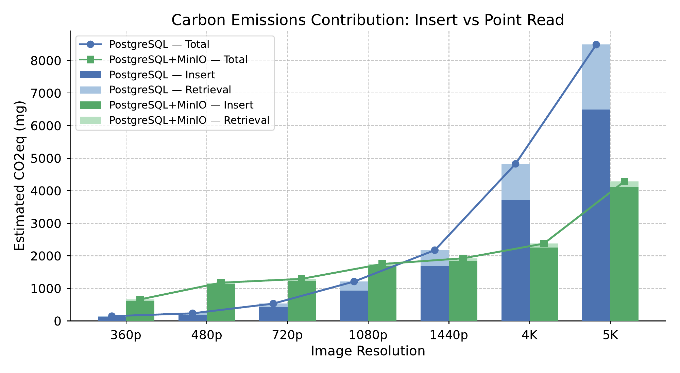
- Estimated per-profile CO₂eq emissions (mg) split into insert and point-read contributions. PM emits more at small profiles but less from 1440p upward.

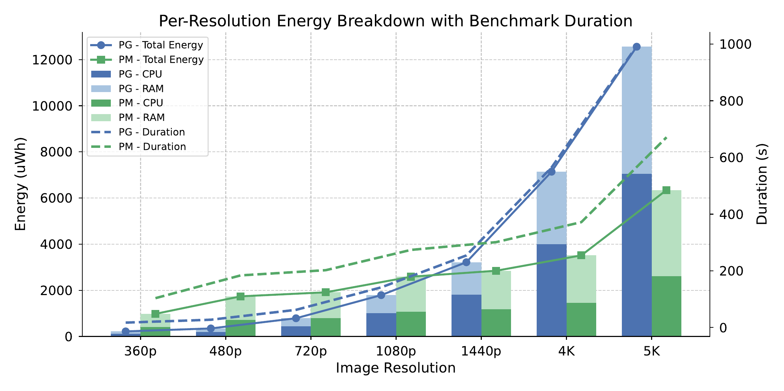
- Per-profile energy breakdown (CPU + RAM, stacked bars) with benchmark duration shown as dashed lines. PM's carbon crossover is consistent with the crossover in end-to-end benchmark time.

Scalability considerations. Our benchmark uses 2,000 rows per resolution. At larger scales, PG's inline BYTEA disadvantage at high resolutions should compound: TOAST tables grow, and WAL volume scales linearly with payload size. PM writes only lightweight metadata rows to PostgreSQL, so WAL and index overhead scale with metadata rather than payload size. MinIO's horizontal scale-out with erasure coding could further favour PM at large data volumes.
Threats to validity. Results are from a single host and a single container topology. Different hardware, distributed object-storage deployments, or more compressible media could shift the exact crossover points. The fixed batch size of 50 records may not reflect all production ingestion patterns; alternative batch sizes could shift the observed carbon crossover. CPU and RAM power are measured via Intel RAPL hardware counters (tracking_mode=machine); the per-profile carbon table is a proportional estimate based on a constant power-rate assumption rather than a hardware-instrumented per-operation trace. All benchmarks use sequential single-client access; concurrent multi-client workloads, mixed read/write patterns, and diverse query types were not evaluated. Even so, both architectures were benchmarked under identical hardware conditions, making the comparative trends informative within this benchmark.

Conclusions
This study evaluated the performance and carbon footprint of two storage architectures for image-based time-series workloads: PostgreSQL with inline BYTEA storage and PostgreSQL with externalised MinIO object storage, using CodeCarbon with RAPL-based hardware energy measurement.
RQ answer: The better architecture depends on payload size and workload emphasis, but the complete seven-profile benchmark on this machine shows lower measured whole-phase energy use and emissions for PostgreSQL+MinIO overall. Measured whole-phase totals show PM emitting 14483.0 mg CO₂eq versus PostgreSQL's 19824.8 mg, a 26.9% reduction. PG remains faster for insertion from 360p through 1440p, while PM becomes faster at 4K and 5K. For latest-payload point reads, PG is slightly faster at 360p and 480p, but PM is faster from 720p onward and the gap reaches 8.1× at 5K.
The key practical finding is therefore a set of crossover points rather than a universal winner. On this host, inline PostgreSQL may suit smaller ingest-heavy workloads, while PostgreSQL+MinIO may become more suitable as binary payload size increases and point-read or carbon efficiency become more important. Future work should evaluate the same architectures on multi-node deployments and under higher client concurrency to determine how stable these crossover points remain outside a single-host setup. Additionally, PostgreSQL Large Objects (LO) merit investigation as a third architecture—using lo_import/lo_export instead of inline BYTEA—to determine whether LO's streaming interface narrows the carbon and retrieval gap with MinIO.
Summary of contributions. Overall, this paper delivers (i) a performance comparison of inline PostgreSQL BYTEA storage (PG) and PostgreSQL with externalised MinIO object storage (PM) for storing and reading image payloads from 360p to 5K, revealing two distinct crossovers—PG leads insertion through 1440p before PM overtakes at 4K as inline WAL and TOAST handling of multi-megabyte payloads dominates the relational write path, while PM leads point-read latency from 720p onward as MinIO's direct HTTP streaming bypasses the cost of materialising large BYTEA values through PostgreSQL's wire protocol, widening to ~8× at 5K; and (ii) a carbon-footprint comparison between the same two architectures under identical image-based time-series workloads, quantifying CO₂-equivalent emissions through CodeCarbon with RAPL-based hardware energy measurement.

Acknowledgment
The authors sincerely appreciate the institutional support of Universitas Pradita and Universitas Multimedia Nusantara. The research problem, experimental framework, analytical approach, and original manuscript draft were prepared entirely by the named authors. Generative AI tools served only in an auxiliary role, assisting with parts of the benchmark implementation and suggesting refinements to readability and style. All such outputs were independently reviewed, validated, and revised by the authors, who remain solely accountable for the final content.

References
- A. Zanella, N. Bui, A. Castellani, L. Vangelista, and M. Zorzi, "Internet of things for smart cities," IEEE Internet of Things Journal, vol. 1, no. 1, pp. 22--32, 2014. [Online]. Available: https://doi.org/10.1109/JIOT.2014.2306328
- Intuz, "Top databases in the market for iot applications," https://www.intuz.com/guide-on-top-iot-databases, 2023, accessed: 2026-05-28.
- G. Petrov and V. Vasilev, "Communication interfaces, protocols, and specialized time series databases for the internet of things (iot) -- survey," Electrotechnica \& Electronica (E+E), vol. 60, no. 1-2, pp. 23--31, 2025, accessed: 2026-05-28. [Online]. Available: https://epluse.ceec.bg/wp-content/uploads/2025/07/20250102-04.pdf
- S. K. Jensen, T. B. Pedersen, and C. Thomsen, "Time series management systems: A survey," IEEE Transactions on Knowledge and Data Engineering, vol. 29, no. 11, pp. 2581--2600, 2017. [Online]. Available: https://doi.org/10.1109/TKDE.2017.2740932
- B. McBride and D. Reynolds, "Survey of time series database technology," Epimorphics Ltd., Tech. Rep., 2020, version 1.0.0, prepared for the ENTRAIN project; accessed: 2026-05-28. [Online]. Available: https://nora.nerc.ac.uk/id/eprint/527832/7/N527832CR.pdf
- The PostgreSQL Global Development Group, '`Postgresql: The world's most advanced open source relational database,'' https://www.postgresql.org/, 2026, accessed: 2026-05-28.
- Tiger Data, "Timescaledb: The time-series database built on postgres," https://www.tigerdata.com/timescaledb, 2026, accessed: 2026-05-28.
- MinIO, Inc., "Minio: High performance object storage," https://www.min.io/, 2026, accessed: 2026-05-28.
- Amazon Web Services, "Amazon s3 -- cloud object storage," https://aws.amazon.com/s3/, 2026, accessed: 2026-05-28.
- Timescale, "Time series benchmark suite (tsbs)," https://github.com/timescale/tsbs, 2018, accessed: 2026-05-28.
- CrateDB, "Independent time series benchmark confirms cratedb top-tier performance," https://cratedb.com/blog/independent-time-series-benchmark-confirms-cratedb-top-tier-performance, 2024, accessed: 2026-05-28.
- N. J. Mohamud and M. S. Brostr\"om, "Assessing query execution time and implementational complexity in different databases for time series data," Master's thesis, KTH Royal Institute of Technology, 2024, accessed: 2026-05-28. [Online]. Available: https://www.diva-portal.org/smash/get/diva2:1865472/FULLTEXT01.pdf
- B. Courty, V. Schmidt, S. Luccioni et al., "mlco2/codecarbon: v3.2.6," Zenodo, version v3.2.6, 2026, accessed: 2026-05-28. [Online]. Available: https://zenodo.org/records/19334697
- N. de Waal, "Literature study: Timeseries databases," Atlarge Research, TU Delft, Tech. Rep., 2022, accessed: 2026-05-28. [Online]. Available: https://atlarge-research.com/pdfs/2022-dewaal-litsurvey.pdf
- The PostgreSQL Global Development Group, "Toast -- the oversized-attribute storage technique," https://www.postgresql.org/docs/15/storage-toast.html, 2026, accessed: 2026-05-28.
- L. Lannelongue, J. Grealey, and M. Inouye, "Green algorithms: Quantifying the carbon footprint of computation," Advanced Science, vol. 8, no. 12, p. 2100707, 2021. [Online]. Available: https://doi.org/10.1002/advs.202100707

