Carbon Footprint of Document-oriented and Relational Storage for Image-based Time-Series Workloads

Alfa Yohannis¹, Alexander Waworuntu², Master Edison Siregar¹, Arya Sanjaya¹, Refgiufi Avrianto¹
¹Universitas Pradita, Indonesia
{alfa.ryano, edison.siregar, arya.sanjaya, refgiufi.patria}@pradita.ac.id
²Universitas Multimedia Nusantara, Indonesia
alex.wawo@umn.ac.id

Abstract—This paper measures and compares the carbon footprint of PostgreSQL (TimescaleDB) and MongoDB for image-based time-series workloads across four resolutions (1080p–5K). Using isolated Dockerized deployments and hardware-level energy tracking via CodeCarbon, we find that the preferred engine depends on resolution. At lower resolutions, MongoDB completes workloads faster and emits less carbon despite comparable per-second power consumption. Above 1440p, PostgreSQL becomes both faster and more energy-efficient, as MongoDB's inline document storage incurs increasing write amplification and cache pressure that prolong execution and raise energy use. PostgreSQL's TOAST mechanism maintains stable storage amplification (1.04×) across all resolutions and yields a 13.3% carbon advantage overall. Per-resolution estimates confirm MongoDB emits less at 1080p–1440p but substantially more at 4K–5K. These findings provide resolution-dependent guidance for carbon-aware database selection in green IoT deployments.
Keywords—time-series databases, IoT building monitoring, PostgreSQL, MongoDB, carbon footprint, green computing, inline image storage

Introduction
Modern smart building and facility-monitoring systems deploy dense networks of IoT cameras and environmental sensors to support occupancy analysis, safety auditing, and predictive maintenance [1,2]. These devices continuously capture high-resolution images—from 1080p security feeds to 4K inspection cameras—which must be stored inline alongside timestamped metadata for temporal queries and audit replay [3,4]. As green building standards increasingly account for the operational carbon cost of IT infrastructure [5], the choice of storage backend is no longer purely a performance decision: it directly affects the energy consumed by the data tier running 24/7 at the edge or in an on-premises data center.
Organizations commonly reuse existing general-purpose databases for this role. PostgreSQL [6] with TimescaleDB [7] extends a proven relational engine with hypertable chunking and employs TOAST [8] to relocate large binary payloads out-of-line. MongoDB [9] offers native Time-Series Collections backed by the WiredTiger [10] storage engine with Snappy [11] block compression, storing image binaries as BSON binary values in documents managed by WiredTiger [10,12]. This inline vs. out-of-line architectural difference is expected to produce divergent energy profiles as image resolution grows.
Existing benchmarks [13,14,15] target lightweight numeric payloads and do not measure energy or emissions. No study evaluates the carbon cost of storing multi-megabyte image frames across varying resolutions in containerized environments. Therefore, this work aims to answer this research question: What is the carbon footprint of inline image-based time-series storage in PostgreSQL (TimescaleDB) versus MongoDB across varying camera resolutions, and which engine is more energy-efficient for IoT building monitoring?
We benchmark both engines across four resolutions (1080p–5K) using Docker containers, measure end-to-end CO₂ emissions with CodeCarbon [16], and report supporting performance metrics to explain the observed energy differences.

Related Work
Time-series databases optimize sequential data ingestion by employing append-only storage, time-based partitioning, and columnar compression to bypass the write amplification inherent in traditional B-Tree indexes [4,17]. TimescaleDB [7] extends PostgreSQL [6] with transparent hypertable chunking that sustains flat ingestion throughput at scale [5,17]. MongoDB [9] introduced native Time-Series Collections in version 5.0, which internally bucket measurements into compacted documents optimized for time-series access patterns [18,19].
Existing comparative benchmarks between these systems are limited to lightweight scalar payloads. The TSBS suite [13] generates synthetic JSON/SQL events of a few bytes each. The evaluation by Mohamud and Broström [15] compared TimescaleDB and MongoDB query execution times using numerical sensor data. CrateDB's benchmark [14] focused on aggregate throughput over numeric IoT metrics. These studies typically do not incorporate binary payloads exceeding a few kilobytes.
This gap is significant because storage engine behavior changes fundamentally with payload size. MongoDB's WiredTiger [10] uses Snappy [11] block compression that achieves excellent ratios on repetitive JSON structures but offers negligible compression on high-entropy binary data such as JPEG images. PostgreSQL's TOAST [8] mechanism stores oversized attributes out-of-line in a separate table, an approach specifically designed for large binary values. MongoDB's alternative for large binaries—GridFS [20]—chunks files into 255 KB segments, but is incompatible with native Time-Series Collections [21].
The carbon footprint of computing infrastructure has attracted growing attention. Lannelongue et al. [22] introduced the Green Algorithms framework, quantifying CO₂-equivalent emissions from computation using energy consumption and regional grid intensity—the same principle adopted by CodeCarbon [16]. Strubell et al. [23] highlighted the disproportionate energy cost of large-scale model training, catalysing interest in per-operation energy accounting across the software stack. Within the database domain, energy efficiency studies have focused on query optimisation [5] and hardware selection, but no prior work applies per-operation carbon accounting to binary time-series storage engines under varying payload sizes.
The present work directly addresses this gap by conducting a systematic multi-resolution benchmark (1080p–5K) for IoT building monitoring, measuring both performance and carbon footprint via CodeCarbon.
According to the gaps identified above, the contributions of this study are as follows:
- A performance comparison of PostgreSQL/TimescaleDB and MongoDB native Time-Series Collections for storing and reading multi-megabyte image payloads, covering insertion throughput and retrieval latency across resolutions from 1080p to 5K.
- A carbon-footprint comparison between the two databases under identical image-based time-series workloads, quantifying CO₂-equivalent emissions through CodeCarbon with RAPL-based hardware energy measurement.

Methodology

Hardware and Software Environment
All experiments execute on a single host machine running Linux 6.8.0-107 with an 11th Gen Intel Core i9-11900H processor (8 cores / 16 threads, 2.50 GHz base), 31 GB RAM, and a 1.9 TB Samsung MZVL22T0HBLB-00BH1 NVMe SSD. The machine is located in Indonesia (Banten grid region); CodeCarbon uses the corresponding national carbon intensity factor. CPU and RAM power are measured via Intel RAPL hardware counters (tracking_mode=machine). Containers share host CPU and memory with no explicit CPU pinning or memory limits beyond the MongoDB WiredTiger cache cap. The software stack consists of Docker Compose v2, PostgreSQL 15 with TimescaleDB 2.x, MongoDB 7.0, Python 3.14.3, and the benchmark libraries psycopg2, pymongo, and CodeCarbon 3.2.6.

Environment and Workloads
All experiments run in isolated Docker [24] containers: PostgreSQL 15 with TimescaleDB [7] using default shared buffers, and MongoDB 7.0 [9] with --wiredTigerCacheSizeGB 30, allocating nearly all available system RAM (31 GB) to the WiredTiger buffer pool. This server-grade configuration allows the complete working set to reside in memory at lower resolutions, isolating the effect of inline document size from cache-pressure artefacts at modest scales. Four quality-90 JPEG resolutions simulate building-camera payloads: 1080p (1920×1080, ~0.80 MB), 1440p (2560×1440, ~1.40 MB), 4K UHD (3840×2160, ~2.99 MB), and 5K (5120×2880, ~5.09 MB). High-quality JPEG at 90 retains high visual entropy that largely defeats internal block compression, reflecting realistic inline storage conditions.

Schema and Operations
PostgreSQL stores each frame as a BYTEA row in a TimescaleDB hypertable; TOAST [8] automatically relocates payloads exceeding ~2 KB out-of-line. MongoDB stores functionally equivalent documents with the binary payload as inline BinData [12] in a native Time-Series Collection (Snappy-compressed WiredTiger B-Tree). Both schemas carry a compound index on (device_id, ts DESC).
For each resolution, 2,000 records are inserted in batches of 50 across 5 runs, followed by 5 binary retrieval runs that fully materialise the payload_data column for 2,000 rows. Each engine is wiped and rebuilt between resolutions. Storage amplification is measured as on-disk size divided by raw payload size. The boxplot figures display the interquartile range and median across all runs; observed variance remained low, supporting the adequacy of 5 runs.

Carbon Footprint Measurement
Each engine phase runs as a single CodeCarbon [16]-tracked process. CodeCarbon reads CPU and RAM power via Intel RAPL hardware counters and converts total energy to CO₂-equivalent using the regional grid intensity for Indonesia (≈0.676 kg CO₂eq/kWh). All operations for a given engine (insertions and retrievals across all four resolutions) are aggregated into one measurement, isolating per-engine carbon cost under identical hardware conditions. Per-resolution emissions are estimated using a constant power-rate model: the measured total energy E and duration T yield an average power P = E/T; each profile's estimated energy is then P × t_{i}, where t_{i} is the sum of mean insertion and retrieval times for that profile across all runs. This model assumes constant CPU and RAM power draw throughout the phase, providing a principled first-order breakdown consistent with CodeCarbon's measurement approach.

Result

Supporting Performance Observations
Table I summarises the performance results. Insert throughput (Fig. 1) crosses over between 1440p and 4K: MongoDB leads at 1080p (337.6 vs. 87.6 r/s, 3.85×) and 1440p (128.3 vs. 49.9 r/s, 2.57×), but PostgreSQL overtakes at 4K (23.3 vs. 18.1 r/s, 1.28×) and widens its lead at 5K (13.6 vs. 7.8 r/s, 1.74×). The crossover is consistent with WiredTiger [10] serialising entire BSON documents—including multi-megabyte BinData—through row-store B-Tree pages [25], which is efficient while documents stay sub-2 MB but degrades per-insert CPU and I/O cost as payload size grows; PostgreSQL's TOAST [8] mechanism, by contrast, relocates oversized values out-of-line and preserves a compact, resolution-independent write path.
Binary retrieval (Fig. 2) favours MongoDB consistently across all resolutions: 2.86× faster at 1080p (2,412 vs. 6,906 ms), 2.73× at 1440p (4,260 vs. 11,619 ms), 2.49× at 4K (10,143 vs. 25,267 ms), and 1.66× at 5K (28,377 vs. 47,044 ms). The same inline BSON layout that penalises insertion benefits retrieval, since payload bytes are co-located with their metadata in the storage-engine path, whereas PostgreSQL must follow TOAST pointers to a secondary table.
Storage amplification (rightmost columns of Table I) shows a resolution-dependent regime change for MongoDB: 0.10× at 1080p (Snappy [11] effectively compresses small documents where JSON metadata dominates) rising to 0.27× at 1440p, then crossing unity to 1.58× at 4K and 3.00× at 5K as the high-entropy JPEG binary payload dominates and defeats block compression; PostgreSQL maintains stable 1.04× amplification at all resolutions thanks to TOAST's sequential out-of-line layout.

Carbon Footprint (RQ)
Table II reports energy and emissions. The complete MongoDB phase consumed 0.0309 kWh over 2,378 s, emitting 20,891 mg CO₂eq. PostgreSQL consumed 0.0273 kWh over 2,167 s, emitting 18,439 mg CO₂eq—a 13.3% carbon advantage for PostgreSQL. CPU energy accounts for approximately 57% of total consumption in both phases; MongoDB's CPU energy is 16.1% higher than PostgreSQL's. The additional carbon cost for MongoDB stems from both longer execution (+9.8%) and slightly higher average CPU power draw during write-intensive phases.

- Insert throughput, retrieval latency, and storage amplification (2,000 rows). PG = PostgreSQL+TimescaleDB, MG = MongoDB. Raw = total logical payload size.
Res. | Raw (MB) | Insert (r/s) |  | Retr. (ms) |  | Storage amp.
 |  | PG | MG | PG | MG | PG | MG
1080p | 1600 | 87.6 | 337.6 | 6906 | 2412 | 1.04× | 0.10×
1440p | 2800 | 49.9 | 128.3 | 11619 | 4260 | 1.04× | 0.27×
4K | 5980 | 23.3 | 18.1 | 25267 | 10143 | 1.04× | 1.58×
5K | 10180 | 13.6 | 7.8 | 47044 | 28377 | 1.04× | 3.00×

- Per-resolution carbon footprint breakdown (constant power-rate estimates; Total row from CodeCarbon measurement). PG = PostgreSQL, MG = MongoDB.
Res. | Duration (s) |  | Energy (µWh) |  | CPU (µWh) |  |  | RAM (µWh) |  | Emissions (mg CO₂eq)
 | PG | MG | PG | MG |  | PG | MG | PG | MG | PG | MG
1080p | 148.7 | 41.7 | 1872 | 542 |  | 1046 | 310 | 826 | 232 | 1266 | 366
1440p | 258.5 | 99.3 | 3254 | 1290 |  | 1818 | 739 | 1436 | 552 | 2200 | 872
4K | 555.8 | 602.1 | 6997 | 7824 |  | 3910 | 4480 | 3088 | 3345 | 4730 | 5289
5K | 973.1 | 1430.1 | 12252 | 18585 |  | 6845 | 10640 | 5406 | 7945 | 8281 | 12562
Total | 2167 | 2378 | 27280 | 30906 |  | 15242 | 17694 | 12038 | 13212 | 18439 | 20891

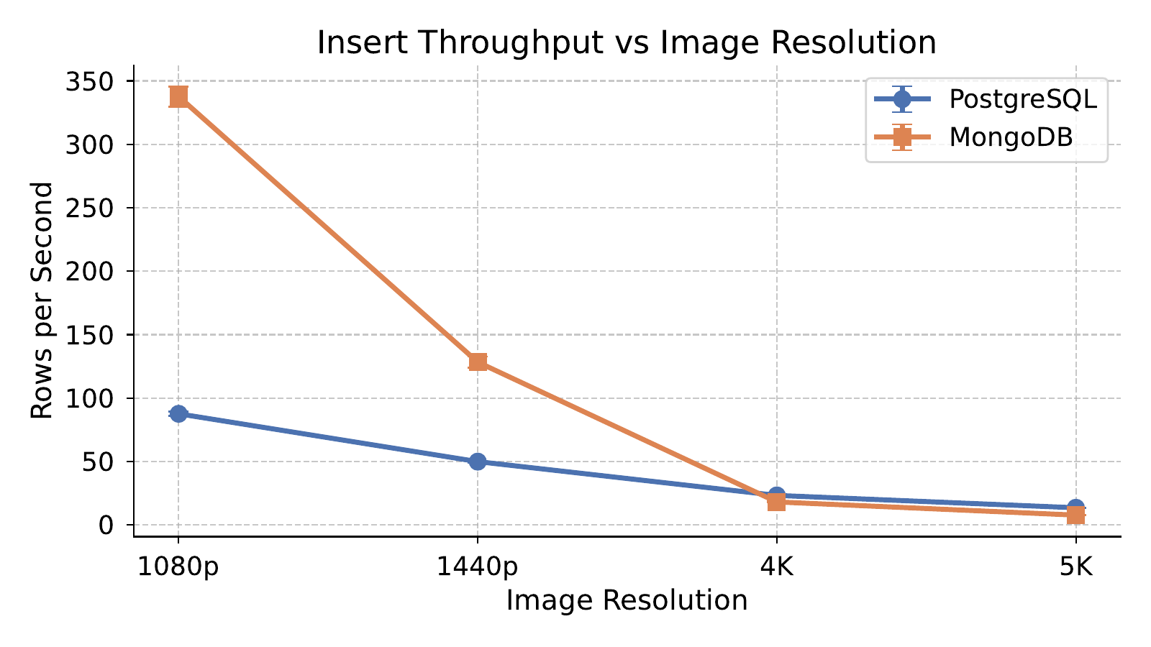
- Insert throughput (rows/s) across 1080p–5K. MongoDB leads at 1080p and 1440p; PostgreSQL overtakes above 1440p.
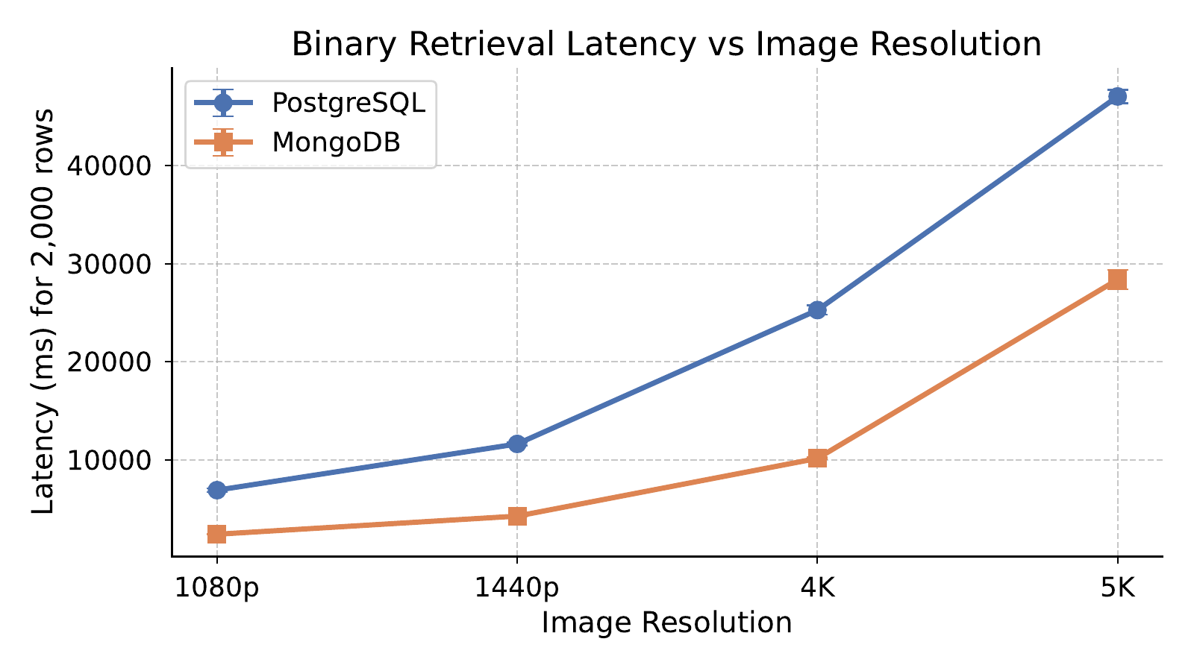
- Binary retrieval latency (2,000 rows). MongoDB is consistently faster across all resolutions.
Per-resolution estimates of total emissions (Fig. 3) and the corresponding energy breakdown (Fig. 4) reveal a nuanced, resolution-dependent picture. At 1080p, MongoDB's much faster insertion (3.85×) means it completes the profile in 41.7 s versus PostgreSQL's 148.7 s, emitting substantially less per resolution (366 vs. 1,266 mg CO₂eq). The same advantage holds at 1440p (872 vs. 2,200 mg). The crossover occurs at 4K, where MongoDB's insertion slows (18.1 vs. 23.3 r/s) due to the inherent overhead of serializing and writing 2.99 MB BSON documents inline into B-Tree leaf pages—even though the 9.3 GB MongoDB database at 4K still fits within the 30 GB cache. This causes it to take 8.3% longer (602 vs. 556 s) and emit 11.8% more (5,289 vs. 4,730 mg).
At 5K the gap widens significantly: the cumulative database grows to ~29.8 GB, approaching the 30 GB cache limit, so later insert runs trigger buffer pool eviction on top of the large-document serialization overhead. MongoDB takes 47% longer (1,430 vs. 973 s) and emits 52% more CO₂eq (12,562 vs. 8,281 mg). The aggregate 13.3% carbon premium for MongoDB is dominated by the high-resolution profiles, which account for the majority of total benchmark time.

Discussion
Why MongoDB costs more energy. MongoDB's WiredTiger engine stores entire BSON documents—including multi-megabyte BinData image payloads—through a row-store B-Tree architecture [10,12,25]. At 1080p and 1440p, the accumulated database (~0.16 and ~0.74 GB respectively) fits entirely within the 30 GB cache, enabling cache-resident writes and explaining MongoDB's strong insertion throughput at these resolutions. The degradation at 4K stems not from cache eviction—the 9.3 GB database still fits comfortably—but from the inherent cost of serializing and writing 2.99 MB documents inline: each insert requires more CPU work per operation and produces less compressible B-Tree page content. At 5K, the cumulative database (~29.8 GB) approaches the 30 GB cache limit; by the later insert runs the buffer pool has no headroom and eviction threads stall application threads to flush dirty pages [26], compounding the large-document overhead. At low resolutions, Snappy compression is effective because structured JSON metadata dominates small documents, explaining MongoDB's 0.10× amplification at 1080p. As payload size grows, the high-entropy JPEG binary defeats block compression [10], causing storage amplification to reach 3.00× at 5K with corresponding extra write I/O energy. GridFS would avoid inline storage but is incompatible with native Time-Series Collections [21].
Why PostgreSQL is more efficient. TOAST [8] relocates payloads exceeding ~2 KB out-of-line into a sequentially-organised secondary table, leaving only a small pointer in the main hypertable row. This keeps the primary B-Tree compact for fast index traversal regardless of resolution, produces stable 1.04× amplification, and avoids the large-page write overhead observed in MongoDB at higher resolutions. The resulting lower I/O volume contributes to PostgreSQL's shorter total execution time (9.8% less than MongoDB at the phase level) and lower energy consumption. Notably, MongoDB's inline storage does deliver faster binary retrieval at all resolutions (1.7–2.9×)—a genuine advantage of the document model for read-heavy workloads—but this benefit is outweighed in energy terms by MongoDB's write amplification at 4K and above.
Implications for green building monitoring. At 1080p MongoDB's inline storage is actually advantageous—faster retrieval, better compression, and lower carbon per profile—so the appropriate choice depends on camera resolution. Above 1440p, PostgreSQL with TimescaleDB is both faster for insertion and more carbon-efficient. The per-row carbon difference at 4K is modest in isolation, but accumulates with ingestion volume. MongoDB paired with an external object store (MinIO, S3) should be evaluated for large-payload scenarios where retrieval speed is paramount.
Scale-up indication. The benchmark measurements provide a per-row emission indicator. At 4K, dividing the measured phase emission rate by the insertion rate yields ~0.49 mg CO₂eq per row inserted for MongoDB and ~0.37 mg for PostgreSQL—a ~33% higher per-row cost. This indicator is derived from a batch benchmark on a single machine and should not be extrapolated directly to production deployments, where workload patterns, concurrency, and hardware differ. It nonetheless illustrates that the relative carbon cost difference per ingested frame grows with resolution and accumulates with data volume.
Engineering guidelines. The following resolution-dependent guidelines emerge for carbon-aware deployment:
- ≲1.5 MB payloads (1080p–1440p): MongoDB native Time-Series Collections deliver higher insertion throughput, lower binary-retrieval latency, and lower CO₂eq per profile due to faster completion; Snappy compression of small documents yields sub-unity storage amplification. MongoDB is therefore the carbon-efficient choice for standard-definition camera streams.
- ≳3 MB payloads (4K and above): PostgreSQL with TimescaleDB becomes both faster for insertion and more carbon-efficient. TOAST out-of-line storage maintains 1.04× amplification and stable write paths, whereas WiredTiger's inline BSON serialisation incurs growing per-insert CPU work, page fragmentation, and—near the cache limit at 5K—eviction-induced stalls that prolong execution and raise energy consumption.

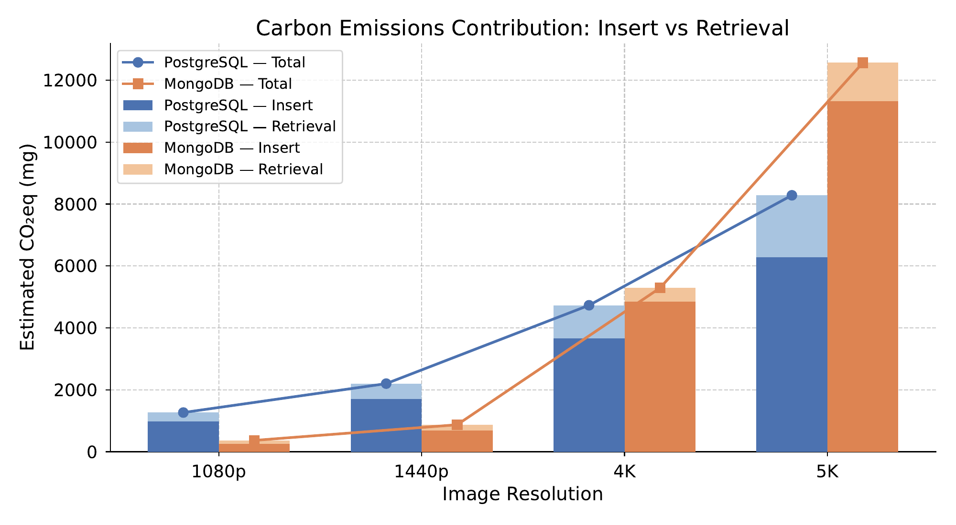
- Estimated CO₂eq emissions (mg) per resolution, split by insert and retrieval contribution. MongoDB emits less at 1080p–1440p due to faster completion; PostgreSQL is more efficient above 1440p.
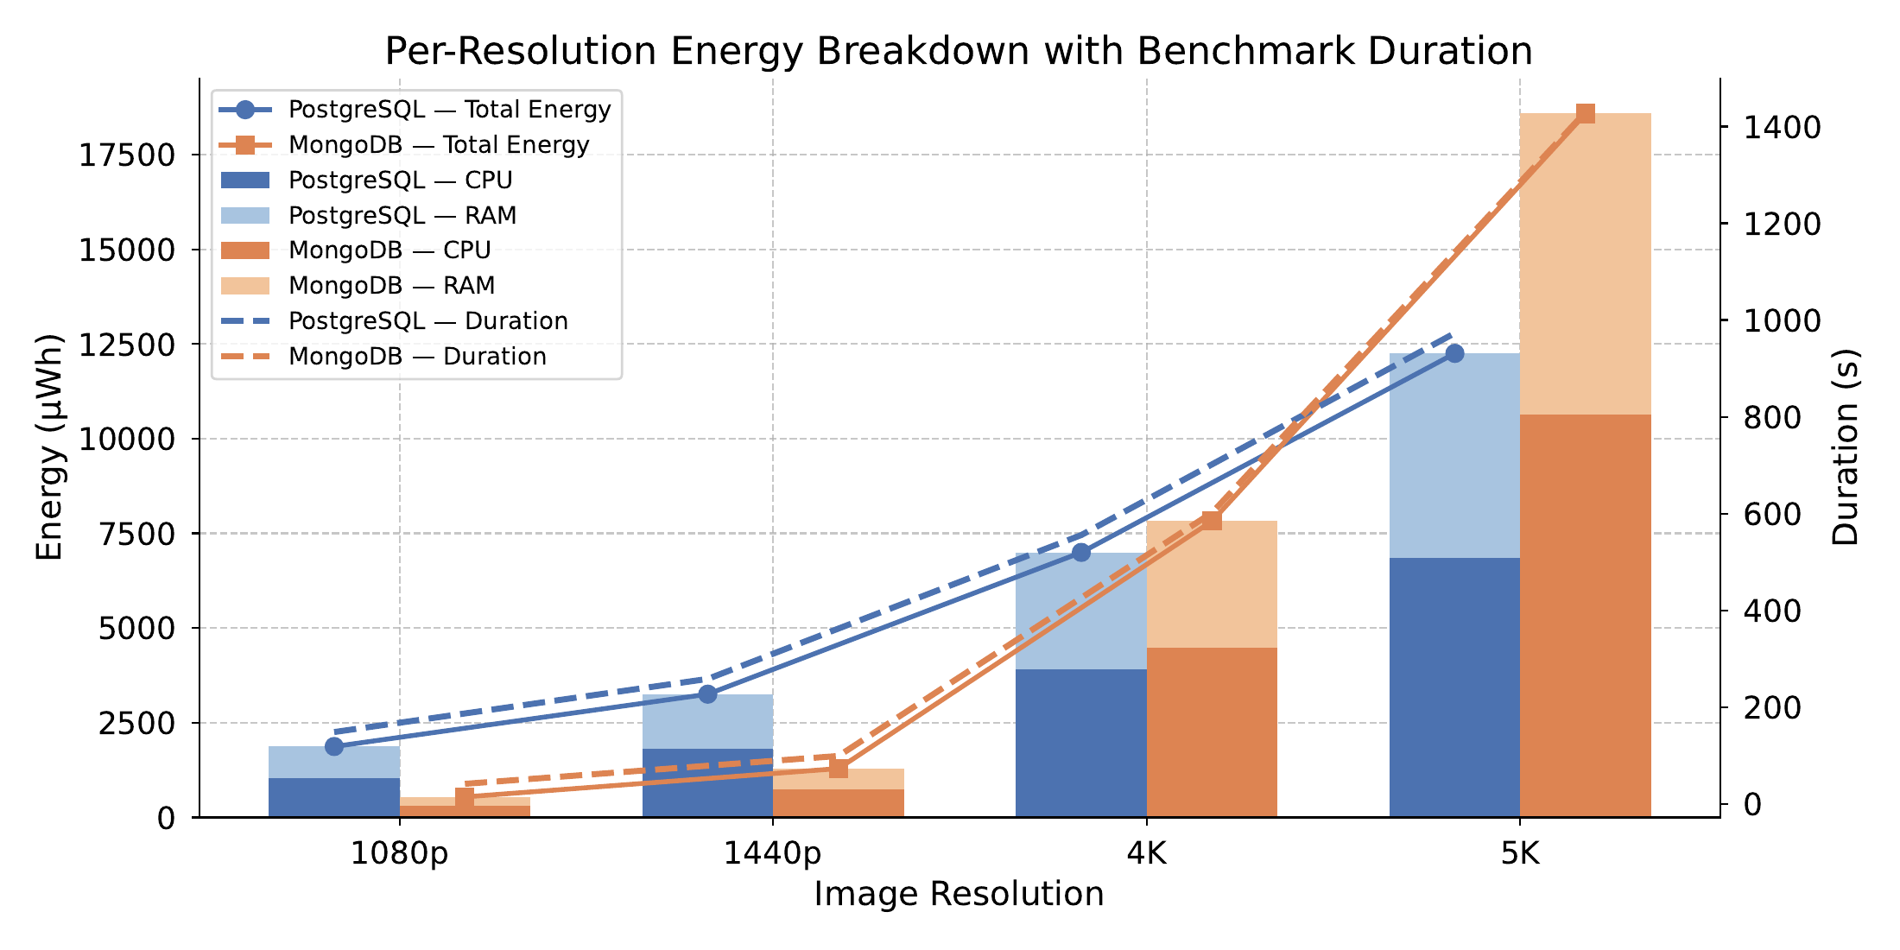
- Per-resolution energy breakdown (CPU + RAM, stacked bars) with benchmark duration (dashed lines, right axis). MongoDB exceeds PostgreSQL above 1440p across all components.

- Retrieval-dominated workloads: MongoDB's inline layout retains a 1.7–2.9× retrieval advantage at every tested resolution; for read-heavy analytics over multi-megabyte frames, MongoDB may still be preferred despite its insertion cost, provided the working set comfortably fits in the WiredTiger cache.
- High-resolution sustained ingestion: where ingestion volume and image size are both growing, a hybrid architecture that keeps queryable metadata in PostgreSQL or MongoDB and stores the binary payload in an external object store (e.g., MinIO, S3) is the natural next step to decouple write amplification from the database engine and bound the carbon cost.
Threats to validity. Results are from a single host; distributed deployments may differ. Quality-90% JPEG payloads represent a realistic but not worst-case scenario; lower-quality images would reduce payload size and shift the crossover point. The fixed batch size of 50 records may not reflect all production ingestion patterns; alternative batch sizes could shift the observed carbon crossover between 1440p and 4K. CPU and RAM power are measured via Intel RAPL hardware counters (tracking_mode=machine); per-resolution emissions are proportional estimates based on a constant power-rate assumption. MongoDB's WiredTiger cache is set to 30 GB (--wiredTigerCacheSizeGB 30), allocating nearly all system RAM; PostgreSQL operates under equivalent memory availability through OS-level page caching. Larger cache allocations on higher-memory machines could delay—but not eliminate—the architectural limitations that drive MongoDB's energy cost at high resolutions. All benchmarks use sequential single-client access; concurrent multi-client workloads, mixed read/write patterns, and diverse query types were not evaluated. Both phases are measured under identical hardware conditions, so the relative comparison remains valid.

Conclusions
This study measured the carbon footprint of PostgreSQL (TimescaleDB) and MongoDB for building-monitoring IoT image workloads across 1080p–5K inside Docker containers using CodeCarbon with RAPL-based hardware energy measurement.
RQ answer: MongoDB emits 20,891 mg CO₂eq (0.0309 kWh) versus PostgreSQL's 18,439 mg CO₂eq (0.0273 kWh)—a 13.3% carbon premium for MongoDB overall. The premium stems from BSON inline serialization overhead at 4K and buffer pool pressure as the 5K working set approaches the 30 GB cache limit, prolonging execution (+9.8%) and raising CPU energy (+16.1%). Per-resolution estimates show PostgreSQL emitting more at 1080p–1440p (where MongoDB's faster completion dominates) but less at 4K–5K where MongoDB's write amplification takes effect.
These results offer actionable guidance for green IoT deployments. At 1080p and 1440p, MongoDB is faster and more carbon-efficient per profile due to faster completion. At 4K and above, PostgreSQL is the better choice under the tested conditions: it is faster for insertion, emits less carbon, and maintains 1.04× storage amplification versus MongoDB's 3.00× at 5K. MongoDB retains a consistent advantage in binary retrieval speed (1.7–2.9× faster) across all resolutions, making it attractive for read-heavy workloads.
Future work will evaluate hybrid architectures that combine PostgreSQL or MongoDB for metadata and time-series indexing with an external binary object store (MinIO, S3) to decouple payload storage from the database engine. Additionally, PostgreSQL Large Objects (LO) merit investigation as an alternative to inline BYTEA, and distributed multi-node deployments would test whether the observed carbon crossover persists under sharded or replicated configurations. Extending the benchmark to 6K resolutions and video payloads would further characterise the crossover dynamics.
Summary of contributions. In summary, this paper contributes (i) a performance comparison of PostgreSQL/ TimescaleDB and MongoDB native Time-Series Collections for storing and reading multi-megabyte image payloads from 1080p to 5K, showing that MongoDB sustains higher insertion throughput at 1080p–1440p while PostgreSQL overtakes MongoDB from 4K upward—an inversion driven by WiredTiger's inline BSON serialisation, which forces multi-megabyte BinData through cache and B-Tree page paths and causes cache pressure and write amplification, whereas PostgreSQL's TOAST mechanism relocates large payloads out-of-line and preserves stable write throughput, with MongoDB's contiguous inline layout in turn yielding lower binary-retrieval latency than PostgreSQL's TOAST pointer indirection throughout the tested range; and (ii) a carbon-footprint comparison between the same two databases under identical image-based time-series workloads, quantifying CO₂-equivalent emissions through CodeCarbon with RAPL-based hardware energy measurement.

Acknowledgment
The authors gratefully acknowledge Universitas Pradita and Universitas Multimedia Nusantara for their partial support of this research. The research topic, study design, methodology, and the initial manuscript draft were conceived and authored solely by the listed contributors. Generative AI tools were employed in a strictly assistive capacity, limited to supporting the implementation of selected benchmarking routines and refining the linguistic clarity and style of the manuscript. All AI-assisted output was critically reviewed, verified, and revised by the authors, who assume full responsibility for the integrity, accuracy, and final content of this work.

References
- M. Bajer, "Iot for smart buildings - long awaited revolution or lean evolution," in 2018 IEEE 6th International Conference on Future Internet of Things and Cloud (FiCloud), 2018, pp. 149--154. [Online]. Available: https://doi.org/10.1109/FiCloud.2018.00029
- A. Al-Fuqaha, M. Guizani, M. Mohammadi, M. Aledhari, and M. Ayyash, "Internet of things: A survey on enabling technologies, protocols, and applications," IEEE Communications Surveys \& Tutorials, vol. 17, no. 4, pp. 2347--2376, 2015. [Online]. Available: https://doi.org/10.1109/COMST.2015.2444095
- G. Petrov and V. Vasilev, "Communication interfaces, protocols, and specialized time series databases for the internet of things (iot) -- survey," Electrotechnica \& Electronica (E+E), vol. 60, no. 1-2, pp. 23--31, 2025, accessed: 2026-05-28. [Online]. Available: https://epluse.ceec.bg/wp-content/uploads/2025/07/20250102-04.pdf
- S. K. Jensen, T. B. Pedersen, and C. Thomsen, "Time series management systems: A survey," IEEE Transactions on Knowledge and Data Engineering, vol. 29, no. 11, pp. 2581--2600, 2017. [Online]. Available: https://doi.org/10.1109/TKDE.2017.2740932
- B. McBride and D. Reynolds, "Survey of time series database technology," Epimorphics Ltd., Tech. Rep., 2020, version 1.0.0, prepared for the ENTRAIN project; accessed: 2026-05-28. [Online]. Available: https://nora.nerc.ac.uk/id/eprint/527832/7/N527832CR.pdf
- The PostgreSQL Global Development Group, '`Postgresql: The world's most advanced open source relational database,'' https://www.postgresql.org/, 2026, accessed: 2026-05-28.
- Tiger Data, "Timescaledb: The time-series database built on postgres," https://www.tigerdata.com/timescaledb, 2026, accessed: 2026-05-28.
- The PostgreSQL Global Development Group, "Toast -- the oversized-attribute storage technique," https://www.postgresql.org/docs/15/storage-toast.html, 2026, accessed: 2026-05-28.
- MongoDB, Inc., "Mongodb: The developer data platform," https://www.mongodb.com/, 2026, accessed: 2026-05-28.
- ------, "Wiredtiger storage engine," https://www.mongodb.com/docs/v7.0/core/wiredtiger/, 2026, accessed: 2026-05-28.
- Google, "Snappy: A fast compressor/decompressor," https://github.com/google/snappy, 2024, accessed: 2026-05-28.
- MongoDB, Inc., "Bson types -- mongodb manual," https://www.mongodb.com/docs/v7.0/reference/bson-types/, 2026, accessed: 2026-05-28.
- Timescale, "Time series benchmark suite (tsbs)," https://github.com/timescale/tsbs, 2018, accessed: 2026-05-28.
- CrateDB, "Independent time series benchmark confirms cratedb top-tier performance," https://cratedb.com/blog/independent-time-series-benchmark-confirms-cratedb-top-tier-performance, 2024, accessed: 2026-05-28.
- N. J. Mohamud and M. S. Brostr\"om, "Assessing query execution time and implementational complexity in different databases for time series data," Master's thesis, KTH Royal Institute of Technology, 2024, accessed: 2026-05-28. [Online]. Available: https://www.diva-portal.org/smash/get/diva2:1865472/FULLTEXT01.pdf
- B. Courty, V. Schmidt, S. Luccioni et al., "mlco2/codecarbon: v3.2.6," Zenodo, version v3.2.6, 2026, accessed: 2026-05-28. [Online]. Available: https://zenodo.org/records/19334697
- N. de Waal, "Literature study: Timeseries databases," Atlarge Research, TU Delft, Tech. Rep., 2022, accessed: 2026-05-28. [Online]. Available: https://atlarge-research.com/pdfs/2022-dewaal-litsurvey.pdf
- MongoDB, Inc., "Time series collections -- mongodb manual," https://www.mongodb.com/docs/v7.0/core/timeseries-collections/, 2026, accessed: 2026-05-28.
- ------, "Best practices for time series collections," https://www.mongodb.com/docs/v7.0/core/timeseries/timeseries-best-practices/, 2026, accessed: 2026-05-28.
- ------, "Gridfs -- mongodb manual," https://www.mongodb.com/docs/v7.0/core/gridfs/, 2026, accessed: 2026-05-28.
- ------, "Time series collection limitations," https://www.mongodb.com/docs/v7.0/core/timeseries/timeseries-limitations/, 2026, accessed: 2026-05-28.
- L. Lannelongue, J. Grealey, and M. Inouye, "Green algorithms: Quantifying the carbon footprint of computation," Advanced Science, vol. 8, no. 12, p. 2100707, 2021. [Online]. Available: https://doi.org/10.1002/advs.202100707
- E. Strubell, A. Ganesh, and A. McCallum, "Energy and policy considerations for deep learning in NLP," in Proceedings of the 57th Annual Meeting of the Association for Computational Linguistics (ACL), 2019, pp. 3645--3650. [Online]. Available: https://aclanthology.org/P19-1355/
- Docker, Inc., "Docker: Accelerated container application development," https://www.docker.com/, 2026, accessed: 2026-05-28.
- WiredTiger, "Wiredtiger architecture guide: Row store and column store," https://source.wiredtiger.com/11.2.0/arch-row-column.html, 2026, accessed: 2026-05-28.
- I. Groenewold, "Tuning mongodb for bulk loads," https://www.percona.com/blog/tuning-mongodb-for-bulk-loads/, 2020, accessed: 2026-05-28.

