Project Title: Restaurant POS Application

Students Name: Miho Akasaka, Azam Shirani Bidabadi

Description:

Our Restaurant POS Application is designed to meet the unique needs of the restaurant industry.

With this program, servers have order management and table management. They are able to send an order to kitchen quickly and que to start next service and also take reservations and view available tables. For payment, they can split checks and send receipt via e-mail.

With back-office features, managers can edit menu items, access payroll information, time clocks, and business reports. Detailed sales reports in this system can help provide management with insight into which items are selling the best.

- Technologies used

・Drag and drop

・Ribbon instead menus

・StackPanel, GridSplitter \* TabControl, ToolBar, TreeView

・Printing

- Special features

・Order management

・Table management

・Employee management

・Bill splitting

・Sales report

・Edit Menu

・Sales report

- challenging items that were not done in class, etc.

・Drag and drop

・Ribbon instead menus

・StackPanel, GridSplitter \* TabControl, ToolBar, TreeView

・Printing

ADD TESTING

Log in Window

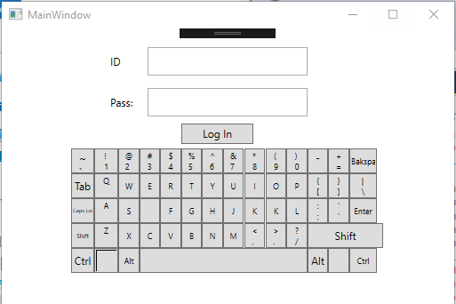

Main window

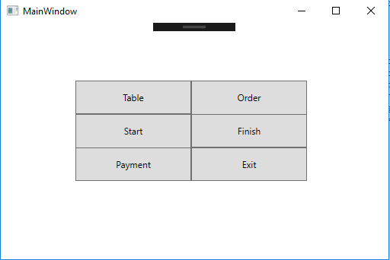

Table:

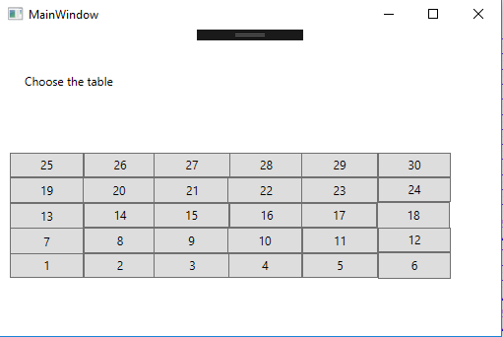

Order Window

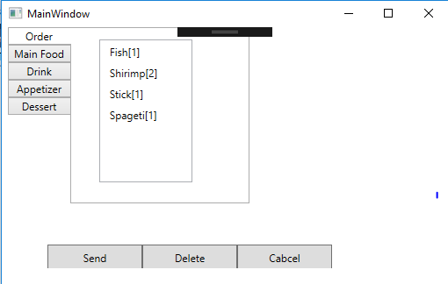

Payment

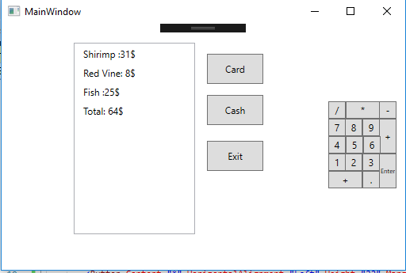

Order detail

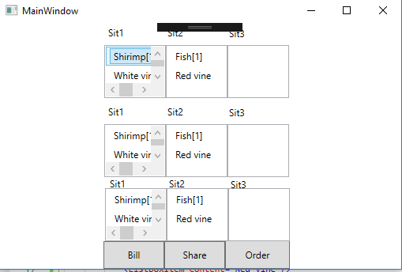

Database structure

