Project Title: Restaurant POS Application

Students Name: Miho Akasaka, Azam Shirani Bidabadi

Description:

Our Restaurant POS Application is designed to meet the unique needs of the restaurant industry.

With this program, servers have order management and table management. They are able to send an order to kitchen quickly and que to start next service and also take reservations and view available tables. For payment, they can split checks.

With back-office features, managers can edit menu items, access payroll information, time clocks, and business reports. Detailed sales reports in this system can help provide management with insight into which items are selling the best.

- Technologies used

・Drag and drop

・StackPanel GridSplitter

・TabControl, ToolBar

・Printing

- Special features

・Order management

・Table management

・Employee management

・Bill splitting

・Edit menu items

・Sales report

- challenging items that were not done in class, etc.

・Drag and drop

・StackPanel GridSplitter

・TabControl, ToolBar

・Printing

Log in Window

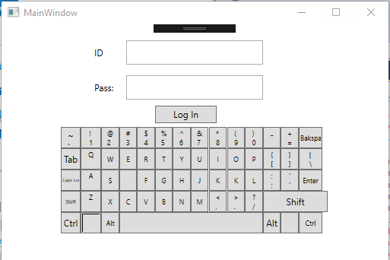

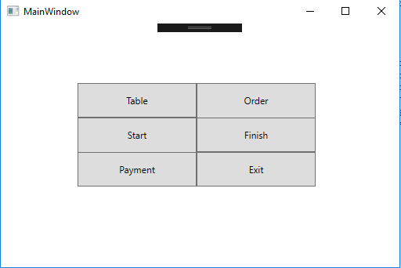

Main window

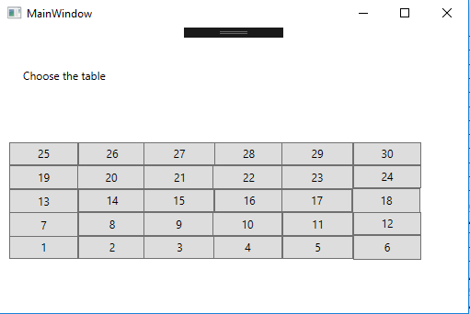

Table:

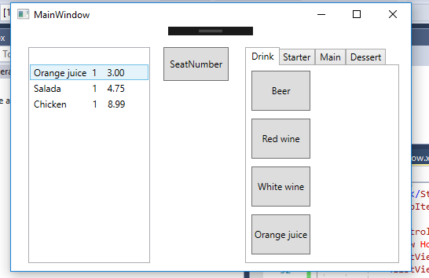Order Window

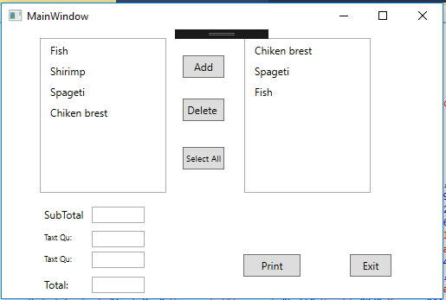

Bill Printing window:

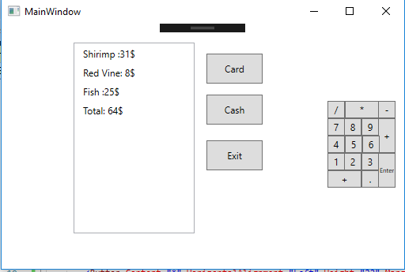Payment window:

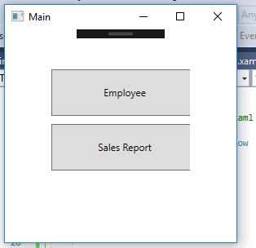

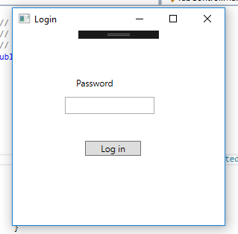Manager POS

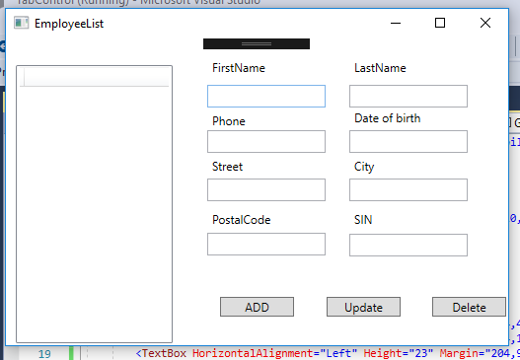

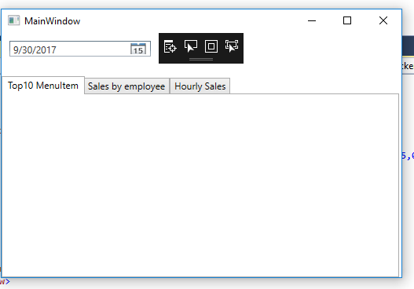

Database structure

