**Phoori Chantima CE6641 66xxxxxxxx**

1. **เชื่อมต่อโครงสร้างเครือข่าย โดยใช้โปรแกรมจำลอง EVE-NG**

1. **การตั้งค่า VLAN**

SW1 show vlan br / show int trunk

SW2 show vlan br / show int trunk

SW3 show vlan br / show int trunk

SW4 show vlan br / show int trunk

1. **ตั้งค่า Inter-VLAN Routing**

R1

R2

R3

R4

1. **การกำหนด Dynamic Routing**

R2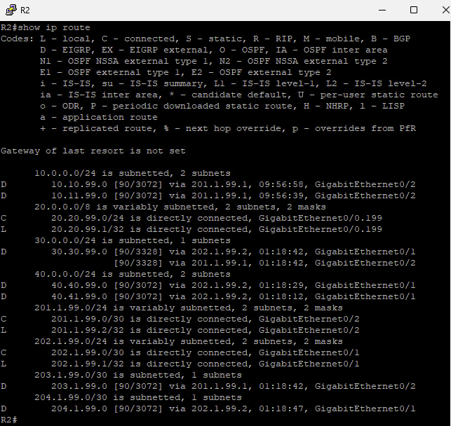

1. **การกำหนด IP Address PCs**

PC11

PC12  
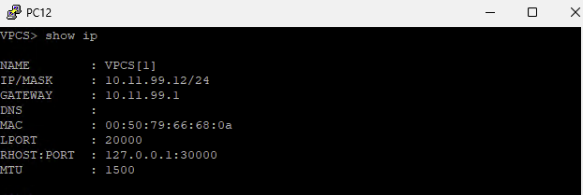

PC21

PC31

PC41

PC42

1. **การทดสอบการเชื่อมต่อเครือข่าย**

PC11

PC12

