**HI!PET APP**  
(Product Briefs)

Alfachran Caesar (3145161066)  
Futuhul Aulad A. (3145163126)  
M. Fathan Qoriiba (3145161299)

* **Global Description**

HI!PET is an Android based application intended for pet owners and people who are interested in raising pets. The app itself focused on two main actors, which are the pet owner and the pet stores. HI!PET allows the user to order all kinds of pet raising kits, pet services (such as grooming and breeding), and even displaying the nearest pet clinics for every pet category (ex: primate, poultry, reptile, etc.). HI!PET also provides the users with couriers to deliver all the pet matters, including the pet itself.

* **Necessity Assessment**

In the scope of pet ownership, the common problem for the pet owners are usually finding a way to deliver their pets for breeding and grooming, since common couriers do not deliver animals. Other problem might be for some unusual pet owners who pet lizards, primates, etc. in finding the nearest pet clinics on their area. In addition, HI!PET allows the user to order all kinds of pet raising kits. Based on those problems, HI!PET will be created.

* **Values Created**

The values created from the app are customer’s trust and funds for greater improvements.

* **Primary Target Segment**

HI!PET primarily targets all of the pet owners and people who are interested in raising pets in DKI Jakarta. We divided the pet owners into two categories, the

* **Competitor**
* Chewy (for ordering dog food)
* BringFido (for finding pet-friendly places)
* **Marketing Strategy**
* Promotion by giving brochures (car free day)
* Creating booth in pet-related events
* Social Media promotion

**Use Case Diagram and Narration**

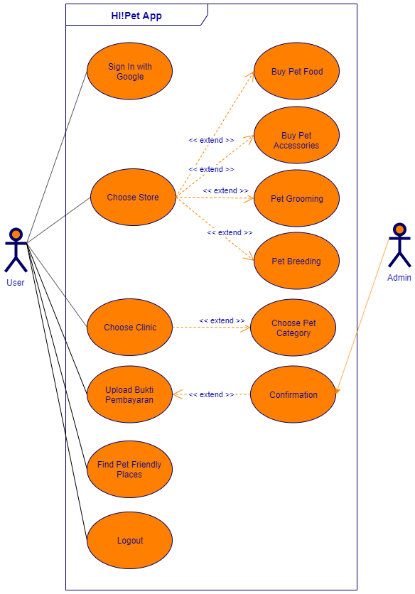

User signs in with Google, without registration. User then launched into the home page. Here, the user can choose the store and click. In this page, the user can choose several menu, such as Buy Pet Food, Buy Pet Accessories, Pet Grooming, and Pet Breeding. After the user clicked one of the menu, they will be served with some information, such as location, price, etc.

In the home page, the user can choose the pet clinic and then served with the Choose Pet Category option. After the click, the app will display the nearest pet clinics based on the chosen pet category.

To complete the transaction, the user must pay via GO-PAY and/or Rekening Bersama, and upload the proof of payment and wait for the admin confirmation.

The user can also choose the Find Pet-friendly Places menu in the home menu to find the pet-friendly places, such as restaurant, hotel, event, etc. (for cats and dogs only).