UNIVERSITAS BANI SALEH

**UJIAN AKHIR SEMESTER GENAP TAHUN AKADEMIK 2023/2024**

|  |  |  |  |
| --- | --- | --- | --- |
| Matakuliah | : ENGLISH 3 | NPM | : 43A87006200202 |
| Prog.Studi/Kelas | : S1/TI/08/B/P | Nama Mahasiswa | : Ilham Fani Ramadhan |
| Hari & Tanggal | : Senin, 15 Juli 2024 | Tanggal Verifikasi | : 12-7-2024 |
| Nama Dosen | : Iin Siah, M. Pd | Diverifikasi Oleh | :  Sabar Hanadwiputra, M.Kom |
| Waktu | : 10.15 s.d 11.15 (60 Menit) | Sifat ujian | : Pilihan Ganda |
|  | : | Bentuk Pelaksanaan | : online |

*Bismillahirrohmanirrohim*

**TEST 1 : LISTENING COMPREHENSION**

* Listen the Audio and answer the questions based on the audio
* There will be 3 Parts in the Test :Part A, B and C for 50 questions
* The time will be provided for about 30 Minutes
* The Audio will be enclosed in GRC

**TEST 2 : STRUCTURE**

* There will 2 Parts in the Test for 40 Questions
* The time will be Provided for about 25 Minutes
* Google Drives are Provided for each class, Make sure that you sent through the right class
* **GOOD LUCK #**

**LISTENING COMPREHENSION PART 1**

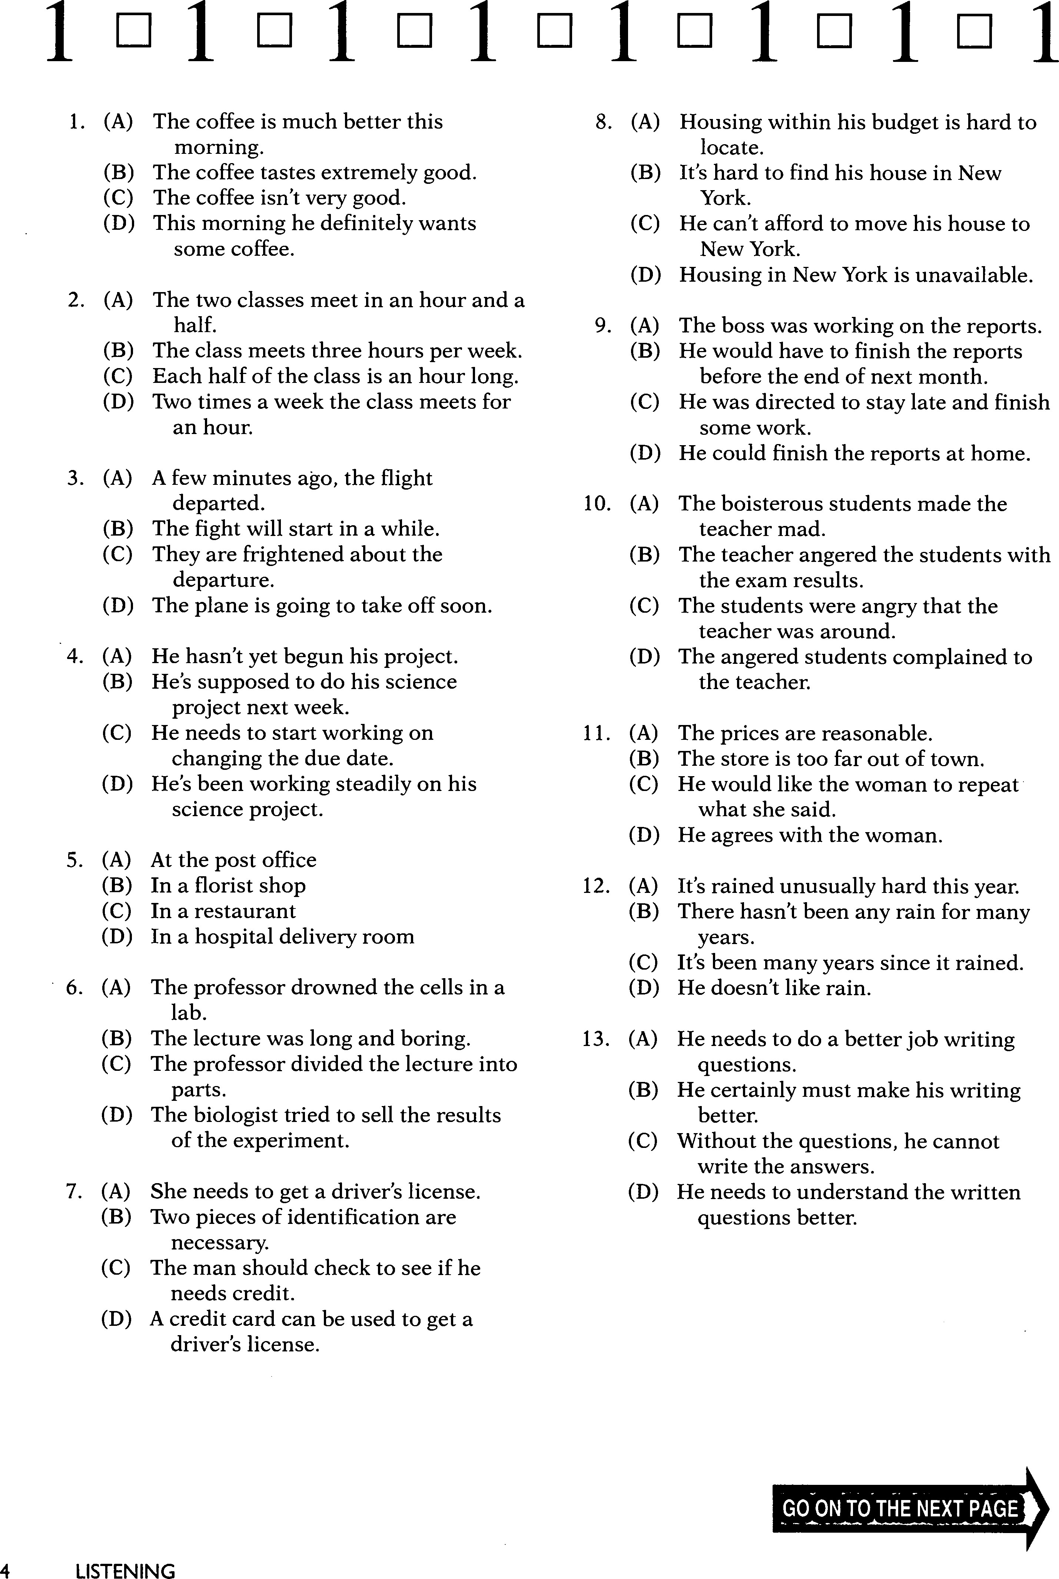

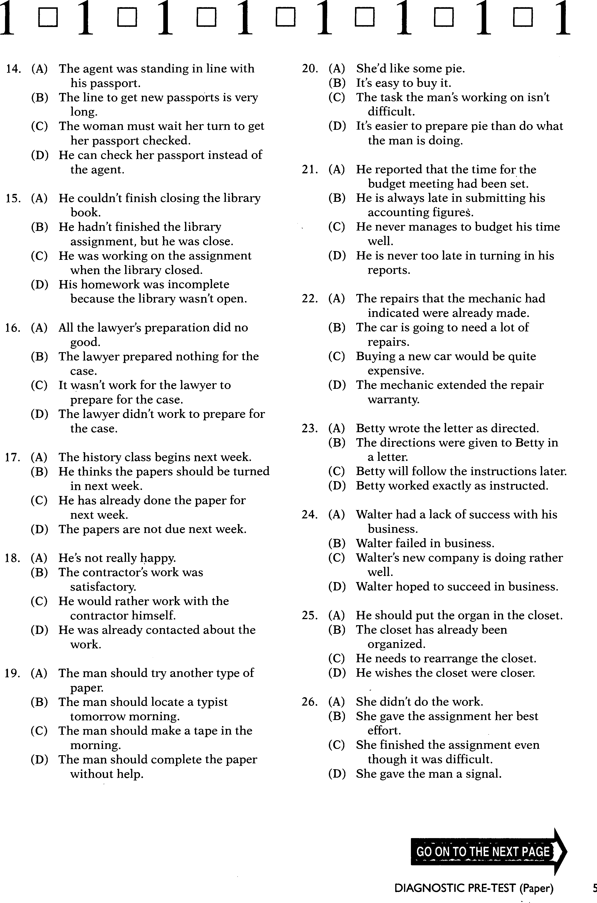

1. **(A). She said some terrible things 29. (A) The woman is more than a week late**
2. **She didn’t say anything Nice (B) The children would have wrecked the**
3. **She didn’t have any nice things house later**
4. **She said really wonderfull things (C) The woman was so late that she was a wreck**

**(D) He’s glad that she was not any later**

1. **(A) New Employees are rarely initiated into 30. (A) He had not gone to the store**

**The company (B) He was still at the market**

1. **New workers don’t generally undertake (C) He was going to take care of the shopping**

**Actions on their own (D) He Always went to the market**

1. **New Employees are initially rated**
2. **It’s rare for employees to make new**

**suggerstions**

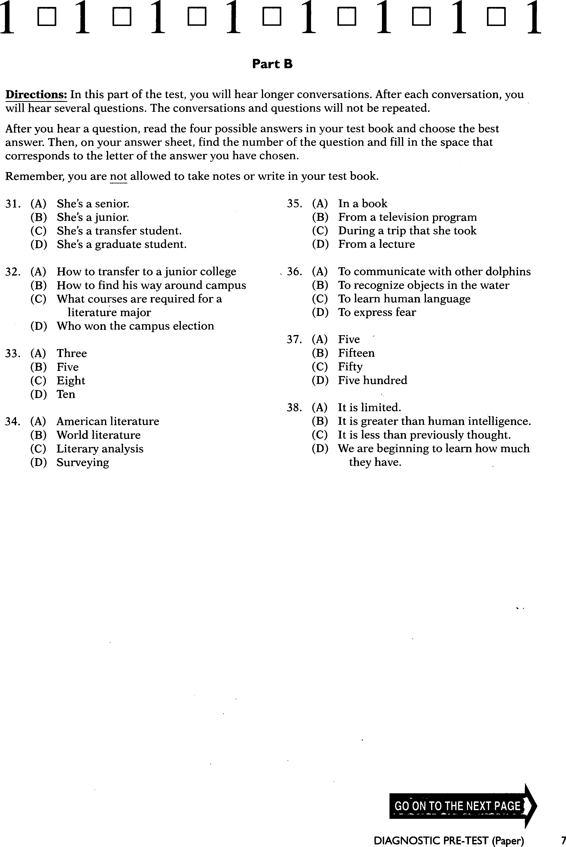

**PART C**

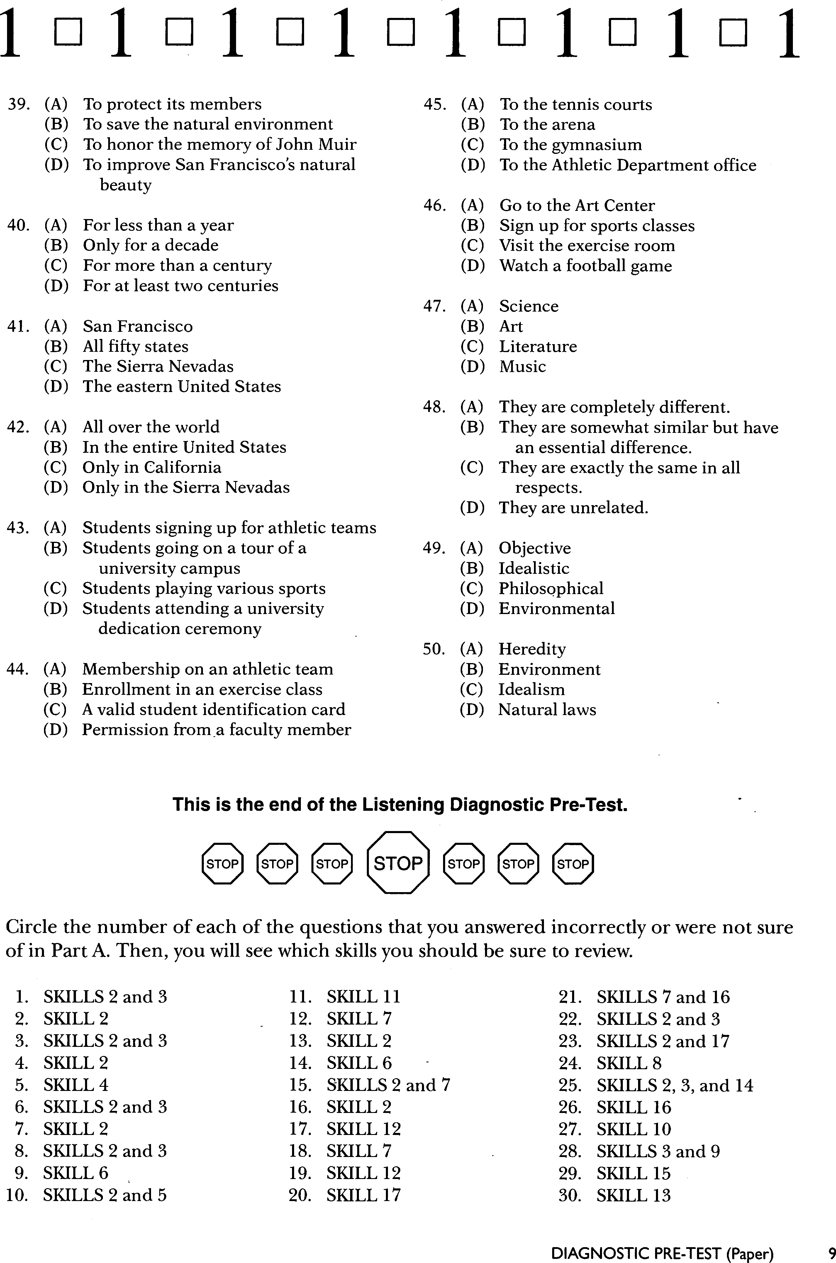

**TEST 2 : STRUCTURE**

**PART 1 : FIND THE BEST ANSWER**

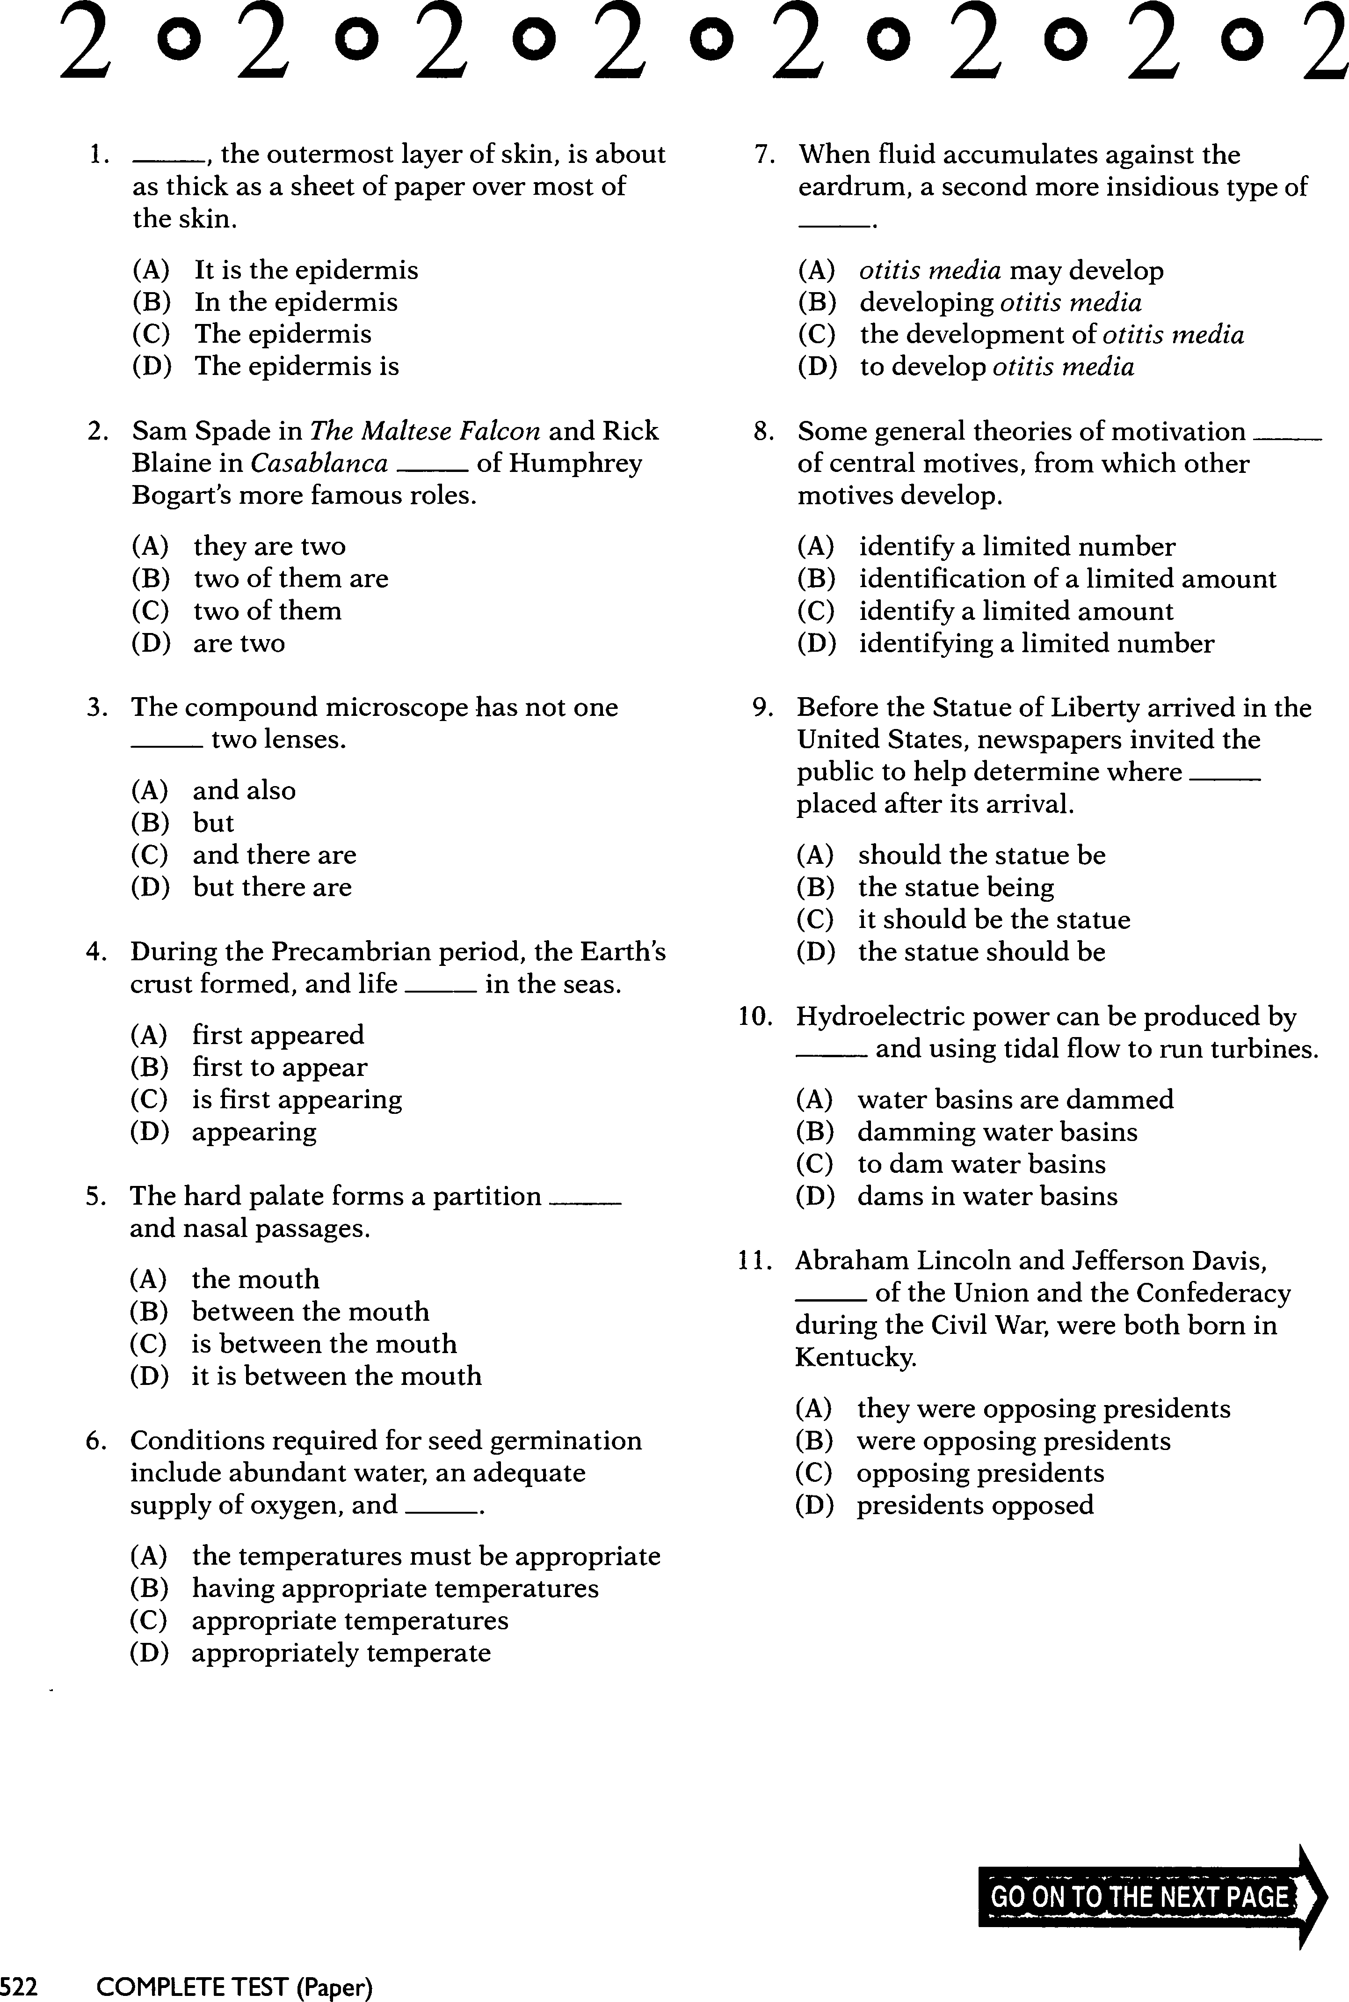

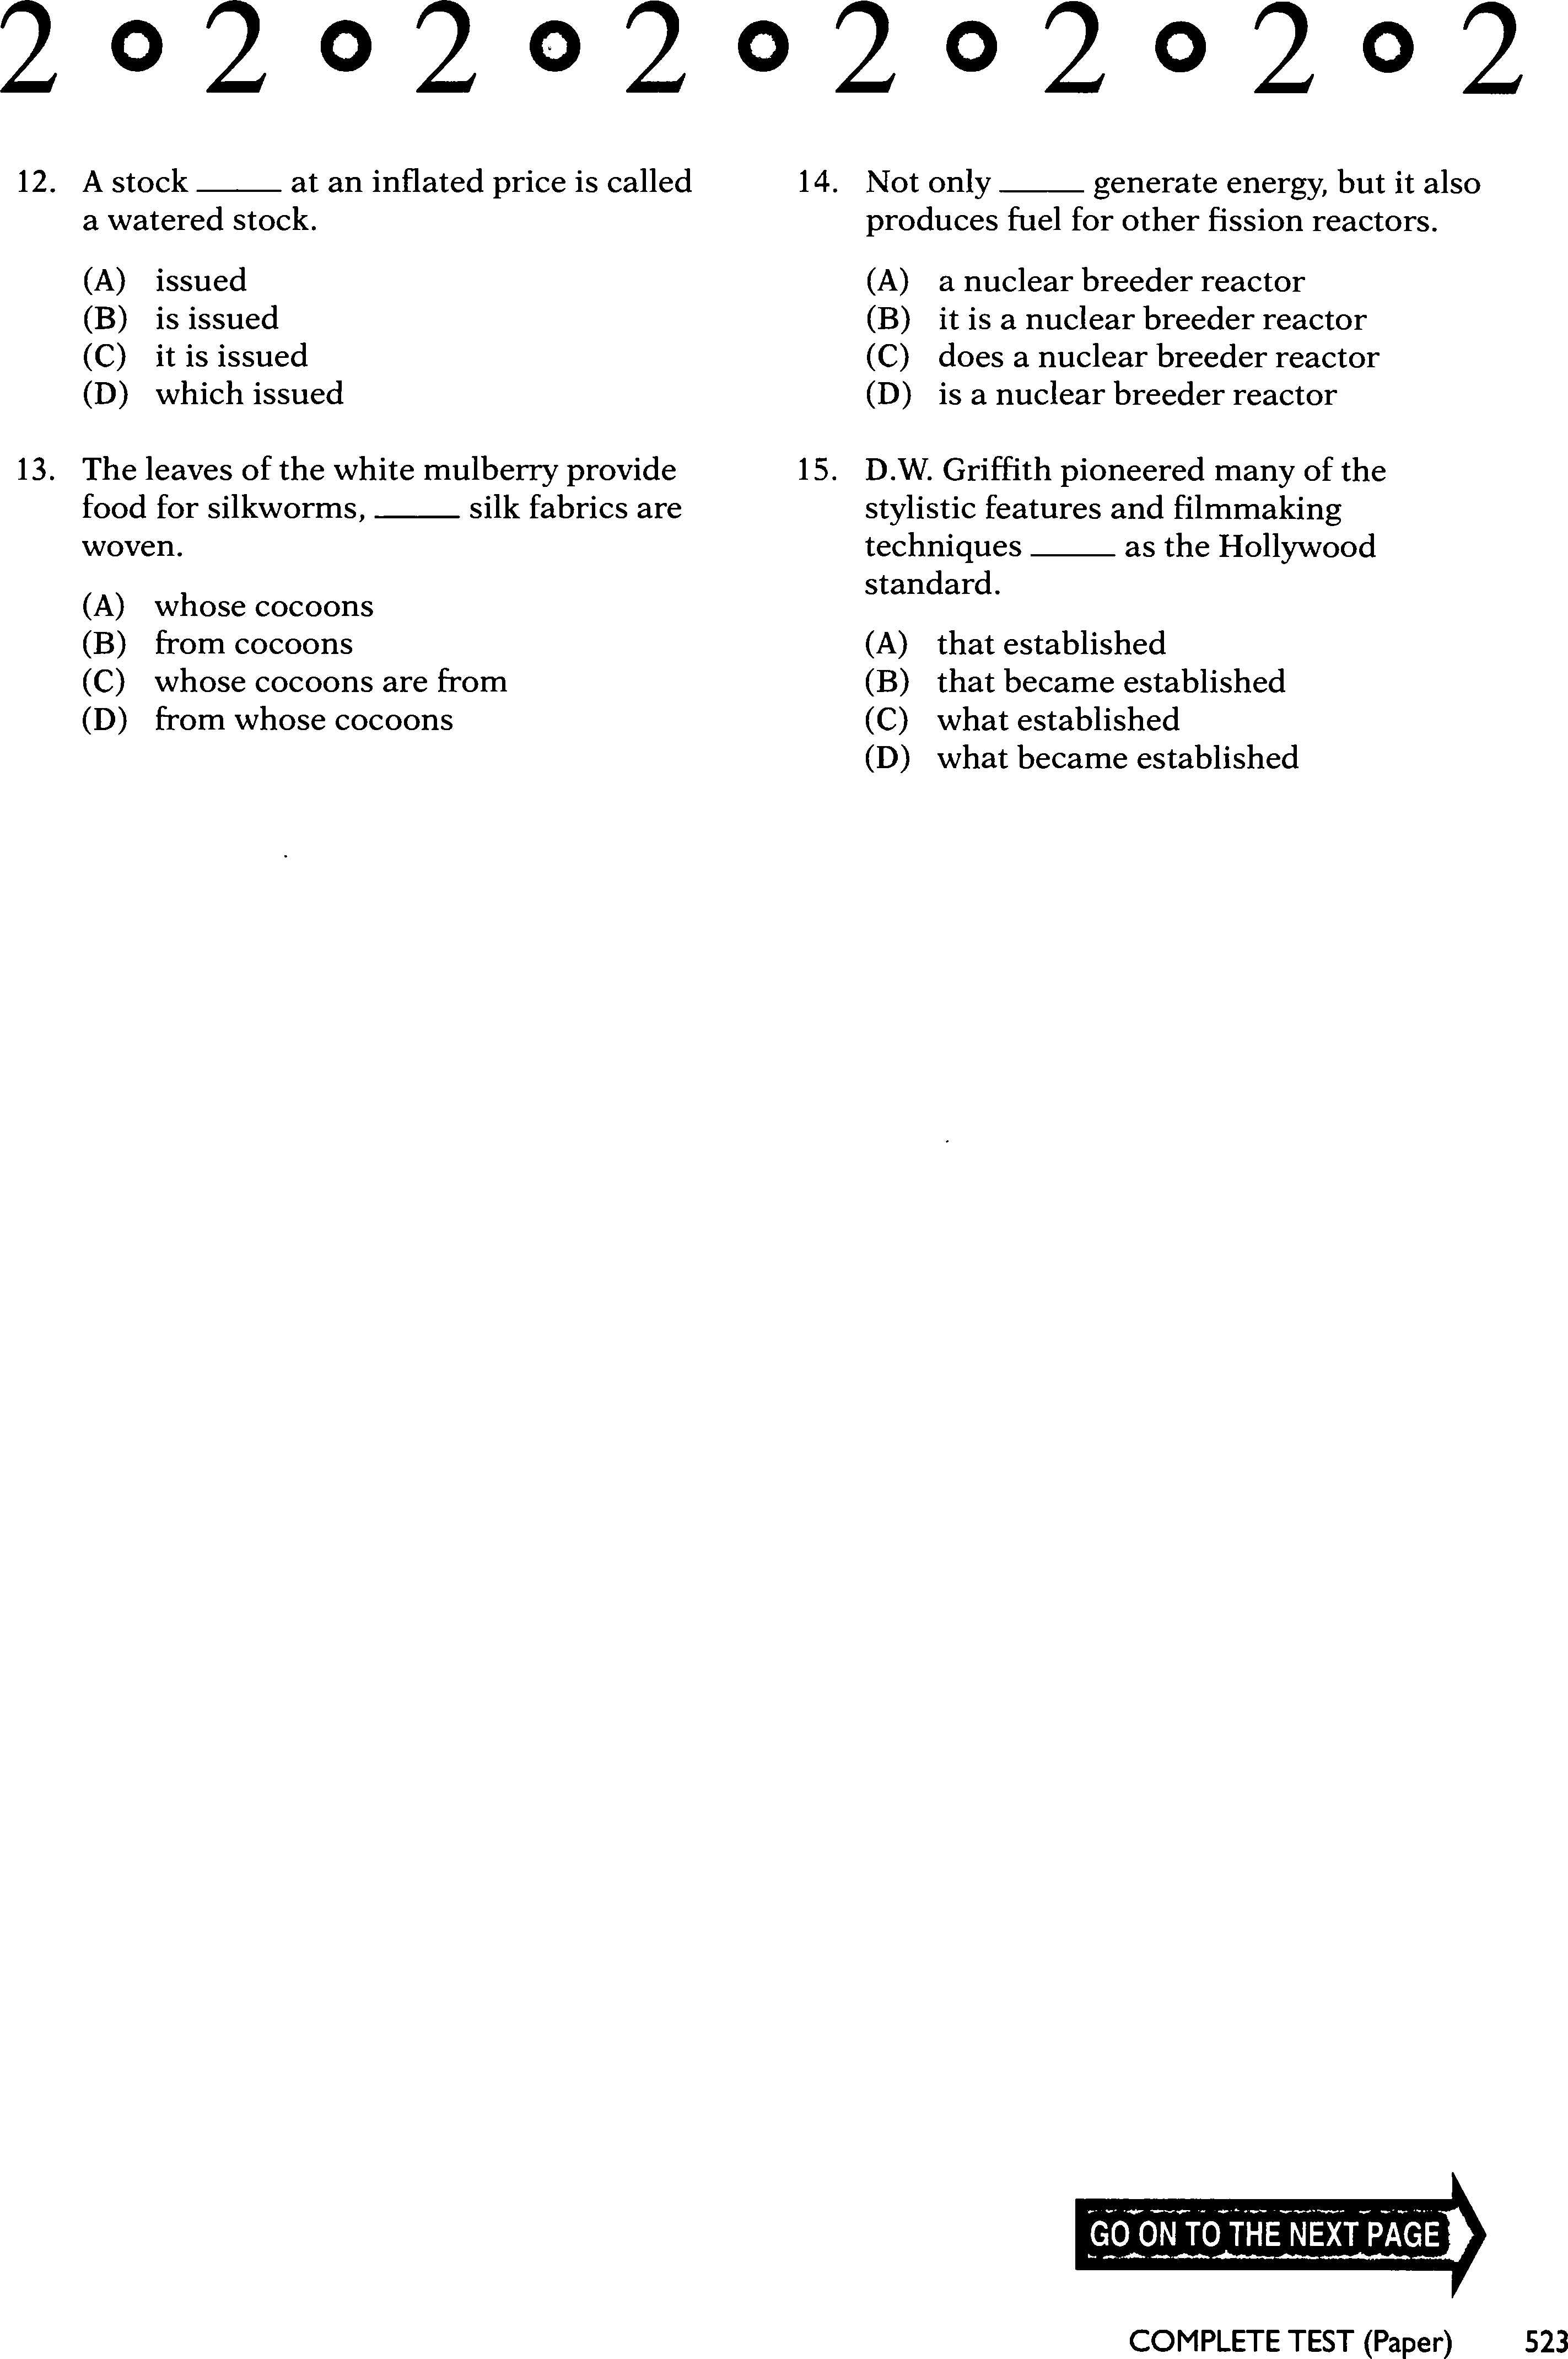

PART B : ERROR ANALYSIS

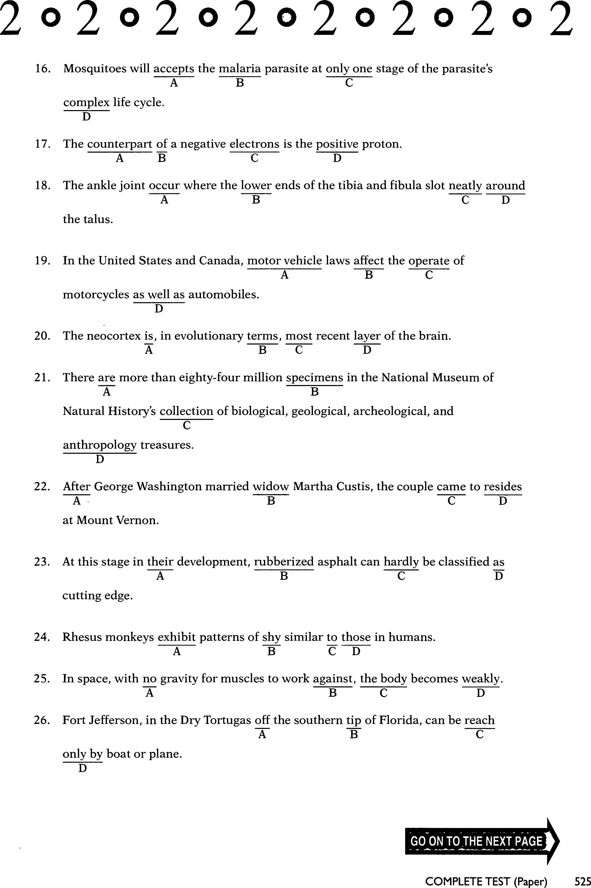

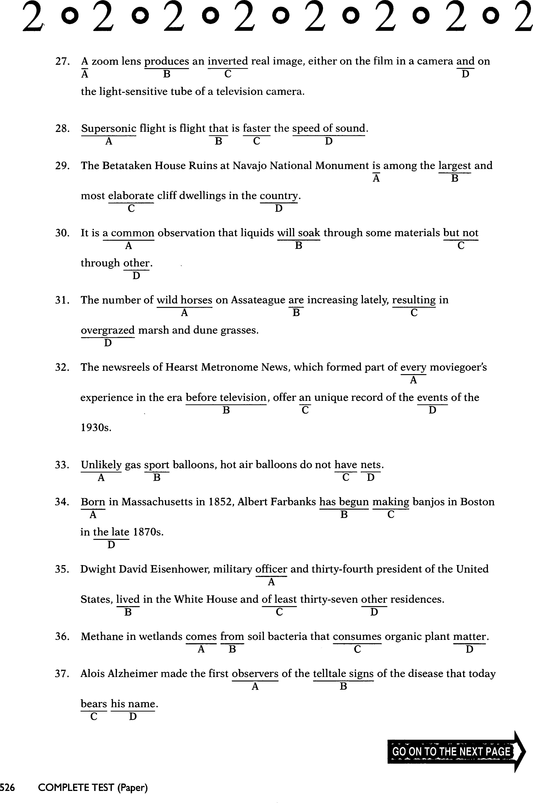

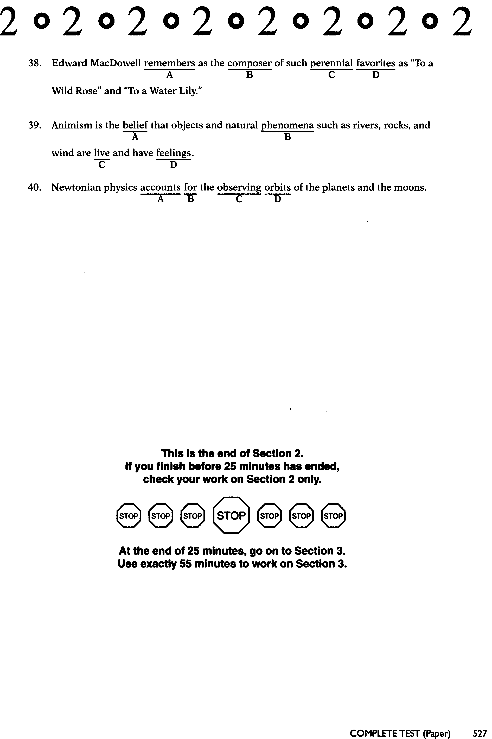

Final Test Listening Answer

1. As
2. As
3. As
4. Asa
5. Sas
6. As
7. Asa
8. Sa
9. Sas
10. Asa
11. Sa
12. Sa
13. Sa
14. Sas
15. As
16. As
17. As
18. As
19. As
20. As
21. As
22. As
23. As
24. As
25. As
26. As
27. As
28. As
29. As
30. As
31. As
32. As
33. As
34. As
35. As
36. As
37. A
38. Asas
39. As
40. As
41. B. All fifty States
42. B. In the entire United States
43. B. Students going on a tour of a university campus
44. C. A valid student identification card
45. D. To the Athletic Department office
46. A. Go to the Art Center
47. C. Literature
48. B. They are somewhat similar but have an essential difference.
49. A. Objective
50. C. Idealism

Final Test Structure Answer