ToursBMS Product Information API

ToursBMS Product API Overview
- ToursBMS provides general Open API of Products。
- The Travel Agency who is given the authorization by ToursBMS can use the API.
- Agency authorized by ToursBMS could pull the data of products from this API。
- Every parameter about Time or Date are taking the same time zone as ToursBMS’s as the standard. Please contact the administrator of ToursBMS for more details.
- The currency of any price information is using the settlement currency between an agency and Jupiter legend Corporation (Universal Vision). Users can check the settlement currency at the agent-end of the system.

Instruction of API Process

Authentication Process
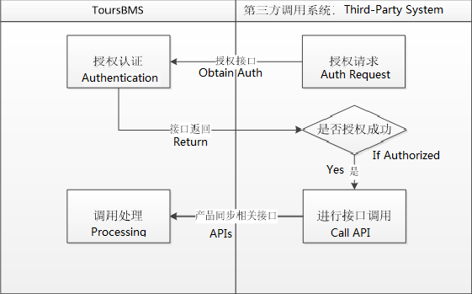

Product Information Updates

Full Data Updates
Obtain the required product catalog according to the search criteria, and then obtain product details information according to the product catalog.
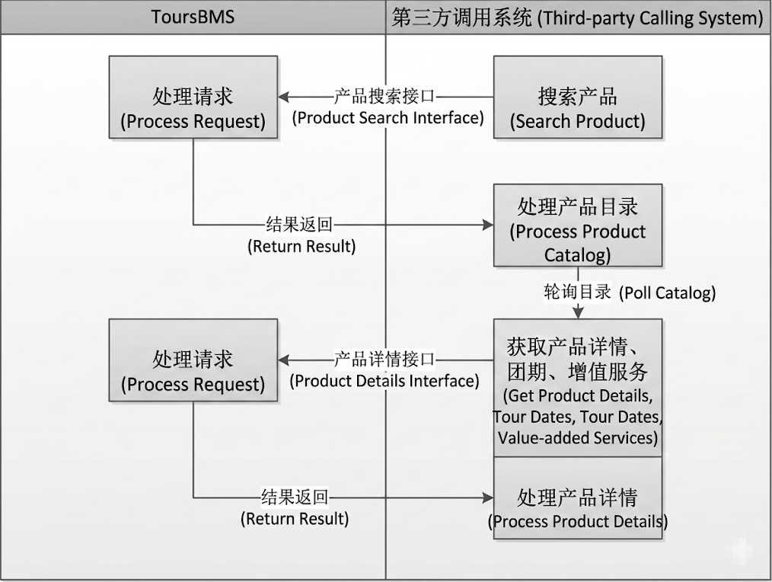

Incremental Updates

Obtain the product incremental log according to the search criteria, and then update the product information according to the product incremental log。
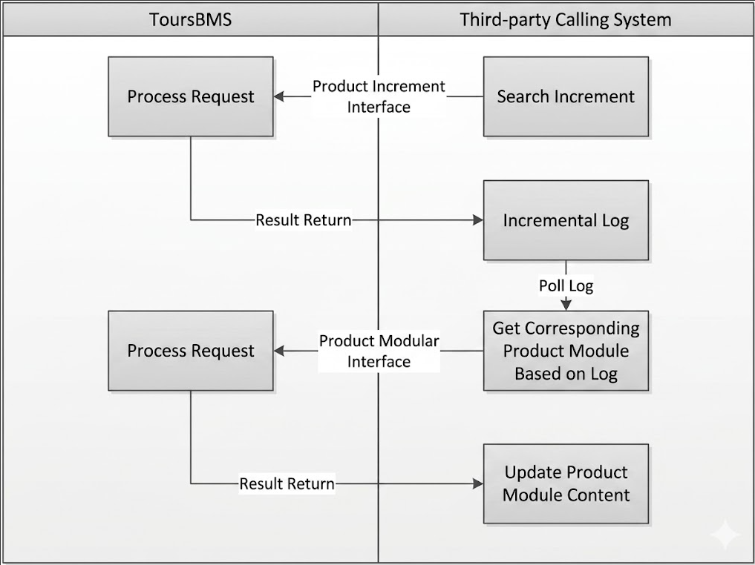

API Instruction

Request URL：
- Test Environment: default.
- Production Environment：http://api.toursbms.com/

Header
Field Name | Mandatory | Data Type | Description
TokenCode | Mandatory | String | Token
Note：When calling GetToken. the TokenCode in the Request Http Header can be set to empty String ( “” )， and this field is required.

Request Notes:
The parameters should be passed in JSON format, and the “Content-Type” in HTTP Header should be “application/json”.

Response:
Field Name | Mandatory | Data Type | Description
code | Mandatory | String | HTTP Status Code（200、400）  200-Success  400-Error
msg | Mandatory | String | Statues Message
data | Mandatory | String | Response Data
Sample response, in JSON：
{
"code": "400",
"msg": "账号不存在或密码不正确！",
"data": ""
}

API List

Authentication
Request Method：POST
Request URL：/openapi/v1/auth/getMerchantToken
Request parameter：
API Method | getToken
Field Name | Mandatory | Data Type | Description
merchantId | Mandatory | String | Merchant ID  Provided by ToursBms
timestamp | Mandatory | String | Current Timestamp in seconds  Sample in Java：String timestamp=Long.toString(new Date().getTime()/1000);
signature | Mandaory | String | Signature  Create an MD5 Hash of a string：merchantId + secretKey+timestamp  Sample is as follow：
Sample Request：
{
"merchantId": "",
"timestamp": "",
"signature": ""
}
Signature sample：MD5(MI0000189B302C6F0752B845EAC5FCC22419027B1543371700)
Red Part: merchantId
Blue Part: secretKey
Black Part: timestamp

Response (data)：
Field Name | Data Type | Description
merchantId | String | Merchant ID
tokenCode | String | Token
expireTime | String | Expiration Time  yyyy-MM-dd HH:mm:ss
createUserId | String | User ID
createTime | String | Token Creation time  yyyy-MM-dd HH:mm:ss
remark | String | Remark notes
Sample response ：
{
"code": 200,
"msg": "success.",
"data": {
"merchantId": "MI000022",
"tokenCode": "3C2BC823334AA751A8EFA97EBDD96521",
"expireTime": "2021-11-22 11:18:30",
"createUserId": "",
"createTime": "2021-11-22 11:18:30",
"remark": ""
}
}

Product Type
Before getting specified product type, users should call the method, GetProductType (which is as follow) in advance, in order to collect the code of product type form ToursBMS。

Request Method：POST
Request URL：/openapi/v1/product/getProductType
Request parameter：
API Method | getProductType
Field Name |  | Mandatory | Data Type | Description
categoryType |  | Optional | Integer | Product Category:  Bus Tour=1
Request parameter示例：
{
"categoryType": 1
}

Response (data)：
Field Name | Data Type | Description
productCategoryList | productCategory[] | Product Category List.
productCategory > categoryType | Int | Product Category:  Bus Tour Line =1
productCategory > productType | String | Code of Product type
productCategory > productTypeName | String | Name of product type
Sample response ：
{
"code": 200,
"msg": "success.",
"data": [
{
"categoryType": 1,
"productType": "PC00000003",
"productTypeName": "南部产品"
},
{
"categoryType": 1,
"productType": "PC00000002",
"productTypeName": "西部产品"
},
{
"categoryType": 1,
"productType": "PC00000001",
"productTypeName": "东部产品"
}
]
}

Product Searching
Request Method：POST
Request URL：/openapi/v1/product/getProductList
Request parameter：
API Method | getProductList
Field Name |  | Mandatory | Data Type | Description
productType |  | Optional | String(50) | Code of Product type  Default(Leave it empty): all types.
productForm |  | Optional | String(50) | Code of Product Form：  Package Bus Tour=1  DIY Tour=2  Private Group Tour=3  Default(Leave it empty): all.
language |  | Optional | Integer | Language  Default(Leave it empty): all Languages.  If requested language is unavailable, the Main language of the system will be returned.  Simplified Chinese=1  Traditional Chinese=2  English=3
productCode |  | Optional | String(50) | Product Code
departureCity |  | Optional | String(200) | Departure City
publishTimeStart |  | Optional | String | Start time of Publish.  yyyy-MM-dd HH:mm:ss
publishTimeEnd |  | Optional | String | End time of Publish.  yyyy-MM-dd HH:mm:ss
updateTimeStart |  | Optional | String | Start time of Latest updates.  yyyy-MM-dd HH:mm:ss
updateTimeEnd |  | Optional | String | End time of latest updates.  yyyy-MM-dd HH:mm:ss
keywords |  | Optional | String | Keywords of Product
pager |  | Mandatory | Pager | Pagination (Pager)
pager > pageSize |  | Optional | Integer | Number of results (products) per page.  Default(Leave it empty): 10 products.
pager > pageIndex |  | Optional | Integer | Page number  Default(Leave it empty): page 1.
Request parameter示例：
{
"productType": "",
"productForm": "",
"language": 0,
"productCode": "",
"departureCity": "",
"publishTimeStart": "",
"publishTimeEnd": "",
"updateTimeStart": "",
"updateTimeEnd": "",
"status": 0,
"keywords": "",
"pager": {
"pageIndex": 0,
"pageSize": 0
}
}

Response (data)：
Field Name | Data Type | Description
pager | Pager | Pagination
Pager > pageSize | Int | Number of results per page
Pager > pageIndex | Int | Current Page number
Pager > totalCount | Int | Total products results
Pager > totalPage | Int | Total pages
Pager > hasPrePage | Boolean | If there are previous pages
Pager > hasNextPage | Boolean | If there are Next pages
list | Product[] | Product List
Product > productID | String | Product ID
Product > productCode | String | Product Code
Product > productName | String | Product Name
Product > subtitleName | String | Product Subtitle
Product > productType | String | Code of Product Type
Product > productTypeName | String | Name of Product Type
Product > productForm | Int | Code of Product Form：  Package Bus Tour=1  DIY Tour=2  Private Group Tour=3
Product > language | String | Language  Different languages are separated by ‘ , ’.  Simplified Chinese=1  Traditional Chinese=2  English=3
Product > publishTime | String | Publish time of product  (publishTime = 0, If this product has been suspended)
Product > updateTime | String | The time of latest update
Product > productStatus | Int | Product Status  Published =1  Suspended =0
Product>schemeList | List<ProductSchemeBO> | Package Product
ProductSchemeBO>schemeCode | String | Combination code of the package
ProductSchemeBO>schemeName | String | Combination name of the package
Sample response ：
{
"code": 200,
"msg": "success.",
"data": {
"pager": {
"pageSize": 10,
"pageIndex": 1,
"totalCount": 26,
"totalPages": 3,
"hasPreviousPage": false,
"hasNextPage": true
},
"list": [
{
"productID": "P00000300",
"productCode": "R0000032",
"productName": "苏州+乌镇+杭州3日2晚跟团游暑期保证宿乌镇内",
"subtitleName": "品牌酒店 美食体验得月宴&桃源餐",
"productType": "PC00000023",
"productTypeName": "华东短途",
"productForm": 1,
"language": "1",
"publishTime": "1535537711",
"updateTime": "1536112443",
"productStatus": 1,
"schemeList":[]
},
{
"productID": "P00000286",
"productCode": "R0000022",
"productName": "aaaaaa越南芽庄6日5晚半自助19",
"subtitleName": "",
"productType": "PC00000001",
"productTypeName": "东部产品",
"productForm": 1,
"language": "1,3,2",
"publishTime": "1531921160",
"updateTime": "1533004039",
"productStatus": 1,
"schemeList":[]
},
{
"productID": "P00000294",
"productCode": "R0000028",
"productName": "北京5日跟团游",
"subtitleName": "",
"productType": "PC00000001",
"productTypeName": "东部产品",
"productForm": 1,
"language": "1",
"publishTime": "1532057629",
"updateTime": "1532067349",
"productStatus": 1,
"schemeList":[
{
"schemeCode":"SC001",
"schemeName":"套餐方案1"
}
]
}
]
}
}

Information of Products
Request Method：POST
Request URL：/openapi/v1/product/getProductInfo
Request parameter：
API Method | getProductInfo
Field Name |  | Mandatory | Data Type/Mandatory项 | Description
productID |  | Mandatory | String(50) | Product ID
language |  | Optional | Integer | Language  Simplified Chinese=1  Traditional Chinese=2  English=3
schemeCode |  | Optional | String | Combination code of the package product. (It is Mandatory, if get the info of package product)
Request parameter：
{
"productID": "P00000300",
"language": 1
}

Request parameter for Package Product:
{
"productID": "P00017693",
"schemeCode": "SC00000717",
"language": 1
}

Response （data）：
Field Name | Data Type | Description
productID | String(50) | Product ID
productCode | String | Product Code
publishTime | String | Publish time of product  (publishTime = 0, If this product has been suspended)
updateTime | String | The time of latest update
productStatus | Int | Product Status  Published=200  Suspended =300
language | Int | Language  Simplified Chinese=1  Traditional Chinese=2  English=3
categoryType | Int | Product Category:  Bus Tour Line=1
productType | String | Code of Product Type
productTypeName | String | Name of Product Type
groupNo | String | Product Code
productName | String | Product Name
subtitleName | String | Product Subtitle
tripDay | Int | Number of Trip Days
nightDay | Int | Number of Trip Nights
productForm | Int | Code of Product Form：  Package Bus Tour=1  DIY Tour=2  Private Group Tour=3
departureCity | String | Departure City  {  "regionCode":"City or region code",  "regionName":"Name"  }  *other parameter could be empty.
destinationCity | String | Destination City  {  "regionCode":" City or region code ",  "regionName":" Name "  }  *other parameter could be empty.
Destination | String | Destination(like nations, attractions)  {  "scenicSpotCode":"Code",  "scenicSpotName":"name"  }  *other parameter could be empty.
Vehicle | String | Transportation，types are separated by ‘|’.  Bus=1  Train=2  Airplane=3  Cruise=4  Other=5
productImgUrl | String | Picture of Product. The URLs are separated by ‘|’
productSpecial | String | Description of feature of product
salesNote | String | Promotional information
departureDate | String | Departure Date
settlementCurrencyNum | String | Settlement Currency code:  CNY, USD…
settlementCurrencyName | String | Name of Currency
airport_pick_up | Boolean | Airport Pick Up or not.  true = Pickup  false = Not
airport_drop_off | Boolean | Airport drop off or not.  true = Drop off  false = Not
advanceDay | Int | The number of days before the product is closed for sale.
advanceTime | String | Booking time in advance.
productCarpoint | ProductCarpoint[] | The places of the Group Joining o/Leaving (list)
ProductCarpoint > CarpointCode | String | The place code of the Group Joining/Leaving
ProductCarpoint > carpointType | Int | Type of the place：  Place of Group Joining =1  Place of Group Leaving =2
ProductCarpoint > carpointAddr | String | Name of the place
ProductCarpoint > carpointDesc | String | Description of the place
ProductCarpoint > carpointTime |  | The time of the Group Joining/Leaving
ProductCarpoint > isAirport | Int | If it is an airport  Not = 0  Yes = 1
bookRestriction | BookRestriction | Attributes of Reservation Restrictions
BookRestriction > confirmType | Int | Type of Confirmation  Confirm Manually =1  Confirm Automatically =2
BookRestriction > id | Int | If the product needs customer’s ID Number.  Not =0  Yes =1
BookRestriction > age | Int | Age Restrictions  No Restriction =0  Restriction =1
BookRestriction > child | Int | The price of Child  Not available = 0  Available =1
BookRestriction > childAge | Int | If there is a child price, the return value means that the age of child should not older than the Value. e.g. childAge = 5, the age of child should not older than 5 years old.
BookRestriction > childHeight | Int | If there is a child price, the return value means that the standard height should not taller than the value. Unit: CM.
BookRestriction > childDesc | String | Description of Child Price
BookRestriction > isAgeAgreement | String | The specific content of the agreement of Reservation Restrictions
travel | Travel[] | Information of product itinerary (list data)
Travel > travelDay | Int | The certain day of the itinerary。e.g., 2 = the second day of the itinerary.
Travel > travelSection | String | Starting place to ending place  e.g., ‘NYC [ BUS ] Boston’ means that taking bus to Boston from NYC.
Travel > travelContent | String | The description of the itinerary，  please refer to the instruction of travelContent below.
Travel > hotelContent | String | The information of hotel  {  "HotelCode":"Code",  "HotelName":"Name",  "HotelAddr":"Address",  "HotelEmail":"Email",  "HotelLinkMan":"Contact person",  "HotelLinkWay":"Phone num",  "RegionCode":"Code of place",  }
notice | Notice[] | Reservation Notice
Notice > noticeType | Int | Type of Notice  Price Includes = 0  Booking Notice = 1  Travel Tips = 2  Cancellation Policy =3  Visa Instructions =4  Age Restrictions =5  Others = 6  Price Excludes = 7
Notice > noticeName | String | Name of the Notice
Notice > noticeContent | String | Description of the Notice
cost | Cost[] | Extra expense (list)
Cost > costName | String | Name of the expense
Cost > costDay | String | Day of itinerary
Cost > costDesc | String | Description of the expense
Cost > costPrice | CostPrice[] | The details of the price
CostPrcie > expPriceName | String | Item name of the price
CostPrcie > expPriceMoney | Decimal | Price
shop | Shop[] | Shopping point
Shop > shopName | String | Name of Shopping point
Shop > shopDay | String | Day of itinerary
Shop > shoptime | String | Shopping time period
Shop > shopDesc | String | Description of Shopping point
breachClause | BreachClause | Cancellation Clause
BreachClause  > travelerBreachClauseList | TravelerBreachClauseList[] | Cancellation Clause for Agent
TravelerBreachClauseList  > fromDaysBeforeDeparture | String | Start day before departure
TravelerBreachClauseList  > toDaysBeforeDeparture | String | End day before departure
TravelerBreachClauseList  > isHoliday | Boolean | If it charge the penalty during Holidays.
TravelerBreachClauseList  > lossPercent | String | If it is in breach of contract, the default amount is Total * lossPercent%.
BreachClause  > agencyBreachClauseList | AgencyBreachClauseList[] | Cancellation Clause for Tour Operator (BMS)
AgencyBreachClauseList  > fromDaysBeforeDeparture | String | Start day before departure
AgencyBreachClauseList  > toDaysBeforeDeparture | String | End day before departure
AgencyBreachClauseList  > isHoliday | Boolean | If it charge the penalty during Holidays.
AgencyBreachClauseList  > lossPercent | String | If it is in breach of contract, the default amount is Total * lossPercent%.
PackageSchemeTravelPreviewBo->travelDay | Integer | The number of days of the product.
PackageSchemeTravelPreviewBo->subProductList | SubProductPreviewBO[] | Sub-Products of the package product.
SubProductPreviewBO->journeyBeginDay | Integer | Sub-product, the number of Start day
SubProductPreviewBO->journeyEndDay | Integer | Sub-product, the number of End day
SubProductPreviewBO->subProductType | Integer | Type of Sub-product:  1 - Default product  2 - Optional product  3 - resources (like hotel)  4 - Free tour
SubProductPreviewBO->productID | String | Sub-Product ID(without Free tour)
SubProductPreviewBO->productCode | String | Sub-Product Code
SubProductPreviewBO->parentProductCode | String | Sub-product code for order(like the Code of one Optional product is the normal product code of this product, as mentioned above)
SubProductPreviewBO->productName | String | Sub-product Name
SubProductPreviewBO->resourceType | Integer | Type of resource (only for 3- resources)
SubProductPreviewBO->groupNo | String | Sub-product Group No.
SubProductPreviewBO->productViewCode | String | Outdated
SubProductPreviewBO->travelContent | String | Itinerary of sub-product
SubProductPreviewBO->hotelInfo | List<String> | Hotel info of sub-product
Sample response ：
{
"code": 200,
"msg": "success.",
"msgCode": "SYS999999",
"data": {
"productID": "P00000300",
"productCode": "R0000104",
"publishTime": "1550075006",
"updateTime": "1579106776",
"productStatus": 200,
"language": "1",
"categoryType": 1,
"productType": "PC00000025",
"productTypeName": "重庆-日本游轮旅行",
"groupNo": "A12345",
"productName": "20190203",
"subtitleName": "A4567",
"tripDay": 1,
"nightDay": 1,
"productForm": 1,
"departureCity": "{\"RegionCode\":\"120018\",\"RegionName\":\"巫山\",\"ResourceType\":1}",
"destinationCity": "{\"RegionCode\":\"A093\",\"RegionName\":\"沙坪坝区\",\"ResourceType\":0}",
"destination": "[{\"CountryCode\":\"\",\"CountryName\":\"\",\"ProvinceCode\":\"A386\",\"ProvinceName\":\"四国\",\"ScenicCode\":\"\",\"ScenicName\":\"\",\"ScenicSpotCode\":\"\",\"ScenicSpotName\":\"\",\"ResourceType\":0},{\"CountryCode\":\"110000\",\"CountryName\":\"中国\",\"ProvinceCode\":\"100009\",\"ProvinceName\":\"四川\",\"ScenicCode\":\"1484\",\"ScenicName\":\"西岭雪山\",\"ScenicSpotCode\":\"10558940\",\"ScenicSpotName\":\"锦里\",\"ResourceType\":1}]",
"vehicle": "1|2|3",
"productImgUrl": null,
"productSpecial": "<p>测试12345</p>",
"salesNote": "<p>测试12345</p>",
"departureDate": "",
"settlementCurrencyNum": "USD",
"settlementCurrencyName": "美元",
"advanceDay": -1,
"advanceTime": "",
"productCarpoint": [
{
"carpointCode": "ANM00000069",
"carpointType": 1,
"carpointTime": null,
"isAirport": 1,
"carpointAddr": "turn off中文简体,",
"carpointDesc": ""
},
{
"carpointCode": "ANM00000052",
"carpointType": 2,
"carpointTime": null,
"isAirport": 1,
"carpointAddr": "北部机场 中文简体,石帆胜丰",
"carpointDesc": ""
}
],
"bookRestriction": {
"confirmType": 1,
"id": 0,
"age": 0,
"child": 1,
"childAge": "12",
"childHeight": "125",
"childDesc": "",
"isAgeAgreement": null
},
"travel": [
{
"travelDay": 1,
"travelSection": "重庆【汽车】成都",
"travelContent": "[{\"TravelType\":\"2\",\"TravelContent\":{\"Time\":\"07:00\",\"Information\":\"汽车\",\"Distanc\":\"345\",\"Hours\":\"4\",\"Minutes\":\"40\"}}]",
"hotelContent": "[]"
}
],
"notice": [],
"cost": [],
"shop": [],
"breachClause": {
"travelerBreachClauseList": [
{
"fromDaysBeforeDeparture": "0",
"toDaysBeforeDeparture": "0",
"isHoliday": false,
"lossPercent": "0.0200"
},
{
"fromDaysBeforeDeparture": "1",
"toDaysBeforeDeparture": "2",
"isHoliday": false,
"lossPercent": "0.0200"
}
],
"agencyBreachClauseList": [
{
"fromDaysBeforeDeparture": "0",
"toDaysBeforeDeparture": "0",
"isHoliday": false,
"lossPercent": "0.0200"
},
{
"fromDaysBeforeDeparture": "1",
"toDaysBeforeDeparture": "2",
"isHoliday": false,
"lossPercent": "0.0200"
}
]
},
"travelPreviewList":[
{
"travelDay":1,
"subPorductList":[
{
"journeyBeginDay":1,
"journeyEndDay":1,
"subProductType":3,
"productID":"P00017692",
"productCode":"R0013074",
"parentProductCode":"SC0000717",
"productName":"线路产品",
"resourceType":null,
"groupNo":"",
"travelContent":"",
"hotelInfo":null
}
]
}
]
}
}

Details of travelContent

- Different travelType
{
"travelType": "Flight=1, Transportation=2, Attractions=3, Meals=4, Shopping=5, DIY=6, Other=7",
"travelContent": Object. Different travelType with different Object. Those Objects are sharing same attributes with Base Class。）
}

- travelContent Base Class (All kinds of travelType include those attributes) ：
{
"time":" Flight Departure Time",// Two different data types：[1] Time（hh:mm）;[2] enum（1： All day；2： Morning；3： Afternoon；4： Night）
"information":" Flight info/Transportation info/Meals",
"distanc":" Travel distance (km)",
"hours":" Travel time",
"minutes":" Travel time"
}

- travelType=1("Flight") Base class inheritance
{
"type": undetermined =0, non-stop=1, multi-stop=2(integer)
}

- travelType=2("Transportation ") attributes same as Base Class
{
}

- travelType=3("Attractions") Base class inheritance
{
"stayHours": "Activity time, Hours",
"stayMinutes": "Activity time, Minutes",
"content": //Contents of Attractions
{
"Type": 1, // Non =0, Multiple choice=1, All=2
"ScenicCode": "Code",
"ScenicName": "Name",
"SceniceDesc": "Descriptions",
"IsAppearance": "Outside tour, 0=No 1=Yes",
"ResourceType": " Resource Type：1=From BMS 2=From Trip.com ",
"SourceType": "Source：2=BMS 3=Trip.com",
"SceniceExplain": "Details of Attractions",
"ListImage": [List of Images]
}
}

- travelType=4("Meals") Base class inheritance
{
"content": [
{
“sourceType”：POI source，2= BMS Local；3=Ctrip POI,
“restaurantName”："Restaurant Name",
“isPaySelf”：Pay by Self，true；false
“avgPrice”：" Average consumption per person"
}
]
"type": Type of Meals, // 1=Breakfast, 2=Lunch, 3=Dinner,4= Teatime,
“distancUnit”：Unit of length 1: km; 2: m; 3: mi; 4: yd,
"stayHours": " Activity time, Hours ",
"stayMinutes": " Activity time, Minutes ",
"description": "Remark"

}

- travelType=5("Shopping") Base class inheritance
{
"stayHours":" Activity time, Hours ",
"stayMinutes":" Activity time, Minutes ",
"content":" Contents of Shopping"
{
"type":Non=0, Multiple choice =1, All=2(integer),
"shoppingCode":"Code",
"shoppingName":"Name",
"shoppingDesc":" Descriptions ",
}
}

- travelType=6("DIY") Base class inheritance
{
"stayHours":" Activity time, Hours ",
"stayMinutes":" Activity time, Minutes ",
"listImage":[ List of Images],
"description": Descriptions.
}

- travelType=7" Other, attributes same as Base Class
{
}

Departure Date of Product
Request Method：POST
Request URL：/openapi/v1/product/getProductDate
Request parameter：
API Method | getProductDate
Field Name |  | Mandatory | Data Type/Mandatory项 | Description
productID |  | Mandatory | String(50) | Product ID
mode |  | Optional | Integer | Update Mode  Full data Updates =0（Defaults）  Specified period of tour departure date = 1  Specified tour departure date =2
productDateStart |  | Optional  （When mode=1, Mandatory） | String | Start day of Departure Date，  yyyy-MM-dd
productDateEnd |  | Optional  （When mode=1, Mandatory） | String | End day of Departure Date,  yyyy-MM-dd
productDate[] |  | Optional | String[] | If the update mode is Specified tour departure date, this array can be included several date。  yyyy-MM-dd
schemeCode |  | Optional(Mandatory for Package product ) | String | Combination code of the package product.
productClassify |  | Optional | Integer | Pattern of product:  0 - Normal Bus Product (default)  1 – Package Product
Request parameter示例：
{
"productID": "P00000300",
"mode": 2,
"productDateStart": "",
"productDateEnd": "",
"productDate": [
"2019-01-01"
]
}

Response (data)：
Field Name | Data Type | Description
productID | String | Product ID
settlementCurrency | String | Settlement Currency:  CNY  USD  EUR  INR  THB
productDate | ProductDate[] | Departure Date (List)
ProductDate > date | String | Departure Date  yyyy-MM-dd
ProductDate > status | Int | The status of Departure Date  Closed =300  For sale =200
ProductDate > groupStock | Int | Remaining seats
ProductDate > isExceedStock | Int | Availability of Overbooking  0 = No  1 = Yes
ProductDate > priceType | PriceType[] | Price List
PriceType > type | Int | Type of Price  No accommodation：  Adult Price =1  Child Price=2  Accommodation:  Single occupancy =3  Double occupancy =4  Triple occupancy =5  Quadruple occupancy =6  Share occupancy =7  Child Price=2
PriceType > price | String | Selling Rate
PriceType > settlementprice | String | Settlement Rate
Sample response ：
{
"code": 200,
"msg": "success.",
"data": {
"productID": "P00000300",
"settlementCurrency": "USD",
"productDate": [
{
"date": "2021-11-22",
"status": 200,
"groupStock": 10,
"isExceedStock": 0,
"priceType": [
{
"type": 2,
"price": "132.15",
"settlementprice": "105.72"
}
]
}
]
}
}

Additional Services（Value-Added Service）
Request Method：POST
Request URL：/openapi/v1/product/getPromoteInfo
Request parameter：
API Method | getPromoteInfo
Field Name |  | Mandatory | Data Type | Description
productID |  | Mandatory | String(50) | Product ID
schemeCode |  | Mandatory | String | Combination code of the package product.
promoteCode |  | Optional | String(50) | Code of promotion，the default is ALL.
language |  | Optional | String | Language  Simplified Chinese=1  Traditional Chinese=2  English=3
Request parameter：
{
"productID": "P00000052",
"language": 1
}
Request parameter for Package Product:
{
"productID": "P00000053",
"schemeCode": "SC001",
"language": 1
}

Response (data）：
Field Name | Data Type | Description
productID | String | Product Code
settlementCurrency | String | Settlement Currency  CNY  USD  EUR  INR  THB
promote | Promote[] | List of Additional Services
Promote > promoteCode | String | Code of Additional Services
Promote > promoteType | Int | Type of Additional Services  Hotel room upgrade = 1  Miscellaneous = 2  Required Items = 3
Promote > promotePattern | Int | Type of Additional Services Available Date  Independent date=0  Product related date=1
Promote > promoteDay | String | Service day, separated by ‘|’
Promote > peopleType | Int | Type of customer  1：Adult  2：Child
Promote > promoteName | String | Name of the Additional Service
Promote > promoteDesc | String | Description of the Additional Service.
Promote > productID | String | ID of Additional Services (Package product only)
Promote > bindType | Int | Binding Type (Only valid when PromoteType = 3)  - 1 = Bind by price item  - 2 = Bind by order
Promote > listPromoteClause | ApiResPromoteClause | Bind price item
ApiResPromoteClause > clauseCode | String | Custom Code
ApiResPromoteClause > promotePriceType | Integer | Price Type (Occupancy / Demographics)  1 = Adult Price  2 = Child Price  3 = Single Occupancy  4 = Double Occupancy  5 = Triple Occupancy  6 = Quad Occupancy  7 = Solo Room Share  9 = Infant Price  10 = Senior Price
ApiResPromoteClause > promoteClauseType | Integer | Price Type  1 - Number of Rooms  2 - Number of Tourists  3 - Single Room Supplement Count
ApiResPromoteClause > promoteClauseDesc | String | Rule Description
Sample response ：
{
"code": 200,
"msg": "success.",
"data": {
"productID": "P00000052",
"settlementCurrency": "CNY",
"promote": [
{
"promoteCode": "S00000008",
"promoteType": 2,
"promotePattern": 1,
"promoteDay": "1,2,3",
"peopleType": 1,
"promoteName": "导游服务费",
"promoteDesc": "",
"productid":null
},
{
"promoteCode": "S00000012",
"promoteType": 1,
"promotePattern": 0,
"promoteDay": "2,3",
"peopleType": 0,
"promoteName": "豪华套房",
"promoteDesc": "",
"productid":null

}
]
}
}

Sample response for package product：
{
"code": 200,
"msg": "success.",
"data": {
"productID": "P00000052",
"settlementCurrency": "CNY",
"promote": [
{
"promoteCode": "S00000008",
"promoteType": 2,
"promotePattern": 1,
"promoteDay": "1,2,3",
"peopleType": 1,
"promoteName": "导游服务费",
"promoteDesc": "",
"productid":"P00000053"
},
{
"promoteCode": "S00000012",
"promoteType": 1,
"promotePattern": 0,
"promoteDay": "2,3",
"peopleType": 0,
"promoteName": "豪华套房",
"promoteDesc": "",
"productid":"P00000054"

}
]
}
}

Available date of Additional Services
Request Method：POST
Request URL：/openapi/v1/product/getPromoteDate
Request parameter：
API Method | getPromoteDate
Field Name |  | Mandatory | Data Type | Description
productID |  | Mandatory | String(50) | Product ID
schemeCode |  | Mandatory | String | Combination code of the package product.
promoteCode |  | Mandatory | String(50) | Code of Additional Services
mode |  | Optional | Integer | Update Mode  Full data Updates =0（Defaults）  Specified period of tour available date = 1  Specified tour available date =2
promoteDateStart |  | Optional | String | Start day of Available Date，  yyyy-MM-dd
promoteDateEnd |  | Optional | String | End day of Available Date,  yyyy-MM-dd
promoteDate |  | Optional | String[] | If the update mode is Specified tour available date, this array can be included several date.  yyyy-MM-dd
Request parameter示例：
{
"productID": "104",
"promoteCode": "15554",
"mode": 719,
"promoteDateStart": "bzj7ma",
"promoteDateEnd": "dbdf9o",
"promoteDate": [
"vcarns"
]
}

Response (data)：
Field Name | Data Type | Description
productID | String | Product ID
promoteCode | String | Code of additional services
settlementCurrency | String | Settlement Currency:  CNY  USD  EUR  INR  THB
promoteDate | ProductDate[] | Available date
ProductDate > date | String | Available date  yyyy-MM-dd  If the type of Available Date is the [Product related date], then this attribute will be empty.
ProductDate > status | Int | Status of Available date  Closed =300  For sale=200  If the type of Available Date is the [Product related date], then this attribute will be empty.
ProductDate > groupStock | Int | Remaining seats.  If the type of Available Date is the [Product related date], then this attribute will be empty.
ProductDate > isExceedStock | Int | Availability of Overbooking  0 = No  1 = Yes  If the type of Available Date is the [Product related date], then this attribute will be empty.
ProductDate > priceType | PriceType[] | Price
PriceType > type | Int | Type of price  No accommodation：  Adult Price =1  Child Price=2  Accommodation:  Single occupancy =3  Double occupancy =4  Triple occupancy =5  Quadruple occupancy =6  Share occupancy =7  Child Price=2  Room upgrade fee= 8
PriceType > price | String | Selling Rate
PriceType > settlementprice | String | Settlement Rate
Sample response ：
{
"code": 200,
"msg": "success.",
"data": {
"productID": "P00000258",
"promoteCode": "S00000329",
"settlementCurrency": "CNY",
"promoteDate": [
{
"date": "2019-11-22",
"status": 200,
"groupStock": 100,
"isExceedStock": 1,
"priceType": [
{
"type": 3,
"price": "10.00",
"settlementprice": "8.50"
},
{
"type": 4,
"price": "20.00",
"settlementprice": "19.60"
}
]
}
]
}
}

The update log of Product Information
When incremental changes occur to a product, you can fetch this interface log to obtain the change type and perform a partial update on the product.
Note: Users can get the log of updates (Like, departure date), then try to get details by calling the API methods (like, GetProductDate). This method only provides a notice of updates.

Request Method：POST
Request URL：/openapi/v1/product/getProductUpdates
Request parameter：
API Method | getProductUpdates
Field Name |  | Mandatory | Data Type | Description
productID |  | Optional | String(50) | Product ID
noteTimeStart |  | Mandatory | String | Start time of the log。  YYYY-MM-DD HH:MM:SS
noteTimeEnd |  | Mandatory | String | End time of the log。  YYYY-MM-DD HH:MM:SS
productClassify |  | Optional | Integer | Pattern of product:  0 - Normal Bus Product (default)  1 – Package Product
Request parameter：
{
"productID": "",
"noteTimeStart": "2019-01-01 10:01:00",
"noteTimeEnd": "2019-01-31 12:01:00"
}

Response (data)：
Field Name | Data Type | Description
productID | String | Product ID
noteTime | String | Time of update log  Timestamp accurate to the second
updateType | String | Change Types  1= Product Listed  2= Product Delisted  [3,36,37,43,46]= Product Information Change (GetProductInfo) > Note: If the productID corresponds to a package product, productData will return the corresponding package plan name.。  4= Tour Date Information Change (GetProductDate) > Note: productData returns the list of changed dates.  5= Tour Date Sales Suspended (GetProductDate) > Note: productData returns the list of changed dates.  6= Tour Date Sales Resumed (GetProductDate) > Note: productData returns the list of changed dates.  [7,18,26,27,28,32]= Value-Added Service Change (GetPromoteInfo) > Note: If the productID corresponds to a package product, it is required to iterate through the package plans to re-fetch the value-added service information.  [22,24,25]= Value-Added Service Schedule Change (GetPromoteDate) > Note: If the productID corresponds to a package product, it is required to iterate through the package plans to re-fetch the full schedule of value-added services.  34= Package Product Plan(scheme) Listed > Note: productData returns the corresponding package plan name.  35=Package Product Plan(scheme) Delisted > Note: productData returns the corresponding package plan name.  [38,40,41,42]= Package Plan Schedule Change (GetProductDate) > Note: productData returns the corresponding package plan name; re-fetch the full schedule of the package plan.  39=Package Basic Information Change (GetProductInfo) > Note: It is required to iterate through the package plans to re-fetch the product information.
productData | String[] | The details of update
Sample response ：
{
"code": 200,
"msg": "success.",
"data": [
{
"noteTimeTz": "1535911540",
"updateType": 4,
"productID": "P00000336",
"productData": [
"2025-07-25","2025-07-24","2025-07-26","2025-07-27"
]
},
{
"noteTime": "1535911819",
"updateType": 3,
"productID": "P00000336",
"productData": []
},
{
"noteTimeTz": "1535911819",
"updateType": 38,
"productID": "P00000442",
"productData": ["套餐方案a名称"]
},
{
"noteTimeTz": "1535911819",
"updateType": 34,
"productID": "P00000442",
"productData": ["套餐方案B名称"]
},
{
"noteTimeTz": "1535911819",
"updateType": 32,
"productID": "P00000442",
"productData": []
}

]
}

Region information library
Request Method：POST
Request URL：/openapi/v1/product/getRegionInfo
Request parameter：
API Method | getRegionInfo
Field Name |  | Mandatory | Data Type | Description
regionType |  | Optional | Int | Type of Region  Nation = 1  State/Province = 2  City = 3
regionLanguage |  | Optional | Int | Language  Simplified Chinese=1  Traditional Chinese=2  English=3
Request parameter：
{
"regionType": 1,
"regionLanguage": 1
}

Response (data)：
Field Name | Data Type | Description
regionLanguage | Int | Language
regionType | Int | Type of Region  Country = 1  State/Province = 2  City = 3
regionCode | String | Code of Region
regionName | String | Name of Region
parRegionCode | String | Parent Region type of this Region.  1、If this region is [Country], the parent region is “ ” (empty)  2、If this region is [State/Province], the parent region is “Country”  3、If this region is [City], the parent region is “State/Province”
regionStatus | Int | Status  Enabled =200  Disabled =300
lastUpdateTime | string | Last Update Time of the region information
Sample response ：
{
"code": 200,
"msg": "success.",
"data": [
{
"regionLanguage": 1,
"regionType": 1,
"regionCode": "",
"regionName": "度尼西亚",
"parRegionCode": "",
"RegionStatus": 200,
"lastUpdateTime": "1543375203"
}
]
}

POI/Attractions library
Request Method：POST
Request URL：/openapi/v1/product/getListScenic
Request parameter：
API Method | getListScenic
Field Name |  | Mandatory | Data Type | Description
nameKeywords |  | Optional | string | Keywords of Attractions
scenicType |  | Optional | int | Type of Attraction  Scenic Spot =4,  Attractions =5,  Others =9,
regionCode |  | Optional | string | Region of Attraction
language |  | Optional | int | Language  Simplified Chinese=1  Traditional Chinese=2  English=3
Request parameter示例：
{
"nameKeywords": "",
"scenicType": 4,
"regionCode": "",
"language": 1
}

Response (data)：
Field Name | Data Type | Description
resCode | string | Code of attraction
resName | string | Name of attraction
resFullName | string | Official Name of attraction
language | Int | Language  Simplified Chinese=1  Traditional Chinese=2  English=3
Sample response ：
{
“code”: 200,
“msg”: “success.”,
“data”: [
{
“resCode”: “69259”,
“resName”: “Mandatoryanfor.sanford”,
“resFullName”: “Mandatoryanfor.sanford”
}
]
}

Tour Joining/Leaving(J/L) place library
Request Method：POST
Request URL：/openapi/v1/product/getAggregateSite
Request parameter：
API Method | getAggregateSite
Field Name |  | Mandatory | Data Type | Description
nameKeywords |  | Optional | string | Keywords for searching
regionCode |  | Optional | string | Regions of the J/L place
isAirport |  | Optional | int | It’s Airport or not.  Yes=1  No=0
language |  | Optional | int | Language  Simplified Chinese=1  Traditional Chinese=2  English=3
Request parameter示例：
{
"nameKeywords": "",
"regionCode": "",
"isAirport": 1,
"language": 1
}

Response (data)：
Field Name | Data Type | Description
code | string | Code of J/L place
name | string | Name of J/L place
address | string | Address of J/L place
description | string | Description
isAirport | int32 | It’s Airport or not.  Yes=1  No=0
status | int32 | Status  Enabled =200,  Disabled =300
createTime | string | Creation time
lastUpdateTime | string | Last update time
language | int | Language  Simplified Chinese=1  Traditional Chinese=2  English=3
Sample response ：
{
"code": 908,
"msg": "29ls7b",
"msgCode": "69259",
"data": [
{
"code": "69259",
"name": "stacie.sanford",
"address": "42815 Kertzmann Ports， Abshireside， KS 74874-6341",
"description": "btztjt",
"isAirport": 855,
"status": 542,
"createTime": "2021-11-22 18:03:02",
"lastUpdateTime": "2021-11-22 18:03:02"
}
]
}

