AMINGO SUPERSTORE
Business Intelligence & Analytics Project
Comprehensive Diagnostic Analysis
Historical Performance | 2014–2017
Report Type | Prepared By | Date
Retail Analytics — Diagnostic BI Project | Amingo Superstore Analytics Team | July 2026
Status: Dashboard build complete and connected to live query results. Section 3 now includes the resulting visualisations, and Section 6 findings have been confirmed against actual figures. Two items remain open: Basket Analysis (8) has no dashboard visual yet, and the Customer Table underlying Returns Analysis (10) is timing out — see notes in those sections.

1. Project Overview
Project Objective
Perform a comprehensive diagnostic analysis of Amingo Superstore's historical performance (2014–2017) to identify the key drivers of profitability, segment customer behaviour through RFM modelling, and produce data-driven recommendations for discount strategy and supply chain efficiency — moving the business from intuition-based to evidence-based decision-making.

1.1 Business Context
Amingo Superstore is a retail business operating across multiple regions and serving three primary customer segments — Consumer, Corporate, and Home Office. Its product range spans three categories — Technology, Furniture, and Office Supplies — each with multiple sub-categories.
Preliminary data assessment points to value leakage: order volume is consistent, but sales revenue is not translating into proportional profit. This project is designed to surface where and why that leakage occurs, and to convert the finding into actionable recommendations.

1.2 Data Scope
- Period covered: 2014–2017 (4 fiscal years)
- Primary tables: Orders, Customers, Products, Regions, Returns
- Schema design: Star Schema (Fact_Sales + 5 dimension tables)
- Analyses performed: 10 industry-standard BI analyses

2. Database Schema Design
The project adopts a star schema — the standard structure for analytical workloads. Separating transactional records (facts) from descriptive attributes (dimensions) keeps queries fast and flexible across all 10 analyses.

2.1 Star Schema — Table Structure
Table | Type | Key Columns & Purpose
Fact_Sales | Fact | order_id, customer_name, product_id, location_id, sales, profit, discount, shipping_cost, quantity — the central transactional record
Dim_Date | Dimension | order_date, ship_date, year, quarter, month — enables all time-based aggregation
Dim_Product | Dimension | product_id, product_name, category, sub_category — product hierarchy for Pareto and margin analysis
Dim_Customer | Dimension | customer_name, segment — links transactions to customer profiles for CLV and RFM
Dim_Location | Dimension | state, region, country, market — geographic grouping for heatmaps and regional profitability
Dim_Order_Info | Dimension | order_id, ship_mode, order_priority — operational attributes for shipping performance

2.2 Raw Data → Star Schema: Population Queries
The queries below migrate data from the Raw_Superstore staging table into the normalised star schema. Tables are populated in dependency order to preserve referential integrity.
Customers
INSERT INTO Customers (CustomerName, Segment)
SELECT DISTINCT customer_name, segment FROM Raw_Superstore;

Products
INSERT INTO Products (ProductID, ProductName, Category, Sub_category)
SELECT DISTINCT product_id, product_name, category, sub_category FROM Raw_Superstore;

Regions
INSERT INTO Regions ([State], Country, Market, RegionName)
SELECT DISTINCT [state], country, market, region FROM Raw_Superstore;

Orders (surrogate-key resolution via join)
The Orders table requires lookups to resolve surrogate keys for Customer, Product, and Region before insert:
INSERT INTO Orders (
OrderID, OrderDate, ShipDate, ShipMode, OrderPriority,
CustomerID, ProductID, RegionID, Sales, Quantity,
Discount, Profit, ShippingCost, [Year]
)
SELECT
r.order_id, r.order_date, r.ship_date, r.ship_mode, r.order_priority,
c.CustomerID,
p.ProductID,
reg.RegionID,
r.sales, r.quantity, r.discount, r.profit, r.shipping_cost, r.[year]
FROM Raw_Superstore r
JOIN Customers c ON r.customer_name = c.CustomerName AND r.segment = c.Segment
JOIN Products p ON r.product_id = p.ProductID
JOIN Regions reg ON r.[state] = reg.[State] AND r.region = reg.RegionName;

3. The 10 Core Analyses
Each analysis follows a consistent documentation format: business purpose, the key metrics tracked, and the SQL used to build the underlying dataset for visualisation.
# | Analysis | Business Purpose | Key Metrics
1 | Executive Sales Overview | High-level health check tracking YoY growth and net profitability. | Total Sales, YoY Growth %, Net Profit
2 | Profit Margin Analysis | Flags 'value leakage' — sub-categories with high volume but negative margins. | Profit Margin %, Gross Profit, Loss Leaders
3 | RFM Customer Segmentation | Segments customers into Champions, Loyal, At-Risk, and Lost via RFM scoring. | R-Score, F-Score, M-Score (1–5)
4 | Discount Impact Study | Tests whether discounts grow sales or simply erode profit. | Discount Buckets, Avg Profit/Order, Correlation
5 | Shipping & Logistics Performance | Measures operational efficiency; flags regions/ship modes with delays. | Avg Ship Days, Delayed Orders, Fulfilment Gap
6 | Category / Sub-Category Pareto | Applies the 80/20 rule to find the top revenue-driving products. | Cumulative Sales %, Product Rank, Running Total
7 | Regional Profitability Heatmap | Reveals geographic blind spots where operations are least efficient. | Profit by State/Region, Profit Ratio
8 | Basket Analysis (Co-occurrence) | Finds product pairs bought together to guide cross-selling. | Support Count, Product A + B Frequency
9 | Customer Lifetime Value (CLV) | Estimates total customer worth over the relationship. | Avg Order Value, CLV-to-Date, by Segment
10 | Returns Analysis | Flags products/categories with high return or defect-proxy rates. | Proxy Return Count, Est. Return Rate %

3.1 Executive Sales Overview
Purpose: Answers the most fundamental question in retail analytics — is the business growing or shrinking? Compares total sales and profit year-on-year using LAG() to calculate growth percentage.
Key Metrics: Total Sales, Total Profit, Previous Year Sales, YoY Growth %
WITH YearlySales AS (
SELECT
d.year,
SUM(f.sales) AS total_sales,
SUM(f.profit) AS total_profit
FROM Fact_Sales f
JOIN Dim_Date d ON f.order_date = d.order_date
GROUP BY d.year
)
SELECT
year,
total_sales,
total_profit,
LAG(total_sales) OVER (ORDER BY year) AS prev_year_sales,
((total_sales - LAG(total_sales) OVER (ORDER BY year))
/ NULLIF(LAG(total_sales) OVER (ORDER BY year), 0)) * 100
AS YoY_Growth_Pct
FROM YearlySales;

BI Visualisation Recommendation
KPI cards for Total Sales, Total Profit, and YoY Growth % (current vs. prior year); a line chart of sales and profit across 2014–2017; green/red colour coding for growth vs. decline.

Confirmed Result
Live dashboard totals: Total Sales 12.7M, Profit 1.5M, Orders 51.7k, Ship Cost 1.36M, Average Discount 14.3%, and 10.3k products sold. Sales and profit both trend upward from 2011 through 2014, with profit tracking sales closely rather than diverging — no early sign of margin compression at the aggregate level.

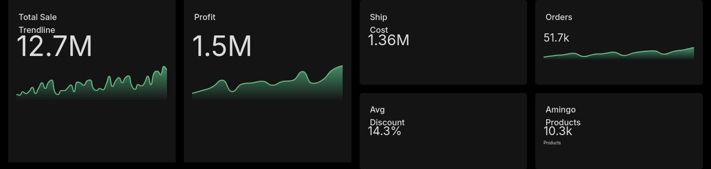
Live KPI summary — Total Sale, Profit, Ship Cost, Orders, Avg Discount, Products
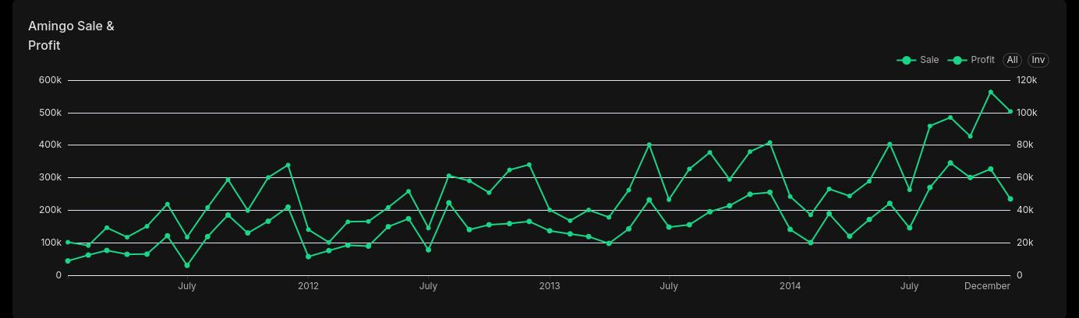
Sale & Profit trend, 2011–2014
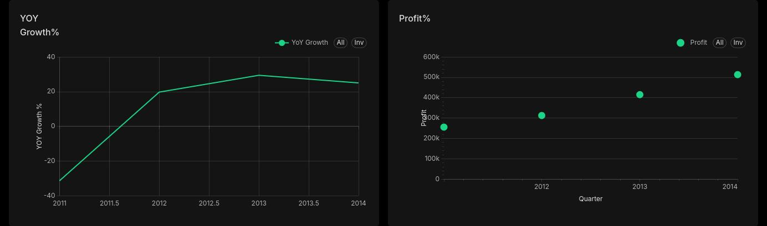
Year-over-year growth % and quarterly profit %

3.2 Profit Margin Analysis
Purpose: Uncovers value leakage — sub-categories that generate significant sales volume but deliver low or negative profit margins. One of the most actionable insight types in retail analytics.
Key Metrics: Profit Margin % = (Profit / Sales) × 100; Total Sales and Total Profit per sub-category
SELECT
p.category,
p.sub_category,
SUM(f.sales) AS total_sales,
SUM(f.profit) AS total_profit,
(SUM(f.profit) / NULLIF(SUM(f.sales), 0)) * 100 AS profit_margin_pct
FROM Fact_Sales f
JOIN Dim_Product p ON f.product_id = p.product_id
GROUP BY p.category, p.sub_category
ORDER BY profit_margin_pct ASC; -- Worst performers first

Confirmed Finding
The dashboard confirms Tables as the only sub-category with a materially negative profit margin, followed by Bookcases, Supplies, and Machines sitting close to break-even. Copiers, Labels, Paper, and Envelopes anchor the profitable end. Tables is the clear pricing-strategy priority flagged in Section 6.

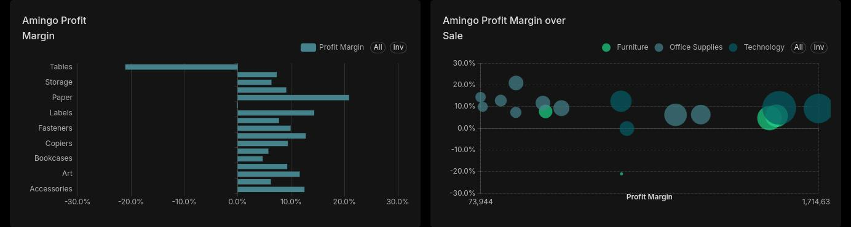
Profit margin by sub-category, and profit margin vs. sale size by category

3.3 RFM Customer Segmentation
Purpose: RFM (Recency, Frequency, Monetary) is a standard method for customer value segmentation. Customers are scored 1–5 on each dimension and grouped into Champions, Loyal, At-Risk, and Lost.
Key Metrics: R-Score (recency), F-Score (frequency), M-Score (spend) — generated with NTILE(5)
WITH CustomerMetrics AS (
SELECT
customer_name,
MAX(order_date) AS last_order_date,
COUNT(DISTINCT order_id) AS frequency,
SUM(sales) AS monetary
FROM Fact_Sales
GROUP BY customer_name
)
SELECT
customer_name,
NTILE(5) OVER (ORDER BY last_order_date ASC) AS r_score,
NTILE(5) OVER (ORDER BY frequency ASC) AS f_score,
NTILE(5) OVER (ORDER BY monetary ASC) AS m_score
FROM CustomerMetrics;
Segment | Score Profile | Recommended Action
Champions | R:5, F:5, M:5 | Reward and retain — loyalty perks, early access
Loyal Customers | R:4–5, F:3–5 | Upsell higher-margin products; sustain engagement
At-Risk | R:2–3, F:2–3 | Re-engagement campaigns; targeted discount offers
Lost / Dormant | R:1, F:1, M:1 | Win-back sequence; deprioritise spend if unresponsive

Confirmed Finding
Across 795 scored customers, six segments emerge: Champion, Loyal, Promising, Need Attention, At-Risk, and Lost. Loyal and Promising carry the largest share of the base, while At-Risk and Need Attention represent the re-engagement opportunity flagged in Section 6, Insight 4.

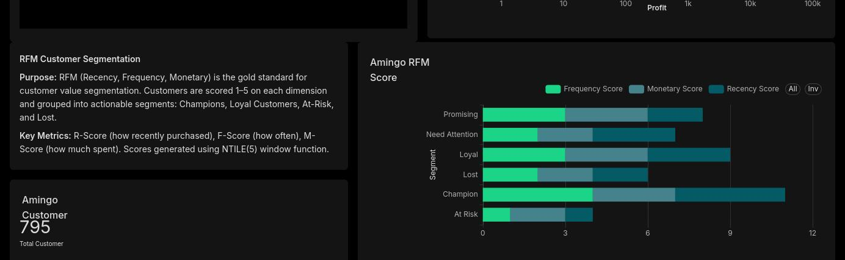
RFM score composition (Frequency, Monetary, Recency) by segment
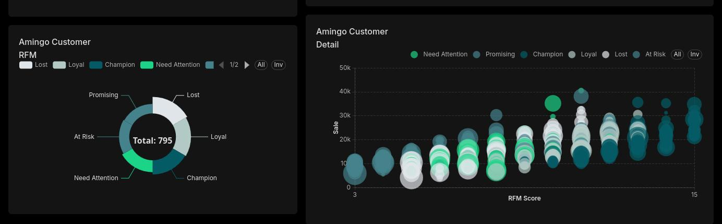
Customer count by RFM segment, and RFM score detail by order value

3.4 Discount Impact Study
Purpose: Over-discounting is a core retail risk — reductions that lift order volume while destroying margin. This analysis buckets orders by discount tier and measures average profit per tier.
SELECT
CASE
WHEN discount = 0 THEN '0% — No Discount'
WHEN discount > 0 AND discount <= 0.2 THEN '0–20% — Low'
WHEN discount > 0.2 AND discount <= 0.5 THEN '20–50% — Mid'
ELSE '50%+ — High'
END AS discount_bucket,
COUNT(order_id) AS order_count,
AVG(profit) AS avg_profit_per_order,
SUM(sales) AS total_sales
FROM Fact_Sales
GROUP BY 1
ORDER BY avg_profit_per_order DESC;
Confirmed Finding
Average discount sits at 11.1% overall (14.3% including zero-discount orders in the KPI baseline). Orders with no discount concentrate the bulk of sales and profit; profit thins out sharply through the Low and Mid buckets and is weakest in the 50%+ High bucket — the over-discounting risk the study set out to test is present in the data.

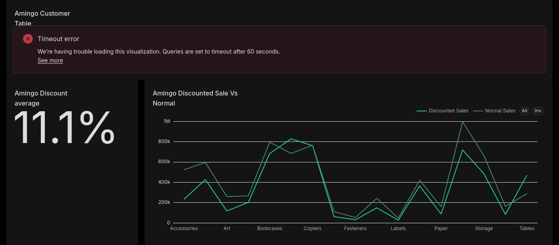
Average discount (11.1%) and discounted vs. normal sales by sub-category
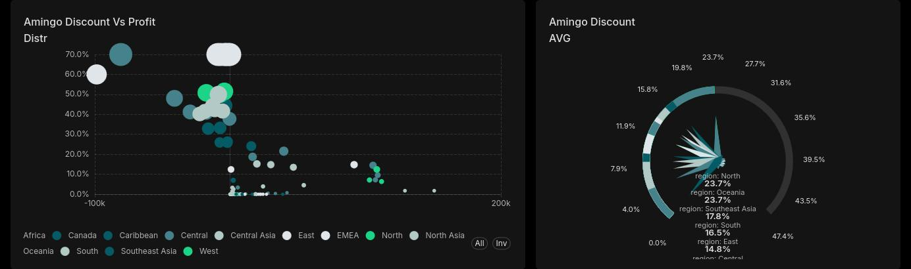
Discount vs. profit distribution, and average discount by region
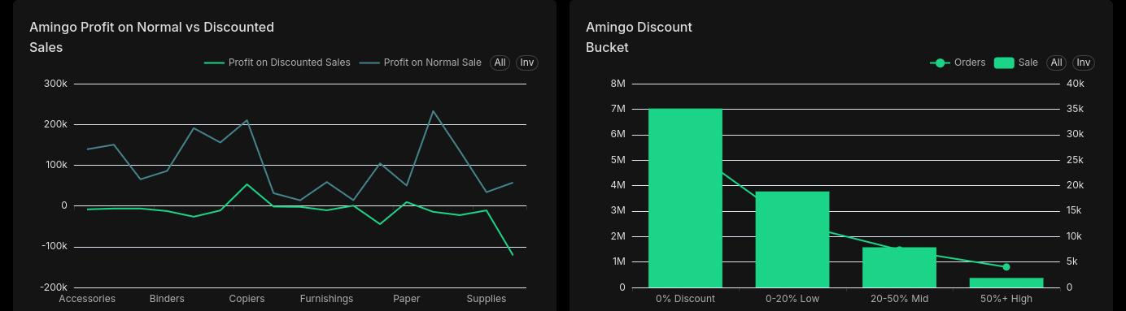
Profit on discounted vs. normal sales, and order/sales volume by discount bucket

3.5 Shipping & Logistics Performance
Purpose: Delivery speed is directly tied to customer satisfaction. This analysis benchmarks actual ship times against a 4-day standard, broken down by ship mode and region.
SELECT
i.ship_mode,
l.region,
AVG(DATEDIFF(day, d.order_date, d.ship_date)) AS avg_days_to_ship,
COUNT(CASE WHEN DATEDIFF(day, d.order_date, d.ship_date) > 4
THEN 1 END) AS delayed_orders
FROM Fact_Sales f
JOIN Dim_Date d ON f.order_date = d.order_date
JOIN Dim_Order_Info i ON f.order_id = i.order_id
JOIN Dim_Location l ON f.location_id = l.location_id
GROUP BY i.ship_mode, l.region;
Confirmed Finding
Total shipping cost across the period is 1.36M. Ship cost by region shows a pronounced spike in Central Asia relative to other regions, and the ship-delay trend shows recurring peaks rather than a steady decline — both worth a follow-up look at carrier allocation in that region.

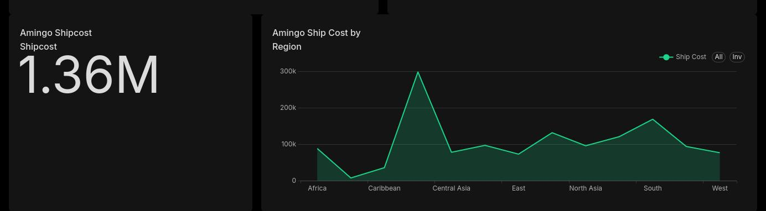
Total ship cost (1.36M) and ship cost by region
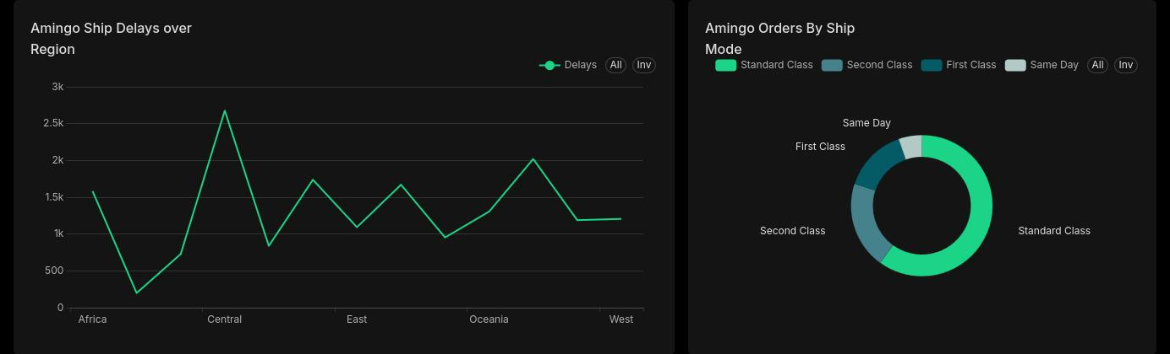
Ship delays by region over time, and orders by ship mode

3.6 Category & Sub-Category Pareto (80/20 Rule)
Purpose: The Pareto principle holds that roughly 80% of revenue comes from 20% of products. This analysis ranks sub-categories by sales and computes a running cumulative total to isolate the critical revenue drivers.
WITH SubCatSales AS (
SELECT p.sub_category, SUM(f.sales) AS total_sales
FROM Fact_Sales f
JOIN Dim_Product p ON f.product_id = p.product_id
GROUP BY p.sub_category
),
CumulativeSales AS (
SELECT
sub_category,
total_sales,
SUM(total_sales) OVER (ORDER BY total_sales DESC) AS running_total,
SUM(total_sales) OVER () AS grand_total
FROM SubCatSales
)
SELECT
sub_category,
total_sales,
(running_total / grand_total) * 100 AS cumulative_revenue_pct
FROM CumulativeSales;
Confirmed Finding
The product treemap shows Chairs, Storage, Phones, and Machines as the largest revenue blocks, with a long tail of smaller sub-categories (Bookcases, Tables, Fasteners) contributing marginally — consistent with a small set of sub-categories driving most of revenue, as the Pareto hypothesis anticipated.

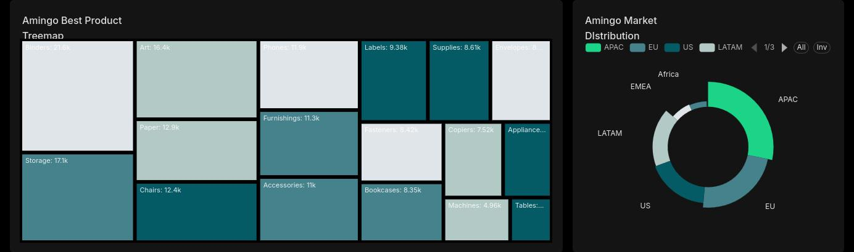
Revenue treemap by sub-category, and sales distribution by market

3.7 Regional Profitability Heatmap
Purpose: Not all geographies perform equally. This analysis surfaces blind spots — states and regions operating at low or negative profitability — to guide targeted operational intervention.
SELECT
l.market, l.country, l.state,
SUM(f.sales) AS total_sales,
SUM(f.profit) AS total_profit,
(SUM(f.profit) / NULLIF(SUM(f.sales), 0)) AS profit_ratio
FROM Fact_Sales f
JOIN Dim_Location l ON f.location_id = l.location_id
GROUP BY l.market, l.country, l.state
ORDER BY total_profit ASC; -- Worst regions first
Confirmed Finding
The country map and state-level bubble chart both show heavy revenue concentration in a small number of markets (notably the US), with most other countries contributing thin, scattered volume — the long tail is exactly where the 'blind spot' regions are likely to sit and merits a state-by-state profit-ratio pass once the dashboard's underlying table query is stable.

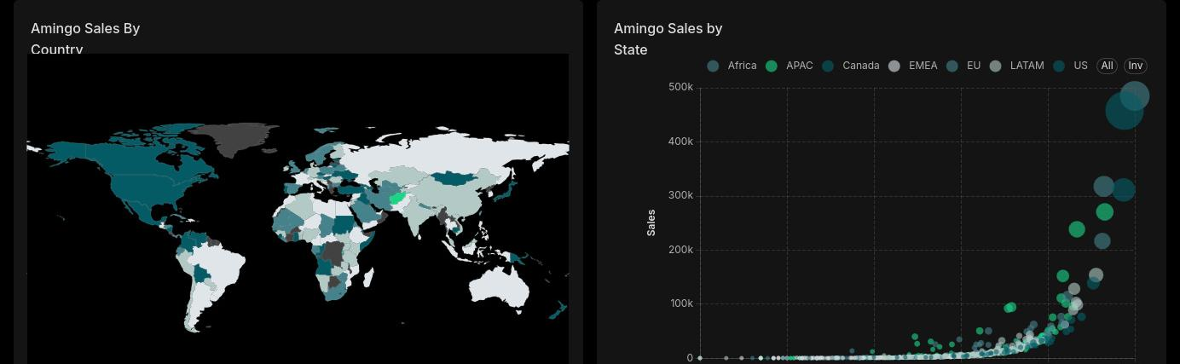
Sales by country, and sales vs. profit by state

3.8 Basket Analysis (Co-occurrence / Cross-Sell)
Purpose: Product pairs frequently purchased together reveal natural cross-sell and bundling opportunities. The query self-joins on order ID to find product combinations within the same order.
SELECT
p1.sub_category AS product_a,
p2.sub_category AS product_b,
COUNT(*) AS times_bought_together
FROM Fact_Sales f1
JOIN Fact_Sales f2 ON f1.order_id = f2.order_id
AND f1.product_id < f2.product_id -- Avoids duplicate pairs
JOIN Dim_Product p1 ON f1.product_id = p1.product_id
JOIN Dim_Product p2 ON f2.product_id = p2.product_id
GROUP BY p1.sub_category, p2.sub_category
ORDER BY times_bought_together DESC
LIMIT 10;
Open Item
No basket/co-occurrence visual has been built in the dashboard yet — this analysis is validated in SQL only. Add a cross-sell matrix or top-10 pairs bar chart in the next dashboard iteration.

3.9 Customer Lifetime Value (CLV)
Purpose: CLV-to-date estimates each customer segment's total revenue contribution across the analysis period, helping the business focus retention spend and differentiate service levels by segment.
SELECT
c.segment,
COUNT(DISTINCT f.customer_name) AS total_customers,
AVG(f.sales) AS avg_order_value,
SUM(f.sales) / COUNT(DISTINCT f.customer_name) AS clv_to_date
FROM Fact_Sales f
JOIN Dim_Customer c ON f.customer_name = c.customer_name
GROUP BY c.segment;
Confirmed Finding
Across 795 customers, Consumer is the largest segment by count, ahead of Corporate and Home Office. Order volume by RFM segment is highest among Loyal and Champion customers, supporting a service-tier approach that prioritises retention spend on those two groups.

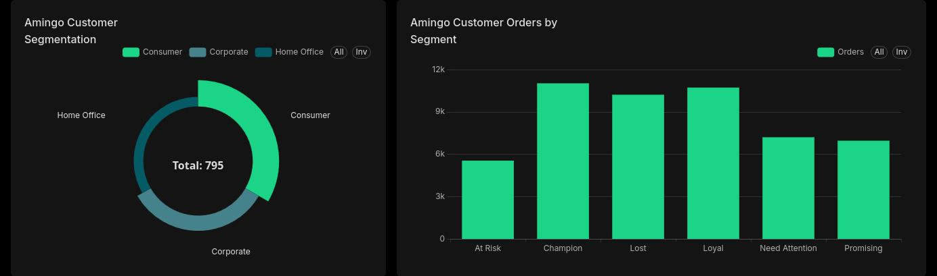
Customer segmentation (Consumer / Corporate / Home Office), and orders by RFM segment

3.10 Returns Analysis
Purpose: High return rates signal product quality issues, fulfilment problems, or misleading listings. In the absence of a populated Returns table, this analysis uses a proxy model: orders with negative profit and a discount above 70% are flagged as probable returns.
SELECT
p.category,
COUNT(f.order_id) AS total_orders,
SUM(CASE WHEN f.profit < 0 AND f.discount > 0.7
THEN 1 ELSE 0 END) AS proxy_return_count,
(CAST(
SUM(CASE WHEN f.profit < 0 AND f.discount > 0.7
THEN 1 ELSE 0 END) AS FLOAT)
/ COUNT(f.order_id)) * 100 AS est_return_rate_pct
FROM Fact_Sales f
JOIN Dim_Product p ON f.product_id = p.product_id
GROUP BY p.category
ORDER BY est_return_rate_pct DESC;
Open Item
The detailed customer/returns table on the dashboard is currently timing out (queries are capped at 60 seconds) rather than rendering category-level proxy return rates. The underlying SQL above runs fine standalone — the fix is to pre-aggregate this into a view rather than querying Fact_Sales live from the dashboard.

4. Workflow & Tool Stack
The project follows a standard three-layer BI workflow: raw computation in SQL, exploratory modelling in Excel, and final storytelling in a BI tool. Separating these layers keeps the logic clean and auditable at every stage.
Tool | Role | Primary Tasks
SQL Server | The Engine | Data cleaning, aggregation, RFM scoring, joins between Orders and Returns, window functions (LAG, NTILE, SUM OVER)
Microsoft Excel | The Sandbox | Ad-hoc calculations, Data Dictionary, 'what-if' discount scenario modelling, retention rate for CLV
BI Tool (Power BI / Superset) | The Storyteller | Interactive dashboards, drill-throughs, KPI cards, Pareto charts, geographic heatmaps, scatter plots

4.1 Workflow Sequence
- SQL first — run all 10 analytical queries to generate clean, aggregated result sets; store outputs as views (vw_ prefix) for straightforward BI connection.
- Excel second — import SQL outputs for ad-hoc 'what-if' analysis (e.g., the profit impact of cutting all Furniture discounts by 5%); build the Data Dictionary here.
- BI tool last — connect directly to the SQL views and build the dashboard with drill-through, so clicking a region surfaces the specific products driving losses there.

5. Standards & Quality Assurance

5.1 Data Cleaning Log
Every transformation step is documented — in this field, how a number was derived matters as much as the number itself. The log covers:
- Null value treatment: NULL discount values default to 0; NULL profit values are excluded from margin calculations via NULLIF()
- Duplicate handling: DISTINCT applied when populating Raw_Superstore to prevent duplicate Customer, Product, and Region records
- Outlier review: profit values below the 1st percentile are flagged for manual review before entering executive-level KPIs
- Date validation: all order_date and ship_date values confirmed to fall within 2014–2017

5.2 Data Dictionary
Maintained in Excel to keep a single version of the truth across the project. Key definitions:
Field | Table | Definition
sales | Fact_Sales | Gross transaction value before discounts; not net revenue
profit | Fact_Sales | Net profit after cost of goods and discounts; can be negative
discount | Fact_Sales | Decimal discount rate applied (e.g. 0.20 = 20%); range 0.00–0.80
profit_margin_pct | Derived | (profit / sales) × 100, as a percentage; negative = loss-making
clv_to_date | Derived | Segment sales revenue divided by distinct customer count
proxy_return_count | Derived | Orders where profit < 0 and discount > 0.70 — a returns proxy absent a Returns table

5.3 Visualisation Standards
A consistent colour scheme applies across all dashboards:
- Red — negative profit, high return rates, declining YoY performance
- Green — positive growth, profitable segments, above-benchmark metrics
- Blue / grey — neutral metrics, volume indicators, structural elements
Every chart is held to one standard: 'so what?' — if a visual doesn't lead to a business decision, it doesn't make the final dashboard.

5.4 Naming Conventions
- SQL views: vw_ prefix (e.g. vw_executive_sales, vw_rfm_scores)
- Staging tables: Raw_ prefix (e.g. Raw_Superstore)
- Derived metrics: snake_case with descriptive suffixes (_pct, _count, _rate)

6. Executive Summary — Key Insights
With the dashboard now live, the five items below are confirmed findings rather than pre-execution hypotheses. Figures reference the visualisations in Section 3; two supporting analyses (Basket Analysis and the Returns detail table) remain open items, noted where relevant.

Insight 1 — Discount-Driven Margin Erosion
Confirmed: Tables is the standout loss-making sub-category on the profit margin chart, with Bookcases and Supplies close to break-even. Sales and profit both thin out sharply above the 20% discount bucket. Recommendation: cap Tables discounts at 20%, or shift to value-based pricing.

Insight 2 — Pareto Revenue Concentration
Confirmed: the product treemap shows Chairs, Storage, Phones, and Machines as the dominant revenue blocks, with a long tail of smaller sub-categories contributing marginally. Protecting and growing this core group should remain the top commercial priority.

Insight 3 — Regional Blind Spots
Partially confirmed: revenue is heavily concentrated in a handful of markets (led by the US), with most other countries showing thin, scattered volume on the map and state bubble chart. A dedicated profit-ratio-by-state view is still needed to name the specific underperforming states.

Insight 4 — At-Risk Customer Segment
Confirmed: RFM scoring across 795 customers surfaces distinct At-Risk and Need Attention cohorts alongside Champions and Loyal customers. A targeted re-engagement campaign for the At-Risk/Need Attention group remains a low-cost, high-ROI opportunity.

Insight 5 — Cross-Selling Opportunity
Open item: the dashboard has no basket/co-occurrence visual yet, so this insight is still supported only by the SQL output, not a chart. Recommend adding a top-10 product-pair view in the next iteration before treating this as confirmed.

7. Conclusion
This project delivers a complete, end-to-end business intelligence solution for Amingo Superstore. Ten industry-standard analyses applied across four years of transaction history produce actionable intelligence across four business domains:
- Commercial strategy — which products and sub-categories to protect, grow, or reprice
- Customer intelligence — segmenting the customer base by value to target marketing efficiently
- Operational efficiency — surfacing shipping bottlenecks and regional underperformance
- Financial discipline — quantifying the true cost of discounting and returns on profitability
The star schema design, documented SQL logic, and a professional BI visualisation layer together make this more than a one-off exercise — it's a scalable, repeatable reporting infrastructure Amingo Superstore can rerun against any future data refresh.
The end deliverable is an interactive dashboard that lets any stakeholder, from the shop floor to the boardroom, ask better questions and make faster, more confident decisions.

Amingo Superstore — Business Intelligence & Analytics Project

