Week 2

1. Convert a 32-bit value from Little Endian to Big Endian format using RISC-V assembly

.data

a: .word 0x12345678

b: .word 0xff

c: .word 0

.text

la x2,a

la x5,b

la x6,c

lw x3,0(x2)

lw x4,0(x5)

and x7,x3,x4 #00000078

slli x7,x7,24 #78000000

srli x3,x3,8 #00123456

and x10,x3,x4 #00000056

slli x10,x10,16 #00560000

or x7,x7,x10 #78560000

srli x3,x3,8

and x11,x3,x4

slli x11,x11,8

or x12,x7,x11

srli x3,x3,8

and x13,x3,x4

or x12,x13,x12

sw x12,0(x6)

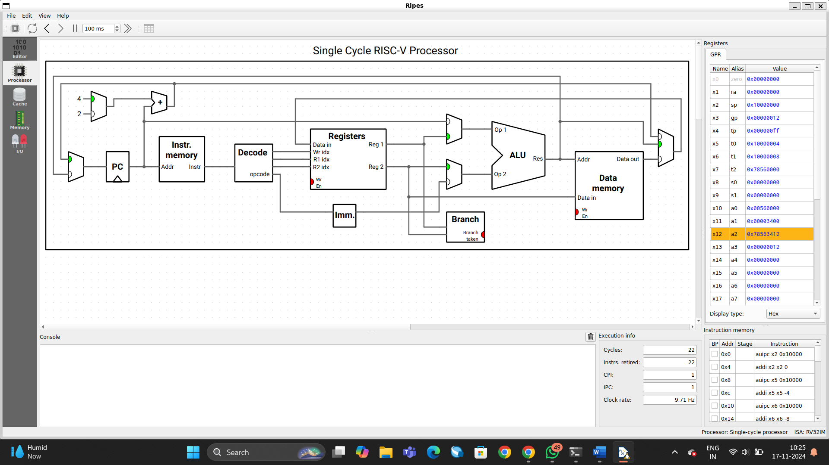

. 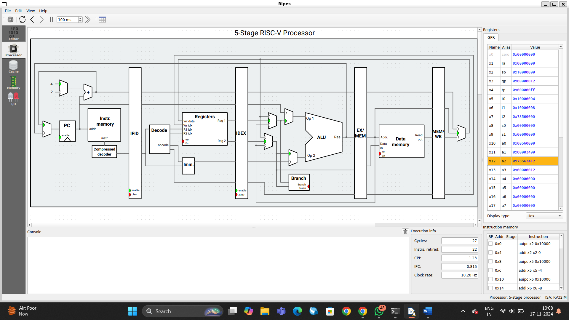

1. Write an Assembly Program for addition of 2 64-bit numbers on RV32I

.data

n1: .dword 0xffffffffffffffff

n2: .dword 0xffffffffffffffff

.text

la x1, n1

lw x2, 0x00(x1)

lw x3, 0x04(x1)

la x4,n2

lw x5,0x00(x4)

lw x6,0x04(x4)

add x7,x3,x6 #msb

sltu x9,x7,x3 #carry generated

add x8,x2,x5 #lsb

sltu x10,x8,x5 # carry generated

add x11,x7,x10 #addition of carry to msb

sw x8,0x08(x4)

sw x11,0x0c(x4)

sw x9,0x16(x4)

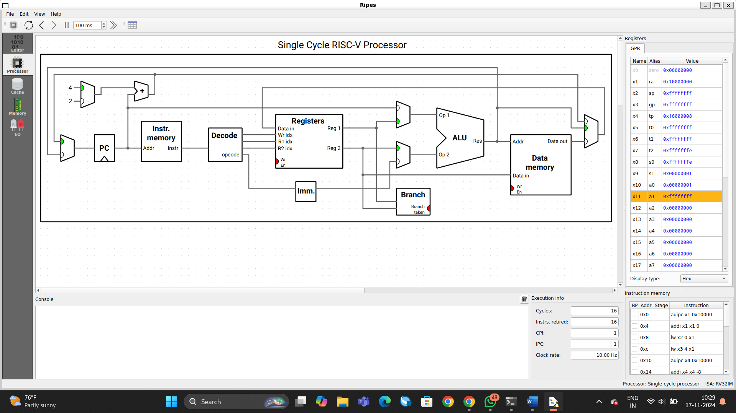

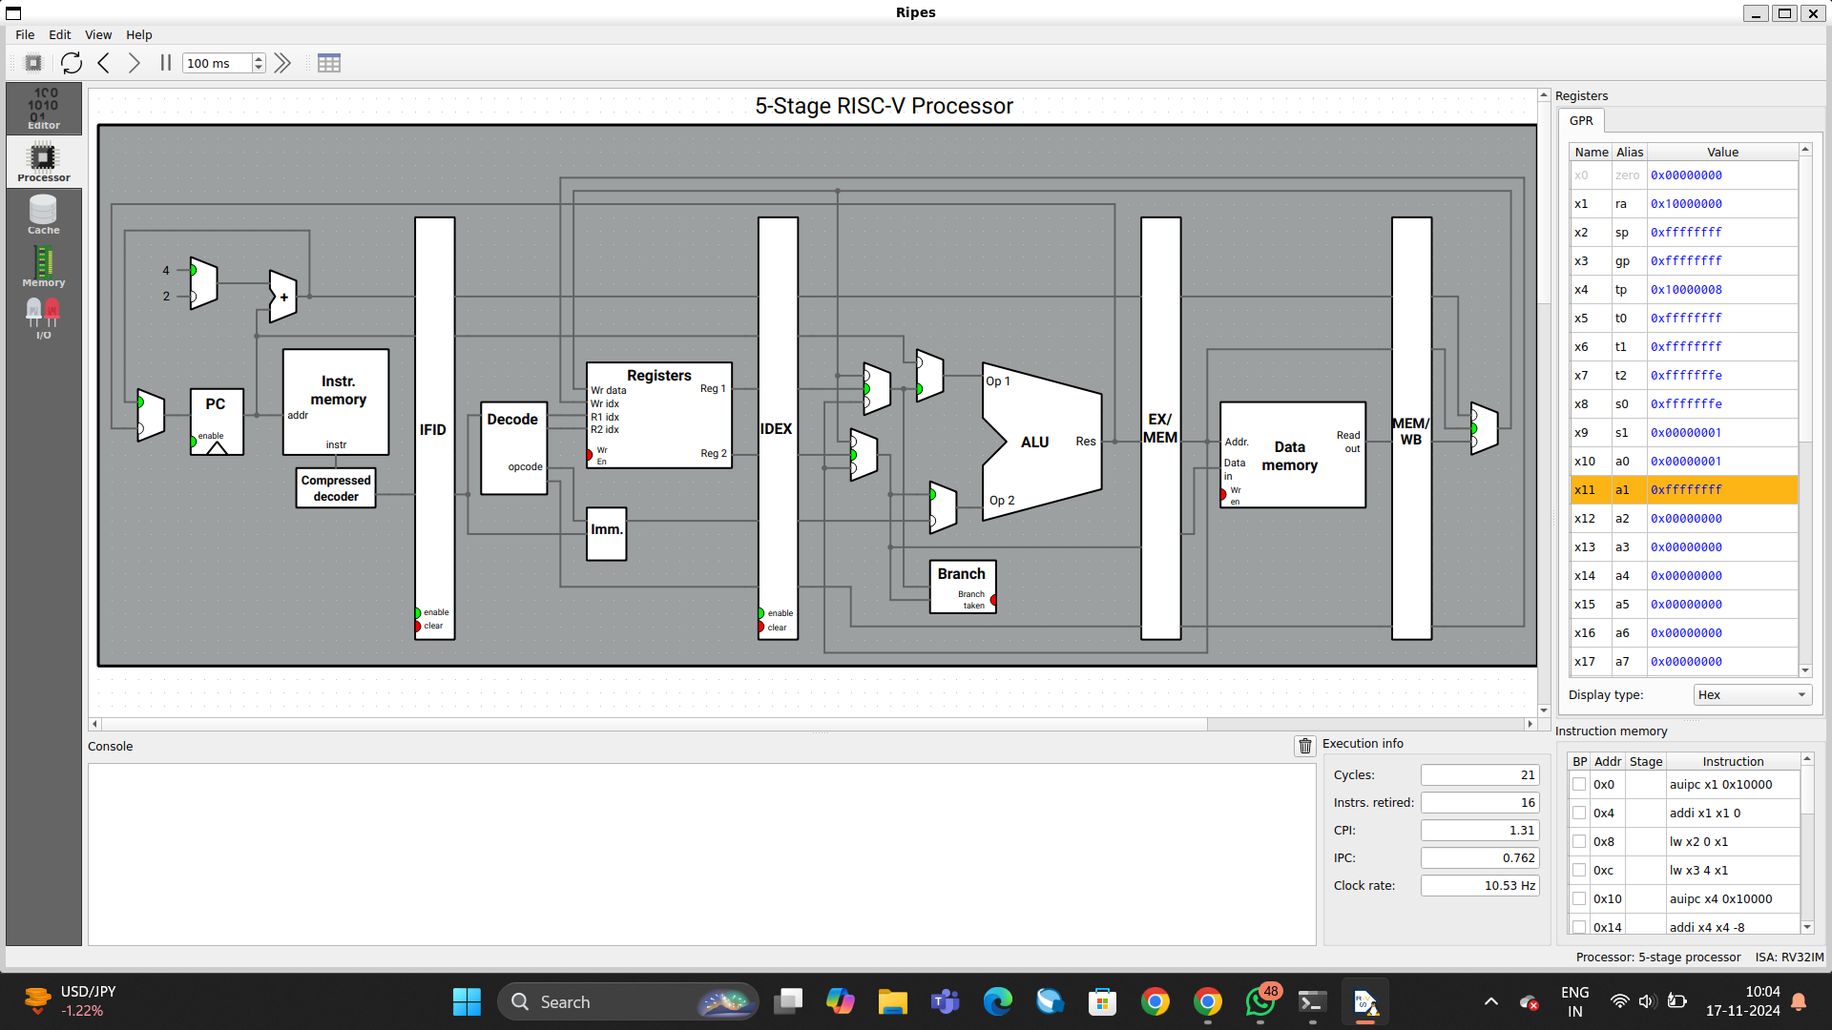 2.