Week 2

1. Write an Assembly Program for:
2. addition of N words

.data

a: .word 0xffffff23,0xee456aee

.text

la x1,a

lw x2,0(x1)

lw x3,4(x1)

add x4,x3,x2

sw x4,8(x1)

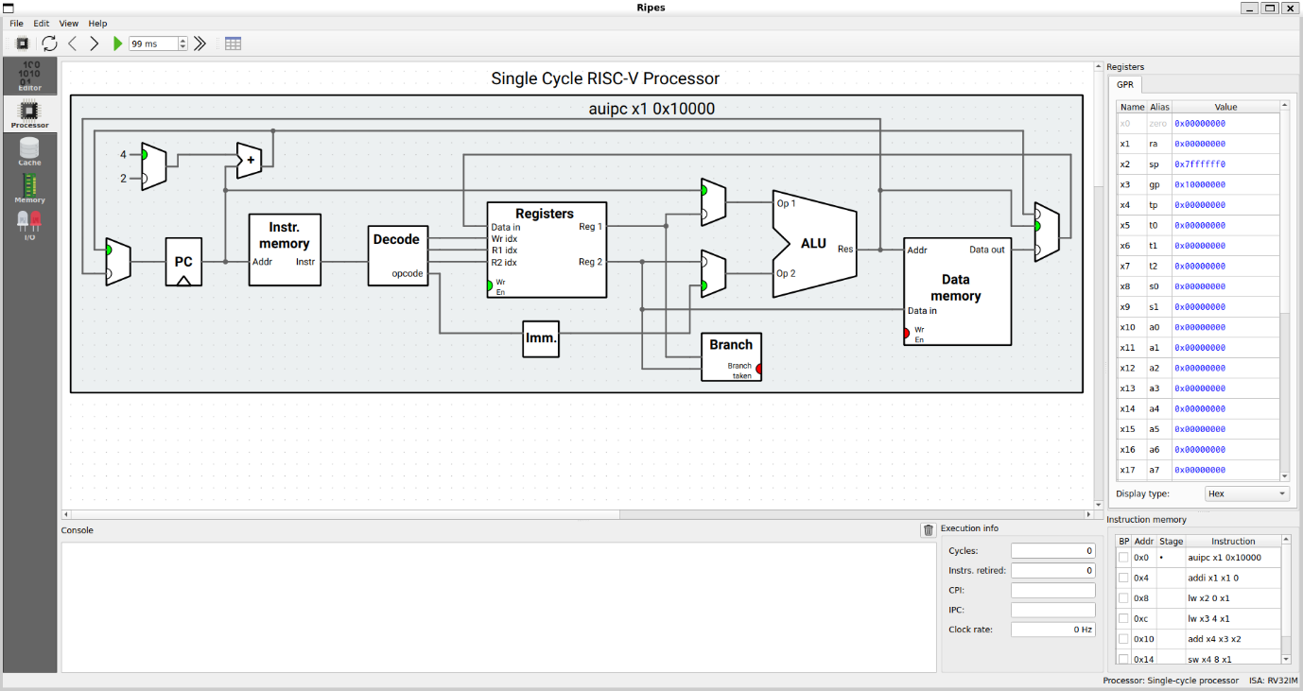

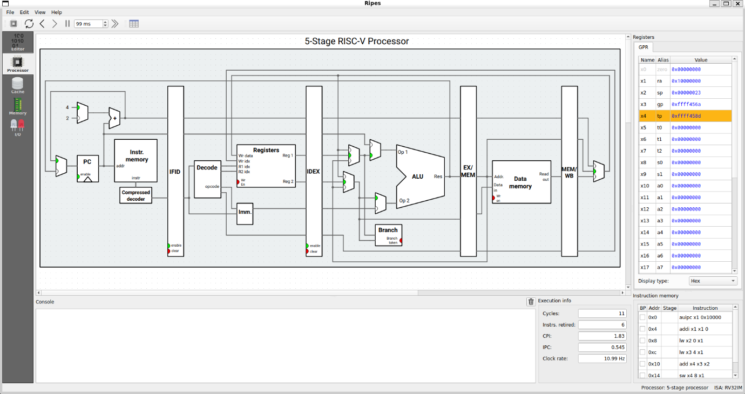

1. addition of N half words

.data

a: .half 0x4321, 0x7689

.text

la x1, a

lh x2, 0(x1)

lh x3, 2(x1)

add x4, x3, x2

sh x4, 4(x1)

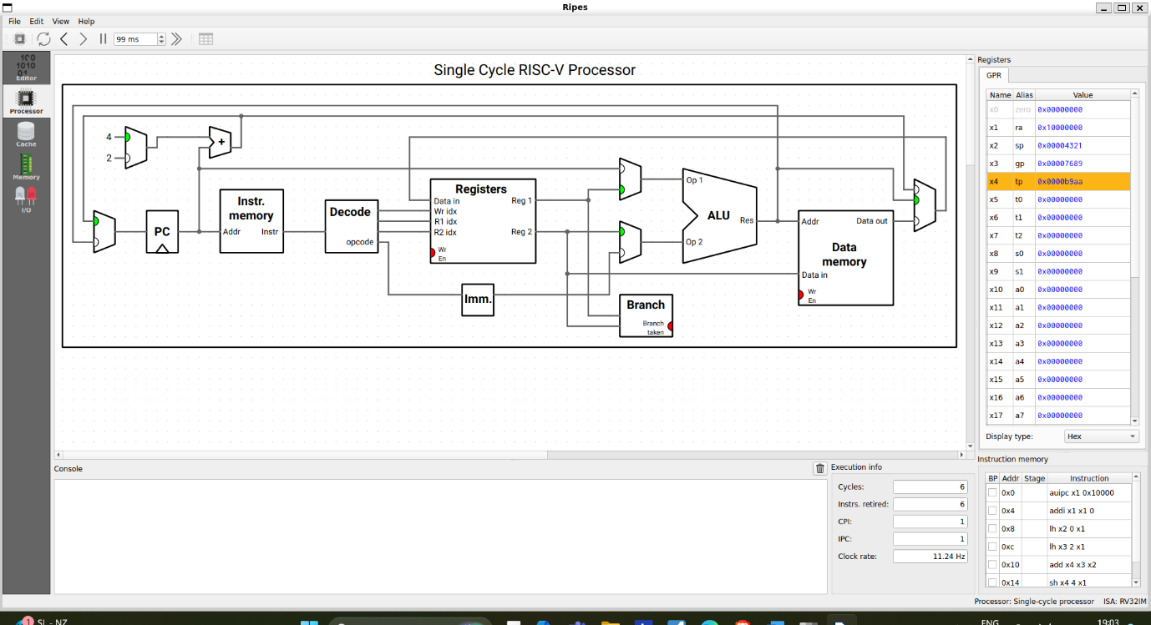

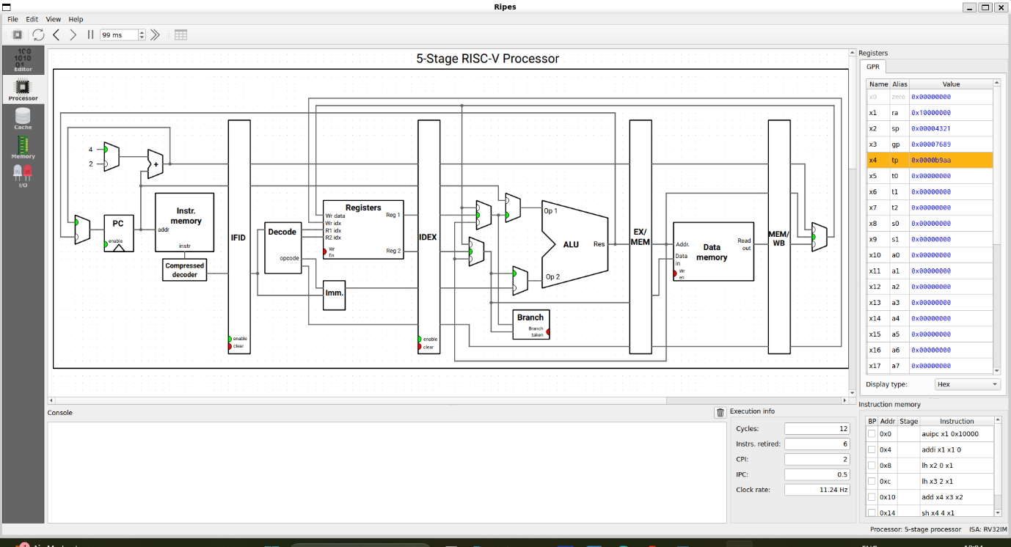

1. addition of N bytes

.data

a: .byte 0x12, 0x8A

.text

la x1, a

lb x2, 0(x1)

lb x3, 1(x1)

add x4, x3, x2

sb x4, 2(x1)

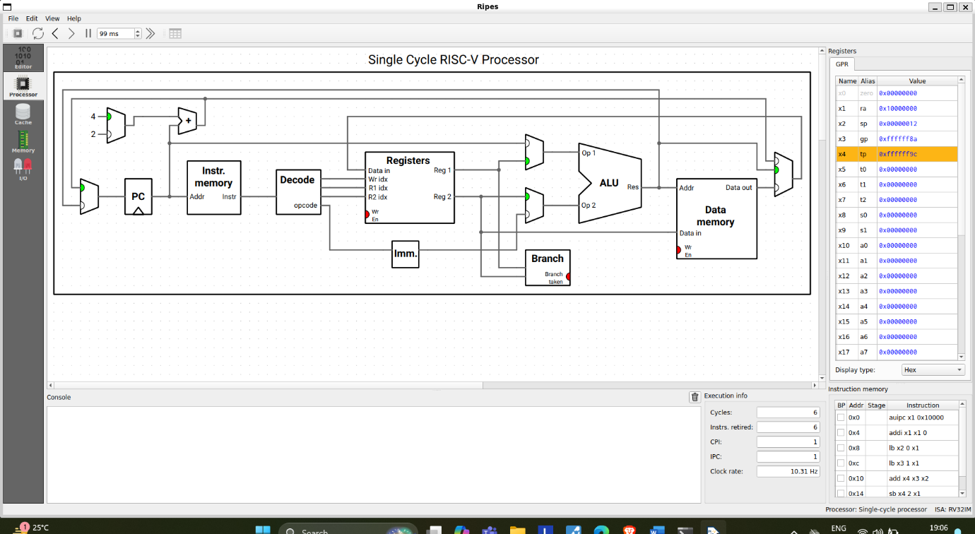

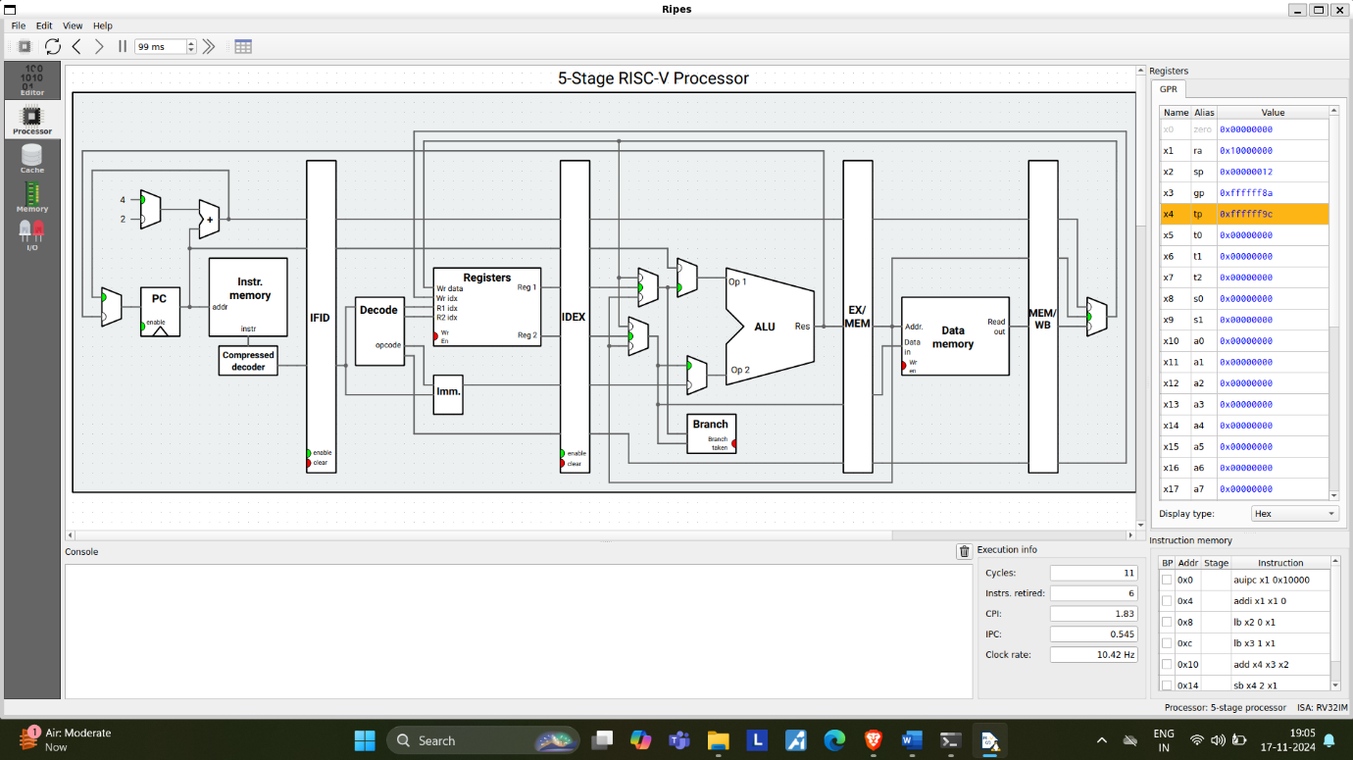

* 1. Write an Assembly program for calculating x = (y + m) - (L - D) + (Z + C) - D, where x, y, m, L, D, Z, C are elements of 32-bits wide

.data

y: .word 65 # Value of y

m: .word 95 # Value of m

L: .word 76 # Value of L

D: .word 5 # Value of D

Z: .word 34 # Value of Z

C: .word 40 # Value of C

x: .word 0 # To store the result (x)

.text

la x1, y

lw x2, 0(x1)

la x3, m

lw x4, 0(x3)

add x5, x2, x4

la x6, L

lw x7, 0(x6)

la x8, D

lw x9, 0(x8)

sub x10, x7, x9

sub x11, x5, x10

la x12, Z

lw x13, 0(x12)

la x14, C

lw x15, 0(x14)

add x16, x13, x15

add x17, x11, x16

sub x18, x17, x9

la x19, x

sw x18, 0(x19)

li a7, 10

