Week 4

1. Write an assembly program to find whether a given string is a palindrome or not, using stack operations

.data

string: .byte 97,11,45

len: .word 3 # Length of string

result: .word 0

.text

.globl _start

_start:

la x5, string # Load base address of string

lw x6, len # Load length of string

li x7, 0 # Left index (i)

addi x6, x6, -1 # Right index (j = length - 1)

loop:

bge x7, x6, palindrome # If left >= right, it's a palindrome

# Load characters at left and right indices

add x8, x5, x7 # Address of left char

add x9, x5, x6 # Address of right char

lb x8, 0(x8) # Load left char

lb x9, 0(x9) # Load right char

bne x8, x9, not_palindrome # If chars don't match, not a palindrome

addi x7, x7, 1 # i++

addi x6, x6, -1 # j--

j loop

palindrome:

li x8, 1 # Set result to 1

j store_result

not_palindrome:

li x8, 0 # Set result to 0

store_result:

la x5, result # Load address of result

sw x8, 0(x5) # Store the result

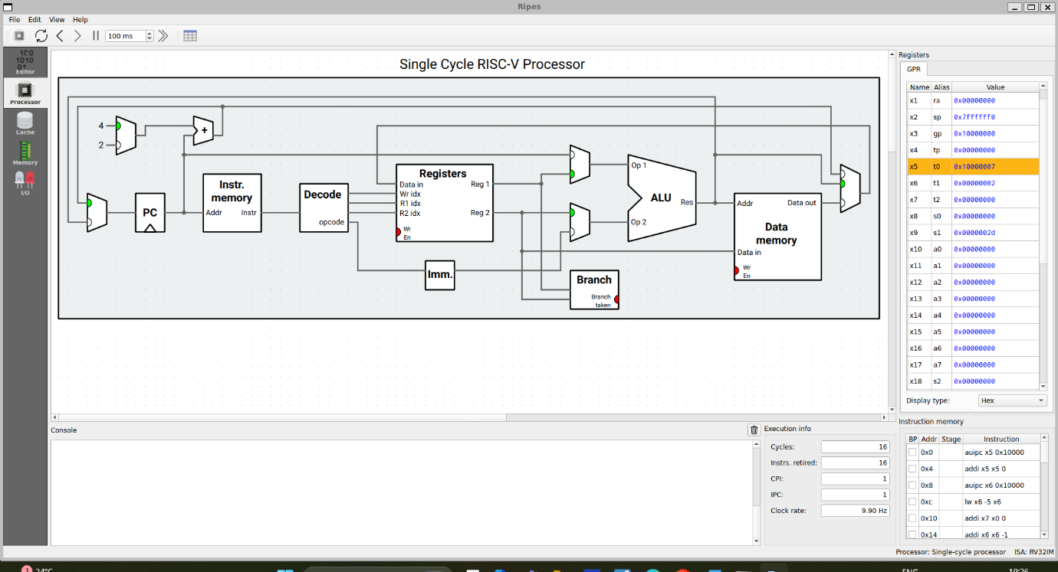

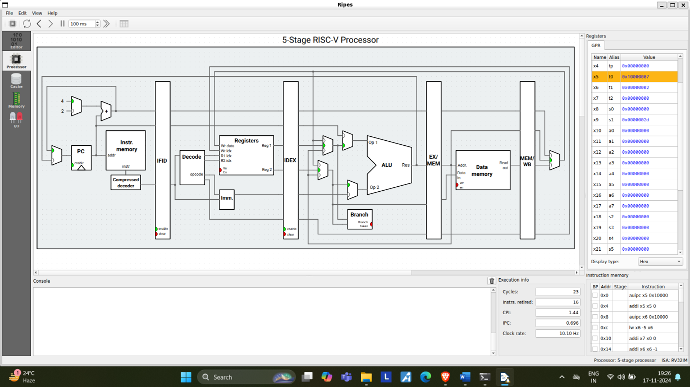

* 1. Write an assembly program to search a given number in an array

.data

a: .byte 0x67, 0x82,0x03,0x72

b: .byte 0x72

.text

la x10,a #address of array

la x11,b #address of the no to searched

lb x16,0(x11) #no to be searched

addi x20,x0,4 #no of loops

addi x27,x0,0

loop: lb x12,0(x10) #loading the values of the array

beq x12,x16,exit #checking if no is present in array

addi x27,x27,1 #incrementing the loop

beq x27,x20,exit2 #cheching for the loop iteration i<4

addi x10,x10,4 #incrementing the array address

beq x0,x0,loop

exit: addi x25,x0,1 #if x25 is 1 the no is present

exit2: nop

