Week 6

1. Write an assembly program to sort an array using bubble sort to sort N-elements

.data

a: .word 4,67,9 # Array of 3 elements

n: .word 3 # Number of elements in the array (N)

.text

.globl _start

_start:

la x6, n # Load address of N

lw x21, 0(x6) # Load the value of N into x21

addi x21, x21, -1 # Set the outer loop limit to (N - 1)

li x1, 0 # Outer loop counter (i)

loop1:

li x2, 0 # Inner loop counter (j)

la x10, a # Load the base address of the array into x10

loop2:

lw x11, 0(x10) # Load word from address x10 into x11

lw x12, 4(x10) # Load word from address x10 + 4 (next element) into x12

ble x11, x12, no_swap # If x11 <= x12, no need to swap

# Swap elements

sw x12, 0(x10) # Store x12 (larger) in the current position

sw x11, 4(x10) # Store x11 (smaller) in the next position

no_swap:

addi x10, x10, 4 # Increment the pointer to the next element (4 bytes)

addi x2, x2, 1 # Increment inner loop counter (j)

sub x6, x21, x1 # Calculate the effective limit for inner loop (N - 1 - i)

bge x2, x6, end_inner_loop # If j >= (N - 1 - i), end inner loop

j loop2 # Continue inner loop

end_inner_loop:

addi x1, x1, 1 # Increment outer loop counter (i)

bge x1, x21, end_program # Stop outer loop if i >= (N - 1)

j loop1 # Continue outer loop

end_program:

# Exit program without infinite loop

li a7, 93 # Exit syscall number for RISC-V

ecall

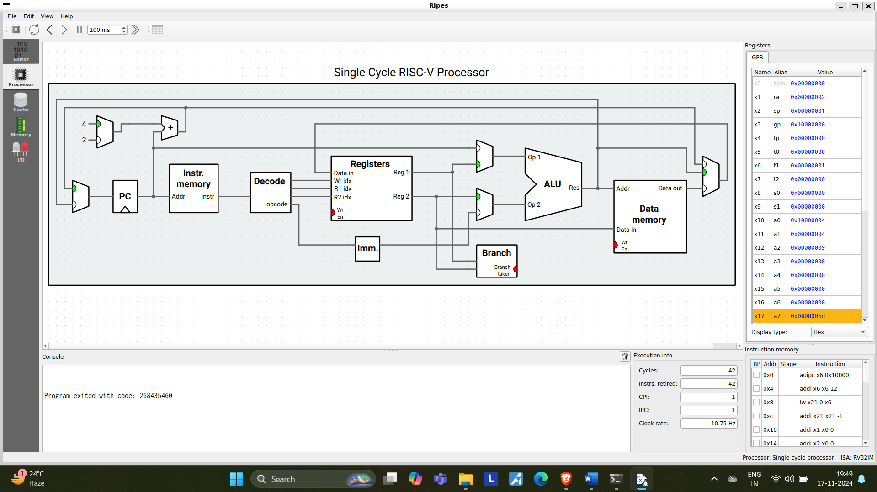

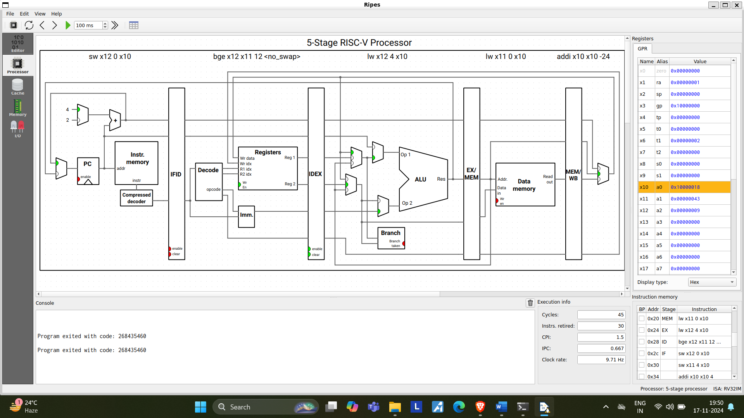

1. Write an assembly program to calculate the factorial of a number with & without recursion

Without recursion:

.data

num: .word 5 # The number to calculate the factorial of

result: .word 1 # Store the result of the factorial

.text

la x5, num # Load address of 'num' into x5

lw x6, 0(x5) # Load 'num' into x6 (x6 = 5)

li x7, 1 # Initialize the result to 1 (x7 = 1)

factorial_loop:

beq x6, x0, done # If x6 is 0 (end of the loop), done

mul x7, x7, x6 # result = result * x6

addi x6, x6, -1 # Decrement x6 (x6 = x6 - 1)

j factorial_loop # Repeat the loop

done:

la x8, result # Load address of result into x8

sw x7, 0(x8) # Store the result in memory

j exit # Jump to exit (end of program)

exit:

j exit # Infinite loop to end the program

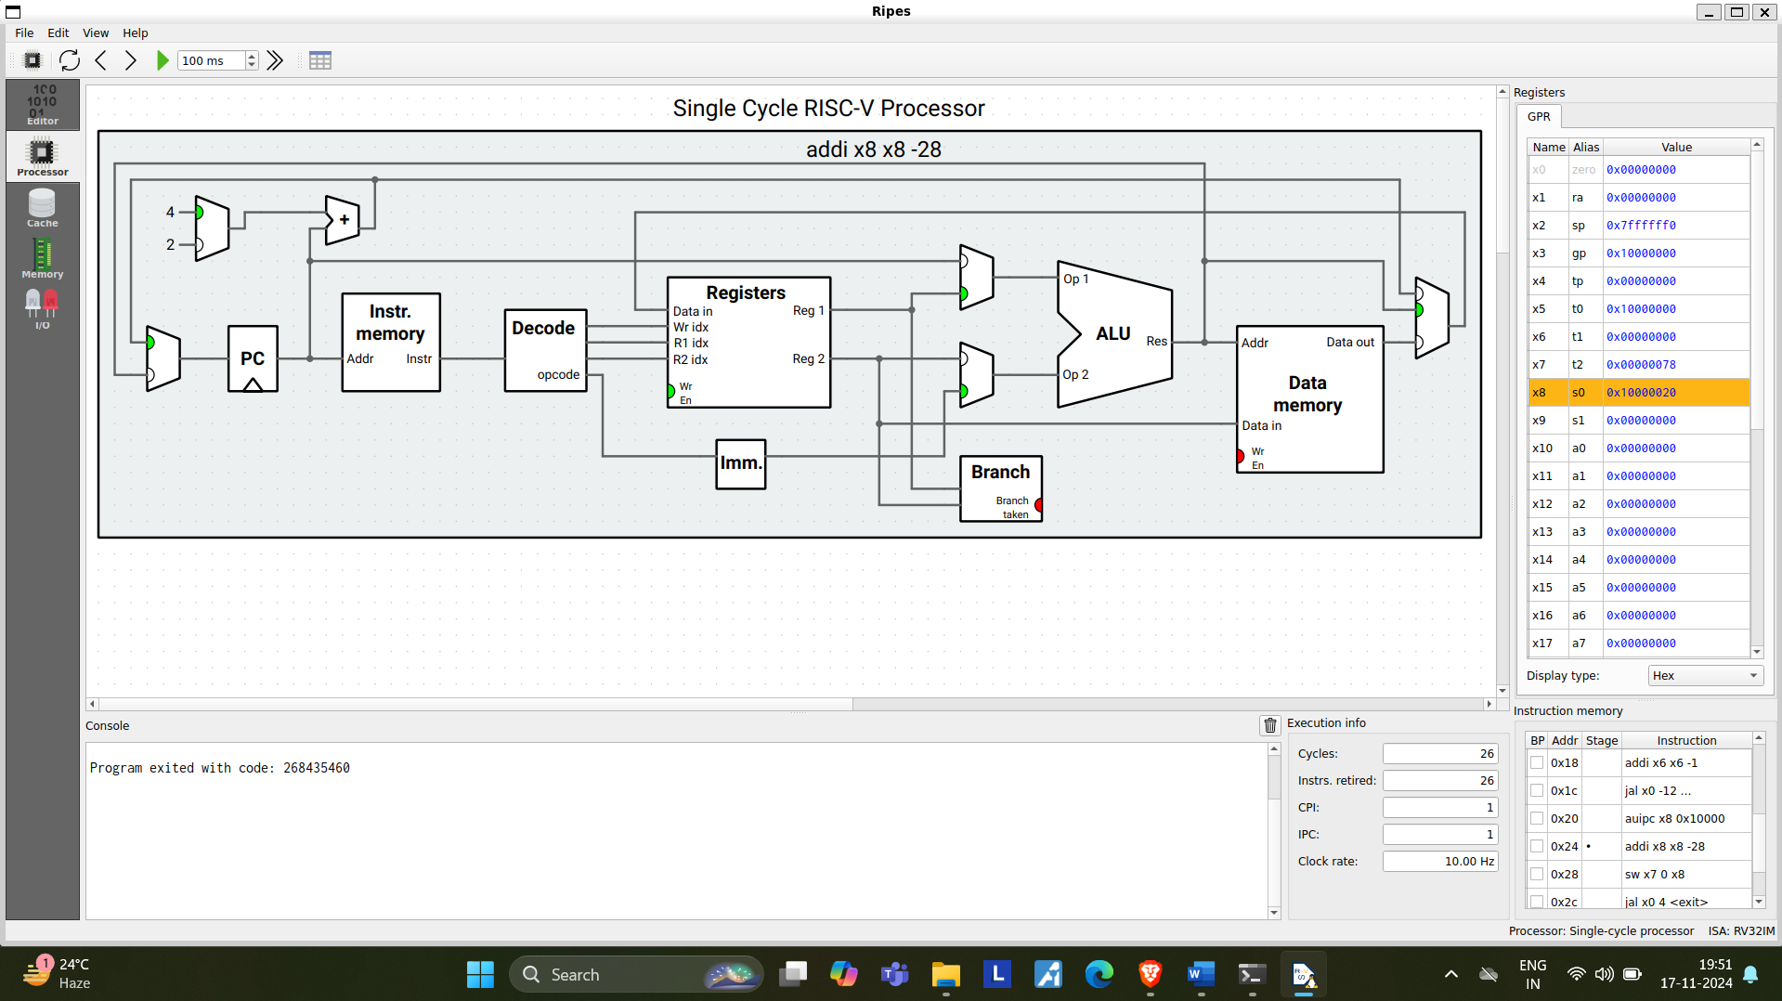

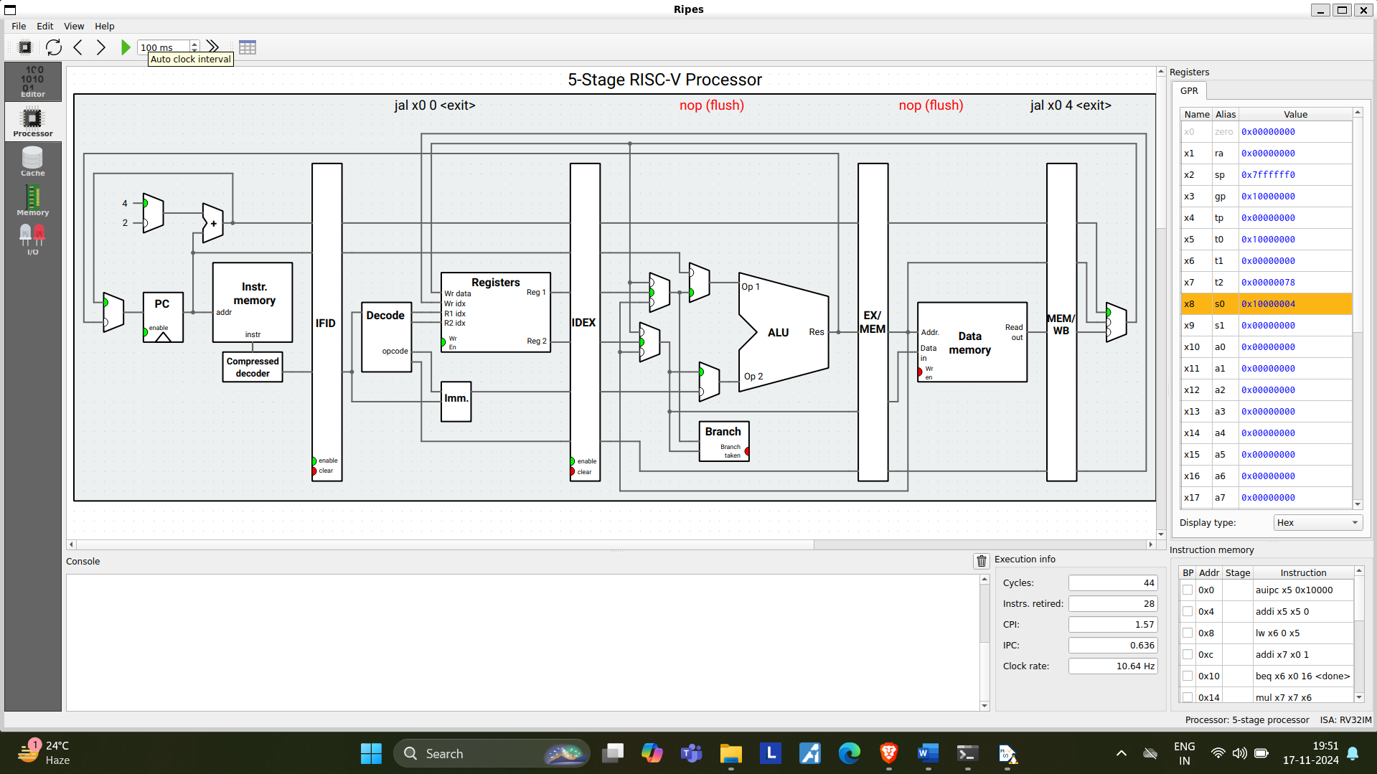

WITH RECURSION:

.data

num: .word 5 # The number to calculate the factorial of

result: .word 0 # Store the result of the factorial

.text

la x5, num # Load address of 'num' into x5

lw x6, 0(x5) # Load 'num' into x6 (x6 = 5)

# Start the recursive factorial function

jal ra, factorial # Jump to factorial function

la x8, result # Load address of result into x8

sw x6, 0(x8) # Store the result in memory

exit:

j exit # Infinite loop to end the program

# Recursive factorial function

factorial:

addi sp, sp, -4 # Make space on stack for return address

sw ra, 0(sp) # Save return address

bge x6, x0, factorial_continue # If x6 >= 1, continue the recursion

li x6, 1 # If x6 == 0, return 1 (base case)

j factorial_done # Jump to finish the recursion

factorial_continue:

addi x6, x6, -1 # Decrement x6 by 1

jal ra, factorial # Recursive call to factorial

mul x6, x6, a0 # Multiply the result (return value) by the current x6

factorial_done:

lw ra, 0(sp) # Restore return address

addi sp, sp, 4 # Clean up stack

ret # Return from the function

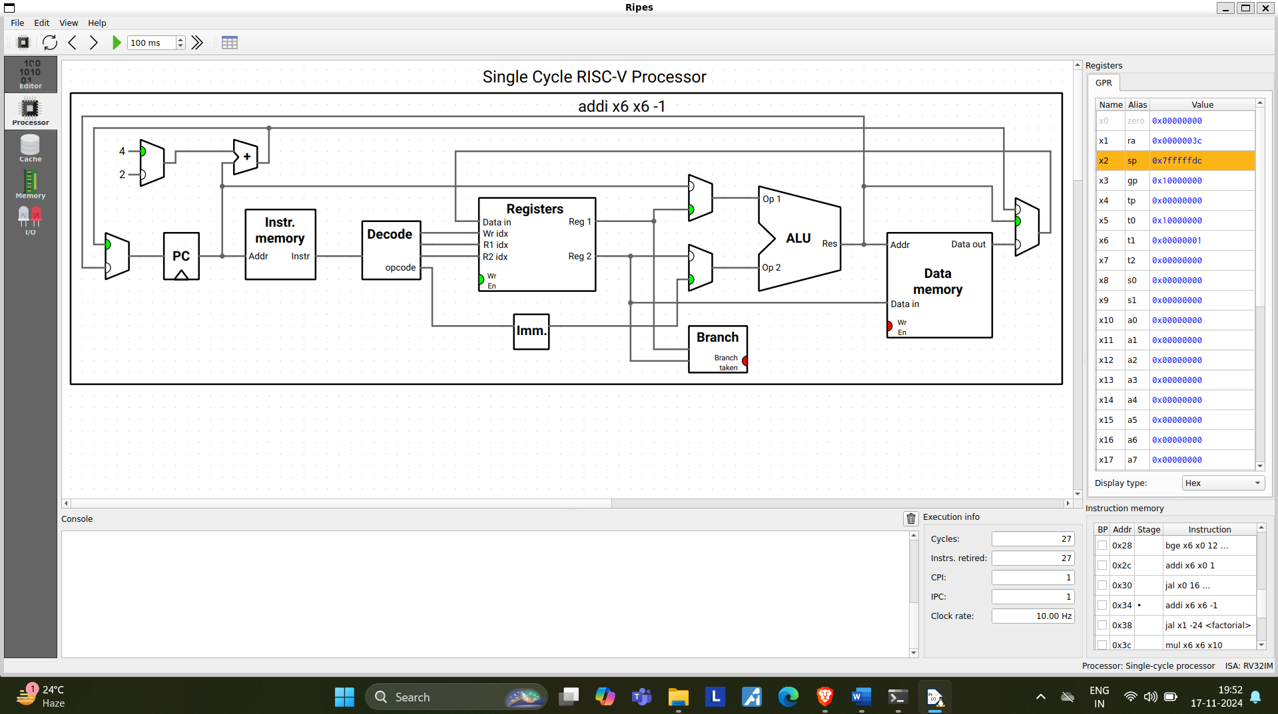

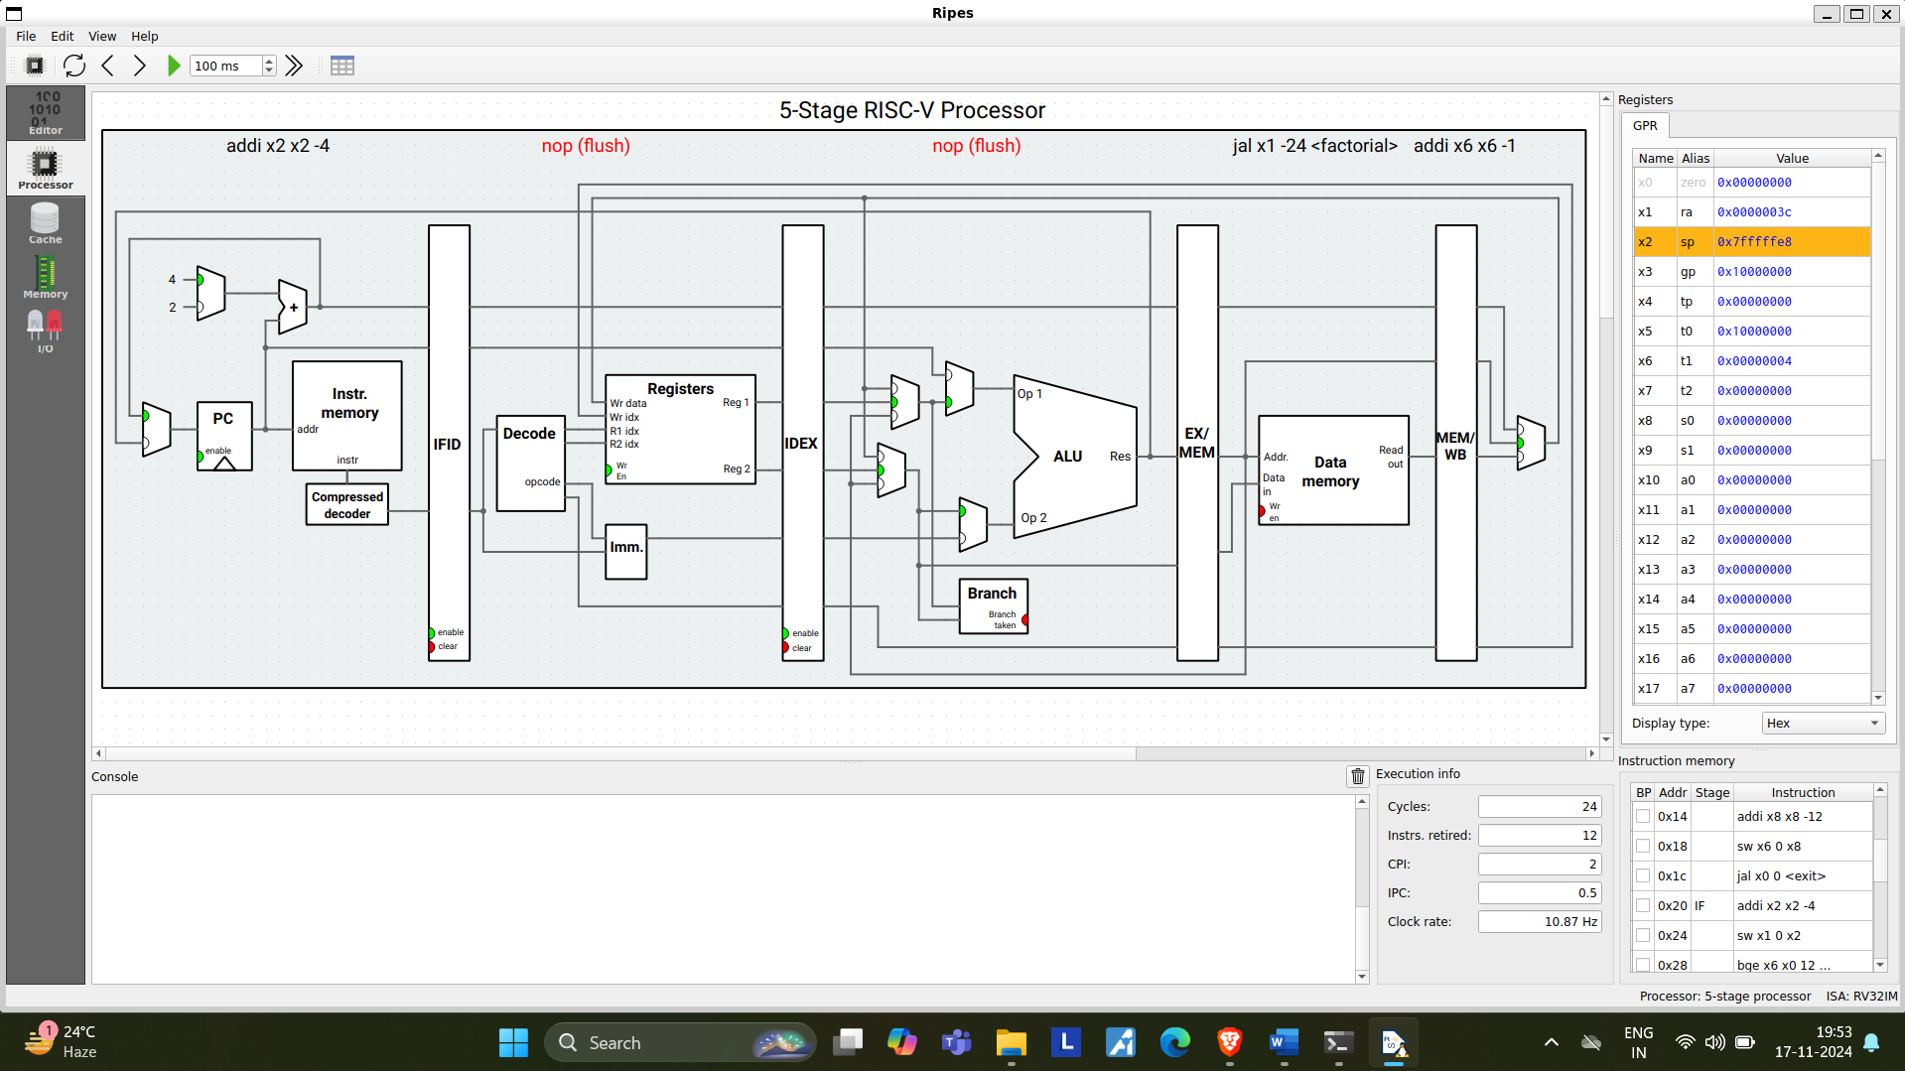

1. Write an assembly program to do matrix multiplication

.data

A: .word 1, 2, 3, 4 # Matrix A: 1 2 / 3 4

B: .word 5, 6, 7, 8 # Matrix B: 5 6 / 7 8

C: .word 0 # Result matrix C (2x2), 4 words (each 4 bytes)

.text

# Load matrix A elements

la x5, A # Load address of A into x5

lw x6, 0(x5) # Load A[0][0] into x6 (1)

lw x7, 4(x5) # Load A[0][1] into x7 (2)

lw x8, 8(x5) # Load A[1][0] into x8 (3)

lw x9, 12(x5) # Load A[1][1] into x9 (4)

# Load matrix B elements

la x10, B # Load address of B into x10

lw x11, 0(x10) # Load B[0][0] into x11 (5)

lw x12, 4(x10) # Load B[0][1] into x12 (6)

lw x13, 8(x10) # Load B[1][0] into x13 (7)

lw x14, 12(x10) # Load B[1][1] into x14 (8)

# Matrix multiplication C[0][0] = A[0][0]*B[0][0] + A[0][1]*B[1][0]

mul x15, x6, x11 # x15 = A[0][0] * B[0][0] (1 * 5 = 5)

mul x16, x7, x13 # x16 = A[0][1] * B[1][0] (2 * 7 = 14)

add x17, x15, x16 # C[0][0] = 5 + 14 = 19

la x18, C # Load address of C into x18

sw x17, 0(x18) # Store C[0][0] = 19 in C

# Matrix multiplication C[0][1] = A[0][0]*B[0][1] + A[0][1]*B[1][1]

mul x15, x6, x12 # x15 = A[0][0] * B[0][1] (1 * 6 = 6)

mul x16, x7, x14 # x16 = A[0][1] * B[1][1] (2 * 8 = 16)

add x17, x15, x16 # C[0][1] = 6 + 16 = 22

sw x17, 4(x18) # Store C[0][1] = 22 in C

# Matrix multiplication C[1][0] = A[1][0]*B[0][0] + A[1][1]*B[1][0]

mul x15, x8, x11 # x15 = A[1][0] * B[0][0] (3 * 5 = 15)

mul x16, x9, x13 # x16 = A[1][1] * B[1][0] (4 * 7 = 28)

add x17, x15, x16 # C[1][0] = 15 + 28 = 43

sw x17, 8(x18) # Store C[1][0] = 43 in C

# Matrix multiplication C[1][1] = A[1][0]*B[0][1] + A[1][1]*B[1][1]

mul x15, x8, x12 # x15 = A[1][0] * B[0][1] (3 * 6 = 18)

mul x16, x9, x14 # x16 = A[1][1] * B[1][1] (4 * 8 = 32)

add x17, x15, x16 # C[1][1] = 18 + 32 = 50

sw x17, 12(x18) # Store C[1][1] = 50 in C

exit:

j exit # Infinite loop to end the program

