Week 7

1. Write a SV program for Instruction Decode Stage

module instr_decode (

input logic [31:0] inst,

output logic [31:0] rs1_data,

output logic [31:0] rs2_data,

output logic [31:0] imm32,

output logic [6:0] func7,

output logic [2:0] func3,

input logic [31:0] wr_data,

input logic reset,

output logic [6:0]opcode);

wire [4:0] rs1_addr;

wire [4:0] rs2_addr;

wire [4:0] rd_addr;

wire [11:0] imm12;

wire regwrite;

decoder g1(inst,rd_addr,rs1_addr,rs2_addr,func3,func7,imm12,opcode);

regfile g2(rs1_addr,rs2_addr,rd_addr,regwrite,wr_data,reset,rs1_data,rs2_data);

sign_exe g3(imm12,imm32);

endmodule

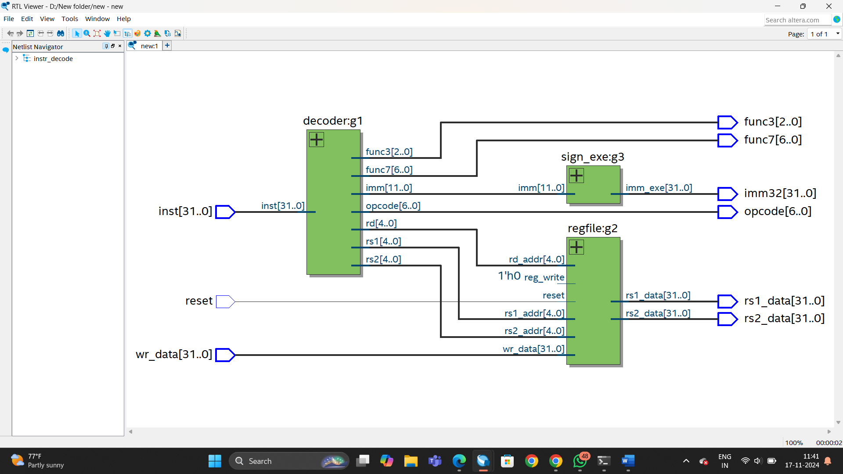

1. Write a SV program for the Decoder

module decoder (input logic [31:0]inst, output logic [4:0]rd,output logic [4:0]rs1, output logic [4:0]rs2,output logic [2:0]func3, output logic [6:0]func7,output logic [11:0]imm,output logic [6:0]opcode);

always_comb

begin

rd = 5'b0;

rs1 = 5'b0;

rs2 = 5'b0;

func3 = 3'b0;

func7 = 7'b0;

imm = 12'b0;

opcode=inst[6:0];

case(inst[6:0])

7'b0110011:

begin

rd=inst[11:7];

rs1=inst[19:15];

rs2=inst[24:20];

func3=inst[14:12];

func7=inst[31:25];

end

7'b0010011:

begin

rd=inst[11:7];

rs1=inst[19:15];

func3=inst[14:7];

imm=inst[11:0];

end

7'b1100011:

begin

rs1=inst[19:15];

rs2=inst[24:20];

func3=inst[14:12];

imm={inst[31],inst[30:25],inst[11:8],inst[7]};

end

7'b0100011:

begin

rs1=inst[19:15];

rs2=inst[24:20];

func3=inst[14:7];

imm={inst[31:25],inst[11:7]};

end

7'b0000011:

begin

rd=inst[11:7];

rs1=inst[19:15];

func3=inst[14:7];

imm=inst[11:0];

end

endcase

end

endmodule

1. Write a SV program for the Register File

module regfile(input logic [4:0]rs1_addr,rs2_addr,rd_addr,input logic reg_write,input logic [31:0]wr_data, input logic reset,output logic [31:0]rs1_data,rs2_data);

logic [31:0]rfile[0:31];

always_comb

begin

if(~reset)

begin

rs1_data=rfile[rs1_addr];

rs2_data=rfile[rs2_addr];

end

else

begin

rs1_data=32'b0;

rs2_data=32'b0;

end

end

always_ff @(posedge reg_write or posedge reset) begin

if (reset) begin

for (int i = 0; i < 32; i++) begin

rfile[i] = 32'b0; // Clear all registers

end

end

else if (reg_write) begin

rfile[rd_addr] = wr_data; // Write data to the specified register

end

end

endmodule

1. Write a SV program for the Immediate Unit

module sign_exe (input logic [11:0]imm,output logic [31:0]imm_exe);

always_comb

begin

if(imm[11]==0)

begin

imm_exe[31:12]=20'b0;

imm_exe[11:0]=imm[11:0];

end

else

begin

imm_exe[31:12]=20'b1;

imm_exe[11:0]=imm[11:0];

end

end

endmodule