Week 9

1. Write a SV program for Memory Access & Writeback Stage

Memory Access

a)

module memstage #(parameter N=32, M=1024) (

input logic [N-1:0] alu_out, data_in,

input logic mem_read, mem_write,

output logic [N-1:0] data_out

);

logic [N-1:0] mem [0:M-1];

always_comb

begin

if( mem_read==1 && mem_write==0)

data_out= mem[alu_out];

else if (mem_read==0 && mem_write==1) begin

mem[alu_out]= data_in;

data_out= 32'b0;

end

else

data_out= 32'b0;

end

endmodule

b)

module data_mem #(parameter N=32) (

input logic [N-1:0] alu_out, data_in,

input logic mem_read, mem_write,

output logic [N-1:0] data_out

);

memstage g1(alu_out, data_in,mem_read, mem_write,data_out);

endmodule

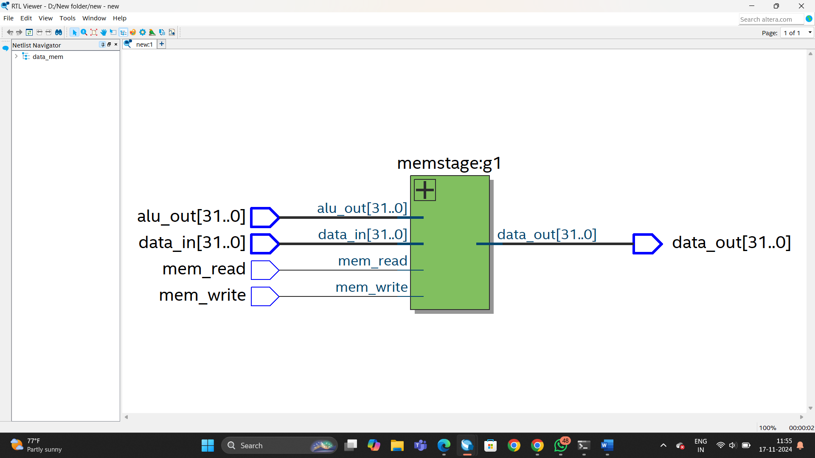

Write Back

module write_back1 #(parameter N=32)(

input logic [N-1:0] alu_result,

input logic [N-1:0] data_out,

input logic mem_reg,

output logic [N-1:0] wr_data

);

mux_1 wb_mux (alu_result,data_out,mem_reg,wr_data);

endmodule

