**Scenes Overview:**

1. **Scene : A Smart City**

Moving cars, ambulances (flashing lights), trains, ships, and boats on a rippling river.

Static buildings, bridges, trees, and decorative streetlights with flickering effects.

Smooth day-night transitions .

Zooming for adjustable scene views.

Weather effects like rain and snow add atmosphere to the scene.

**Graph:**

**Scene 1-**

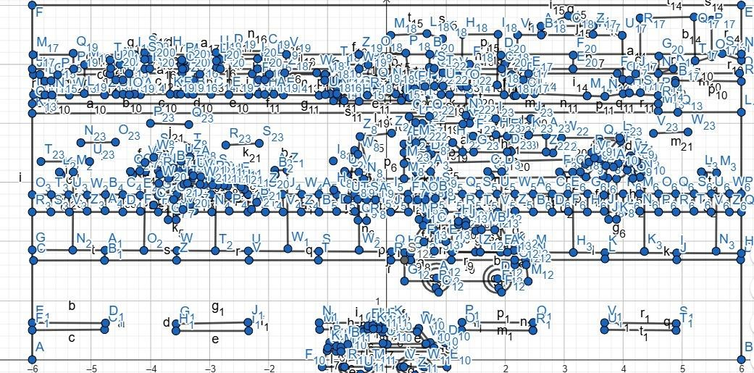

|  |  |  |
| --- | --- | --- |
| **SL#** | **Object ID** | **Obeject Name** |
| 1 | buildings1 | building |
| 2 | sky | sky |
| 3 | r_l_train | train |
| 4 | bridge | bridge |
| 5 | Wire | Wire |
| 6 | bridge_wirepillar | bridge_wirepillar |

|  |  |  |
| --- | --- | --- |
| 7 | road_border | road_border |
| 8 | road1 | road |
| 9 | public_bus | public_bus |
| 10 | road_marking | road_marking |
| 11 | p_fence | fence |
| 12 | pillar | pillar |
| 13 | buildings | buildings |
| 14 | river | river |
| 15 | flow | Water flow |
| 16 | ships | ships |
| 17 | speed_boat | speed_boat |
| 18 | road | road |
| 19 | footpath | footpath |
| 20 | lamp_post | lamp_post |
| 21 | bench | bench |
| 22 | fence | fence |
| 23 | human | human |
| 24 | ambulance | ambulance |
| 25 | policecar | policecar |
| 26 | suv | suv |
| 27 | warehouse | warehouse |
| 28 | car | car |
| 29 | tree | tree |
| 30 | isSnow | Snowfall |
| 31 | isRain | Rainfall |

Scene:

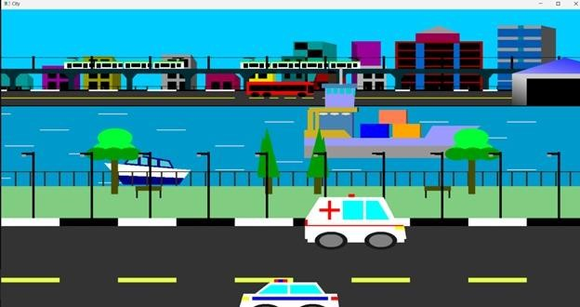

Conclusion:

Our project successfully demonstrated the capabilities of computer graphics using OpenGL and GLUT through the creation of a Smart City scene. This visually immersive environment combines dynamic animations of moving vehicles, trains, ships, and boats with static urban elements like buildings, bridges, and streetlights enhanced by flickering effects. The seamless day-to-night transitions, along with atmospheric weather effects such as rain and snow, contribute to a realistic and engaging simulation. Zoom functionality allows for flexible scene viewing, while detailed animations like flowing water and flickering lights add depth and vibrancy. Overall, the project met its goals by delivering a rich, interactive urban experience, showcasing the power of OpenGL and GLUT for building dynamic visual simulations.